**Lecture Notes**

**FYS 4260/FYS 9260:**

**Microsystems and electronic packaging and interconnection technologies**

Frode Strisland - Associate Professor II

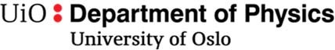

**Preface**

These lecture notes are intended as a support literature for students following the FYS4260/FYS9260 course *Microsystems and electronic packaging and interconnection technologies* at the University of Oslo. *Electronics packaging* (here used as a short-term covering all the course subject matter) is an essential ingredient in the physical realization of all electronics products, it is the major cost factor in manufacturing of electronics, and it affects all aspects of the physical realization of electronics.

The course has previously been offered using the book "Electronic Components, Packaging and Production" by Halbo and Ohlckers [1]. The scope of this book is still relevant, and I have kept the overall approach and sequence to the various topics. However, more than 20 years of development has made increasing sections of it obsolete. A number of other books have also been published, but either use information from the same time frame (the 1990s) [2] [3] or are sold out [4]. Meanwhile, several changes have happened to the industry, such as a move from hole mounted components to surface montage, and increasing use of environmental friendly electronics (lead solders banned), and microsystems technology is now included in many devices. In addition, there has been a general progression of technology performance. All of this and more will be covered in the course.

Whereas it is a large and active research and industry field, it is challenging to find good teaching material. I have therefore decided to develop lecture notes for topics not suitably covered from other sources. The course will therefore be based on a combination of lecture notes and extracts of chapters form selected text books. Feedback on the text and advices for improvements are therefore appreciated.

Electronics packaging is a challenging since it demands an understanding of many different fields, including materials properties, metallurgy, chemistry, physical and mechanical properties. As well as electronics, obviously! An understanding of how the various basic fields interact is necessary in order to find the optimum mix of solutions for the problem at hand. The course will give a large amount of information. My challenge to you is to try to understandthe broad lines rather than to try to memorize a lot of material constants and other details. I place the same challenge on myself to try to focus on giving you this understanding. The course literature will give you an important foundation for the course, but it is essential to gain operational understanding. This will be done through

* **Exercises** – targeting to train you to see how the text content can be applied in real life
* **Mandatory lab project** – where you will design, produce and test your own printed circuit board
* **Company visits** – to see how electronics are made in large scale – both real life visits and virtual (youtube) visits will be included.

Oslo, January 2020 Frode Strisland

1. **Introduction to microsystems and electronics packaging and interconnection technologies**

**Objectives:**

* Introduce electronics packaging terms and course content
* Design, manufacturing and test process for electronic products
* Give an overview of the electronics packaging hierarchy
  1. **Definition of terms**

Microelectronics is a subfield of electronics devoted to small, highly integrated electronic designs and components. These devices are typically made from semiconductor materials, such as a digital integrated circuit (IC).

Microsystems are microminiaturized and integrated systems based on microelectronics, photonics, RF, micro-electro-mechanical systems (MEMS) and packaging technologies.

Electronic packaging is the physical (hardware) realization of an electronic product or system, starting from a block-/circuit diagram level. It involves choices of technology for implementation, choice of materials, assembly, detailed design in chosen technology, analysis of electrical and thermal properties, reliability and much more. We however limit the scope to the physical realization aspects.

Interconnections are the electrical connections being part of the electronic system. This can be implemented for example by means of soldering, conductive adhesives, welding and other techniques.

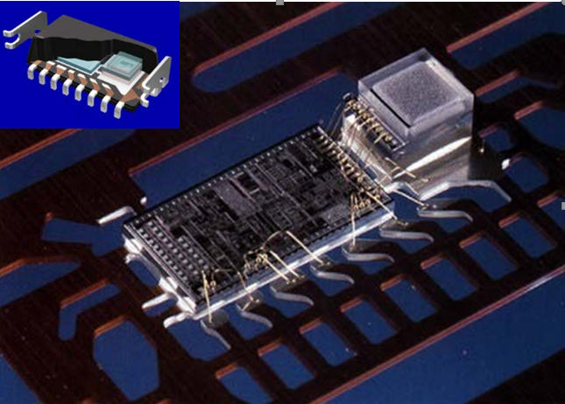EXAMPLE: Figure 1 shows an example of microsystem device during the packaging process. The MEMS sensor element and an application specific integrated circuit (ASIC) is assembled on a metal lead frame. The ASIC drives the sensor element, read out the sensor reading, add the calibration, and gives as output a measurement in a standardized analog or digital format. Electrical connections are implemented by gold wire bonding. In subsequent packaging steps, the unit will be integrated in a housing (an epoxy encapsulation), and lead frame legs will be trimmed and shaped to allow the device to be used on an electronics circuit board, see figure insert. The illustration also exemplifies that packaging and interconnection represent the main source of failures in electronic systems, and in particular within microsystems packaging: being very sensitive, the sensor element was also easily influenced by packaging induced mechanical stresses, thereby causing a NOK 229 million investment loss when the development had to be terminated.

*Figure 1: Interior chip assembly of the SA30 automotive Crash Sensor, a microsystem from SensoNor, Norway. A MEMS sensor element (right) and an application specific integrated circuit (ASIC) (left) mounted on a metal lead frame with electrical interconnections implemented by gold wirebonding. An impression of the final package is shown in the insert.*

The term *micro* in microelectronics and microsystems indicates that typical feature sizes are of the order micro meters (µm). However, chips and ICs are becoming smaller and smaller, thus terms as *nanoelectronics* and *NEMS* (nano-electro-mechanical systems) are becoming more and more popular. Within nanoelectronics, 10 nmprocess dimensions are currently under development, and intense research efforts are made to incorporate nanowires in NEMS devices. However, in the course we will not deal with this technology.

CHALLENGES BROUGHT BY MINIATURIZATION:

* ICs have a large number of input/output (I/O) points that must be connected. With smaller size, the distance between the various connections, and the possibility to electrically insulate the different interconnects from each other becomes more difficult.
* there is less material protecting the delicate, fragile electronic structures from the surrounding environment, making it more prone to corrosion processes.

* 1. **On the need for a structured design and manufacturing process**

Electronics design, manufacturing and testing are the main ingredients in product development. A long period passes between the target specification and achieving testable circuits, (several months to year(s)), and with limited possibility to fix design flaws without severe development delays 🡪 it is crucial that every effort is made to ensure that

1) the right product is made: we must develop a useful product that encounters customer needs 🡪 for this PRECISE TARGET SPECIFICATION IS ESSENTIAL!

2) the product is made right: we want to realize electronic systems that work from an electronic perspective without no short circuits, unintended cross talk or grounded signal paths

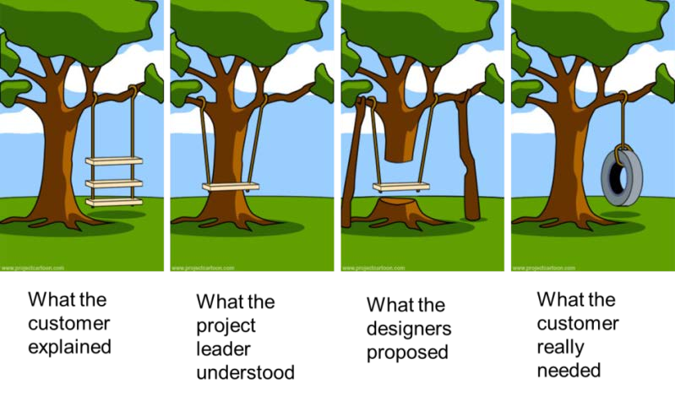

*Figure 2: Defining the right product is often more difficult than to make the product right!*

## **Regulatory requirements and design concerns for specific product groups**

Electronic products need CE marking in Europe2 in order to indicate that they meet all necessary regulatory compliance requirements on safety, health, and environmental protection requirements to be sold legally.

Products have to satisfy:

* Safety testing: the product is safe to use for all users
* electromagnetic compliance: the product is not influenced by other systems (immunity) and electromagnetic emission levels are acceptable

For some electronics systems the manufacturer may state that the applicable standards and procedures are applied, but for others, third party "notified bodies" are required to inspect and verify that requirements are met. The Norwegian institution Nemko is one example of such an organization verifying product regulatory compliance.

Certain product categories need additional safety measures, and are therefore to stricter regulatory requirements: medical devices, machinery, radio/telecommunication equipment and childrens' toys.

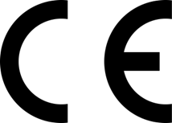

* + 1. **Different product groups have different demands on the electronics**

The demands on electronics products vary enormously depending on their use and intended market:

* + - * *Low end consumer electronics:* Very large market volume, high price pressure, the target lifetime is a few years, and failed products are replaced rather than repaired
      * *Automotive and avionics electronics:* Must tolerate very harsh environments, vibration, large temperature variations and lifetimes of at least 10-20 years. High reliability, low weight,

indication that systems are working or have failed. Repair when necessary. A very high development and test cost is acceptable in order to avoid expensive repairs or catastrophic failures

* + - * *Medical devices:* User safety and device effectiveness (that it works reliably as intended) are essential. Relatively high price for extensively tested products. Implanted electronic devices such as pace makers are life critical equipment that are not readily accessible for repairs
      * *Satellite electronics:* One unit, extreme demands on performance, reliability, low weight, small volume. Repair impossible. Very high development and production cost is acceptable.
    1. **The steps of the product development process**

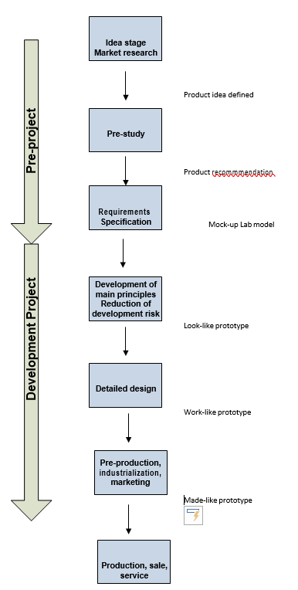

*Figure 3: Typical stages in the development of electronic systems*

It is important to run a systematic and staged product development process: anticipated results can be described and decisions can be made at defined points in time. An example process is shown in Figure 3.

In addition to the technical development aspects, we have to analyse and minimize marketing risks. The pre-project activities may only involve a few % of the overall product development cost, but care in this stage can save a lot of time and money in later stages by avoiding late stage design changes.

“SMART” RULE FOR TARGET SPECIFICATIONS

|  |  |
| --- | --- |
| **S**pecific | All requirements should be written in clear, unambiguous engineering terms |
| **M**easurable | All requirements should be quantified so that it is possible to verify at a later stage that the requirement was met. |
| **A**chievable | All requirements should be realistic to reach within the project constraints |
| **R**elevant | All requirements should be related to the product under development (and not related to factors outside the project) |
| **T**ime-limited | All requirements should be related to the time-frame of the product development |

One way to check that requirements are SMART is to inspect that all requirements can be tested. Testing can for example be done by a

* demonstration (when the on-off button is pressed, the device starts)
* observation (alarm button is red)
* experimental testing, which in particular is of relevance in performance testing.

The main development project starts after a decision is made to move forward towards a product. In this stage: multiple expert developers in multiple fields have to work together. Critical parts are realized and tested first. Often, several iterations of lab prototypes are developed to evaluate technology, lower risk and ensure from end user feedback that the development is indeed on the right track. Test prototypes focusing specifically on appearance (look-like prototype, which may not at all be functional) and function (work-like prototype, which includes all functionalities, but not in the targeted appearance) can be efficient steps on the way until a made-like production prototype can be realized. Here, all functions are integrated in a prototype with the targeted form factor, and where components are made using the same manufacturing technology as the final product.

MARKETING AND TIMING: even if costs increase, it is often better to shorten development time in order to reach the market opportunity at the right time. There are instruments that help in reducing the time consuming: 3-dimensional Computer Assisted Design (3D CAD) tools together with rapid prototyping (RP) technology have made visualization much easier, and allow over-night realization of realistic physical models.

* 1. **Electronics packaging hierarchy**
* 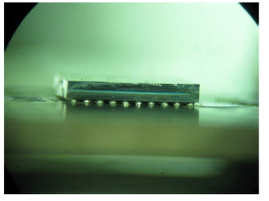level 0 is the interconnection of integrated, single transistors on a silicon (or gallium arsenide) integrated circuit (IC) chip. IMPORTANT: packaging starts on wafer level and not after the wafer is cut into circuits

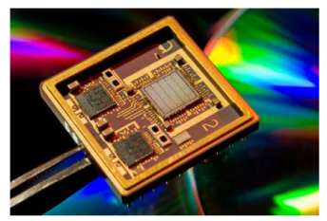

* the chips communicate by interconnection on level 1, which is a hybrid circuit or a module. Alternatively it can be the wiring inside an IC package, between the chip and the external solder joints of the package.

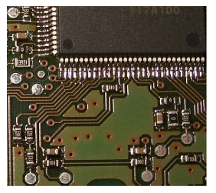

* Level 2 is the wiring on a printed circuit board (PCB) where ICs and discrete components are mounted.

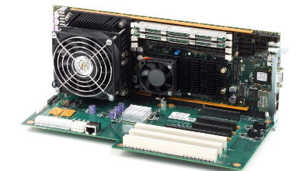

* The circuit boards in a larger system are mounted on to a back plane, interconnection level 3.
* Several back planes may make up a cabinet, with internal cabling, level 4.
* 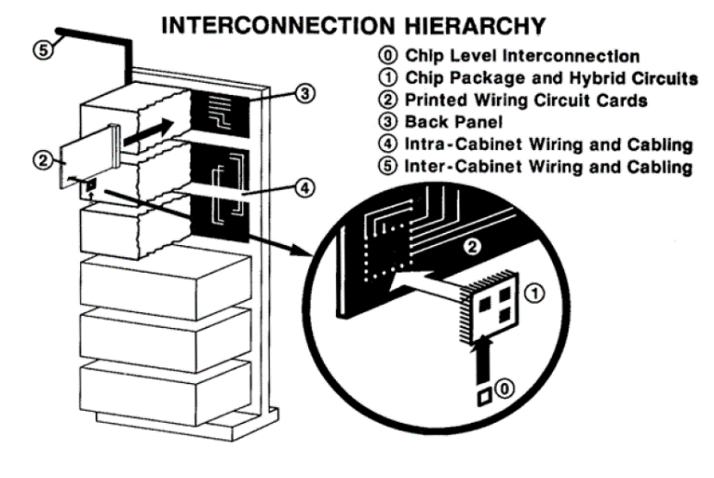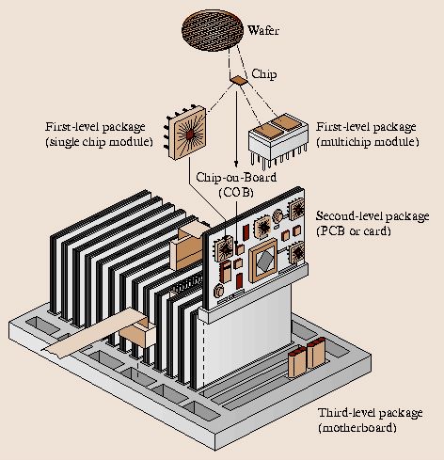Very large systems have several cabinets with cabling between them, interconnection level 5.
  + 1. **Moore’s law**

Technologies in microelectronics have made huge steps in the last decades 🡪 many efforts devoted to increase the number of components per unit area in a IC. This is described by Moore’s law

More transistors 🡪 more contact points on smaller dimensions 🡪 more demanding packaging

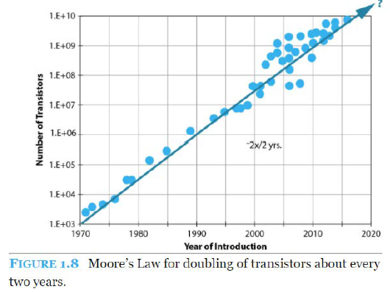Example: More heat is required to be dissipated

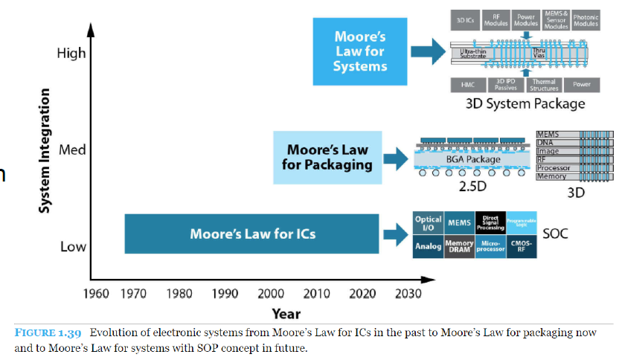

**BEFORE PROCEEDING: A SMALL DIGRESSION ABOUT SOLDERING PROCESSES THAT WILL BE NOMINATED IN THE NEXT SECTION**

* 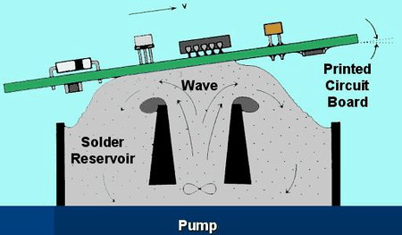**Wave Soldering:** **In this process t**he circuit board is passed over a pan of molten solder in which a pump produces an upwelling of solder that looks like a standing wave. The flux used for wave soldering is usually made up of more solvents than flux used for other applications, and will be sprayed on the board prior to it going through the solder wave. Once in place, the flux will clean the components that are to be soldered to remove any oxide layers that have formed. If the board is using a less corrosive type of flux, then the board will have to go through a pre-cleaning before the flux is applied.
* **Solder Reflow:**  solder reflow is a soldering technique in which surface-mount components are held in position on a circuit board using a paste containing solder which melts to form soldered joints when the circuit board is heated. For boards that are going through the solder reflow*,* a paste composed of a sticky flux and small spheres of metal solder is used. This solder paste holds the parts in place until the heat of the oven causes the solder particles to reflow. Not only are the metal surfaces cleaned by the flux, but the pasty nature of the flux seals out the air preventing further oxidation. The solder paste flux also contains additives to improve the flow characteristics of the solder as it melts.
* **Selective Soldering:** The flux used for selective soldering processes is applied either by spraying it, or by using a more precise drop jet process.

1. **Overview of electronics manufacturing technologies**

**Objectives:**

* Give an overview of the main technologies applied in electronics systems
* Give an understanding of how individual components are integrated into a complete electronics system.

This chapter will give an overview of the main technologies applied in electronics. Electronics packaging starts where the design of integrated circuit ends 🡪 we need to start the physical realization of the product.

## All the techniques presented here will be better illustrated in further chapters.

**BREADBOARDS**: they are a quick solution for simple prototypes, but they fail completely when it comes to realizing complex, long term stable, reliable, and reproducible (mass‐manufacturable) electrical circuits. Many components are also virtually impossible to connect to unless attached to a circuit board.

**STRIPBOARDS/VEROBOARDS**: they are equivalent to breadboards, but here soldering is permitted.

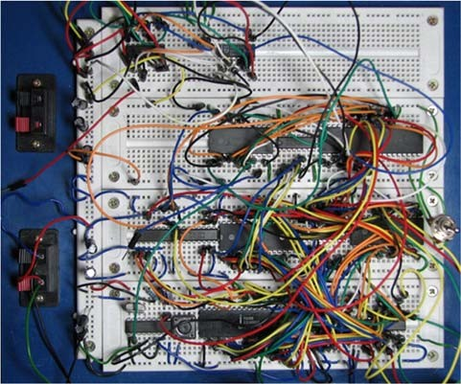

We will start with the most conventional printed wiring board technologies, thick film and thin film hybrid technologies, chip on board and multichip‐modules. We will also introduce briefly MEMS technology concepts. The different technologies have different strengths and weaknesses. The optimal choice of technologies therefore depends on a large number of factors, which must be weighed against each other for the system under development. This includes:

* Performance specifications, such as speed, accuracy, power consumption, physical dimensions
* Operating environments
* Required reliability and lifetime of product
* Production volume
* Service/repair needs
* Cost
* Engineer's approach*: Keep it simple, stupid (KISS).* Good enough is enough! It is an art not to overdo a design!
  1. **Introduction to printed circuit board technology**

The purpose of a Printed Circuit Board (PCB) is to mechanically support and electrically connect electronic components using conductive tracks, pads and other features etched from copper sheets laminated onto a non‐conductive substrate [6].

An illustration of a PCB cross‐section is shown in Figure 6. PCBs can be single sided (one copper layer), double sided (two copper layers), four layer (as in Figure 6) or multi‐layer. Conductors on different layers are connected with plated‐through holes called vias. Advanced PCBs may contain components ‐ capacitors, resistors or active devices ‐ embedded in the substrate.

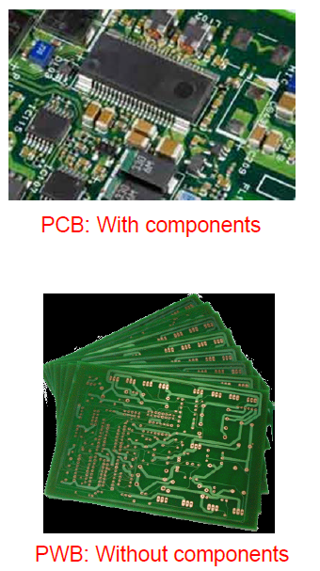We must distinguish between PRINTED CIRCUIT BOARDS AND PRINTED WIRING BOARDS

* PWB: Historically, the term Printed Wiring Board (PWB) has been used to describe the electrical wire pattern of the board before any electrical components have been mounted. (Nowadays also called PCB)
* PCB: the term PCB was reserved for boards *when* components had been assembled (consistent with the definition that an electrical circuit is not established until it is closed – which means that a circuit board without circuit are just a board of wires, and not an electrical circuit). (nowadays also called PCB-A)

The use of PWB is nowadays not consistently used in this way, with the exception of some cases where it is useful to highlight the wiring aspects of the board. We will mainly use the term PCB in this course to cover boards both with and without components.

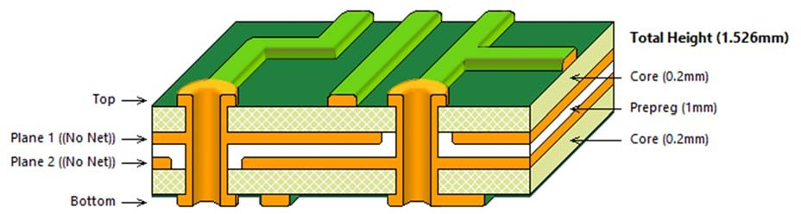

The most common PCB laminate technology 🡪 FR‐4:

* it uses a glass epoxy matrix as the primary insulating substrate.
* One or more thin layers of copper foil are laminated to one or both sides of the FR‐4 panel
* circuitry interconnections are etched into copper layers to produce printed circuit boards

FR‐4 technology is the dominating circuit board technology world‐wide, and its processing technology will be presented in more detail at a later stage of the course. FR‐4 will also be the work horse of the course lab project where you will design, assemble and test a 4‐layer FR‐4 PCB.

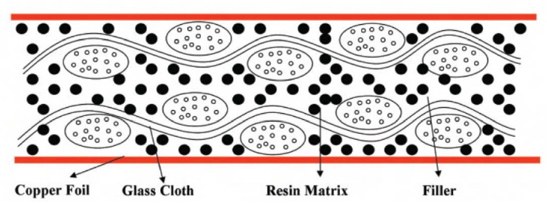

ADVANTAGES WITH FR4: reliable, inexpensive, suitable for mass production

COMPOSITION: it has a woven fiber glass (tessuto in fibra di vetro) cloth with (intrecciato con…) an epoxy resin binder that is flame resistant! This building technique is similar to that used for concrete: steel increases the strength and the elasticity, while concrete is more leading to structural properties.

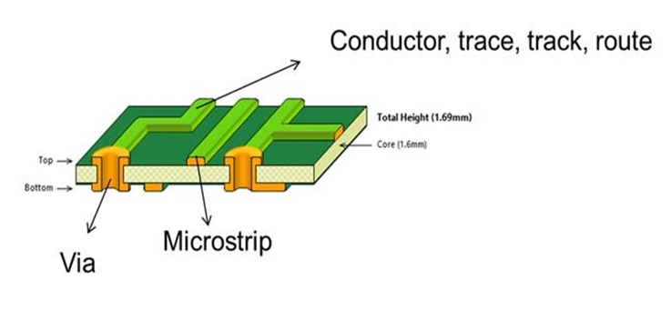**Some common PCB terms**

PCB conductors on the top or bottom layers are known as conductors, trace, track, route and several others.

Conductive holes through the circuit board are called vias.

Vias that only go between layers in a multi‐layer PCB are called micro‐vias.

A microstrip is a thin conductor line separated from ground – often used for RF signals.

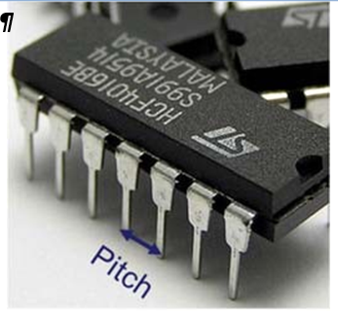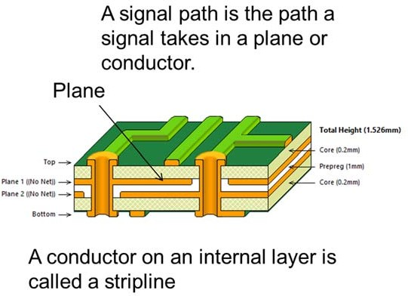PITCH = lead‐to‐lead or pad‐to‐pad dimension.

In multilayer PCBs, internal conductor layers are referred to as planes. It is very common to define a plane as ground and one power plane.

DIMENSIONS:

* For drilled thru‐hole components, the pitch is usually 0.1 inch, corresponding to 100 mil (where 1 US inch = 1000 mil).
* PCB and component dimensions in mil are widely used (and mil is a practical dimension).
* Remember therefore that 1 mil = 25.4 µm!

## **PCB ROUNTING WORKFLOW**

CIRCUIT DESIGN: gives just the idea of the circuit, real values and components are not specified

CIRCUIT SCHEMATICS: this is the actual target implementation, real values and components are specified 🡪 we need to modify this file to add components to the circuit

LAYOUT DESIGN: this is the process in which we transfer elements from schematics to a virtual version of the real pcb 🡪 we can place components, pads, tracks… using PR editor. OUTPUT FILES: each layer is well described and can be used as template for the production phase

PCB PRODUCTION: the board is printed, connections have to be soldered. Generally, different PCB can be obtained from a unique big panel

Electronic components, packages, PCB component montage techniques will be discussed in the further chapters.

* + 1. 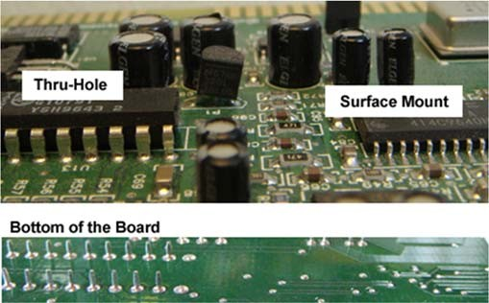**Thru-hole mounting and surface mount technologies**

**THRU-HOLE MONTAGE:** In printed circuit boards (PCBs) with hole mounting, or insertion technology, the components are mounted by insertion through holes in a laminated substrate, the printed wiring board (PWB), and the pins are soldered to the substrate wiring on the backside. This is the traditional way to build electronic circuits.

The components are interconnected on the laminated substrate by conductor lines that are defined in a single layer or multiple layers of copper foil by etching techniques.

The components are discrete devices (resistors, capacitors, transistors, switches, connectors, etc.) or integrated circuits 🡪 The dual-in-line package (DIP) having a center-to-center pin pitch of 0.1" (2.54 mm) is the most used package for integrated circuits.

Laminated glass/epoxy is the most used substrate material. This is made of several layers of woven fibreglass sheets in a matrix of epoxy (see FR4).

Mass soldering is also possible by wave solder bath.

**SURFACE MOUNTED DEVICES**: surface mounted devices (SMDs) are soldered to bonding pads on the surface of the substrate. This technology has been growing very fast since approximately 1980, and is expected to take over the lead from insertion technology as the dominating PCB mount technology.

The most striking advantage 🡪 increased packaging density - the devices are smaller and the conductor pattern of the substrate is routed with a finer pitch.

GLUEING TECHNIQUES: Wave soldering and reflow soldering by infrared (IR) heating, vapour-phase, hot gas, thermode-or laser heating.

Whereas many components are offered in a range of different packages, it might be required to apply a combination of surface mount and thru‐hole montage due to component availability. Especially large and bulky components are predominantly offered for thru‐hole montage since this technology is mechanically more robust.

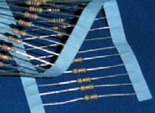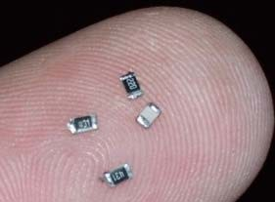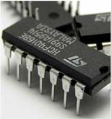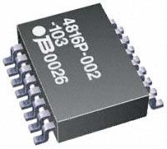

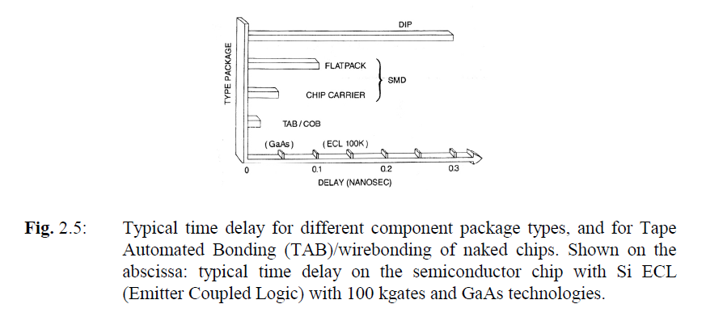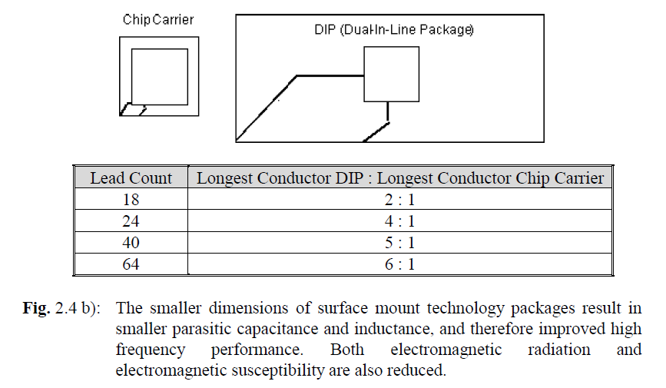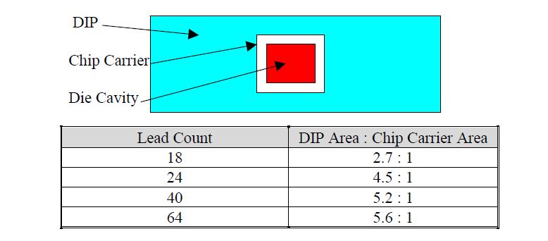

|  |  |  |
| --- | --- | --- |
| Factor | Thru‐hole technology | Surface mount technology |
| Component dimensions (footprint) | Large components.  Board vias occupy space on all layers in multi‐layer boards.  Mainly single side component montage  Standard grid for holes correspond to 100 mil = 2,54 mm pitch | Superior miniaturization potential.  Small sized components possible – often only limited by the size of e.g. the integrated circuit material itself  Double sided component assembly common  Grid for flip chip montage can typically correspond to 150 µm pitch |
| Manufacturing costs | High cost associated with drilling many high accuracy holes. | Cost of package is in many cases negligible compared to the active component material. |
| Manufacturing process | Accurate insertion processes.  Several insertion devices have conductor legs that must be bent before insertion,  and cut after montage | Surface mount components well suited for pick‐and‐place robots.  Many components can be supplied on carrier tapes. |
| Electrical connections | Predominantly component fixing by soldering | Soldering most common, but also conductive adhesives are in widespread use. |
| Serviceability (repair possibilities) | Relatively easy to remove components.  Suitable for testing (fits in breadboards) and "do it yourself" circuits | Repairs often difficult do to small dimensions. Several components are impossible to remove because of connections under the package.  Components attached by adhesives are also difficult to repair |
| Reliability | Very good reliability. Good solder attachment in holes, and metal package pins can compensate mechanical stresses otherwise induced in the package | Good reliability, but problems with thermomechanical stresses – especially for large components.  Large and heavy components such as large capacitors and AC/DC converters are not suited for surface montage, and are only offered as thru‐hole components.  Possibility of overheating components in the soldering processes may give reduced reliability |

## **Direct chip attachment: Chip on board**

Direct chip attachment – chip on board (COB): Bare (naked) silicon or GaAs chips are mounted directly on a wiring board without any packaging.

The three most common electrical connection methods between the chip and the package are shown here.

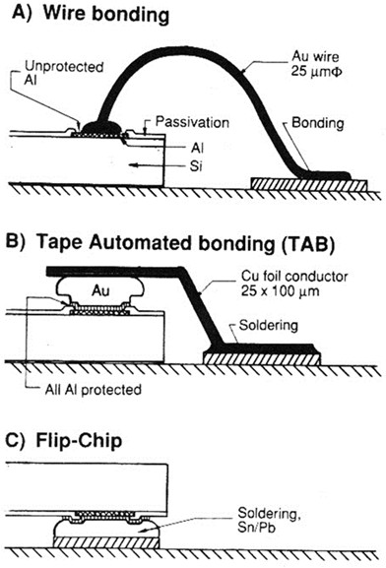

*Figure 13: Summary of the main electrical connection technologies for Chip on Board (from [1]).*

1. *Wire bonding: A thin Au or Al wire is connected from each bonding pad on chip to substrate. Contact by heat, pressure and/or ultrasonic vibration*
2. *Tape automated bonding (TAB): A film with pre‐ fabricated Cu conductor pattern is gang bonded to Au bumps on chip and soldered to substrate.*
3. *Flip chip: Chip is soldered directly, upside down, to substrate by bumps of solder alloy on bonding pads.*

**WIRE BONDING:**

https://www.youtube.com/watch?v=Mi9_ll_Z8mk&list=PLa45mK9hZkZJV6jo1ZoY8gsrlIZtWpNu-

It is done in the same way as for chip packaging 🡪 a silicon chip is attached to the substrate by a die attach material, and electrical connections are made by aluminum or gold wire bonding between connection pads on the chip and connection pads on the subtrate. Wire bonding is described in more detail in Chapter 4.

The thin wire bonds are very fragile 🡪 protected either by inserting the circuit board in a hermetic package, or by adding a droplet of sealing material that protects the fragile interconnects from mechanical and environmental stress (GLOB TOP PROTECTION).

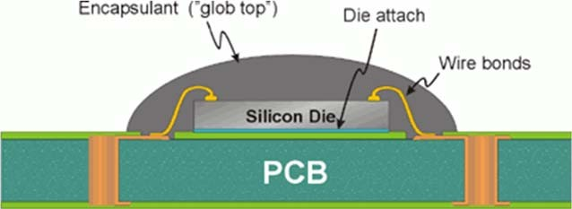

**TAPE AUTOMATED BONDING** (TAB): https://www.youtube.com/watch?v=X104jJNTvuc

has a conductor pattern of copper as interconnections between chip and substrate.

The conductor pattern is pre-processed from a continuous copper tape on a dielectric carrier film. Once that you have this copper tape processed, you connect the copper pads to some gold "bumps" on the silicon chip (see figure above). At this stage, the whole IC + copper package is still separated from the substrate. Mounting of the chip on the substrate is done after cutting off the copper fingers from the tape just outside the chip area.

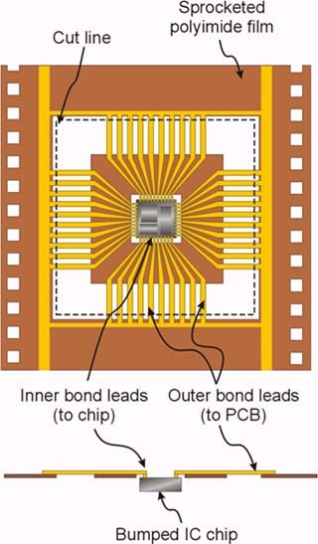The technique 🡪 also called a "tape carrier package" (TCP) because you connect the copper tape to the chip, you mount the whole pack on the substrate, you cut the copper leads and CARRY them to the pads on the substrate.

The leads are soldered to the substrate with a specialized tool employing "impulse soldering".

Following the interconnection process, it is very common to do a glob top process to protect the chip and interconnection.

**FLIP CHIP**: https://www.youtube.com/watch?v=m0K57meeMZ8

It is done by mounting the chip upside down on the substrate, after having deposited solder bumps on all interconnection pads of the chip. The chip is soldered directly onto the substrate, calling for CLOSE THERMAL MATCHING OF THE CHIP AND SUBSTRATE.

* The highest packaging density of the different interconnection methods
* It is common to apply an underfill material that enters into all the voids between the chip and the substrate 🡪 addition strength and environmental protection.
* It is also excellent with respect to electrical characteristics (short signal paths) and is also excellent reliability when properly used.
* it is a very demanding technology both to establish and operate. Initial costs are high, favouring high-volume or high-end applications.

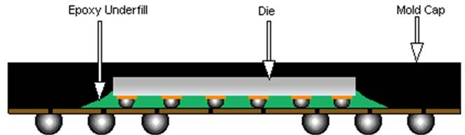

* 1. 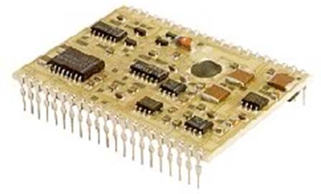**Thick film hybrid technology**

In hybrid technology, chips are interconnected on a substrate, this substrate has the capability of including passive components such as resistors, capacitors and insulators as an integrated part of it.

* Packaging density between integrated circuit technology and printed circuit board technology.
* 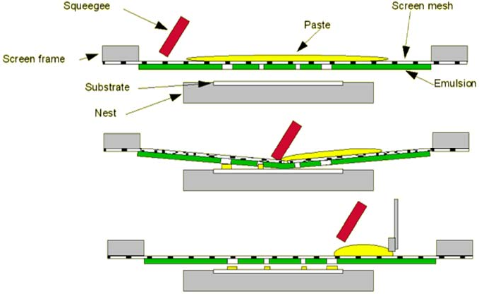sintered 96% aluminium oxide (alumina, ceramic aluminium oxide) as the substrate material. Conductors, resistors and insulators are made as thin layers, deposited by screen printing 🡪 thick film pastes with low resistivity gives conductors, pastes with a higher resistivity give resistors. Insulators are made with dielectric pastes. The layers of conducting, resistive and insulating materials are placed on the alumina substrate by screen printing where pastes are squeezed onto the substrate in predefined patterns defined by the screen mesh
* The thick film pastes for conductors and resistors are made up of conductive particles (metals or metal oxides) in a matrix of glass particles, organic filler materials and solvents. After each printing step, the hybrid substrate is dried and heat treated at a high temperature (700 - 900°C) to remove the solvent and the organic vehicles by evaporation. Meanwhile the glass melts to make up a homogenous mixture of conductive filler in a glass matrix.
* Thick film is an example of an *additive* technology where the wiring and other structures are defined layer‐by‐layer in build‐up process. PCB technologies, in which the copper conductor patterns are defined by etching of a copper layer, are on the other hand referred to as a *subtractive* technology.
* FEATURES: high reliability and stability of both components and interconnections, the packaging density is also high

Usage example: Thick film circuits are widely used in the for example the automotive industry where high reliability is required, combined with demands for extended temperature range operation and massive thermocycling3. Thick film hybrid circuits are therefore found in electronics and sensor applications such as fuel/air mixture sensing, pressure sensing, engine and gearbox controls, sensors for releasing airbags and airbag ignitors.

The drawbacks is a relatively high cost. The ceramic substrates are much more expensive than the typical glass/epoxy laminates used for printed circuit boards. Alumina is a brittle material prone to breakage.

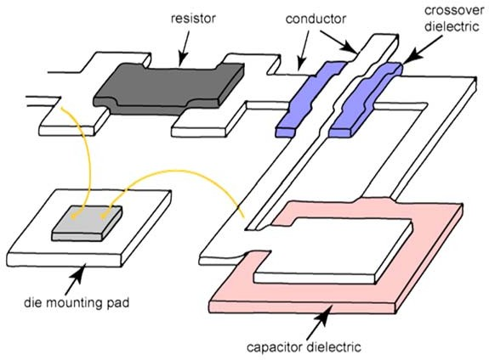

**POLYMER THICK-FILM HYBRID TECHNOLOGY (PTF)**

Thick film hybrid technology high cost 🡪 due to high temperature processing temperature.

Alternative thick film pastes are developed making use of organic, polymer materials instead of glass as matrix material.

* Can be printed on ordinary glass/epoxy laminates and cured at 150-200 °C. PTF can therefore be combined with traditional printed circuit board technology
* The conducting particles in the pastes are silver, copper or carbon.
* PTF has inferior long term reliability compared to traditional hybrid technology and PCB and relatively poor long term stability of the printed resistors
  1. **Thin film hybrid technology**

Alumina ceramics as carrier substrate.

Based on using photolithography in order to obtain very precise conductor patterns, instead of using screen printing. For this reason, polished 99% alumina substrates are used as the process basis.

PHOTOLITOGRAPHY 🡪 based on the deposition of very thin films (≤ 1um) of conducting or resistive materials; in conventional thin film just one conductor layer and one resistor layer is applied.

***Positive photoresist***, the most common type, becomes soluble in the developer when exposed; with ***negative photoresist***, unexposed regions are soluble in the developer

Thin film circuits normally have to be encapsulated in a hermetic metal box or similar in order to protect the thin films of conductor material from environmental exposure causing corrosion.

FEATURES:

* Thin film circuits can be very compact, high performance, and have very high reliability. They do however tend to be expensive.
* Thin film technology is a specialised technology with relatively few suppliers.
* Chips are attached with chip-on-board technique
* 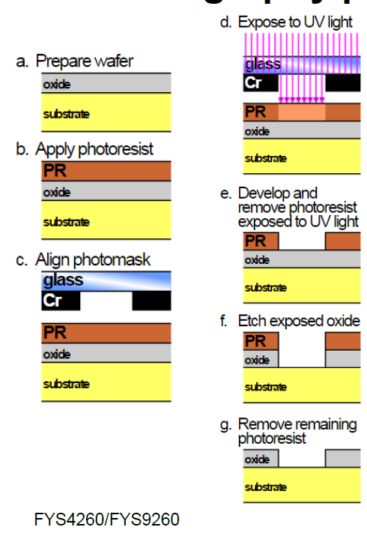Passive components with glued conductive adhesives

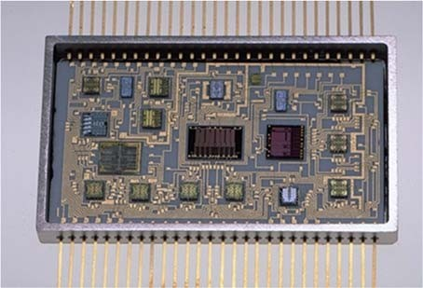

## **Multichip modules**

ICs are required to be more and more performing! Main requirements are:

* Fine-line conductor dimensions with short conductor lengths
* Controlled characteristic impedance
* Low thermal resistance to heat sink
* Matched thermal expansion coefficients

POSSIBLE SOLUTION: advanced multilayer printed circuit boards made of advanced materials with special processing. However, PCB technology has limited performance. Example 🡪 narrow conductors are difficult to make (typical width = 100 μm, compared to less than 1 μm for silicon integrated circuits).

We can define the **maximum achievable interconnection density**: the maximum total line length per unit area when using minimum line width and line spacing times the no. of conductor layers. This parameter can be maximized using Multichip module (MCM) technology 🡪 MCM = a module containing multiple integrated circuits, semiconductor dies and/or integrated discrete components packaged so that they can be as if it was a single component.

4 main groups:

1) MCM-Z (Z for Zero): Modules using no substrates 🡪 we use direct chip-to-chip interconnection and direct chip-to-package connection.

2) MCM-L (L for Laminate): Modules using fine-lined printed wiring board technologies to form the copper conductors on plastic laminate-based dielectrics.

3) MCM -C (C for Ceramic): Modules constructed on co-fired ceramic substrates using thick film (screen printing) technologies to form the conductor patterns (“Cofired” means that the conductors and the ceramic are all heated in an oven at one time). In addition, we include here modules made by thick film printing of conductor pattern on pre-fired bulk ceramic substrates with no previous conductor pattern.

4) MCM-D (D for Deposited) are modules whose interconnections are formed by the thin film deposition of metals on deposited dielectrics, which may be polymers or inorganic dielectrics. Ceramic, glass, silicon or metal are used as base substrate. The denotion MCM-S is sometimes used for MCM-D on silicon substrate.

The main driving forces behind moving towards MCM packages 🡪 the possibility of making very advanced "turn‐key" (chiavi in mano) components that can implement target functionality within a self‐contained package that is straightforward to combine with other electronics.

Examples of MCM packages include DC‐DC converters, motor controllers, and several MEMS packages.

Another alternative: system-in-package (SiP) or system‐in‐a‐package is a more recent term for even more advanced packages where a number of integrated circuits are enclosed in a single module (package). The SiP performs all or most of the functions of an electronic system, and is typically used inside a heavily miniaturized device such as a smartphone. Dies containing integrated circuits may be stacked vertically on a substrate: they are internally connected by fine wires that are bonded to the package, or they are stacked together using flip chip technology.

SiP dies can be stacked vertically or tiled horizontally, unlike slightly less dense multi‐chip modules, which place dies horizontally on a carrier. SiP connects the dies with standard off‐chip wire bonds or solder bumps, unlike slightly denser three‐dimensional integrated circuits, which connect stacked silicon dies with conductors running through the die.

Some examples of Multichip and multilayer modules are contained in the book Electronic components, 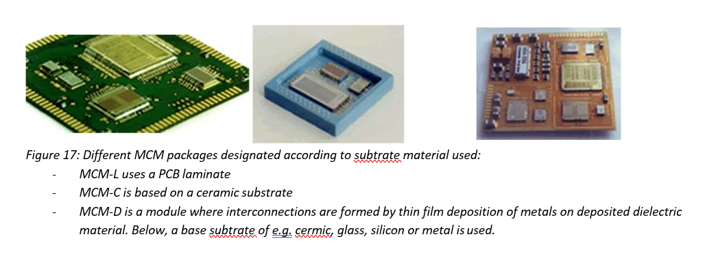packaging and production.

* 1. **Integrated Circuits Application Specific Integrated Circuits (ASICS)**

Design and realization of integrated circuits is not a topic of the present course. Understanding of how standard ICs or custom developed Application Specific Integrated Circuits (ASICs) is however important in order to design optimal electronic systems.

Integrated circuits can be classified into **analog**, **digital** and **mixed signal** (both analog and digital on the same chip). In MEMS applications, it is often necessary to move to a dedicated ASIC front‐end analog or mixed signal electronics realization in order to obtain the accuracy, low noise and configuration capability needed for a highly specialized case. Development expenses are high and development times long (typically around 12 months), but cost in high volume low, making ASICs the alternative for high value or high-volume products.

Standard integrated circuit can range from very simple, such as logic gates and multiplexers to a wide range of configurable processors from small 8‐bit versions and up to very complex state‐of‐art computers processors.

ASICS can be constructed following different procedures:

* GATE ARRAY CUSTOM DESIGN: a gate arrays is made up of a prefabricated layout of transistors and basic logical elements. The customer needs only to design the conductor pattern in the way that meets the specified electrical functions. Fast production, but low flexibility
* STANDARD CELL CUSTOM DESIGN: for standard cell custom design the silicon foundry has available a set of predesigned and characterised electrical building block - the standard cells – that can be combined to give the desired function of the chip
* FULL CUSTOM DESIGN: full custom design is performed by designing the circuits in full detail down to the transistor level. The give the best electrical characteristics and highest packaging density, but it requires a strong design know how, advanced equipment, and it is time consuming.

**Microcontrollers, field programmable gate arrays (FPGA) and digital signal processors (DSP)** can often be used as good alternatives to ASIC or complex electronics realizations 🡪 Figure 18 illustrates the functionalities offered in a microcontroller. In addition, these controllers have a wide range of peripheral systems that can be used in the electronics design, including serial interfaces and I/O, timers and counters, as well as analog modules such as OpAmps, DACs and ADCs. It is therefore possible to avoid substantial electronics hardware realization by selecting and taking advantage of features offered in modern standard 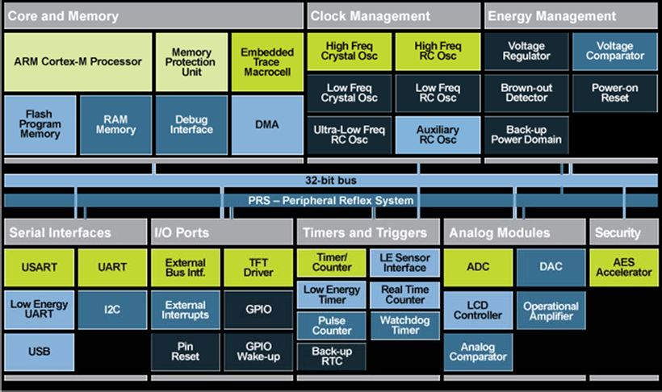ICs.

*Figure 18: Energy Micro 32 bit microcontroller with ARM Cortex core processor.*

## Microsystems technology (MEMS – Micro Electro Mechanical Systems)

Microsystems employs a wide range of existing IC processing technologies such as photolitography, etching techniques, diffusion, implantation, and various deposition techniques and applies them in combination with dedicated technologies to define micro structured features.

Micro Electro Mechanical Systems (MEMS) 🡪 miniaturized mechanical and electro‐mechanical elements (i.e., devices and structures) that are made using the techniques of microfabrication.

MEMS technology is feasible to realize a wide range of miniaturized sensor and actuator elements:

* a sensor element is able to measure a physical quantity
* an actuator is an element that is able to make something happen by means of an electrical signal.

Examples: sensors (pressure, accelerometer, and gyroscope) and actuators (micropumps, valves, digital mirror devices (image component in projectors)).

**TECHINQUES:** Microsystems and IC are mainly distinguished by the techniques used to define 3D structures in silicon. There are three main groups of micromachining technologies that define different types of microsystems elements:

* Bulk micromachining: Wet etching-based approach taking advantage of the full wafer thickness (subtractive process)
* Surface micromachining: Surface micromachining uses layers deposited on the surface of a substrate as the structural materials, rather than using the substrate itself (additive process)
* High aspect ratio (HAR) silicon micromachining, mainly based on Reactive Ion Etching combines surface micromachining approaches with deep reactive ion etching forming deep structures in the wafer

NOTE THAT ALL THESE ETCHING TECHNIQUES WILL BE COVERED IN NEXT CHAPTERS.

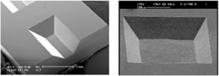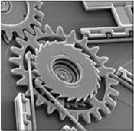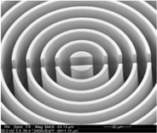

Bulk micromachining Surface micromachining High aspect ratio (HAR) silicon

micromachining

In addition to the microstructuring, MEMS technology employs a wide range of creative techniques to functionalize parts of the elements, for example by adding functional materials.

From a packaging perspective, all the challenges of conventional IC packaging apply, but there are also additional challenges: MEMS devices are usually sensor or actuator components with a window to the environment, thereby adding considerable packaging constraints. Moreover, thermally induced stresses from the packaging can for example give rise to drift in a MEMS sensor.

MEMS will be described in more detail in later stages of the course.

* 1. **The packaging research frontline: Smart Systems Integration**

The present section will give a brief perspective on some current research activities within electronics packaging.

Two main aspects: further miniaturization in IC's and the need for an increasing number of I/Os (input/output) pads from the limited circuit are. These are further driven by the ambition to integrate more functions in small areas or volumes.

Current technology trends include wearable devices and Internet‐of‐things. In both cases, there is a drive towards realizing small, self‐contained units that can sense, process, communicate with other systems while consuming a minimum of power – or harvesting own power from the environment. This research field is often referred to as Smart System Integration in Europe today.

Flip chip bonding and Chip Scale Packages (CSP) are widely used in industry today. CSP is an application of flip chip: ICs are placed on an IC‐sized circuit board by flip chip, connectors are then re‐routed to the other side of the circuit board (often using larger contact pads), thus allowing the use of small (chip size) packages in conventional electronics.

There is also a push for moving from two dimensional to three‐dimensional packaging: In 3D, several ICs (and/or) MEMS devices are stacked on top of each other in a single package. Packaging of memory circuits has been a prime example of where the third dimension has been used to progress miniaturization. Interconnection has been a challenge in 3D packaging since metallization and IC processing generally has been a single side processing technology. During the past decade, techniques for realizing "Through Silicon Vias" (TSV), in which electrical connections are possible from one side to the other side of a wafer, has more common, thereby enabling new constructions. An example of a packaging technology roadmap is shown in Figure 20.

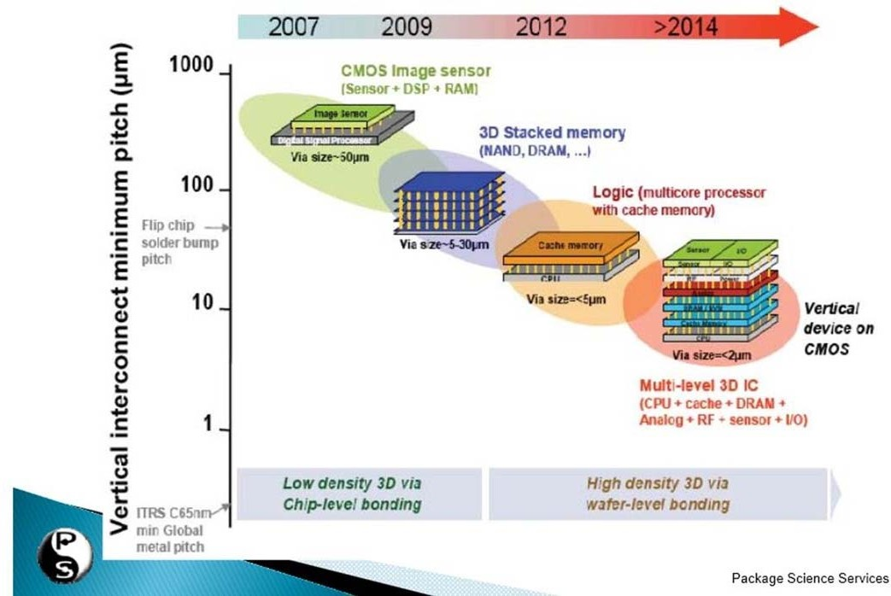

At the research front, there is also very active research on how to develop new functional sensors and concepts. One example is the incorporation of nanostructured parts (nanowires) in electronic devices to establish new logical devices or sensors. Another example is the mixing of electronics with biochemistry to develop ways to sense or manipulate tissue or biofluids.

* 1. **Sustainable electronics**

Electronics has a high impact on the environment, but it can also help in reducing many dangerous effects.

ELECTRONICS 🡪 both part of the problem and the solution!

BAD: poisoning, batteries, Cadmium

GOOD: solar panels, light, information

Many regulations, but not every country has adopted them:

* **RoHS**(The Restriction of Hazardous Substances Directive 2002/95/EC, (RoHS 1) EU
* **Waste Electrical and Electronic Equipment Directive** (WEEE) 2002/96/EC sets collection, recycling and recovery targets for electrical goods

CHALLENGES:

* IoT: sensors and devices are quite difficult to be recycled
* Battery revolution: we need more efficient batteries, with non-azardous compositions
* Trace element shortages (carenza), e.g. rare earth materials used in displays
* Dissolvable electronics and packaging: Truly sustainable electronics should just dissolve itself and leave no footprint for future generations
* Energy consumption associated with production, distribution and destruction

1. **Materials**
   1. 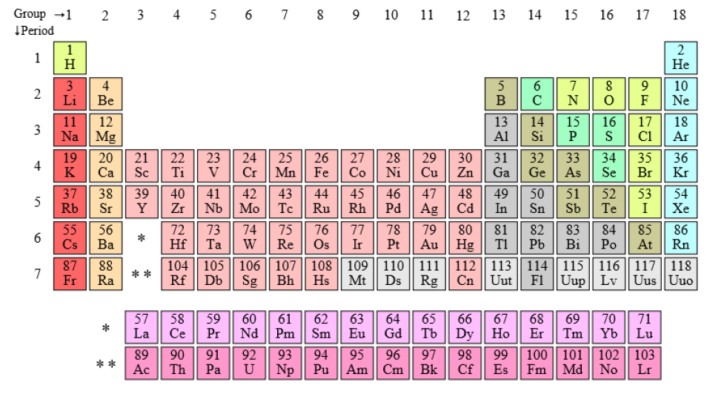**General features**

Periodic table of elements 🡪 elements are stored depending on their electronic structure

* On the eight: elements have completely filled-out shells 🡪 noble gasses
* On the left: Alkaline metals and alkaline earth metals 🡪 the 1st group elements are more reactive
* In between: metals + semiconductors + non-metals

Metals:

* Copper 🡪 most used in electronics
* Ag 🡪 best heat conductor and also good electricity conductor
* Au 🡪 good conductor
* In general, Cu, Au, Ag, Ni, Pd, Pt 🡪 all good conductors

Semiconductors: Si, Ge, Se, As 🡪 building blocks for SC

Fe + C 🡪 steel

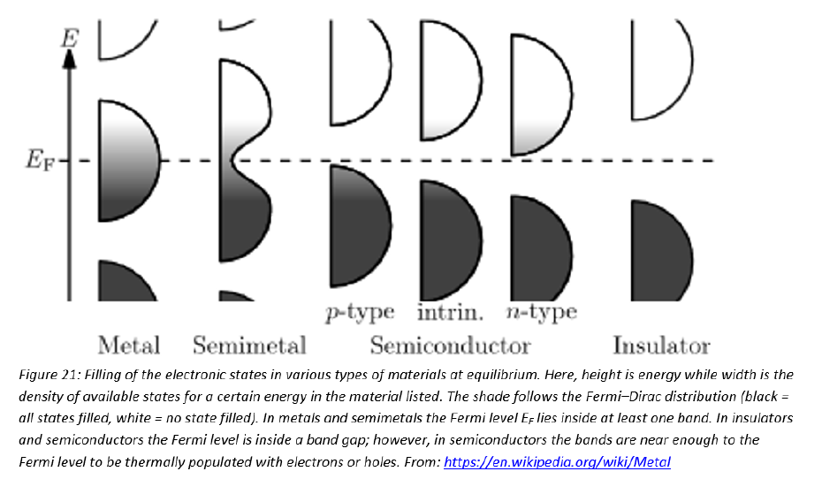How can we distinguish metals, semiconductors and insulators? **THEORY OF SOLIDS**

The innermost electron energy levels are typically completely ﬁlled and tightly bound to the nucleus. However, the outer shells are inﬂuenced by the ﬁelds of other nuclei. From quantum mechanical considerations, the energy levels that are inﬂuenced by a very large number of nuclei form a quasi-continuous band. **The outermost energy band or valence band provides the basis for the prediction of the properties of a solid**

* If the band is partially filled, the electrons can pick up enough energy from an electric ﬁeld to be able to “jump" to a nearby higher energy level in that band, where they can easily be available for conduction. This is the typical situation for metals. The electrons in the conduction band are referred to as **free electrons** and can be considered a classic gas of conduction electrons moving freely thorugh a fixed lattice of ion cores.
* substances which have completely ﬁlled shells in the form of single atoms, but have overlapping bands in the lattice are called semimelals 🡪 In some elements the band above the valence band overlaps with the valence band itself. The overlap between 3s and 3p in Magnesium bands creates available energy states in these lattices, but this overlap does not occur if we consider an isolated atom.
* For insulators, the valence and conduction hands are separated by a large energy gap. The electrons cannot jump easily to the conduction band. They stay in the valence bang where they are tightly bound to are nearby nucleus and hence immobile for conduction. For insulators valence band is completely filled and there are no electrons in the next band (at null temperature). The energy gap is too large to let the electrons be promoted in the conduction band.

Example: polymers and ceramics, quartz (silica) being known as the best insulator

* For semiconductors the forbidden gap is much smaller. This means that some of the electrons have enough energy to jump into the conduction band. The number of excited electrons in an intrinsic semiconductor is exponentially dependent on the absolute temperature. Semiconductors are doped with other elements to improve their conductivity and control their current carriers.
  + When pentavalent atoms are added to a pure semiconductor, there is an excess electron that is not covalent bonded to any atom. These are called **N-type** semiconductors, where electrons are the majority charge-carriers.
  + when a trivalent atom is added to form a **P-type** semiconductor, there is a deﬁciency of electrons, creating a vacancy or hole. The movement of holes from one atom to another consumes charge motion.

Materials can be classified depending on the following properties:

* electrical properties
* mechanical properties
* chemical properties
* metallurgical properties
* low flammability
* corrosion resistance
* stability
* compatibility with other materials used
* weight
* price
* ease of processing
* low absorption of moisture

Let’s now analyze the different features:

* 1. **Metals**

A metal is a material that when freshly prepared, polished, or fractured, shows a lustrous/shiny appearance, and conducts electricity and heat relatively well. Metals are typically malleable (they can be hammered into thin sheets) or ductile (can be drawn into wires). Most metals are either a chemical element such as iron or an alloy (composition of several chemical elements) such as stainless steel.

In physics, a metal is generally regarded as any substance capable of conducting electricity at a temperature of absolute zero.

* good electrical and thermal conductivity
* they are used as mechanical construction materials.
* Copper is a particularly important element in electronics: very high electrical and thermal conductivity, used in foil conductors, lead frames in component packages, thick film conductor materials, heat sinks in power electronic modules, etc.
* Aluminum has similar advantages + low weight and price. Commonly used for mechanical carrying structures, heat sinks, cooling towers. In semiconductor components it is used for bonding wires and circuit metallisation, etc.
* Pure metals TCE = 15 - 30 ppm per degree centigrade, much higher than the semiconductors and most ceramics
* Chemical reactivity varies from very low (Noble metals like gold and platinum), to highly reactive.
* Mechanical properties also vary widely: pure gold, silver and indium are soft, while some of the others are very hard. Mechanical properties may depend on the processing (heat treatment, rolling, etc.), and change with small amounts of additives from other elements.

**ALLOYS**

* have poorer conductivity, both electrical and thermal
* used to achieve better mechanical properties, or often to custom-tailor a desired thermal expansion coefficient: Invar TCE = 1.5 ppm/°C, Kovar = 5.3 ppm/°C, matched to glass, "Alloy 42" = 4.9 ppm/°C, close to that of silicon
* lower melting point than the elements in them and they are used as soldering metals.

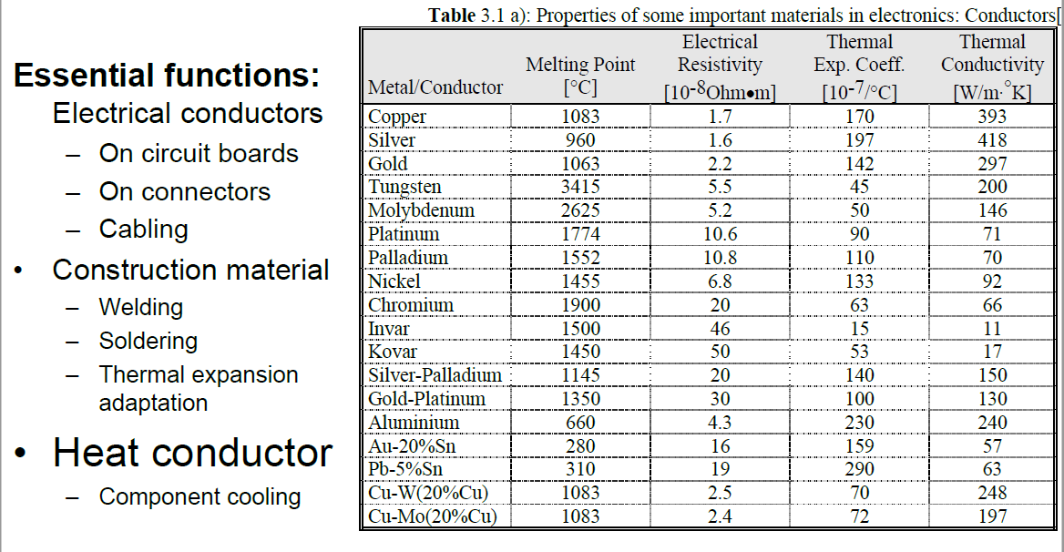

Important features in the table:

* Melting point:
  + Copper - Silver – Gold it is around 1000°C
  + Aluminum: much lower, around 600°C, 🡪 it cannot be used in ceramic circuits because ceramic substrates are exposed to high temperatures
  + Au – 20% Sn / Pb – 5% Sn 🡪 they have a low melting temperature: the message is that we can reduce the T of melting by adding few Sn to Au for example. This is very useful!
* Resistivity:
  + Metals: very low
  + In alloys it increases
* Thermal conductivity: silver is the best
* Thermal expansion coefficient:
  + Invar/Kovar 🡪 designed to have low TEC
  1. **Semiconductors**

Most common 🡪 Si and GaAs

* Crystalline structure
* high thermal conductivity, around 150 W/m
* have very low TCE, around 2.5 ppm/K (Remember Si = 2.6 ppm/K).
* electrical conductivity may be changed over many orders of magnitude by controlled doping.
* Silicon can be "machined" in very interesting ways by anisotropic etching. It has many exciting possibilities as a "mechanical" material. The material keeps its elastic properties practically until it breaks. It is also important for Si that it makes an oxide with very good properties 🡪 SiO2
  1. **Ceramics**

Ceramics: inorganic and non-metallic materials that are artificially manufactured, by high temperature reactions (>600 °C)

* Most interesting for electronics are alumina (Al2O3), aluminium nitride (AlN), beryllia (BeO), silicon carbide (SiC), and glass ceramics.
* Ceramics are made by the **powder method**:
  + the material is made into a powder, mixed with glass particles, organic binders and solvents in two ways:
    - pressing them together in a plate, for example
    - tape casting: this process is used for manufacturing of thin layers of ceramic. From a slurry of for example alumina powder, glass, solvents and binders a thin soft layer is made in the desired width as the material moves through an opening in the bottom of the slurry container, down on a moveable transport band. The distance between the bottom of the opening in the container and the band is controlled with great precision, and it determines the thickness of the layer of ceramic. The consistency is soft and pliable, and the ceramic in this form is called "green tape". After being cut to desired lengths, the material is further processed, by metallisation, punching of holes, etc. Often many layers are laminated on top of each other under pressure

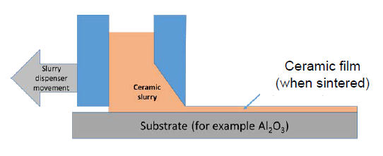

* + Afterwards the material is sintered (heat treated) at temperatures 800 - 1600 °C. During the sintering the binder and solvents are evaporated and the powder particles are bound together. During the process the material typically shrinks 15 - 20 % linearly.

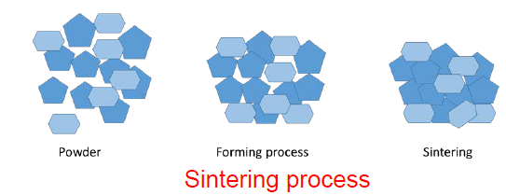

* Ceramics are brittle and crack easily. They are chemically stable and have a good stability in their mechanical properties up to high temperatures. However, they are often difficult to machine after sintering, and they tolerate little mechanical shock.
* Used as substrates in hybrid technology, for component packages, base material in surface mounted resistors, dielectric in capacitors, piezoelectric components, magnet cores (ferrites), etc. Alumina (Al2O3, 90 - 99 %) is the most used ceramics.
* We can see that ceramics have a very wide range of TCE values: from negative to 20 ppm/K. In general it is lower than for metals

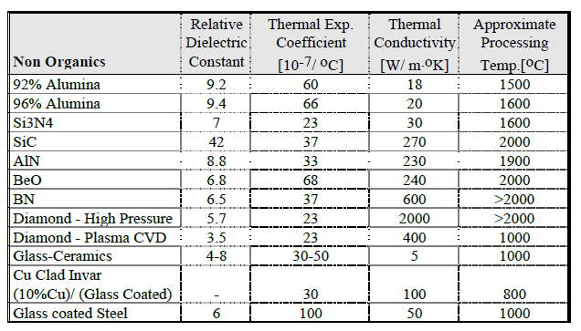

* 1. **Glasses**

A glass is an amorphous, supercooled liquid 🡪 it normally has no regular crystalline structure, and it becomes fluid when re-heated.

EXCEPTION: some materials called **devitrifying glasses**, or glass ceramics, convert to a crystalline state after heating, but do not reflow upon reheating.

* Uses:
  + matrix in thick film pastes
  + Insulator layer and binder material on ceramic circuit boards
  + Isolation on electrical feedthroughs
* Glasses can be available with a wide range of properties

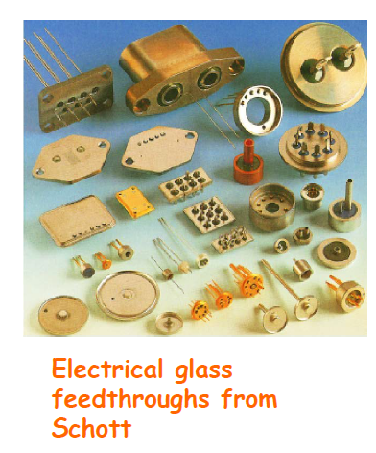

* 1. **Plastics**

Plastic is a large group of organic materials that harden and keep their shape after a moulding or forming process with heat and pressure.

They use polymers as a main ingredient. Most commonly, the continuously linked backbone of a polymer used for the preparation of plastics consists mainly of carbon atoms.

POLYMERS: A **polymer** is a substance or material consisting of very large molecules, or macromolecules, composed of many repeating subunits.

* Usages in electronics:
  + structural materials (boxes, component substrates, connectors, etc.),
  + for thin dielectric layers on circuit boards
  + encapsulation of components
  + electrically conducting or insulating glues, as process materials in production processes (photoresist, etch resist, etc.)
  + as binder for printing pastes in hybrid technology
  + photoresistors in circuit board productions
* BASIC GENERAL FEATURES FOR ELECTRONICS APPLICATIONS:
  + High electrical resistivity, high breakdown field, low dielectric losses, low dielectric constant
  + Thermal and mechanical stability up to the working temperature of the electronics (in general plastics are stable up to 100-200°C)
  + Thermal expansion: 30 – 300 ppm/K 🡪 In general it is higher than in metals and ceramics. This can cause high material stress and possibly cracking. It can also be modified by additives.
  + High mechanical strength for certain applications, softness and flexibility for other applications.
  + Low weight density 🡪 1.0 – 1.5 g/cm3
  + Low thermal conductivity: 0.2 – 0.4 W/K*m this can be a disadvantage when they are used as substrates. This can be increased by adding other particles (ceramics, metals…) to the mixture,
  + Chemical resistance to solvents, etc.
  + Good adhesion to other materials
  + Ease of processing
  + Low water absorption and small change of the properties during the effect of moisture
* ONE OF THE MOST IMPORTANT FEATURE: THEY ARE VERY CHEAP!

**COMPOSITION**

Plastics are synthetic **polymers** 🡪 They consist of very long and complex organic molecules.

Basic building block 🡪 normally is the benzene molecule. We can add other components to the benzenic ring and create **monomers.** When such monomers are bound together in a periodic structure, in a "polymerisation process", we get the analogous polymer composition.

By addition of smaller amounts of other elements or compositions, selected properties can be changed and improved considerably.

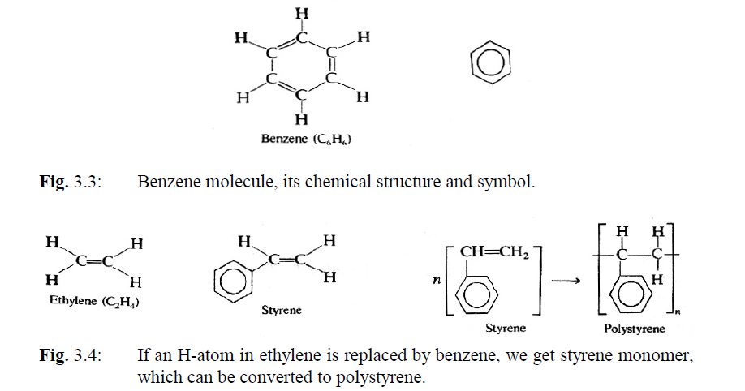

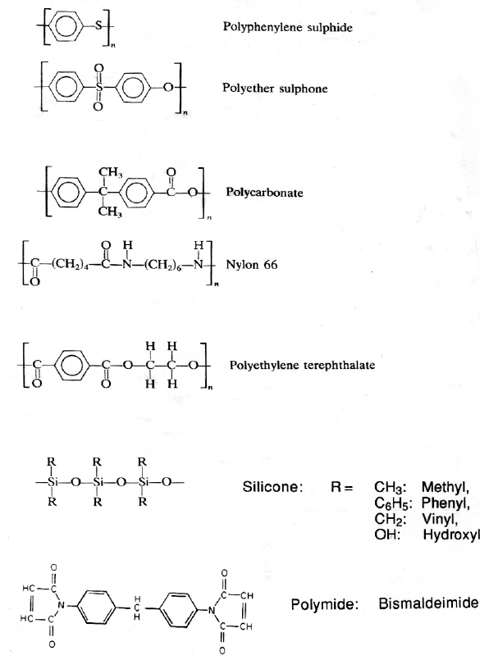

The polymers may be linear, branched, or cross-linked. The cross-linking gives the best chemical stability.

Two important groups of plastics are the:

* **Thermoplastic materials:** melts when it is heated in a reversible process
* **Thermosetting materials**: they are irreversibly cross bound during the polymerisation process, and they cannot be brought back to their original state.

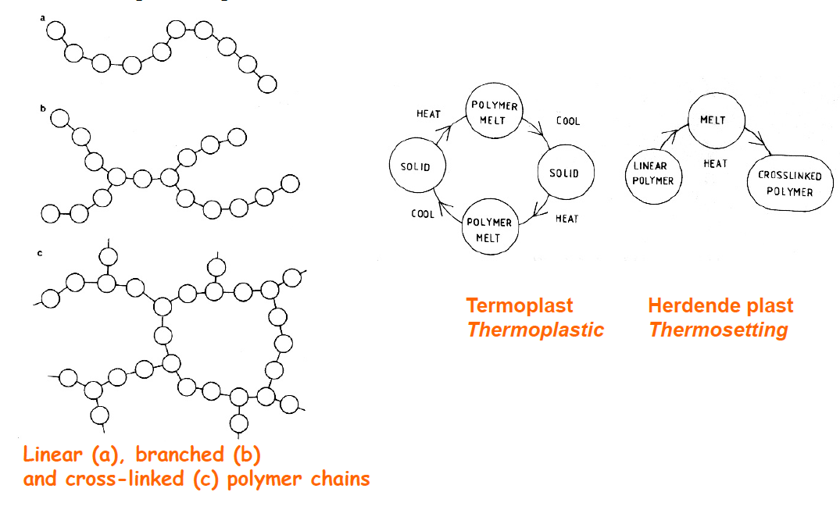

**POLYMERISATION**: it can take place

* by heating
* through pressure, for example with epoxy.
* By exposure exposure to UV-radiation
* two components are stored separately, and the curing starts immediately when they are mixed, even at room temperature (two component system).

**GLASS TRANSITION TEMPERATURE**

The glass transition temperature characterizes the transition of an amorphous material from a brittle state to a rubbery state. Crystalline materials do not show this transition.

Glass transition is manifested by drastic changes in many of the material’s physical properties, such as volume and modulus. The thermal expansion coefficient increases above Tg.

Polymers are subjected to severe thermomechanical stresses and dimension instabilities, related to warpage (the extent or result of being bent or twisted out of shape, typically as a result of the effects of heat or damp) above the glass transition temperature. For many applications, it is important to keep the material above Tg for the shortest time possible. A prolonged permanence in that region could cause an irreversible transition.

Molecular motion is the most important factor in determining Tg 🡪 Molecular chains tend to ﬂuctuate because of thermal energy. The ﬂuctuations are characterized by a distribution of relaxation times that are temperature dependent:

* Below Tg the molecular motion is hampered (ostacolato, relaxation times are very high).
* Above Tg the molecular chains possess sufﬁcient thermal energy to ﬂuctuate between different conformations (rotation of side groups, etc).

Some materials show two distinct relaxation times, one corresponding to the main chain and the other to the side chains. Hence these materials show two glass transition temperatures.

In general:

* Linear polymers and long flexible have very low Tg
* Bulky side groups decrease the mobility of the chain, thus raising Tg.
* Highest Tg 🡪 polymide = 350°C
* Lowest Tg 🡪 silicone
* Range of epoxies: 120 – 200 °C
* (the second graph is referred to epoxy)

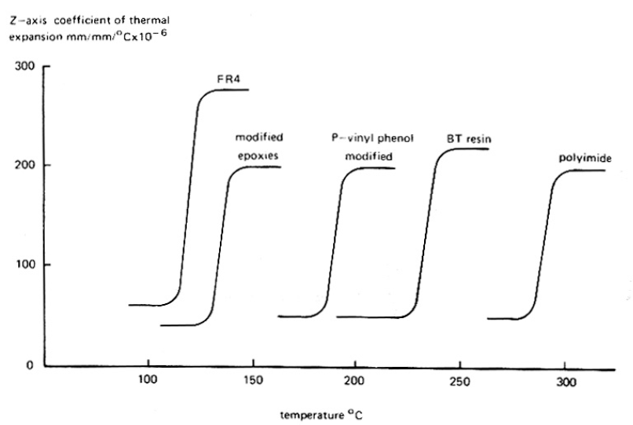

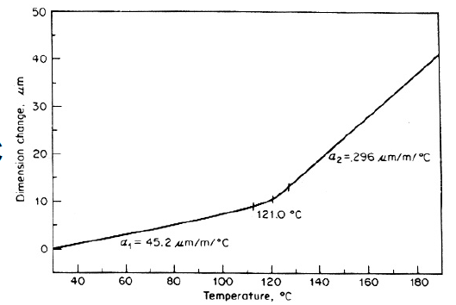

* 1. **Physics behind the materials**

Up to now we discussed many materials and their properties. But which are the general parameters which characterize each of the previously cited categories?

* + 1. **Thermal conductivity**

Main equation 🡪 Fourier’s law: the amount of heat Q transferred per unit time (which is the flux of heat) through a surface with area A is proportional to the temperature gradient. The proportionality coefficient is the thermal conductivity.

$$\frac{dQ}{dt}= -λA∇T$$

Notice the minus sign: heat goes from high temperature region to low temperature region, thus it is opposite to the gradient of temperature. Inserting a minus sign makes the thermal conductivity a positive number.

* Thermal conductivity 🡪 tensor with 9 components.
* Measures the ease with which heat can flow through a surface.
* It is extremely important in IC when they produce a lot of heat 🡪 dissipation is essential! Temperature can be controlled through high-thermal coefficient materials.
* Generally speaking: increasing the average temperature of a component by 10°C reduces its life time to half of its value!

Heat conduction comes from 2 contributions:

* PHONONS:
  + They are quanta of lattice vibrations or oscillations. Their number is not conserved: they are created with high temperature and destroyed with low temperature.
  + Main process responsible for heat conduction in non-metallic materials
  + Scattering of phonons reduced the capability of the material in conducting heat: regular crystals with low impurities are good conductors since they guarantee a low scattering probability for phonons. Impurities or different dimensions for the atoms in the crystal increase the probability. Polymers and plastics 🡪 amorphous structure and thus low thermal conductivity.
* ELECTRONIC MOVEMENT:
  + The flow of current and of heat in metals is based on the same principle: electrons move inside the material! 🡪 intimate link between electrical conduction and heat conduction. This is expressed by Wiedemann-Franz law: the ratio of electrical conductivity and thermal conductivity is proportional to the temperature

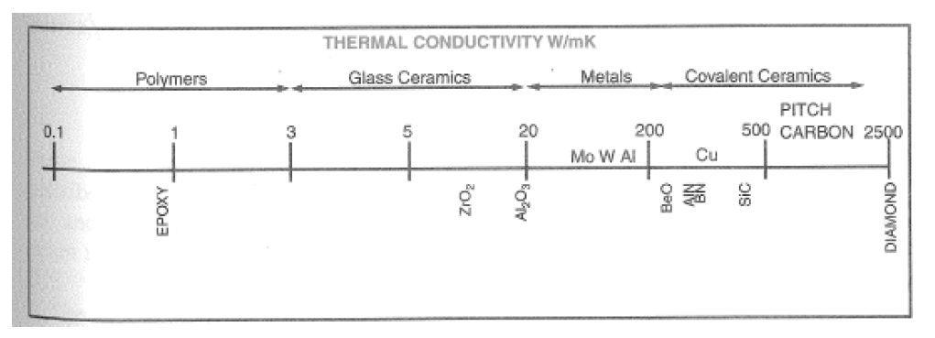

* + 1. **Electrical permittivity**

Consider an electric field applied across a dielectric or an insulator 🡪 positive charges tend to go towards the negative end of the electric field and viceversa for the negative charges 🡪 polarization is induced 🡪 electric flux density inside the material increases (we have additional field lines for every dipole that is created inside the material, thus the density becomes higher).

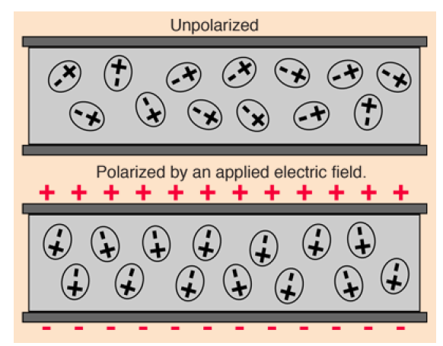

**Electric flux:**  Mathematically, electric flux is the integral of the normal component of the electric field over a given area.

$$ϕ=\int{\vec{E} ⋅d\vec{A}}$$

Conceptually the electric flux can be thought of as "the number of field lines" passing through a given area.

**Electric flux density:** Electric flux density is the electric flux per unit area, and is a measure of strength of the normal component of the electric field averaged over the area of integration.

Define **electrical permittivity** ε as the ratio of the flux density in the material to that in vacuum.

Alternative definition: based on capacity of the dielectric 🡪 the increased flux density manifests through an increased capability in charge storage, which is nothing else that an increased capacity.

Define **electrical permittivity** ε as the ratio of the capacity for a capacitor measured with the material inside and with vacuum.

$$ϵ_{r}=\frac{C_{material}}{C_{vacuum}}$$

Important parameter for packaging: it enters in the formula for the propagation velocity of a signal through the cables and connections 🡪 causes delays.

$$v=\frac{c}{ϵ_{r}}$$

Electric permittivity shows also a dependence on the frequency of the signal traversing the material 🡪 we did not discuss this.

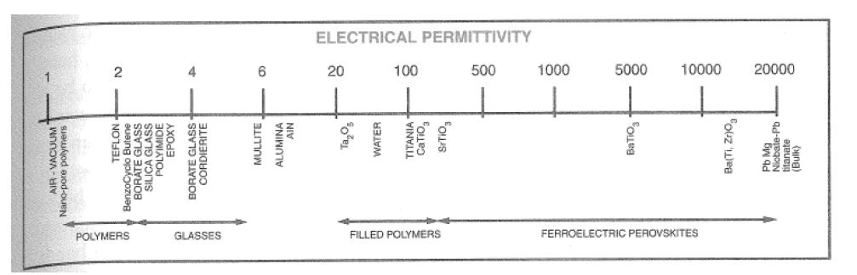

Materials:

* Polymers and glasses have the poorest permittivity values
* Some materials show polarization even in the absence of a ﬁeld (spontaneous polarization) 🡪 ferroelectric materials.

ε = 1k -20k

The polarization results from the asymmetric crystal structure in these ionic compounds, where certain ions are slightly displaced from their electrically neutral positions. Ferroelectric behavior is seen below a certain temperature, referred to as the Curie temperature. Above it the material becomes paraelectric.

Domains: regions spontaneously polarized in ferroelectric materials.

For electronic applications we distinguish:

* Low-K: Materials that form the medium separating transmission lines should have low dielectric constant 🡪 polymers and low—K ceramics are favoured
* High-K: devices for decoupling capacitors, ﬁlters, etc, need high-K materials.

**DELAY:** When a sinusoidal electromotive forte (EMF) is applied at low frequencies the polarization inside a dielectric material develop completely before the ﬁeld reverses. The time-variant polarization is equivalent to an alternating current, which has a phase delay with respect to the EMF exactly by 90 degrees.

Think about this: the voltage becomes positive, the polarization starts to build up. The frequency of the voltage is sufficiently high that the peak in the voltage is reached before the complete build up of the polarization. The polarization however continues even when the voltage is descending, but still positive. Then the polarizability reaches its maximum when the voltage has become null and subsequently it starts descreasing. There is a phase shift of 90 degrees between polarization and voltage!

MAX POLARIZABILITY: when the dipoles can oscillate in resonance to the ﬁeld.

At higher frequencies, when the polarization can no longer keep up with the EMF, the current has a phase delay with the voltage of 90 - d. 🡪 the current has a component that is in-phase with the voltage, hence resulting in a dissipation of energy.

The energy loss can be viewed as resulting from the molecular friction that opposes the molecular motion, leading to an energy loss during polarization.

**Dielectric loss:** measures the energy dissipated per cycle.

How do we model them 🡪 by including a resistive element in series with the capacitor (we’ll see this aspect when treating these components).

Losses are quantified by representing the permittivity as complex: ε = ε(k’ + jk’’). The imaginary part accounts for losses and it can be parametrized by inserting an equivalent series resistance in the circuit.

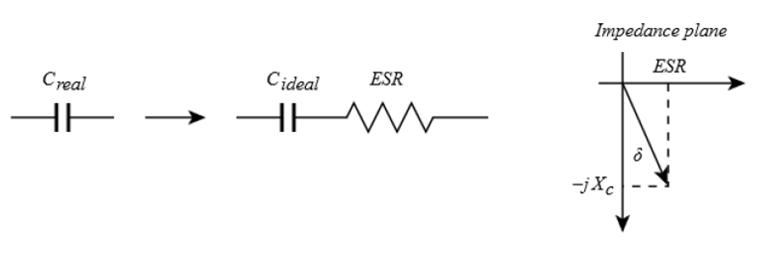

Loss tangent 🡪 parametrizes the dielectric loss. It is defined as the angle between the capacitor's impedance vector and the negative reactive axis.

$$\tan\left(δ\right)= \frac{ESR}{1/ωC}=\frac{1}{Q}$$

Where Q is the quality factor.

* + 1. **Coefficient of thermal expansion**

CTE = dimensional change that occurs per unit rise in temperature per unit length

$$CTE= \frac{1}{l}\frac{dl}{dT}$$

Main concern: when we connect two materials with different CTE (for example, a resistor on a substrate), when temperature changes they can undergo strain and deformations because they do not expand in the same way! 🡪 lifetime is reduced.

Typical values: from -1*10^-6 to 200*10^-6 🡪 units = 1/°C or ppm/°C

Stronger bonds between components in a material 🡪 lower CTE:

* Covalent bonds and loosely (blandamente) packed structures lead to low CTE
* Polymers have weaker bonds 🡪 high CTE
* Above glass transition temperature, CTE increases!
* A special glass ceramic has been developed to match the CTE of Si 🡪 reduces stresses and strains!

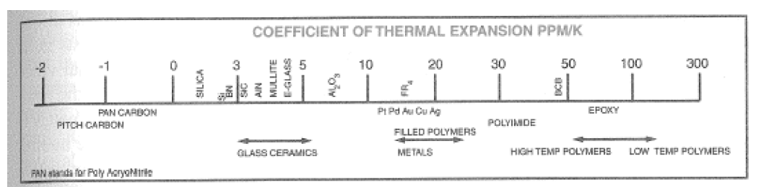**CTE(Si) = 2.6 ppm/°C**

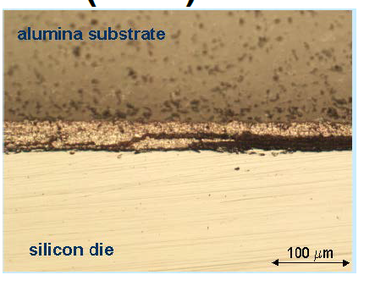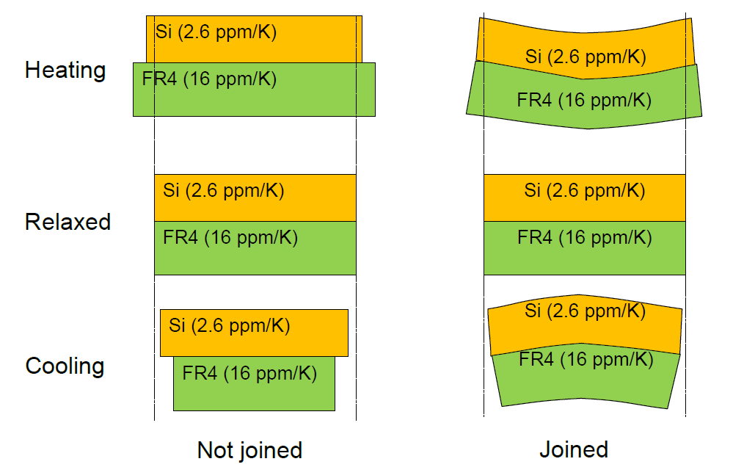

* + 1. **Young’s Modulus**

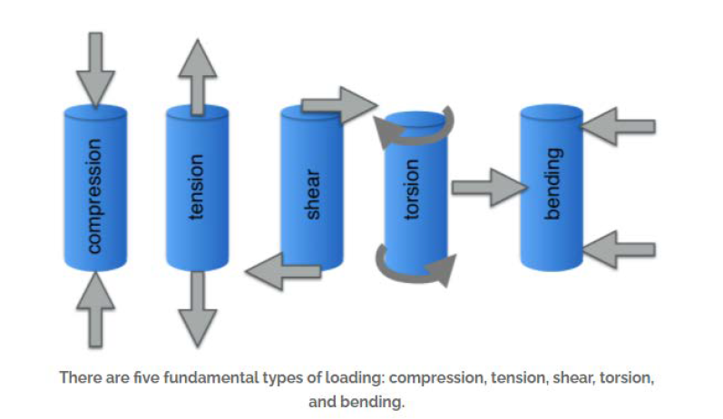Materials can be subjected to forces 🡪 there are different kind of actions that we can perform on a sample

In general, relation between force and deformation is expressed by two 9-components tensors

* Stress: force per unit area applied to the body
* Strain: deformation per unit length produced as a consequence of an applied stress

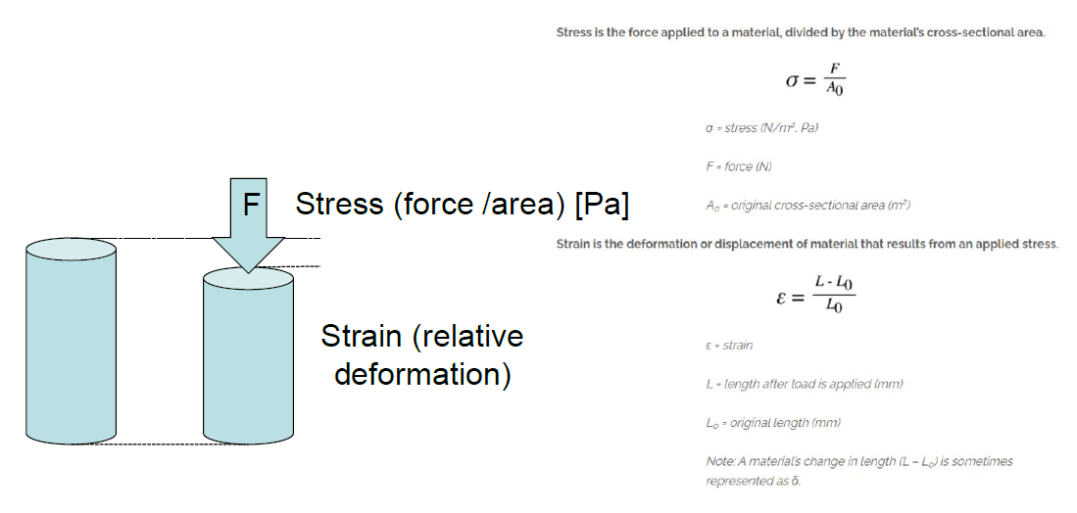

In general:

* for low stresses 🡪 linear relation between stress and strain.
* For high stresses 🡪 plastic behaviour begins and the material irreversibly breaks/fails.

**Young modulus:** stress needed to generate a unitary strain inside a material. It is evaluated as the angular coefficient for the linear dependence between stress and strain in the elastic regime.

**Stiffness:** ability of a material to resist elastic deformation or deflection upon loading 🡪 it is given by both the Young modulus of the material and the geometrical shape of the material.

Materials: the Young modulus is given by several contributions, but in general we can say that stronger bonds between molecules in a material 🡪 higher Young modulus!

In detail:

* Ceramics fails within the elastic regime, they do not have a plastic deformation
* Polymers: considerable plastic and non-recoverable deformations. Contributions: nature of secondary bondings, presence of bulky side groups, cross-linkings
* Metals: considerable plastic and non-recoverable deformations.
* Combinations of materials can be used to enforce structures: when putting materials together always try to match the CTE!
* Fractures are one of the most common causes of failures for the ICs 🡪 we’ll see this aspect when talking about reliability!

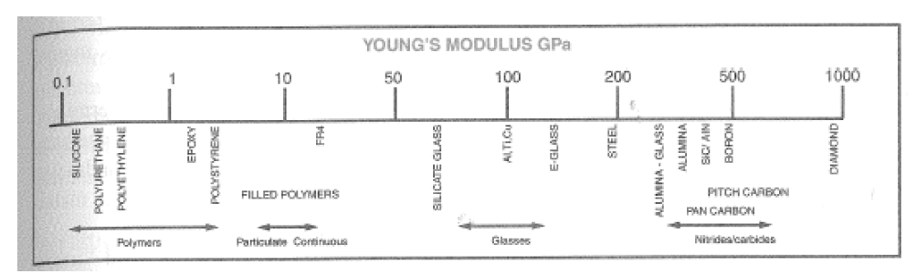

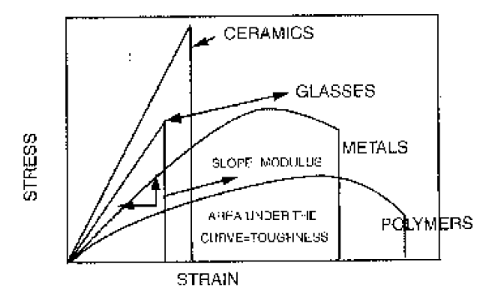

1. **Processes**

Link for video explaining some of the processes: https://youtu.be/8-WGaAmpfOU

In this section we are going to analyse the most important processes for ICs and PCB production. They are:

* Stencil printing
* Photolithography
* Etching
* Plating
* Deposition–Vacuum evaporation
  + RF and DC sputtering
* Methods for electrical and mechanical contact:
  + Soldering
  + Gluing
  + Connections
    - Wire-bonding
    - Flip-chip
  1. **Screen printing and stencil printing**

**Screen printing (or silk printing)**: technique for the transfer of patterns and deposition of materials. One proceeds by in pressing material in paste form through the openings in a printing screen.

Originally screens were made by silk (seta), nowadays from polyester filaments or metal wires.

* The screen is stretched and tensioned on a metal frame
* Preparation of the printing screen: one deposits a photo sensitive film (emulsion) with desirable thickness on the screen.
  + The emulsion: polyvinyl alcohol or -acetate, made light sensitive by additives, e.g. sodium bicarbonate. It softens in water and penetrates into the woven structure (struttura intrecciata).
  + After drying it is exposed through a photomask with the desired pattern, dried, developed and cured (polimerizzato) like the resist in photolithography.
  + Screen/stencil is complete now
* The paste that is to be printed is forced over the screen by a squeegee which is made of polyurethane rubber or similar material. Normally there is a distance of a few millimetres between screen and substrate ("snapoff"), and the screen is forced into contact with the substrate by the pressure of the squeegee.
* CORE: Where there are openings in the resist on the screen, the paste is pressed down onto the substrate.
* After each printing step, everything is dried
* Screen printing is a craftmanship that requires experience and knowledge to give good and reproducible results.

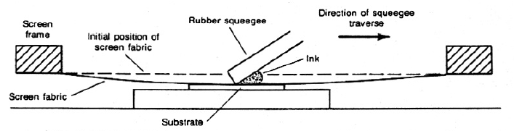

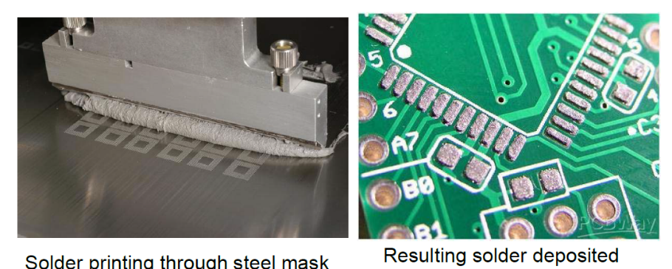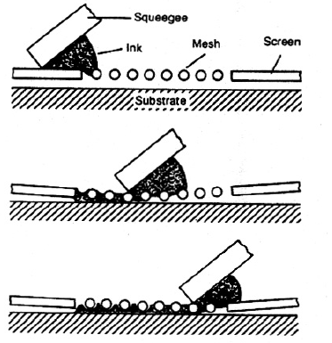

Important factors for good definition, accurate pattern placement and correct amounts of paste are, among others:

* Fineness of the screen and the wire (the number of wires per unit length, "mesh", and the wire diameter)
* Thickness of the resist
* Squeegee hardness, angle and speed of motion
* Tension in the screen and snap-off
* Viscosity and printing properties ("rheology") of the paste 🡪 Certain materials are added to the paste to give high "thixotropy": the paste will flow easily under the pressure of the squeegee, but it has high viscosity when it is not compressed. With high thixotropy narrow printing patterns will get steep walls after printing, since when the pressure from the squeegee is removed the paste returns viscous and does not wet other pieces of surface. This makes it possible to print patterns down toward 0.1 mm widths.

USAGE: Screen printing is used

* in the production of printed wiring boards
* thick film hybrid circuit 🡪 generally alumina (Al2O3) is used as substrate. Components are placed on the substrate by screen printing 🡪 generally based on ceramic pastes = glass particles (mechanical structure) + some materials to define the properties:
  + conductors: pastes containing metals (Ag-Pd) are used
  + Ru2O3 for resistors
  + Insulators made with dielectric pastes
  + Capacitors: 3 steps 🡪 conductive layer, dielectric, conductive layer
* sprinting of solder paste for surface mounting 🡪 For printing of solder paste to high precision, the printing screen is replaced with a thin plate of metal or plastic 🡪 **stencils**. The openings are etched in a photolithography process, or they are punched. Such printing stencils have better dimensional stability and better wear properties than woven screens, BUT one cannot make enclosed patterns or long patterns with short widths, and printing stencils are not suitable for printing of conductor patterns.

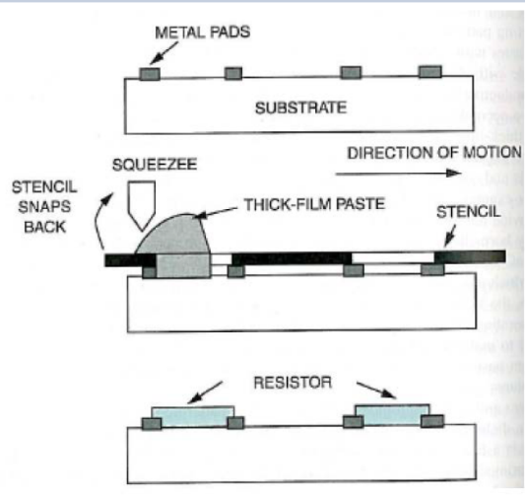

Typical screen parameters

* for thick film:
  + 80 - 400 mesh (number of wires per inch)
  + wire diameter 20 - 100 μm.
* For solder paste printing
  + 40 - 120 mesh typically used
  + wires 60 - 120 μm diameter

High mesh count, thin wire and thin emulsion 🡪 high resolution

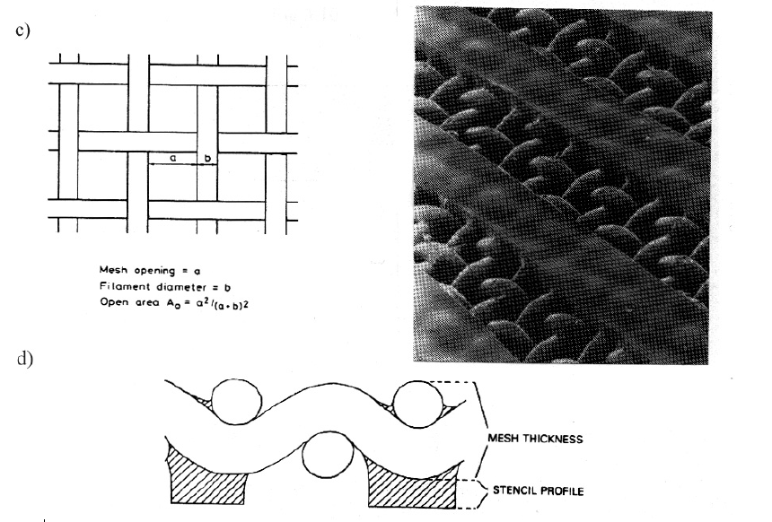BUT with thin emulsion 🡪 more fragile screen that is easily damaged.

* 1. **Spin coating**
* We place a substrate (Si waver) spinning at high speed
* A drop is put on the surface and spreads on the waver 🡪 uniform covering
* Empirical thickness:
$$thickness= \frac{constant}{\sqrt{angular velocity}}$$

* Process optimized for round wavers
* Thickness around 2-20 um

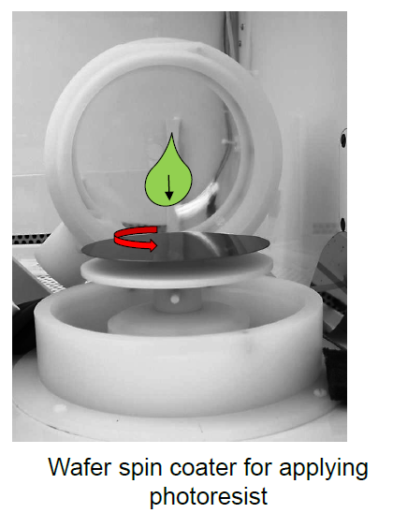

* 1. **Photolithography**

**Photolithography**:

* used for transfer and definition of patterns
* Accuracy and resolution down to 0.2 μm can be achieved, but industries are working for improvements.

PRODUCTION:

* Starting point is a pattern generated from a CAD on a photographic film (photomask)
* The film substrate is a plastic foil, or a glass plate when high precision is required
* The pattern on this film is made by exposure with laser or electron beam (more precise)
* Now the photomask is ready
* A thin layer of photosensitive material (photoresist) may be deposited on the object surface by spinning or spraying or screen printing or laminating on the resist in the form of a dry film 🡪 the photoresist is put on the whole surface, the photomask will cover part of it
* The surface is illuminated through the photo mask. Afterwards the resist is developed and cured by heating
* Two classes of photoresist behave differently:
  + Positively acting: illuminated parts become easily solvable after treating
  + Negatively acting: illuminated partis are difficult to solve

USAGES: Photolithography is used

* for printed wiring boards
* in hybrid technology
* on semiconductor wafers

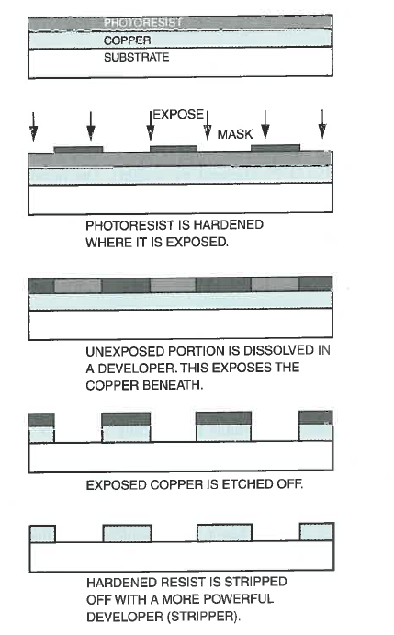

* 1. **Etching**

Subtractive process: we remove the metal that we do not need!

**Wet etching:**

* cover the whole board area with conductor metal
* masking by screen printing or photolithography
* removing the metal where it is not desired by dipping the sample in a chemical bath that dissolves the material, with the other parts of the surface being covered with an etch resist that is not attacked by the etchants
* Etchants: aqueous acidic or alkaline solutions. They can also be sprayed on to the surface.
* The speed of etching depends on the temperature, the composition and concentration of the etchant, how long the etching bath has been in use, circulation, etc
* Regeneration of the etchant is difficult, and the bath has to be discarded when its composition gets out of the specified range 🡪 pollution problem

Example of reactions

Etching of copper through iron chloride, with the following reactions:

FeCl3 + Cu -> FeCl2 + CuCl

In addition the following reaction takes place:

FeCl3 + CuCl -> FeCl2 + CuCl2

In this case: tin/lead is etched and is therefore not usable as "masking". But iron chloride does not attack organic films, which can be used as protection.

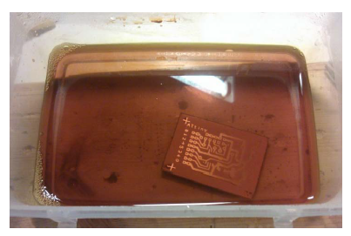

**Dry plasma/ reactive ion etching:**

**Reactive-ion etching** (**RIE**) is an etching technology used in microfabrication.

RIE uses chemically reactive plasma to remove material deposited on wafers. The plasma is generated under low pressure (vacuum) by an electromagnetic field. High-energy ions from the plasma attack the wafer surface and react with it.

PROCESS:

* Plasma is initiated in the system by applying a strong RF (radio frequency) electromagnetic field to two plates on the top and bottom plates inside the vacuum chamber. The bottom plane is above the wafer, but this one is electrically insulated with respect to the system (see figure).
* The oscillating electric field ionizes the gas molecules by stripping them of electrons, creating a plasma. (consider a plasma as a low pressure ionized gas).
* In each cycle of the field, the electrons are electrically accelerated up and down in the chamber, sometimes striking both the upper wall of the chamber and the wafer platter. At the same time, the much more massive ions move relatively little in response to the RF electric field.
* Electrons deposited on the wafer platter cause the platter to build up charge due to its DC isolation 🡪 large negative voltage on the platter, typically around a few hundred volts.The plasma itself develops a slightly positive charge due to the higher concentration of positive ions compared to free electrons.
* Because of the large voltage difference, the positive ions tend to drift toward the wafer platter, where they collide with the samples to be etched. The ions react chemically with the materials on the surface of the samples, but can also knock off (sputter) some material by transferring some of their kinetic energy.
* 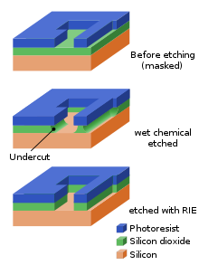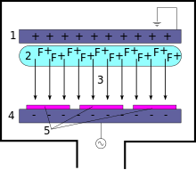Due to the mostly vertical delivery of reactive ions, reactive-ion etching can produce very anisotropic etch profiles, which contrast with the typically isotropic profiles of wet chemical etching.
  1. **Plating**

In general, plating processes are cheap and low-temperature processes 🡪 very used in thin-film applications

* + 1. **Electroplating**

This is a process in which the plating occurs on a conductive inserted in a electrolytic bath composed of a solution of the salt of the metal to be plated.

* A panel to plate is put inside a solution with containing Cu2+ ions 🡪 the panel is the negative electrode of an electrolytic cell, while the anode is constituted by a copper plane
* At the anode: Cu -> Cu2+ + 2e-
* At the cathode: Cu2+ + 2e- -> Cu
* 25-30 um of copper are usually plated
* A voltage is required
* The process works only for etching on conductive plates, not suitable for polymers for example
* Electrolytic plating normally is a simple process. It can give a high rate of deposition (tens of μm per hour). The structure in the deposited material depends of the speed of deposition (current density), temperature and type of plating bath.

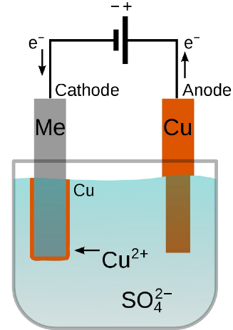

* + 1. **Electroless plating**

This mechanism for plating is an alternative to electroplating.

We describe the activation process:

* Put the panel into a solution rich of Sn2+ ions 🡪 they are absorbed by the material and will act as sensitizers
* We insert an acid solution containing Pd (or Cu, Ag, Au, Pt) 🡪 the acid solution releases the metal in ionic form. The reaction occurs on the surface of the plate: Sn2+ + Pd2+ -> Sn4+ + Pd
* In the plating process, Pd will catalyse the deposition of copper

Then the proper electroless plating:

* The plate rich with Pd is inserted in a bath containing Cu2+ (coming for example from a CuSO4 salt)
* Formaldehyde is a common reducing agent: in this bath Cu2+ is reduced into Cu that covers the whole surface of the plate
* Thickness around 0.5 um
* This is used as precursor process for the electroplating 🡪 an insulating plate becomes conductive and undergo electroplating
  1. **Vacuum deposition**

Thin metal films on hybrid substrates and semiconductor wafers are normally deposited by vacuum evaporation or by sputtering

* takes place in a chamber which is evacuated to 10-6 Torr.
  + Removes impurities that may compromise the deposition
  + Increases mean free path of particles to deposit
  + Reduced the vapour pressure and the temperature that we need to achieve a given deposition rate
* The metal that is to be deposited is placed in a plate of high temperature melting metal (e.g. W) 🡪 the "boat".
* The boat is heated:
  + by passing a high current through it
  + bombard it with an electron beam that is accelerated in an electric field with the boat as anode
* the metal evaporates and its molecules spread out upwards in all directions in the vacuum chamber. The molecules hit the substrate that is located on the substrate holder above.
* Layers under few um 🡪 used for corrosion protection

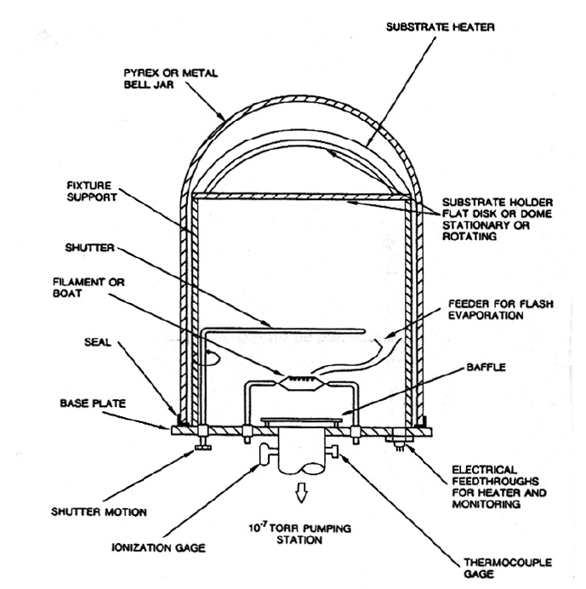

* 1. **Sputtering**
     1. **DC sputtering**

Sputtering is a process under low pressure where a "target" is bombarded by energetic positive ions.

TARGET = material which is hit by the accelerated particles

SUBSTRATE = material that is reached by particles emitted from the target

PROCESS:

* The plasma may be a noble gas, for example argon, at pressure 10^-3 – 10^-3 Torr. The gas is ionised in the strong electrical field, obtained by having 1000 - 2000 V between the target and the anode. A glow discharge is created in the argon gas, which is decomposed into positive ions and free electrons
* The ions are accelerated toward the cathode (target), they give off their charge by receiving electrons and are again neutral. Target material is torn off by the energy released. Energetic secondary electrons interact with neutral Ar atoms that are again ionised.
* The "sputtered" particles hit the substrate that is to be covered

FEATURES:

* Mostly used to deposit metals
* The simplest version is DC sputtering
* Typical deposition rates: 100 - 1000 Å per min
* Film thickness by sputtering is limited to a few μm
* **RF sputtering:** Electrically insulating target materials are not suitable for DC-sputtering, because they will be electrically charged and then disturb the glow discharge 🡪 Then AC radio frequency is used on the target holder electrode.
* **Magnetron sputtering**: uses permanent magnets to provide a field parallel to the target surface 🡪 electrons emitted by the target are captured here
  + Substrate will be cooler because only few electrons will bombard it
  + Deposition rate is enhanced due to electron-atom collision near the target

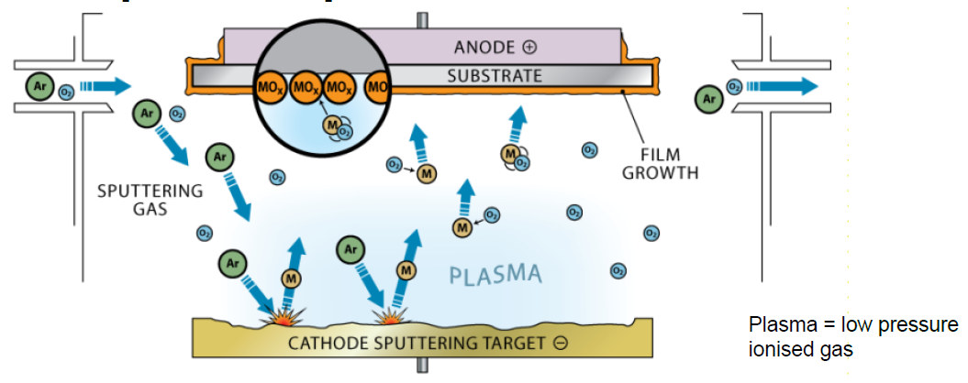

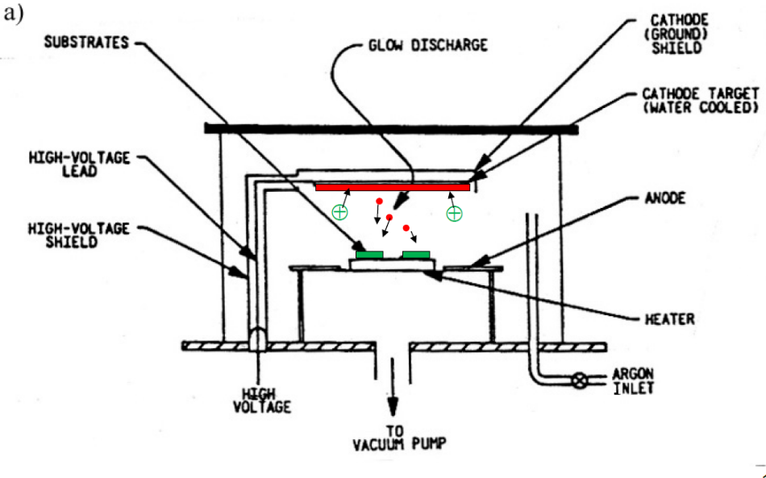

* 1. **Additive manufacturing: rapid prototyping techniques**

Rapid prototyping is a group of techniques used to quickly fabricate a threedimensional model of a physical part or assembly based on 3D CAD design.

For 3D printing we have 2 main techniques:

* **Fused filament fabrication:** a plastic filament is heated up and extruded on a platform layer by layer, creating the final structure. At each new level the platform is lowered
* **Stereolithography:** we use light to get part solidified. A laser illuminated the transparent bottom of a tank filled with a photosentitive resin which polymerizes when it gets in contact with the laser. At each new level the platform is lifted.

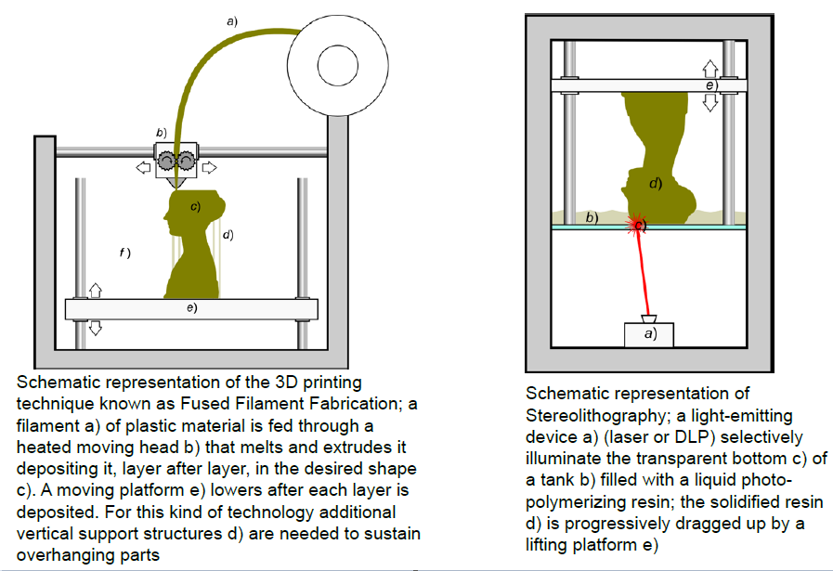

**Methods to establish electrical and mechanical contacts**

* 1. **Soldering**

Soldering is the dominating method for electrical connection of electronic components. It is also important for mechanically assembling and to establish good thermal contact.

SOLDERING: establishment of a metallic bond between two metallic surfaces by use of a different liquid (solder-) metal.

Soldering consists in wetting the surfaces that are to be joined by the molten solder metal and cooling until it solidifies.

**Hard soldering: s**oldering with alloys that melts at high temperatures 🡪 it is used mainly for connecting structural mechanical parts

**Soft soldering:** In electronics, soft soldering with tin/lead alloys, with melting point around 180 °C, dominates. The materials are cheap, the process can easily be automated, and the parts may easily be taken apart for repair.

Yet soldering is the source of a large fraction of the faults in the electronics, during production as well as during the field life of the product afterwards. Some factors that determine solder quality:

* Metallurgical and mechanical properties of the solder metal and compatibility with the metal on the surfaces to be joined
* Wetting
* Surface properties
* Grain structure in the solder metal.
  + 1. **Wetting**

Wetting is the ability of liquids to form interfaces with solid surfaces. To determine the degree of wetting, the contact angle that is formed between the liquid and the solid surface is measured. The smaller the contact angle and the smaller the surface tension, the greater the degree of wetting.

* Poor wetting: the solder metal will tend to contract into a spherical shape seeking the minimum surface area because of surface tension in the solder metal.
* Good wetting: the surface tension between the liquid and the base material dominates and stretches the drop out.

The drop and the base material will minimise the free energy that also includes the surface tension in the base material. This can be described by Young's equation

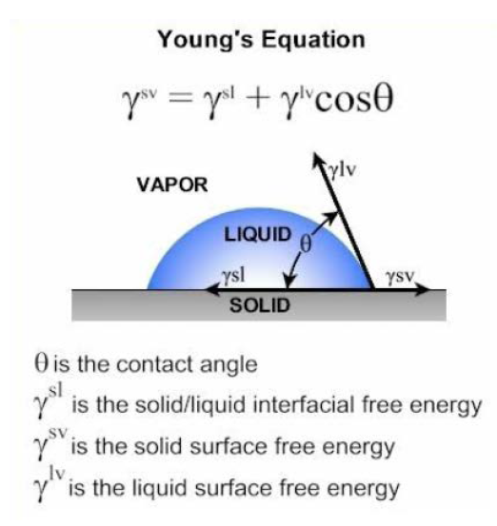

On the book we have that gamma is the surface tension, not the free energy.

Surface properties that determine the wetting depend on many parameters:

* The combination of materials
* purity is important: oxide layer on top of copper or solder metal for example, may ruin the wetting
* The surface structure and the roughness
* In a good solder joint the atoms diffuse from the solder metal into the surface of the base material down to 0.1 - 1 μm. In order to improve the wetting fluxes are used 🡪 we’ll see this.

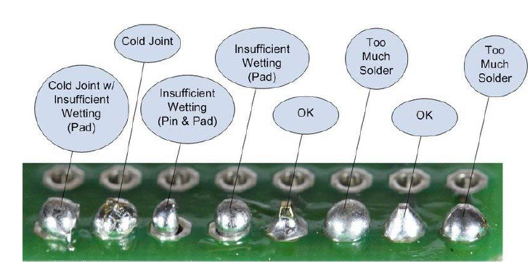

* + 1. **Alloys**

Take home the message: different composition for the soldiering alloys give different properties!

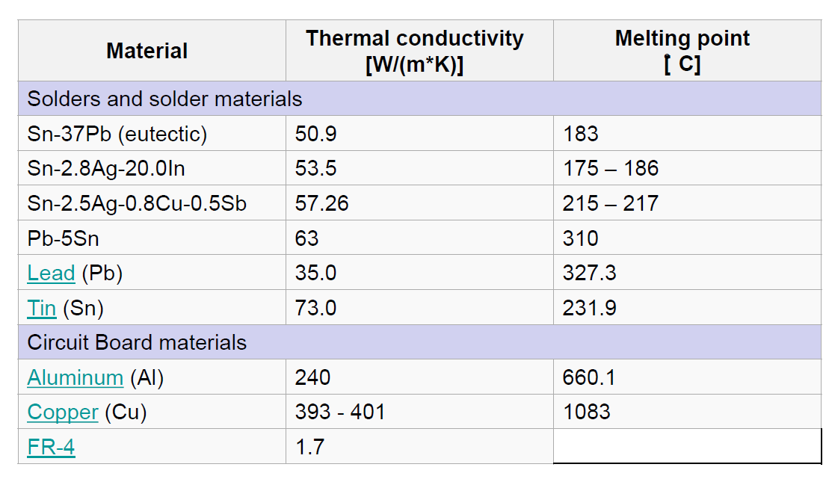We can see that starting with the same two materials (Sn and Pb), just by varying their percentage of a small amount we get completely different melting temperatures and shear strength!

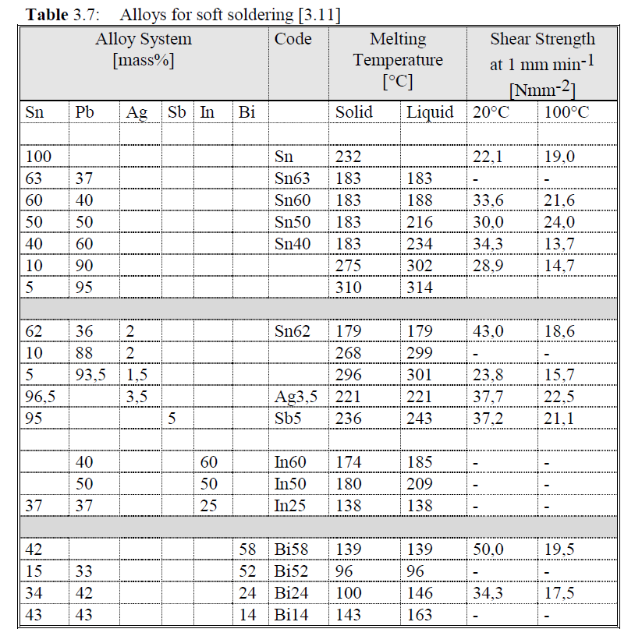

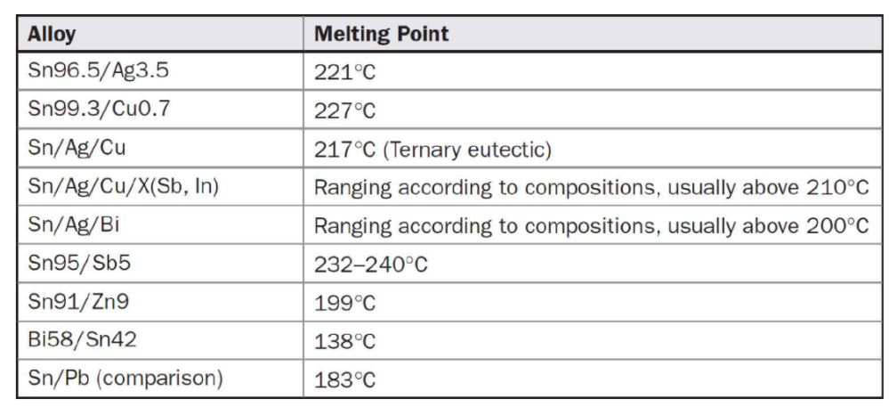

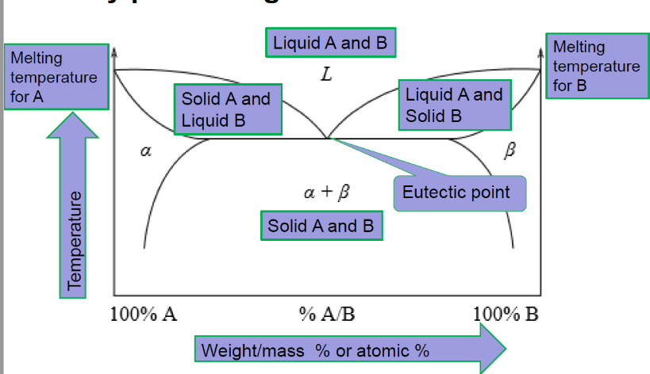**BINARY PHASE DIAGRAM**

We plot the temperature against the relative concentrations of 2 substances in a binary mixture.

On one side of the plot 🡪 we have 100% component A

On the other side 🡪 we have 100% component B

Eutectic system: it is a homogeneous mixture of substances that melts of solidifies at a single temperature that is lower than the melting point of any of the two constituents.

EXAMPLE 🡪 63Sn37Pb

Historically a very common soldering material 🡪 melting temperature 183°C

As we can see, this system is eutectic since the temperature for the components pass from a solid to a liquid state is lower than the melting point of the single pure substances.

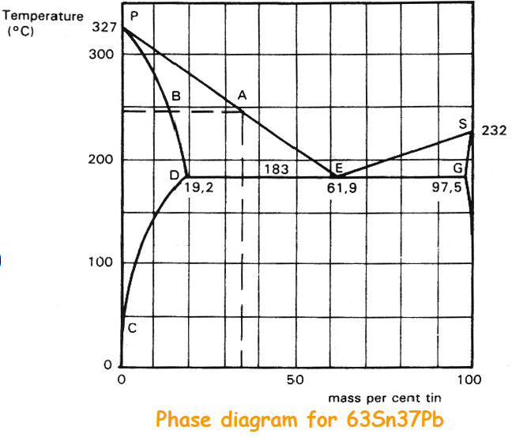Keep in mind that the sentence “Phase diagram for 63Sn37Pb” can lead to errors, since in the phase diagram the composition of the mixture is not fixed!

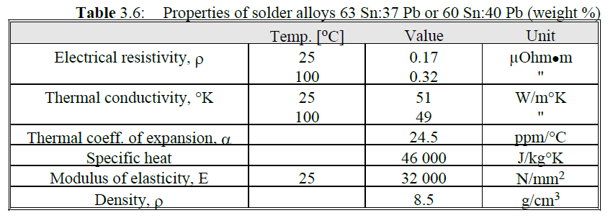

* + 1. **Soldering process step-by-step**
* Put in contact the solder and the materials being joined
* Slow application of heat to warm the parts to be soldered
* Oxide removal from the joining surfaces and solder metallurgies
* Application of heat sufficient to melt the solder
* Solder wetting to join surfaces and intermetallic formation
* Quenching for the solder liquid (raffreddamento)

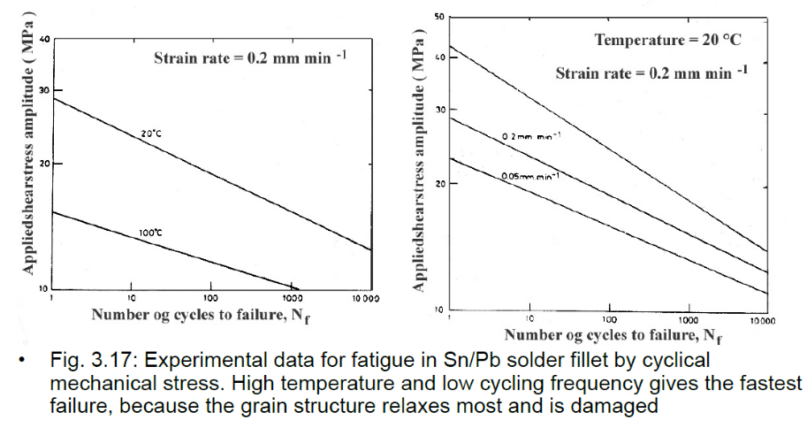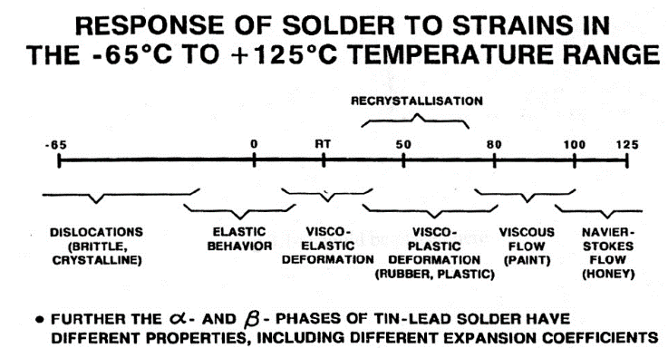REMEMBER: a solder is never just a solder! The material has different properties and features depending on the temperature. Since the solder will become an actual component of the PCB, we have to select it accurately, depending on which will be the usage and the working conditions of our final product.

About soldering you should remember also the Coffin-Manson formula, which describes the reliability of a solder point.

$$N^{0.5}*γ_{p}=constant$$

Where N = number of cycles before the failure and gamma is the relative deformation amplitude.

We’ll see this more in detail in the reliability chapter!

* + 1. **Fluxes and cleanings**

Flux is a chemical cleaning agent used before and during the soldering process of electronic components onto circuit boards. Flux is used in both manual hand soldering as well as the different automated processes used by PCB contract manufacturers. The main purpose of the flux is to prepare the metal surfaces for soldering by cleaning and removing any oxides and impurities. Oxides are formed when metal is exposed to air and may prevent the formation of good solder joints. The flux also protects the metal surfaces from re-oxidation during soldering and helps the soldering process by altering the surface tension of the molten solder.

Flux is made up of a base material and an activator which is the chemical that promotes better wetting of the solder by removing oxides from the metal. It also contains other solvents and additives to help with the soldering process as well as inhibiting corrosion. Flux may be solid, pasty, or liquid in form depending on how and where it will be used. For hand soldering, flux can be applied by a flux pen or is usually in the core of the solder wire that most technicians use.

Fluxes are used to improve the soldering and have several functions:

* Dissolve and remove harmful surface layers (oxide, etc.)
* Protect the surface against new oxidation
* Improve the wetting

Many types of flux are used. They consist of active ingredients dissolved in a liquid. They are of two main categories:

* Soluble in organic liquids
* Water soluble

The category determines how one will be able to clean the flux residues. The common fluxes are also characterised as:

**Organic resin fluxes ("rosin"):**

* most used
* they contain natural resin from (pine-) trees, dissolved in alcohol, etc.
* have a certain effect without additives, but it is normally they are activated by adding an organic chlorine compound 🡪 without activation, wetting of copper takes 6s, with 1% Cl content time is reduced to less than 1s.
* The following symbols/designations characterise the fluxes:
  + R (Rosin, non-activated): Resin flux without chlorine added. It actsbec ause of weak acids in the resin
  + RMA (Rosin mildly activated): Up to 0.5 % Cl content
  + RA (Rosin, activated): Higher content of chlorine

**Organic non resin-based fluxes**

**Inorganic fluxes**

Chlorine is strongly corrosive, and if it remains on the surface after the solder process is completed it may give reliability problems later 🡪 cleaning is required after application.

Popular organic cleaning agents:

* have been trichloro-trifluoro-ethane (Cl3CCF3, also designated TCTFE) mixed with an alcohol 🡪 properties: efficient, does not burn, it is not poisonous and is chemically inert to most materials in electronics, TCTFE is very stable. However, due to its low boiling point the vapour will spread in the atmosphere and the chlorine combinations will over long time break down the ozone layer 🡪 TCTFE and similar combinations are now prohibited from use in most countries
* Cleaning agents based on alcohol are replacements
* cleaning with soap are replacements
* extensive development work is taking place in fluxes that do not need to be removed
  + 1. **Adhesives & gluing**

Gluing is used in electronics to:

* Assemble mechanical parts and keep electronic components in place
* Give electrical connection, as a replacement for soldering
* Give good thermal contact

The types of adhesives used:

* polymers, that generally are electrically and thermally insulating
* often epoxy (or acrylic, phenolic, polyimide, etc.)
  + Adding silver 🡪 better electrical conductivity (we reach 1-10 x 10^-6 Ohm*m) and better thermal conductivity. Thermal conductivity for epoxy without additives typically is 0.2 W/°C * m, and silver filled epoxy has up to 10 x higher value (see figure).
  + 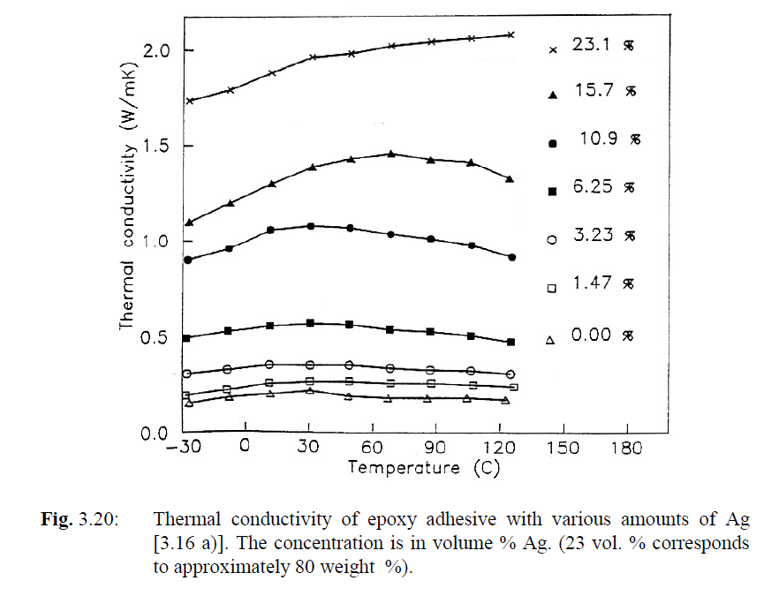Adding Al2O3 or AlN 🡪 Improved thermal contact

The adhesive is deposited by

* screen printing
* dispensing (distribuzione)
* in the form of a partly cured dry film cut to the right size, "preform" (imagine this as scotch). The curing takes place with heat, or by UV-radiation for certain types.

Replacement of component soldering by use of electrically conductive adhesives is an active topic of research.

ADVANTAGES:

* requires lower process temperature with less stress on the components and substrate
* avoid the use of flux, cleaning and poisonous lead
* better long term reliability can be achieved because the adhesive is more elastic and deforms less than the solder metal.

DISADVANTAGES:

* the absorption of moisture in the adhesive polymer may reduce its strength as well as cause migration of the silver 🡪 in the presence of an electric field this migration of silver molecules can give rise to thin wires that can short circuit conductors in the neighbourhood
* you have to be very precise with alignment of components and adhesives: with solders, wetting properties can help you because you get contact between pins and substrates even without a perfect alignment.

REMEMBER: adhesive may shrink a bit while they are drying 🡪 can be good since it helps in keeping close contact between pins and substrate for example

NEW TRENDS:

* **Anisotropically conductive adhesive**: used with components with many pins.
  + It is screen printed over the whole area under the component.
  + It is designed to lead the current just in one way.
  + We can use small conductive balls (as in the figure): they can be metallic or made with polymers covered with metals. The principle is that in the adhesive paste we have a density of these spheres such that for sure there will be some of them between the conductive pins of IC and substrate, but the density is too low to have a continuous chain of these speres between two adjacent pins.
  + In the 1st figure below, refer to c) and d)
  + In the 2nd figure below, refer to a)
* **Isotropically conducting adhesive**: composition is similar in all directions, thus it is also conductive in all directions in the same way. As shown in the figure, we have to prevent the adhesives to join between each other because we would create a short circuit. The working principle is similar to the one discussed above for anisotropically conducting adhesives.

In the 1st figure below, refer to a) and b)

* **insulating instead of conductive adhesive** 🡪 By use of mechanical pressure during the curing, the adhesive is pushed away, and we get direct physical contact between terminal and substrate at points on the slightly non-uniform surfaces. The polymer shrinks during the curing and causes a permanent force that holds the materials together with good reliability. These methods are particularly suitable for components with low current (such as LCD-displays).

In the 2nd figure below, refer to b)

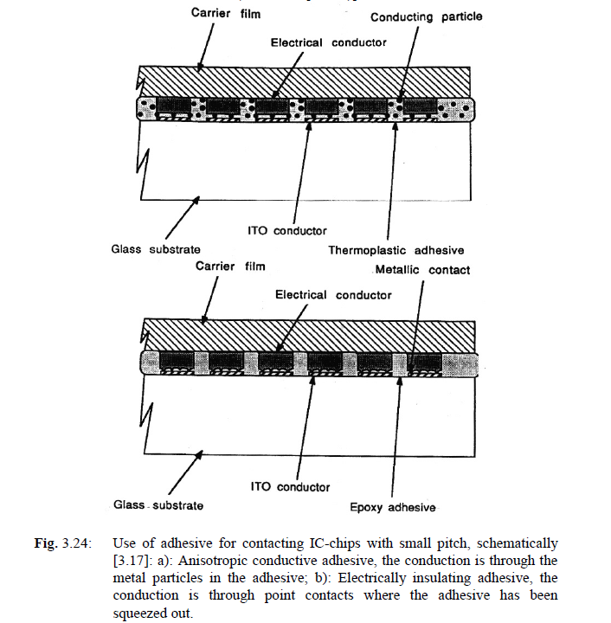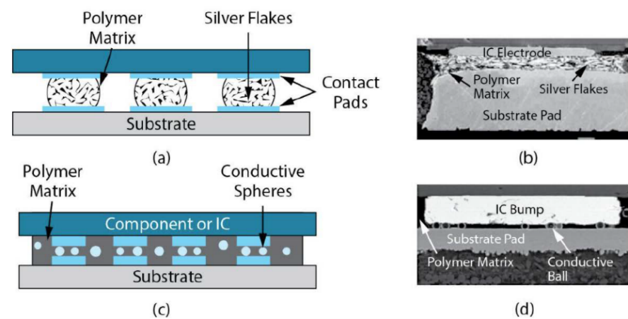

* 1. **Mounting of the semiconductor chips: die bonding**

**Die bonding** (often referred to as die attach) is the process of attaching a die/chip to a substrate or package.

Before electrical connections are made to the chip, the chip must be mounted on the base by "die bonding". That takes place by

* eutectic bonding
* soft soldering
* gluing

Important points with the die bonding are:

* High electrical conductivity if current runs from the chip to the substrate
* good thermal conductivity if the chip dissipates much heat
* mechanical strength and reliability
  + 1. **Eutectic die bonding**

Eutectic bonding takes place when an eutectic alloy is created between silicon and a metal system deposited underneath.

The melting point for the eutectic composition is much below that of the pure elements.

* Au/Si alloy is often used 🡪 melting point 363 °C at 96.7 Au:3.3 Si

while Au melts at 1063 °C

Si at 1412 °C)

* 80 Au:20 Sn 🡪 melting point 280 °C

FEATURES:

* very good electrical and thermal contact
* high mechanical strength
* it is very brittle and when the chips are large the thermal mismatch may cause the chip to crack during the bonding process or during thermal cycling laterUse of gold-rich alloys also makes it costly.
  + 1. **Soft soldering**

Soft soldering 🡪 the classic soldering for circuits:

* used for large chips, particularly in power electronics, where good thermal and electrical conductivity is important
* PbSn, AgPb, SnAgIn and other alloys are used.
  + They are softer than the SiAu eutectic
  + the temperature in the process is lower
  + they can take up thermal mismatch by plastic deformation
  + They are more robust against fatigue than the common SnPb eutectic, but after many thermal cycles the soldering still may fracture due to fatigue.
* The soldering of chips is made by screen printing of solder paste or by use of a solder preform 🡪 It takes place in inert or reducing atmospheres, without flux, to avoid gas pockets or flux residues that may corrode during long term use or which may cause hot spots in high power chips.
  + 1. **Gluing**

Gluing is the dominating method of mounting.

* Made with electrically and thermally conductive epoxy
* Cracks and damage due to thermal mismatch may be a problem with epoxy, but one can obtain soft types that are suited for large chips.
* One limiting factor for high power chips 🡪 poor thermal conductivity of the glue. During thermal cycling (see figure) the adhesive will crack or lose its adhesion to the substrate and the Si chip. The severity depends on chip size, temperature excursion and thermal mismatch between chip and substrate material, as well as the elastic modules and other properties of the adhesive.
* A different kind of chip gluing is done with silver filled low melting glass.

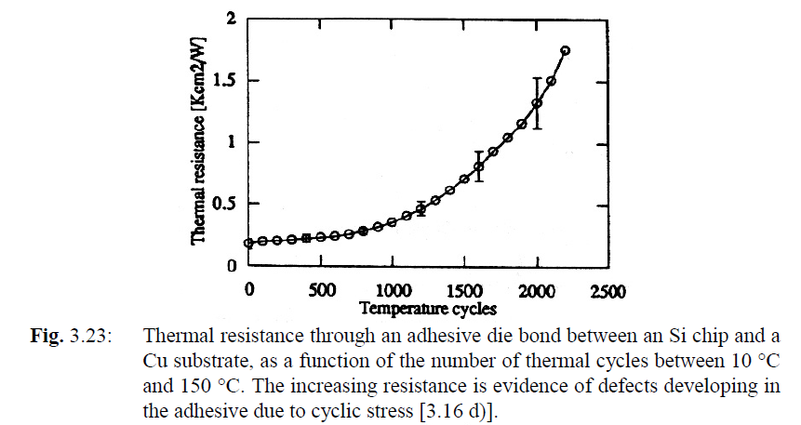

* 1. 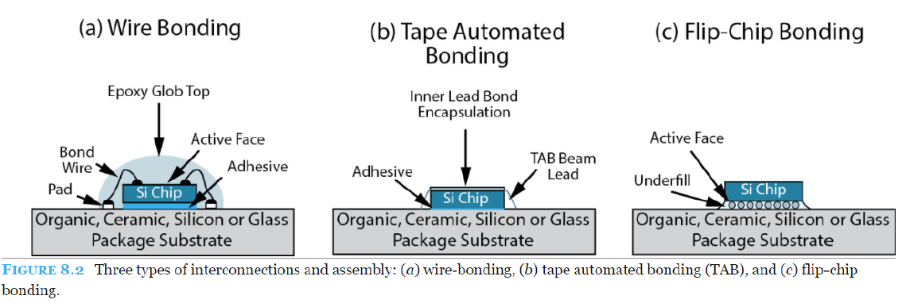**Chip connection techniques**
     1. **Wire bonding**

Wire bonding is the dominating, well established method 🡪 Thin metal wires are connected one by one between the contact points on the semiconductor chip and the corresponding contact point on the substrate outside the chip.

The wires 🡪 made of gold or aluminium, 0.025 - 0.5 mm diameter. Al bond wire with rectangular cross section is also used

The process 🡪

* points where pins are connected on surface of the substrate are normally covered by soft (high purity) gold, deposited by plating or screen printing.
* Then the bonding wire is stretched out through the hole in a capillary tube
* The connection to the chip is made by pressing the wire down onto the Al metallisation on the bonding area of the chip, against the edge of the capillary. There are several processes:
  + Ultrasonic bonding: the capillary vibrates with high frequency during the bonding, and the wire is cold-welded to the base by a combination of pressure and vibration. In addition to the softening of the gold, the vibrations also break up surface oxide layers. The technique is used most for aluminium wire with flat ends on both sides ("wedge -wedge" bonding)
  + Thermocompression bonding: The substrate and chip are heated to about 150 °C during the bonding process. This process is mainly used for gold wire, forming a gold ball at one side and a flat compressed wire end at the other side ("ball - wedge" bonding).
  + Thermosonic bonding is a combination of the two previous methods.
* The end of the gold wire that sticks out of the capillary is brought to melting with a hydrogen flame and it creates a small spherical ball. The capillary is moved down onto the aluminium bonding area on the Si chip, and it is pressed down, making the soft gold flat and sticking to the Al surface. The capillary is pulled up and it is moved over to the substrate bonding area, where it is pressed down and the bonding wire is squeezed flat. Then the capillary is pulled up, while the wire is held firmly inside the capillary and is torn off. The capillary is moved to the next terminal and the cycle is repeated.

With a typical maximum chip size of today (over 20 mm side), there is an upper limit of approximately 1000 terminals for wire bonding.

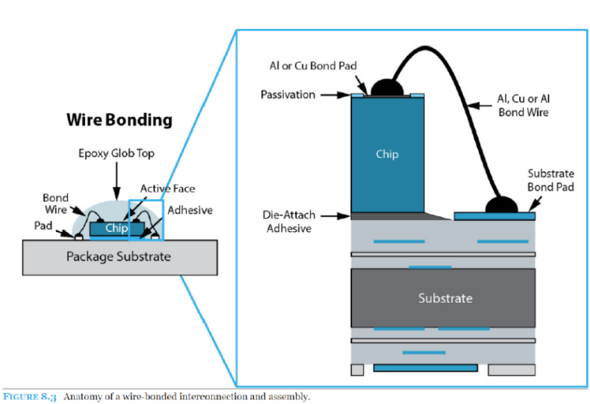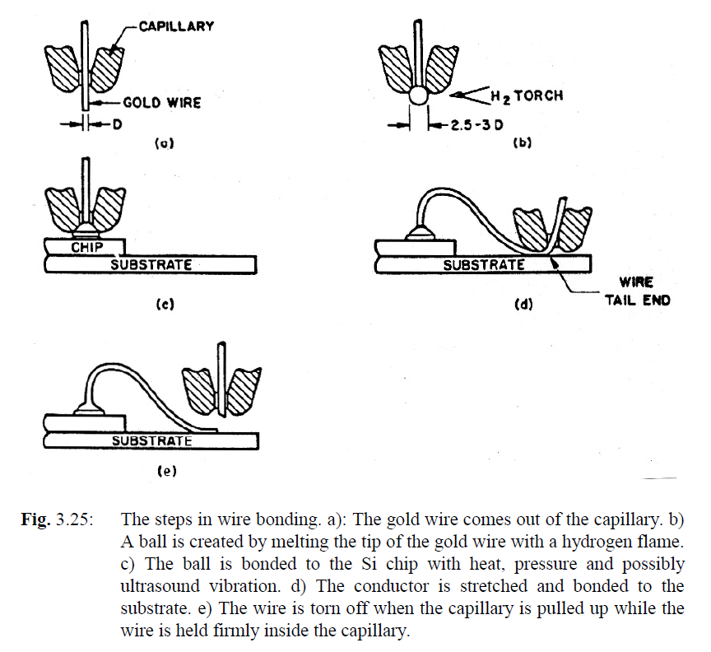

* + 1. **TAB – tape automated bonding**

A conductor pattern has been made in advance, fitting the semiconductor chip and the substrate bonding pad patterns. The conductor foil is on a carrier of polyimide film. The conductors are bonded to Au bumps on the chip.

We will see:

* Fabrication of gold bumps on the chip
* Fabrication of connectors in TAB
* Inner lead bonding 🡪 connection process

In the following picture 🡪 in the outer leads the polymer is placed on top of the conductive copper, while later we’ll see that is placed below 🡪 not so important.

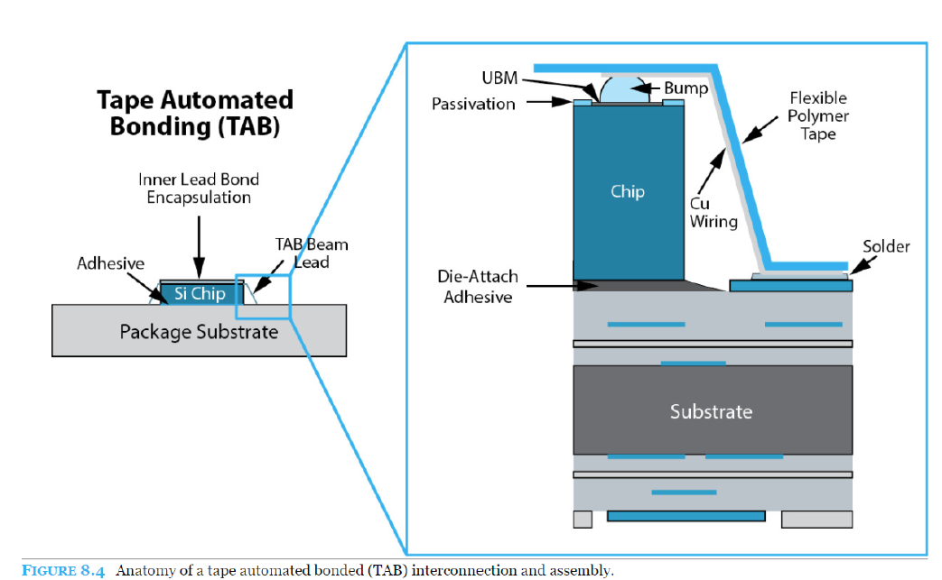

**Frabrication of gold bumps (on the chip)**

**Gold bumps are the pads on the chip. These pads will be connected to the TAB routes with ILB and then the whole package will be placed on the substrate.**

Gold bumps are formed on processed Si wafers.

* First a metal system is deposited on the waver, having the following functions:
  + Covers the Si surface with a conducting layer, such that electrolytic plating can be used
  + Prevents gold from diffusing into Al and Si (diffusion barrier)
  + Gives better adhesion for the gold
* Afterwards a layer of thick photoresist is deposited 🡪 by photolithography we produce holes where Au will be deposited
* Au is electroplated where we produced the holes: the rest of the wafer is protected by the photoresist as plating mask.
* Then the photoresist is stripped, and the barrier metal system is etched off outside the gold bumps.
* Then the wafers are cut into individual chips. The chips are now ready for inner lead bonding (ILB).

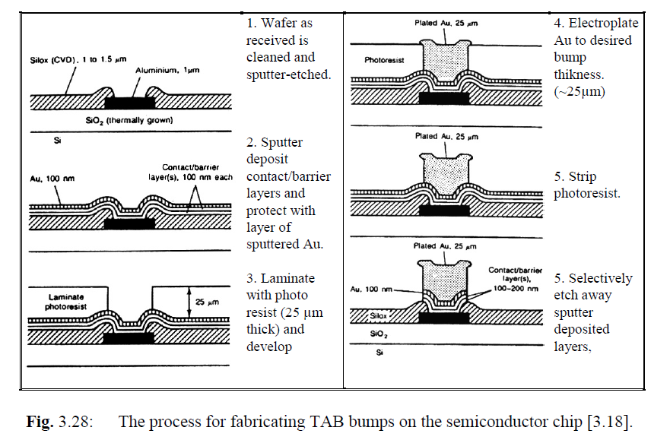

**Fabrication of TAB films**

Starting material: polyimide (it is under the brown part in the picture, the brown color is given by copper)

Holes for handling (analogous to those on camera film) along the edges of the film

Also windows for the Si chip is opened

Copper foil is laminated onto the polyimide, with an adhesive layer in between 🡪 the copper gives the brown color in the picture🡪 conductor pattern in the Cu foil is defined by photoresist that is illuminated through a photo mask with the pattern on it

Then developing follows and etching of the foil 🡪 The conductor pattern is tinned or gold plated. (not mandatory)

So the conductor pattern is gold in the picture!

RESUME:

* Polymide as substrate
* Copper on it
* Gold on copper to create the conductor lines

35 mm wide film is the most common

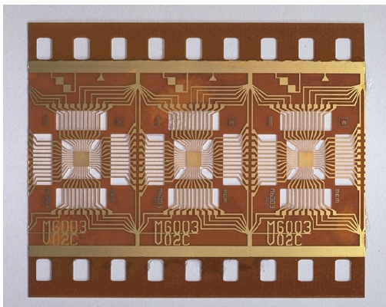

**Inner lead bonding (ILB)**

Inner lead bonding 🡪 mounting of the semi-conductor chip onto the TAB film.

We have to connect the chip to the conductive pattern on TAB 🡪 we can remove a bit of polymer (as in figure) or we can keep the polymer on top (as in the figure presented at the beginning of the section).

Performed by thermocompression bonding.

The bonding tool: thermode 🡪 made by hard metal or diamond. It is pressing all Cu ends against the soft gold bumps simultaneously for approximately 1 sec at a temperature of 300-400 °C. A drop of epoxy is applied on to the chip for mechanical protection and environmental protection encapsulation.

The film with Si chips is rolled on to a reel (bobina) 🡪 ready for selling.

So up to now we have the structure in polymide + copper + gold placed “above” the chip as shown in the figure 🡪 now we have to place the whole package on the substrate, connecting the TAB to the gold bumps on the substrate.

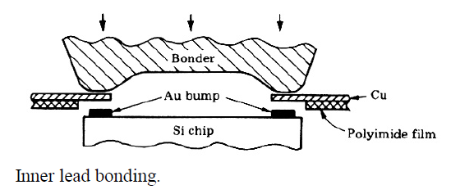

**Mounting, outer lead bonding (OLB)**

Three steps:

* We cut the conductor patterns in excess, creating the leads that will be used to connect the chip to the substrate
* Bending of the leads, so that the outer ends are in the plane of the underside of the Si chip ("lead bending")
* Placement of the chip on the printed circuit board (attached with adhesives in general) and soldering the outer ends of the Cu leads with the gold bumps previously created on the substrate

The connections on the printed circuit board 🡪 made by pressing the copper lead ends down into solder paste or reflowed solder metal on the board. Soldering tool: thermode 🡪 The tool solders TAB chips individually by pressing the Cu leads down into the solder metal and supplies heat by a pulse that lasts a few seconds. The OLB thermode is cooled below the melting point before it

is lifted up. The complete cycle takes 10 - 20 seconds.

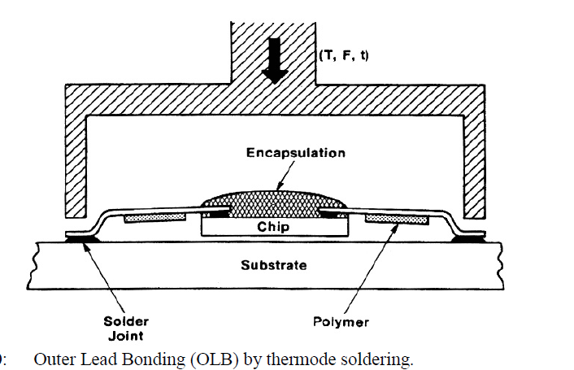

**Advantages and disadvantages with TAB**

* It requires less bonding area for each contact on the chip, and smaller distances between the terminals than wire bonding 🡪 saves chip area at the same time as it makes it possible to interconnect chips with a larger number of terminals (up to approximately 1000).
* The outer lead bonding requires less space on the printed circuit board than the same chip in a regular package. The mounting is simpler and more robust than wire bonding.
* The gold bump on each bonding area gives a hermetic enclosure of the Al metallisation underneath 🡪 reduced possibility of corrosion, and the reliability is improved 🡪 TAB is suitable for use without additional encapsulation
* Soldering all the connections at one time is a more efficient process than wire bonding that is made one bond at a time, and has a higher production yield
* TAB film can also be used as a separate, flexible little printed circuit board, on which it is possible to mount other components as well.
* It requires non-standard process of the Si chips (deposition of the gold bumps).
* It requires special fabrication of carrier film and conductor pattern that is costly and takes time.
* The mounting on the PCB requires special mounting equipment, and a separate tool for each individual component geometry. Individual mounting/soldering of each component is time consuming and costly.
* Repair (replacement of a defect component) on the PCB is demanding.
* Few standard circuits are available in TAB form.
* There is little standardisation of dimensions and tooling, which increases the costs.
  + 1. **Flip chip**

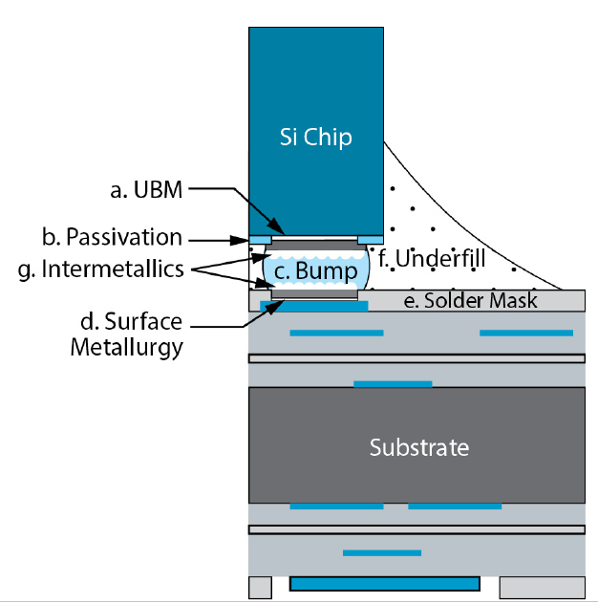Consists in direct soldering between the electrical contact points on the semi-conductor chip and points on the substrate 🡪 the chip is turned upside down.

We start from the Si chip🡪 A bump of solder metal is formed on each bonding area on the silicon chip.

The fabrication of the bumps: start from Si wafer.

* First a metal barrier layer is deposited, for example thin films of Cr/Cu/Au 🡪 they help the soldering process and give reliability and good properties to the connection
* The solder metal: 95 % Pb/5 % Sn (melting point approximately 305 °C) or In alloy 🡪 the solder is deposited on the chip:
  + by sputtering through a metal mask with an opening for each bump
  + vacuum deposition through a metal mask with an opening for each bump
  + by photolithography and electroplating
* After deposition the solder metal is reflowed in a hydrogen atmosphere 🡪 done to:
  + homogenise the composition of the alloy
  + let the surface tension generate a spherical shape of the bumps
  + remove oxides, which will otherwise ruin the solder ability.
* The bumps 🡪 diameter 100 μm
* The Si wafer is cut, and the chips are ready for mounting.

The shape of the drop of solder metal may be strange, so the chip is heated to reflow the solder metal.

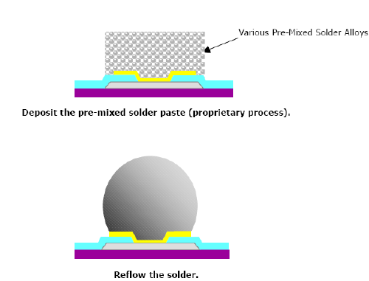

Then each chip is turned upside down and placed very accurately in position on the corresponding solder areas on the substrate.

Before final soldering of the chip on the substrate 🡪 Water- or resin-based flux is used and the subsequent cleaning is very critical.

A certain amount of self-alignment is achieved 🡪 there are surface forces in the molten solder metal which try to move the solder paste to the location where the total surface in all solder joints is a minimum.

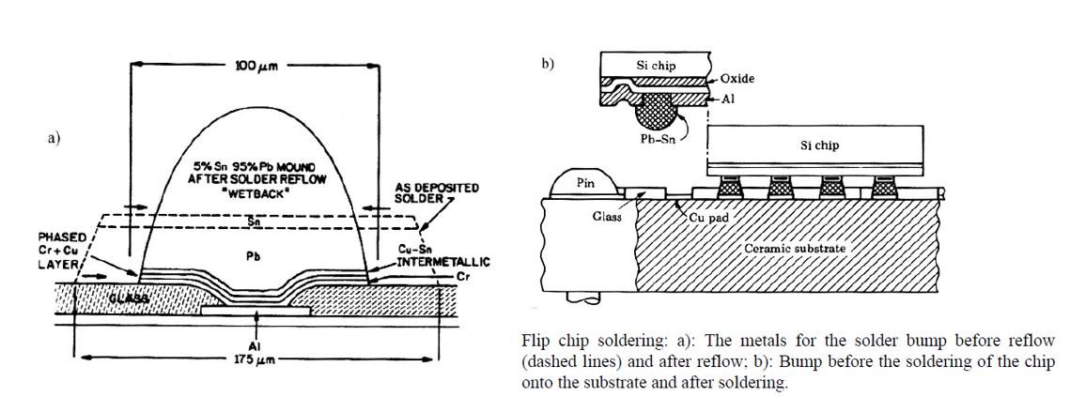Then one heats up until reflow of the solder metal takes place again 🡪 final shape is reached (figure “b” below)

TIPS:

* We use capillary techniques to remove voids in the soldering while we are placing chips 🡪 we use filling materials which eliminate voids and protect soldered points (see blue figure above).
* On the wafer (and/or on the substrate) we can add bumps to enforce the solidity of the soldering (see coloured figure below) 🡪 small bumps (<135 um) with typical pitch around 150 um

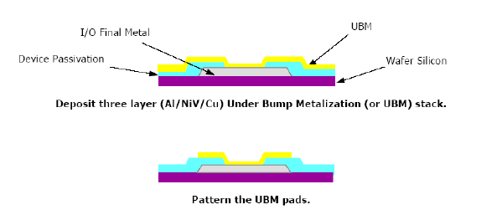

ADVANTAGES:

* one gets a placement on the substrate that does not require more space than the chip itself
* one can have terminals everywhere on the chip area, not only along the periphery
* The electrical properties are better than for other mounting methods, with low electrical resistance and low inductance
* Shortest leads 🡪 best frequency behaviour among all the possible bonding techniques
* We can reach up to 10k I/O pins from a single chip

DISADVANTAGES:

* lack of thermal flexibility, because of the short "conductors" between chip and substrate 🡪 this method thus is best suited for silicon substrate or for small chips on Al2O3 or AlN substrate
* The heat conduction is not so good
* Repair is almost impossible
* Demanding assembly

USAGES: multichip modules in computer and telecommunication applications where extreme erformance and minimum space are required.

**Another technique similar to flip-chip: BALL GRID ARRAY AND CHIP-SCALE PACKAGES**

Combination of flip-chip and package: inside a package we put a chip 🡪 this can be connected to the package substrate with wire bonding, flip chip technique…

The whole package then is connected to the substrate of the PCB by flip-chip technique 🡪 this is a bit more flexible than attaching the chip directly to the PCB

As a rule of thumb, the package should not be much bigger than the the chip itself, otherwise the advantage is reduced.

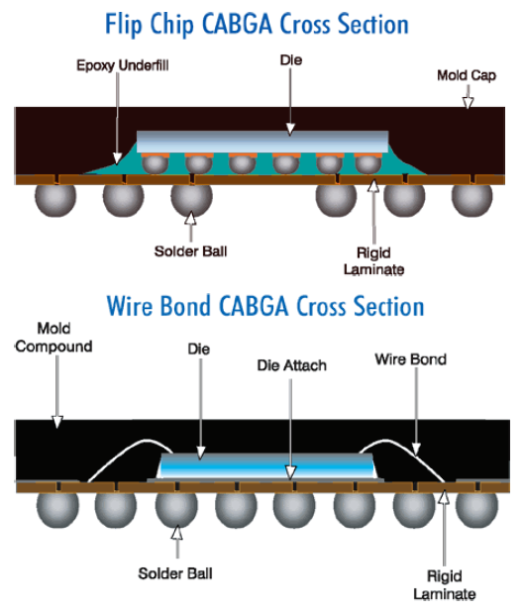

1. **Electronic components**

Objectives:

* Give an overview of the how various central categories of electronic components work, and how they are packaged
* Give an overview of how generic package types are constructed and named
  1. **Introduction to components**

**Passive** components (resistors, capacitors and inductors) are extensively used in virtually all electronic circuits. Passive components can sense, transfer, attenuate and control voltage, but they cannot differentiate between different polarities, nor can they render any amplification or gain. The latter functions are only possible using **active**, semiconductor components. Passive components come in large varieties of different packages for surface mount or thru‐hole montage. In some circuit technologies, such as ceramic hybrids, passive components can be integrated in the circuit as part of the circuit board manufacturing process. However, in conventional PCB technology, passive components are mainly realized as discrete components attached to the circuit board during assembly stages. This chapter will only consider discrete components.

* 1. **Passive components: Resistors**
     1. **Thru-hole mounting**

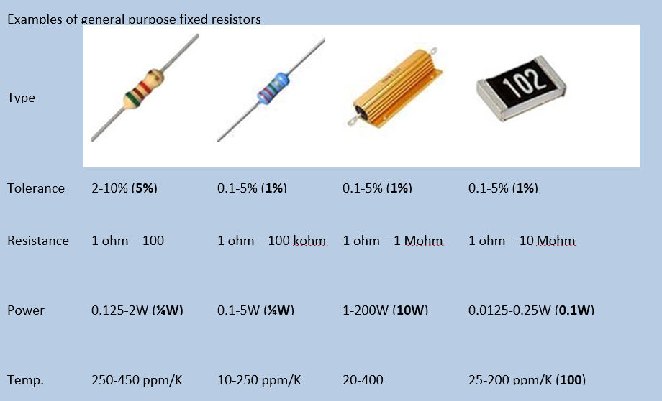Usually are cylindrically shaped with axial leads. High power resistors may have one of their leads designed to function as a heat sink (see for example the third resistor in the figure below).

There are 3 main types of hole mounted resistors:

* **Carbon composite**, which has a massive body of conductive carbon in a matrix of insulating materials
  + The temperature coefficient of resistance is rather high (up to 450 ppm/K) 🡪 the actual value of the resistor may change considerably under temperature changes
  + Carbon composites also have relatively low stability
  + relatively poor resistance tolerances: 5%, 10%, 20%
  + Values: 1 Ohm - 100 MOhm
  + Power dissipation: 1/8 - 2 W
* **Film layer resistors** have a thin film of metal, tin oxide (ossido di stagno) or carbon around an insulating core
  + The film often has a spiral cut to increase the wire length and thereby the resistance. This cutting process also can also be used to trim resistors to accurate values.
  + <1 Ohm – 1 MOhm
  + 20 – 250 ppm/°C
* **Wire wound resistors** consist of an insulating body around which a metal wire, for example NiCr, is wounded, and covered by insulation
  + Wire wound resistors have better (lower) temperature coefficient of resistance than carbon composite resistors (around 70 ppm/°C)
  + also better in terms of stability and tolerance ranges possible.
  + 1 – 100 kOhm
  + 0.1 – 0.5% tolerance

Thru-hole mounted resistors have also a color code to specify value and uncertainties.

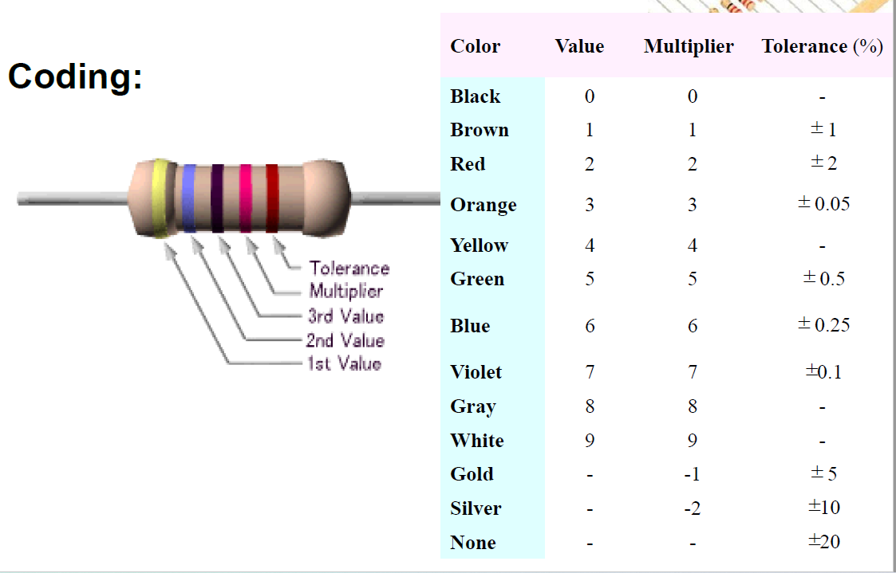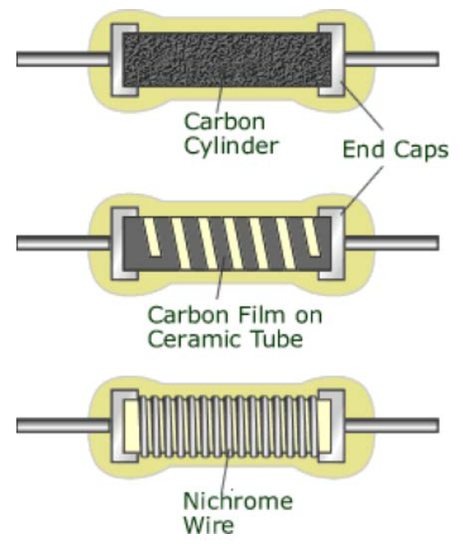

* + 1. **Surface mounted**

Surface mounted resistors normally are rectangular, and with a ceramic body and the whole structure is protected by a layer of glass.

The resistors are made using thick film hybrid technology 🡪 A layer of for example ruthenium oxide is used as resistor material, and it is covered with dielectric layer on top.

The greatest contribution to uncertainty is given by the caps at the end of the component 🡪 to compensate their impact we trimmer the resistor through a laser: we remove material from the sides of the resistive part of the component and we regulate the resistance.

Inner electrode material 🡪 Ag or Au.

Outside electrode material 🡪 AgPd with a diffusion barrier made by Ni with SnPb solder on top. The Purpose of the Ni layer is to prevent Ag from being dissolved in the outer metal, as Ag dissolves fast in Sn and Sn/Pb solder.

SOME TYPICAL VALUE:

* Temperature coefficient of resistance: below +/- 200 ppm per °C
* tolerance +/- 1 - 20 %.
* Maximum power dissipation for 1206 is 1/8 or 1/4 Watt. Higher power resistors have larger bodies.
* Resistor values range from < 1 ohm to approximately 10 Mohms.
* A "zero ohm" component has resistance around 50 Mohms (or milli) and is used as a "jumper" to contact two conductors on the PCB with other conductors between.

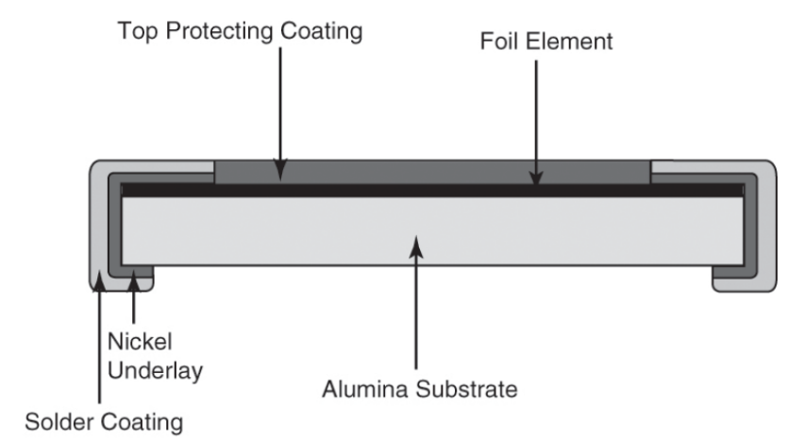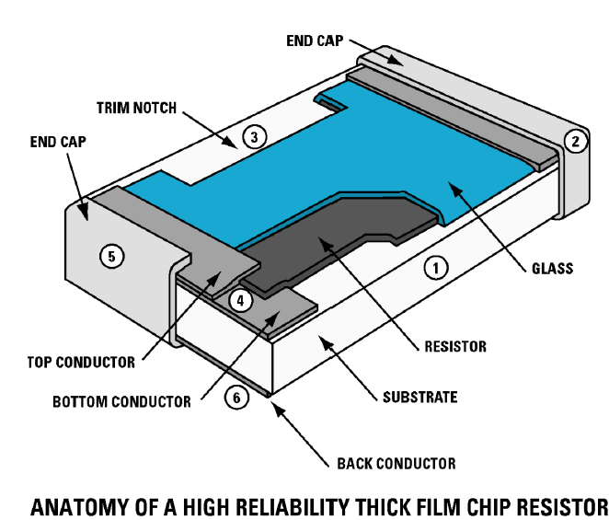

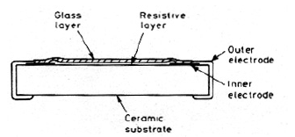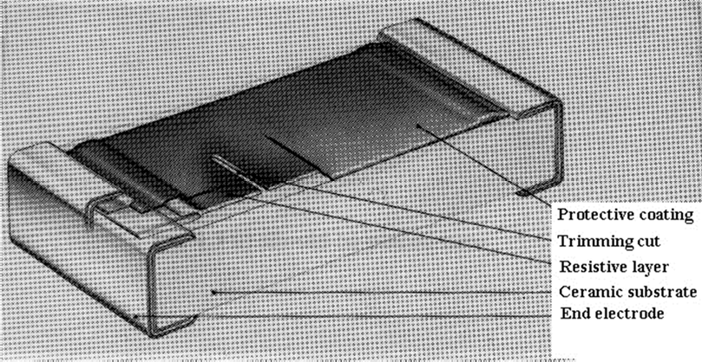

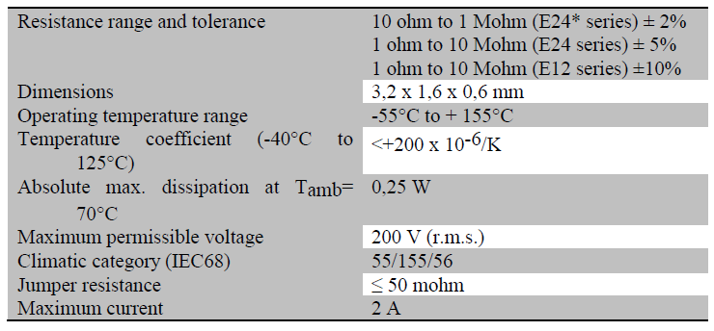

**Dimensions of surface mount discrete components:** Sizes of discrete components are usually defined according to their size using a condensed code. A summary of codes and dimensions are given below. The table also gives a typical power rating for surface mounted resistors.

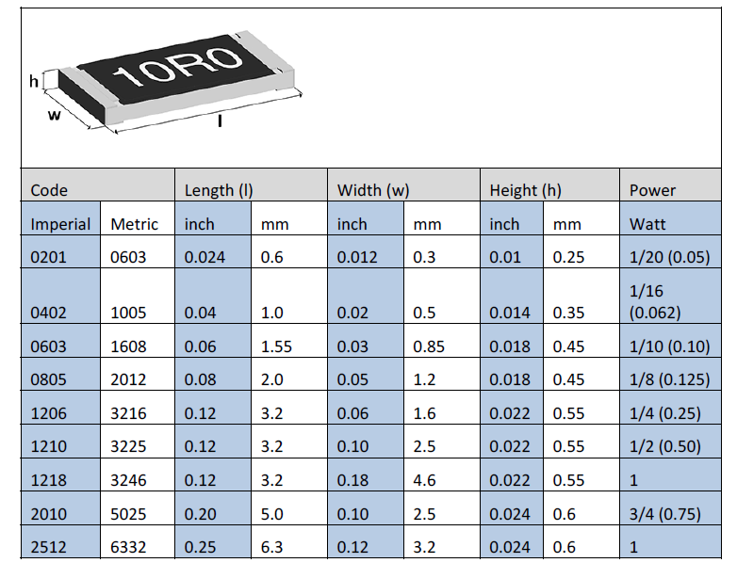Beware! Within electronics, both Imperial (inch) and Metric standards are used. 0603 metric is not identical to 0603 imperial!

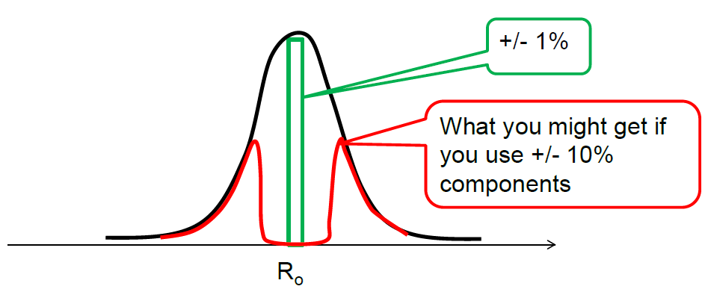Uncertainties: they are referred to a gaussian distribution!

* 1. **Passive components: capacitors**

**A capacitor is a passive two-terminal electrical component that stores electrical energy under the influence of an electric field.**

DIELECTRIC CAPACITORS:

A capacitor with a dielectric material between the capacitor plates has a higher capacitance than a corresponding air-filled capacitor. This is due to polarization effects taking place in the dielectric material.

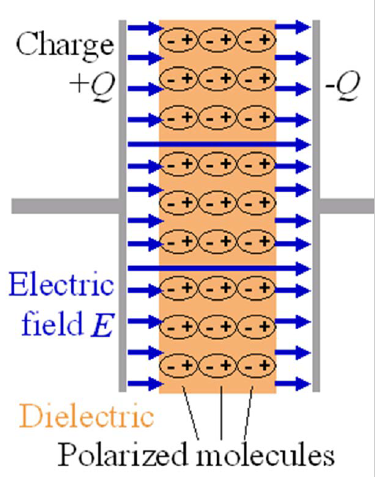

When considering capacitors we have to care about:

* Capacitance
* Maximum voltage rating
* Temperature dependence of the capacitance (temperature coefficient)
* Loss tangent
* Equivalent series resistance
* Long term stability and ageing phenomena
* High frequency properties
* Leakage current
* Ability to withstand various production processes (high temperature, etc.)
* Price, physical size, etc.

We will then consider capacitors of the following main types:

* Ceramic multilayer
* Electrolytic dry, polarized
* Electrolytic, wet, polarized
* Metallized plastic film
* Mica

One important take‐home message: resistors, inductors and capacitors are not ideal 🡪 they tend have both a resistive (real) and a reactive (imaginary) impedance component, and this usually becomes more prominent with increasing frequencies.

* + 1. **Electrical models of passive components**

For an ideal capacitor, the capacitance *C* is given as

$$C=\frac{ϵ_{0}ϵ_{r}A}{d} for A≫d^{2}$$

where *ε0* is the permittivity of vacuum, *εr* is the relative capacitance of the capacitor interface, *A* is the cross‐section area, and *d* is the distance between the capacitor plates.

The energy stored is

$$E=\frac{1}{2}CV^{2}$$

However, for a real, physical capacitor, we need to consider that a capacitor also has resistive and inductive properties, and these affect the frequency response of the capacitor. The full scheme is given by

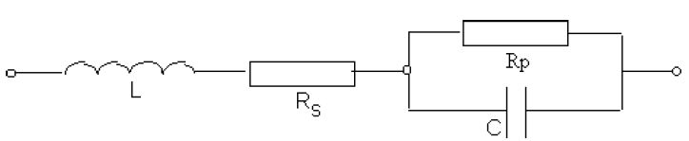

*Rp* represents the capacitors tendency of current leakages through the capacitor.

*Rs* and *Ls* represent the resistive and inductive contributions to the component.

Usually, *Rp* can be neglected, and we obtain the following term for the impedance:

$$\left|Z\right|=\sqrt{R_{s}^{2}+{\left(ωL-\frac{1}{ωC}\right)}^{2}}$$

From the equation, is it evident that there will be a resonant behaviour around *Zmin* = *Rs* corresponding to a cancelling of the inductive and capacitive terms.

$$ωL=\frac{1}{ωC}$$

Above this resonance frequency, the capacitor in fact functions as an inductor.

In the following figure we see the frequency dependence of impedance for multilayer ceramic capacitors

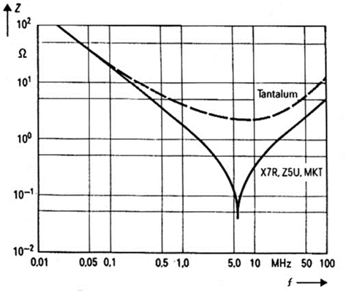and tantalum electrolytic capacitors, all having 100 nF capacitance value.

From circuity theory, it is known that the complex impedance can be written as

$$Z=Z_{real}+iZ_{imaginary}$$

Namely it has a resistive component and the imaginary component called reactance. For a capacitor 🡪 a real term means that the component has losses of energy. A convenient way to assess this is through the loss tangent *tanδ*, which is the relation between the real and the imaginary parts of the equation:

$$tanδ=\frac{Z_{real}}{Z_{imaginary}}=\frac{R_{p}+R_{s}\left(1+{\left(ωCR_{p}\right)}^{2}\right)}{ωCR_{p}^{2}-ωL\left(1+{\left(ωCR_{p}\right)}^{2}\right)}$$

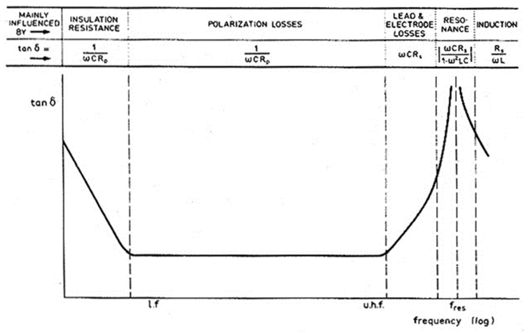Most capacitors will have a relatively wide range within which their loss tangent will be relatively stable, and will primarily be used within this range.

## **Ceramic multilayer capacitors**

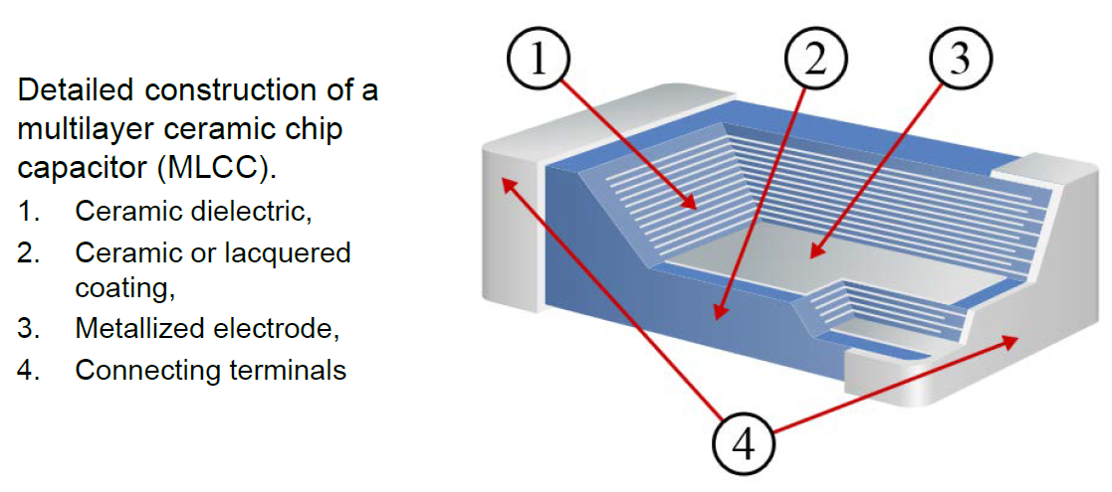Ceramic multilayer capacitors are the most produced and used capacitors in electronic equipment. These are made from a stack of metal electrodes with thin (~ 20µm thick) ceramic dielectrics in‐between, and these may have very strong dielectric properties. Every other conductor layer is connected to the others which we can find on the same side of the capacitor. In this way, high capacitance values can be obtained within a small volume.

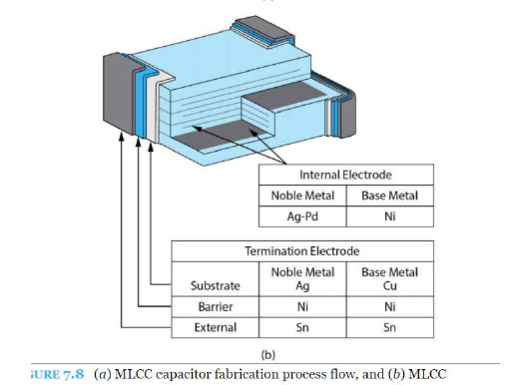

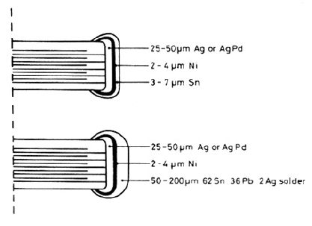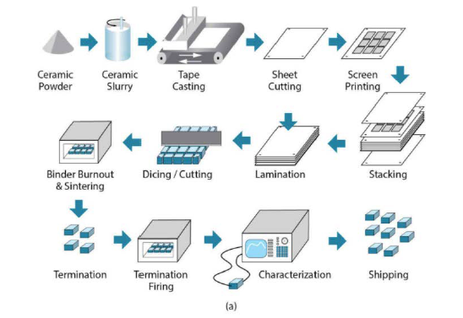

Multilayer ceramic capacitors are grouped into two main classes:

**CLASS 1: RELIABLE AND PRECISE, BUT LOW CAPACITANCE PER UNIT VOLUME**

* ceramic capacitors offer high stability and low losses for resonant circuit applications.
* They offer the most stable voltage, temperature, and to some extent, frequency.
* They have the lowest losses and therefore are especially suited for resonant circuit applications where stability is essential or where a precisely defined temperature coefficient is required.
* The basic materials are composed of a mixture of finely ground granules of paraelectric materials such as Titanium dioxide (TiO 2), modified by additives of Zinc, Zirconium, Niobium, Magnesium, Tantalum, cobalt and Strontium, which are necessary to achieve the capacitor’s desired linear characteristics.
* Class 1 ceramic capacitors have the lowest volumetric efficiency among ceramic capacitors. This is the result of the relatively low permittivity (6 to 200) of the paraelectric materials.
* Types: NP0, N220, N750, COG…

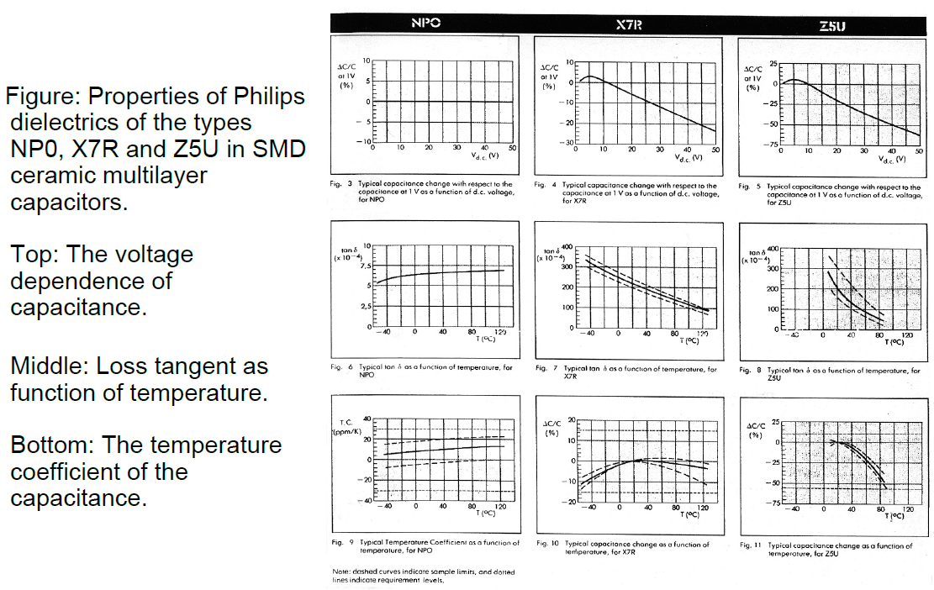

**CLASS 2: LOW PERFORMANCES, BUT HIGH CAPACITANCE PER UNIT VOLUME**

* Ceramic capacitors offer high volumetric efficiency for buffer, by‐pass, and coupling applications.
* The ceramic dielectric is characterized by a nonlinear change of capacitance over the temperature range. The capacitance value also depends on the applied voltage.
* They are suitable for bypass, coupling and decoupling applications or for frequency discriminating circuits where low losses and high stability of capacitance are less important.
* Class 2 capacitors are made of ferroelectric materials such as barium titanate (BaTiO3) and suitable additives such as aluminium silicate, magnesium silicate and aluminium oxide 🡪 Near the Curie Temperature the permittivity is strongly temperature dependent (see figure), and the purpose of the additives is to move the Curie point or in other ways reduce the temperature dependence in the temperature region of use.
* These ceramics have high to very high permittivity (200 to 14,000), which depends on the field strength. Hence the capacitance value of class 2 capacitors is nonlinear, and depends on temperature and voltage applied.

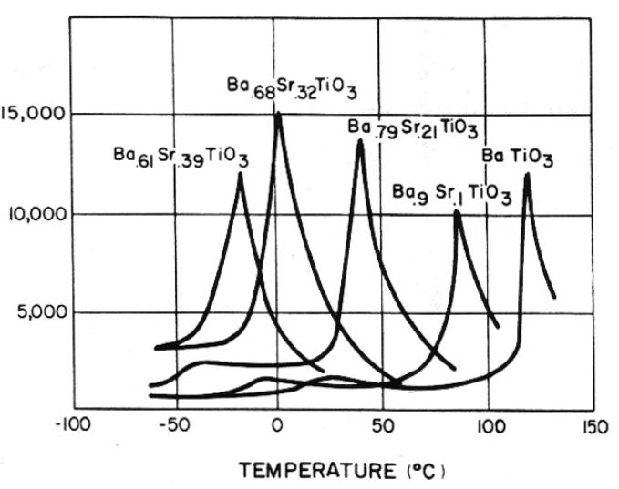

* Types: X7R, Z5U…
* Additionally, class 2 capacitors age over time, and it is simply a decrease in capacitance over time due to crystalline changes that occur in all Class II dielectrics. This is caused by the relaxation or realignment of the electrical dipoles within the capacitor. The phenomenon is affected by time, temperature, voltage (voltage has a minute effect), and is in fact a reversible effect.

IN DETAIL: The effect of time imposes a predictable loss of capacitance in Class II capacitors. For X7R and X5R the loss is calculated at ‐ 2.5% per decade hour and for Y5V it is ‐7% per decade hour. After the manufacturing of the component, the crystalline structure of the dielectric material is reset. Due to the realignment of these crystals after firing, the capacitor goes through a logarithmic loss of capacitance. By heating the capacitors over the “Curie Point” (approx. 125°C for Barium Titanate capacitors) the crystalline structure of the capacitor is returned to its original state and the capacitance value observed after manufacturing. Exposure to 150°C for 1.5 hours is sufficient to return the capacitor to its original value.

See figure for the example: NP0 🡪 class 1, all the others belong to class 2.

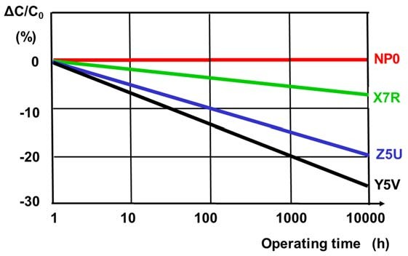

In summary:

* Class 1 capacitors are modest, nice and well‐behaved
* Class 2 capacitors employ high permittivity materials, giving rise to high capacitance per volume, but a less stable nature with temperature and aging effects associated.

**Failure modes in multilayer ceramic capacitors**

Multilayer ceramic capacitors tend to be prone to failures due to mechanical stresses, either originating during assembly or due to thermomechanical stresses during use. Two main sources:

* the solder edge of the component is known to be a crack starting point where stresses tend to concentrate.
* mechanical shocks 🡪 these shocks propagate more or less undamped through the circuit board and into the ceramic capacitor

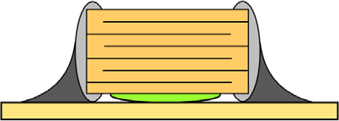Cracking ceramic capacitors might initially cause a lowering of the actual component capacitance since some of the metal layers are not contributing to the capacitor anymore. In more progresses stages, the component fails completely. Until an obvious failure can be observed, ceramic capacitor failures can be gradually change the performance of an electronic system and cause effects that are difficult to identify and understand.

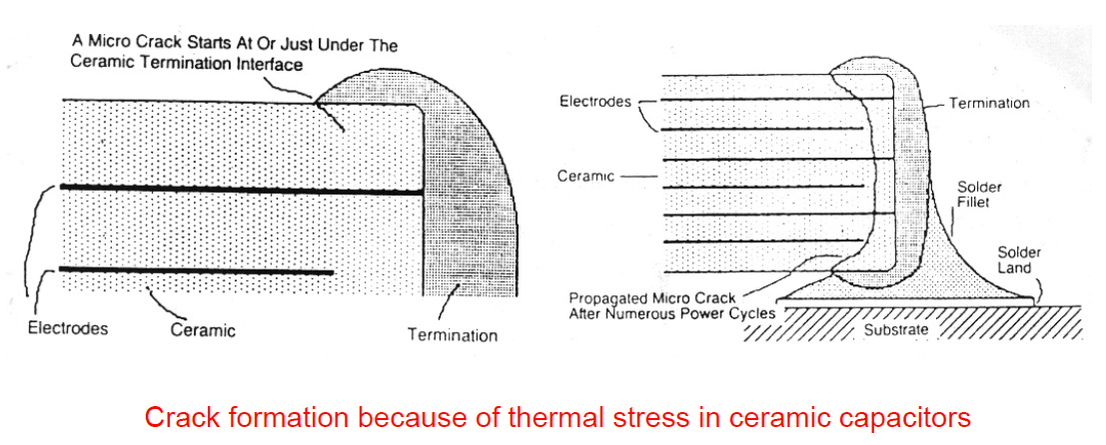

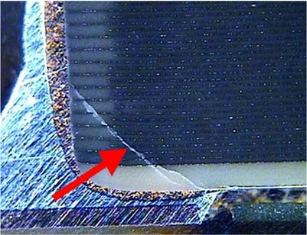

* 1. **Electrolytic capacitors**

An **electrolyte** is a substance that produces an electrically conducting solution when dissolved in a polar solvent, such as water. Salt is an electrolyte, but it does not mean that it is conductive. In fact, it is the solution formed when the electrolyte is solved in water that is conductive, while the salt itself is an insulator.

**Electrolytic capacitors are a range of polarized capacitors with very high capacitance‐to‐volume ratio**.

The high capacitance is obtained by using a very thin (~ 1 µm) metal oxide layer as dielectric. Metals that can form such oxides include aluminum, tantalum and niobium. The oxide forming process is also done in such a way that the oxide interface becomes very rough and with a large surface area.

As said, the dielectric layer is very thin 🡪 that’s the reason why these capacitors can work only with low voltages.

The main challenge: *how to realize an intimate electrode contact on the cathode side*? Both dry materials (dry electrolyte capacitors) and liquids (wet electrolyte capacitors) are used to obtain this interface, and we will exemplify this for the cases of dry tantalum electrolyte capacitors and wet aluminium electrolyte capacitors.

**IMPORTANT CONCEPT**: electrolyte capacitors are *polarized* 🡪 They should only be charged with on bias. The opposite bias will cause the oxygen ions in the dielectric layer to start to diffuse, and will break down the oxide layer so that the capacitor is destroyed.

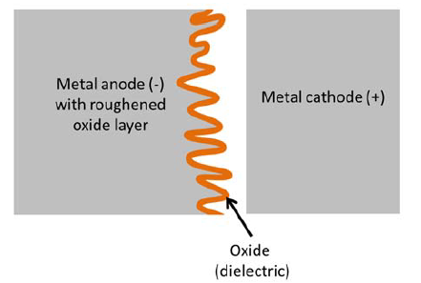

**Dry tantalum electrolyte capacitors**

Dry tantalum electrolyte capacitors: building process.

* They are made from tantalum metal powder that is sintered to form a large surface 🡪 figure 1
* The sintered body is then oxidized to form the dielectric oxide layer of the capacitor 🡪 figure 2
* The structure is then impregnated with manganese oxide powder (electrolyte), which fills all interfaces and forms the intimate cathode interface
* The manganese oxide powder in turn is electrically interfaced with a graphite layer and a silver electrode.

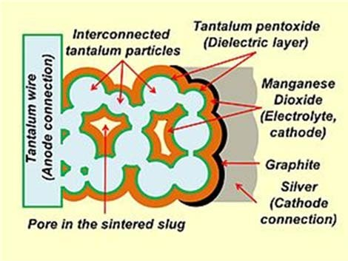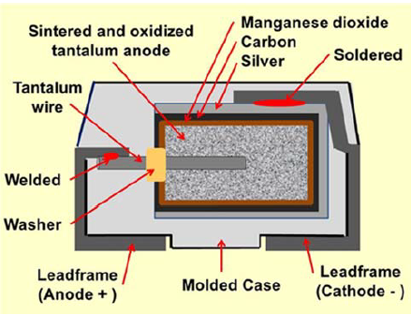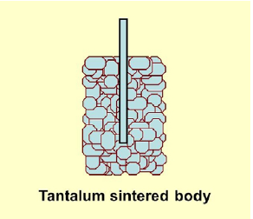

Tantalum capacitors

* high capacitance per volume and weight
* lower equivalent series resistance (ESR), lower leakage, and higher operating temperature than other electrolytic capacitors, although other types of capacitors are even better in these regards.
* Tantalum capacitors are more expensive than other commonly used type of capacitor, so they are used only in applications where the small size or better performance are important.

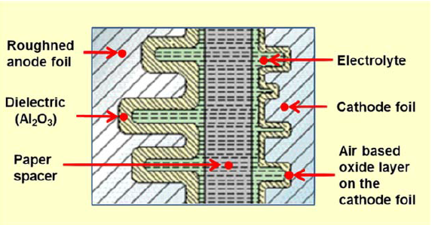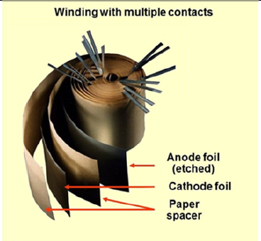**Wet aluminium electrolyte capacitors**

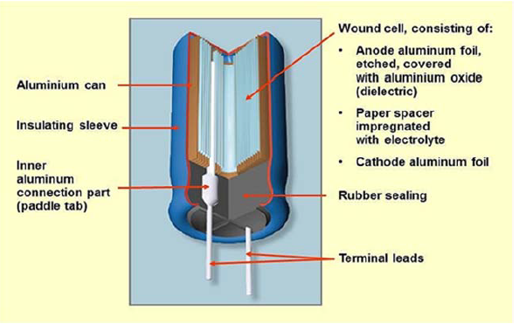

An aluminum electrolytic capacitor with a non-solid electrolyte always consists of two aluminum foils separated mechanically by a spacer, mostly paper, which is saturated with a liquid or gel-like electrolyte.

PRODUCTION:

* Two aluminium foils are used as cathode and anode. The anode foil is roughened to create a large interface area 🡪 figure 2
* Between the foils, a porous material (paper) is placed to separate the two foils.
* The structure is winded up in a cylindrical shape, and the structure with the porous material is soaked in a liquid material to form the electrolyte, which then fills all voids between the two aluminium foils 🡪 figure 2

THIS SECTION HAS TO BE CONFIRMED BY THE PROFESSOR!

On the electronic packaging book I found this version for the wet electrolytic capacitors:

*Wrong polarity of the voltage will ruin the dielectric and short-circuit the capacitor. Positive hydrogen ions will drift through the dielectric, become neutralised at the Al electrode and form hydrogen gas that breaks the dielectric and gives shortages.*

*When the temperature changes the wet electrolyte must "breathe", and the component cannot be sealed. This means that wet electrolytic capacitors cannot withstand long time in wave- or reflow solder processes. In these processes the component life will be reduced - in the worst case high pressure will build up in the electrolyte, which "boils" and may leak out, ruining the component.*

DETAILS: why is it so easy for the electrolytic capacitors to explode?

When you polarize an electrolytic capacitor in the wrong way, the oxygen ions in the dielectric layer start to diffuse and will break down the oxide layer itself. Now the capacitor is conductive and in particular it becomes a short circuit. Tons of current start flowing and it gets hot. The electrolyte fluid melts and starts boiling, pressure increases and it explodes.

* 1. **Packaging and package types for ICs**
     1. **Package types and materials**

Integrated circuits are put into protective packages to allow easy handling and assembly onto printed circuit boards and to protect the devices from damage.

We have a very large number of packages and a lot of them can be provided in both plastic and ceramic versions (also metal packages exist). The same IC can also be provided in different types of packages, depending on the requests from the customer. It is the requirements for the application at hand that must determine the final choice.

The following summary of different IC packages is structured according to features, but also represents an historic packaging development in the move towards smaller and smaller chip footprints. We will treat:

* diode and transistor packages
* thru‐hole mounted packages and their corresponding surface mounted version
* packages entirely dedicated to surface mounting and enabled by the introduction of flip chip technology.

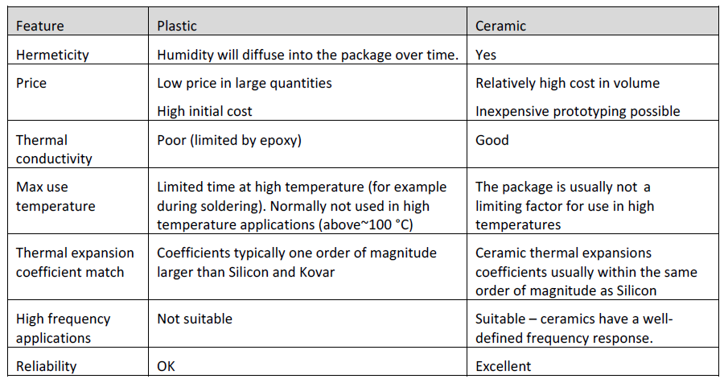

* + 1. **Diode and transistor packages**

Diodes and transistors are examples of small active components. They can be provided both as thru-hole components or surface mounted.

**The transistor outline (TO) package** family consists of many types of packaging solutions for transistors and similar discrete devices as well as simple IC's with low pin counts. The structures of TO packages vary widely, from expensive metal can enclosures to low‐cost plastic‐molded package bodies. TO cans are used for thru‐hole mounting, and are also very convenient for prototyping. Some examples of TO cans are illustrated in the table below. See figure below.

**We have also the SOT family**: small-outline transistor 🡪 family of small footprint, discrete surface mounted transistors. The most common in SOT23. See figure below.

HOW TO CHOOSE THE PACKAGE? Depending on the component power, frequency of operation, reliability required, etc.

* For hole mounted diodes axial packages are most common, the semiconductor chip being mounted in a body of glass or ceramic
* Power diodes have metal housing and screw mounting for better thermal coupling. The cathode of the diode is grounded to the can. Many of the packages have also additional copper planes 🡪 used to dissipate heat!

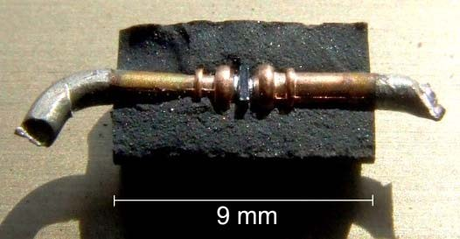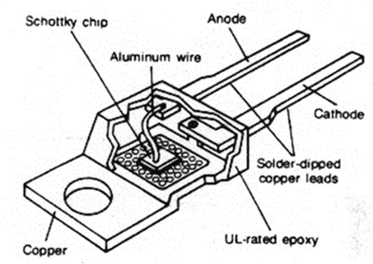

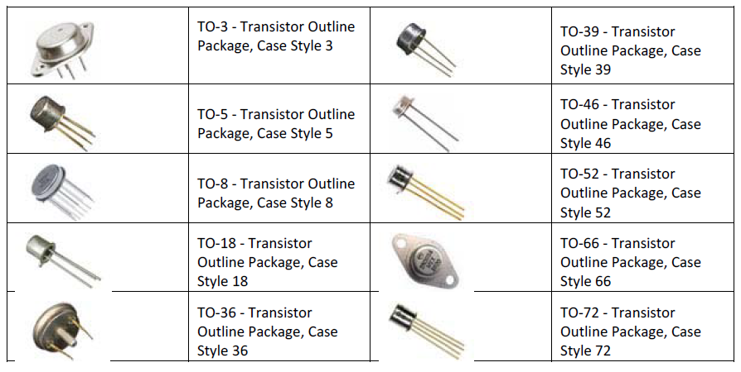

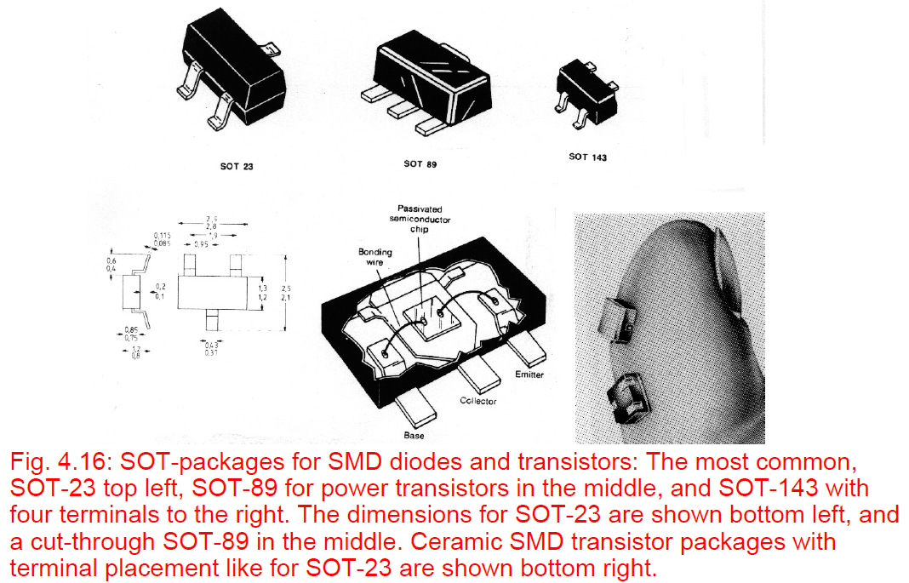

* + 1. **IC Packages for thru‐hole mounting**

Through hole technology uses holes drilled through the PCB for mounting the components. The component has leads that are soldered to pads on the PCB to electrically and mechanically connect them to the PCB.

Examples of packages: the **single‐in‐line package** (SIP) and the **dual-in-line package** (DIP), as well as its ceramic counterpart (CERDIP).

A very nice feature with SIP and DIP packages is however their usefulness in prototyping 🡪 They fit in breadboard and Vero board applications, and they can be used in combination with sockets in cases where it is of interest to be able to easily remove a component from the PCB.

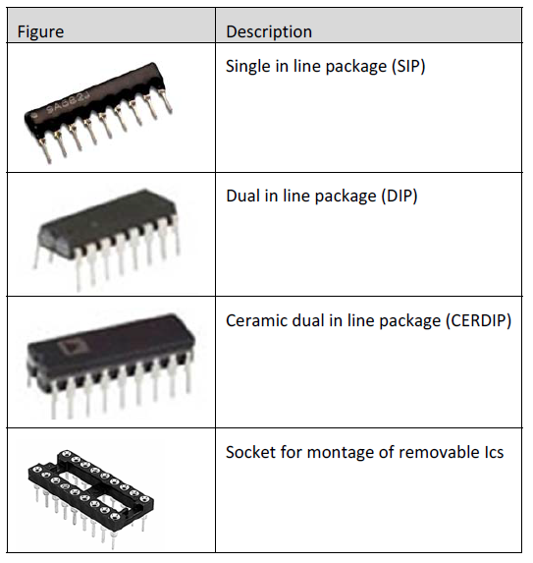

**DIP packages** 🡪

For plastic DIPs the silicon chip is alloyed, soldered or glued to a metal plate (the leadframe) which is often an alloy of Fe/Ni 42/58 ("alloy 42") with low TCE to reduce the mismatch to Si. Components with high heat dissipation have Cu leadframe. Thin gold or aluminium bonding wires provide electric contact between chip and leads. The leads are in two rows. DIP packages are made with 8 - 64 leads. For small circuits with few I/Os several circuits are often made on the same piece of silicon and packaged in the same package.

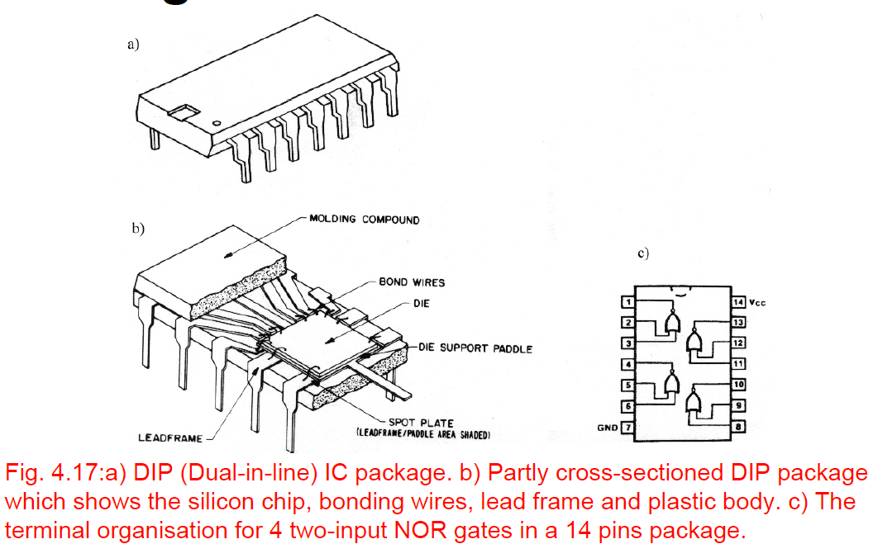Ceramic DIP packages with a cavity for the chip are also common 🡪 more reliable.

**Pin grid array packages** 🡪

They are a logical extension of the in‐line packages. In pin grid array packages, there is room for many more connectors, and packages have been made containing several hundred I/O's. These packages are also attractive for applications where one wants to have a removable/exchangeable processor. However, with increasing pin count, these packages become very hard to insert and remove.

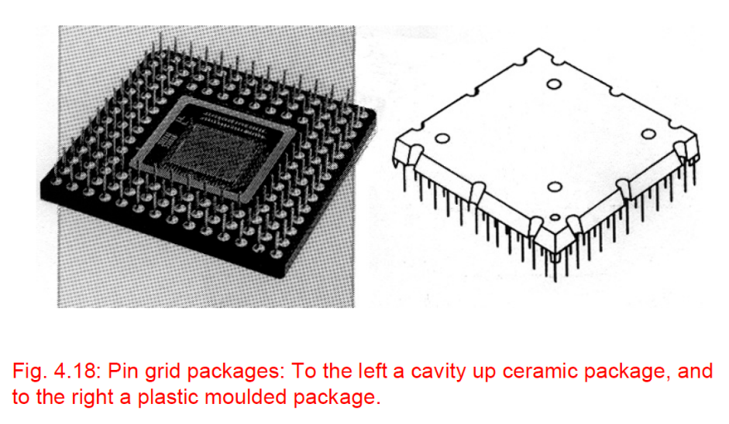

* + 1. **IC packages for surface mounting**

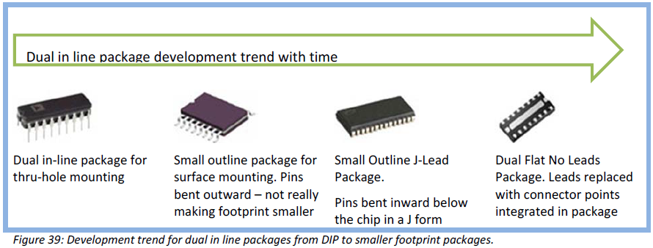Transition from thru-hole ICs to SMD has been gradual:

We have different types of SMD packages, among them we find:

* Small Outline (SO)
* Plastic Leaded Chip Carrier (PLCC)
* Leadless Chip Carrier (LLCC)
* Leaded Ceramic Chip Carrier (LDCC)
* Flatpack, mini-flatpack
* TapePak
* Chip Scale Packages

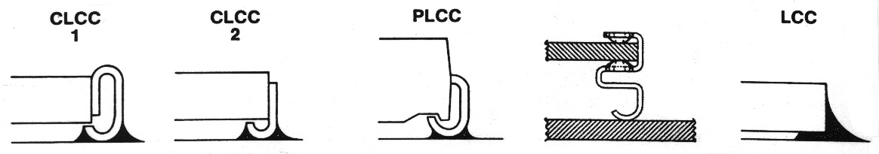We will just analyze the main features of these packages, without going into details.

**SO (Small outline) and VSO (very small outline) 🡪**

* Between 8 and 28 terminals
* is the most common SMD package for ICs.
* They are similar to a small version of the DIP, thus the name.
* lead separation: 50 mils
* the leads are bent out in "gull wing" form.
* A similar package, much used for memory circuits, is the "SOJ", which has its leads bent underneath the body, similarly to the PLCC.
* "Very Small Outline" (VSO) package
  + 40 and 56 leads
  + separation 30 mils

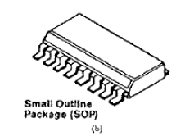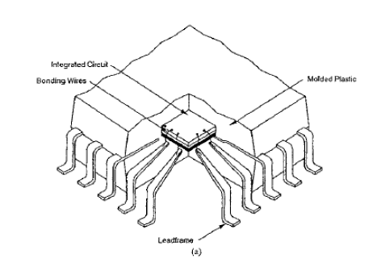

**PLCC (Plastic Leaded Chip Carrier) AND LLCC (Leadless Chip Carrier) 🡪**

They are member of the family of "chip carriers".

Plastic Leaded Chip Carrier 🡪

* leads on all four sides. The leads are folded under the body in J-shape to conserve board area.
* They have 50 mils pitch and are used for 18 - 84 terminals

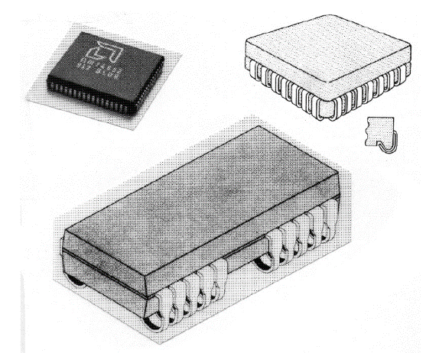

Leadless Chip Carrier (LLCC) 🡪

* No leads 🡪 The terminals are metallized areas on the ceramic body. The ceramic makes the package hermetic and it has thermal properties much superior to the plastic IC packages when they are soldered to the substrate.
* missing flexible leads give a disadvantage: Thermal mismatch to organic PCBs:
  + TCE for glass epoxy laminates is 12 - 16 ppm/°C
  + alumina ceramic has 6 ppm/°C.

When the temperature changes during soldering processes and operation, this mismatch will give mechanical stress and in time possibly broken solder fillets. On the contrary, for leaded packages, stress due to the thermal mismatch normally is negligible.

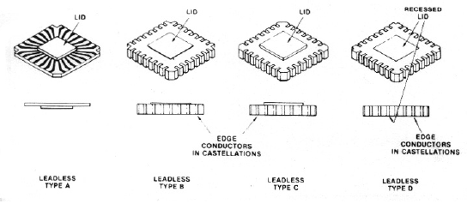

EXTRA: Leaded ceramic chip carriers (LDCC) 🡪

* first we considered plastic chip carriers with leads, then ceramic chip carriers without leads and now ceramic chip carriers with leads: they have a ceramic body with pins with gull wing or J-shape
* 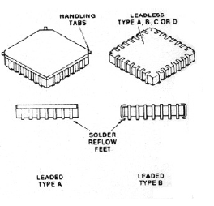they are in limited use.
  + 1. **Quadratic packages**

**Flat Packs 🡪**

* They are made out of plastic or ceramic (and metal for hybrid circuit packages)
* Some have leads on two sides and some on four (Quad flatpacks)
* Chip carriers may have either J‐shaped metal leads for connections by solder or by a socket, or may be lead‐less with metal pads for connections. After production, the leads are encapsulated in an external protective ring. When they are assempled, the ring is broken and the leads are bended in their final shape.
* Many sizes and lead pitches are used for flatpacks.
* Up to 300 terminals are available for plastic or ceramic flatpacks.
* One type of plastic package: Miniflatpack 🡪
  + his package has been accepted for 84 - 244 terminals
  + pitch of 25 mils
  + gull wing lead shape
* Using all four edges and a square package makes it possible to fit more pins on smaller package footprints.

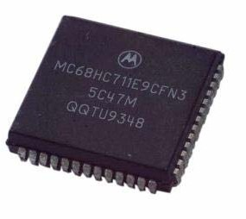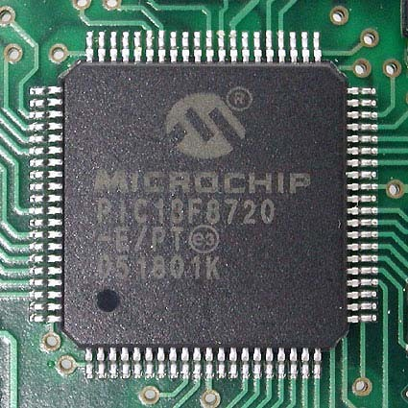

**TapePack 🡪**

National Semiconductor 🡪 plastic package called "TapePak",

* The IC is moulded into the central plastic body.
* The connections to the chip are made by Tape Automated Bonding (TAB) using one-layer tape that serves as leadframe. The TAB leads stick out of the central body, at a pitch of 20 mils or less. further out there is a plastic ring for protection, and the leads go through it too, ending in test points for component testing. The test points have a pitch of 50 mils, for easy testing. During mounting, the leads are cut inside the outer ring in an excising operation, and they are bent to gull wing form, in a combined cut-and-form tool. Then the mounting is done, all in the same automatic machine.
* standardized dimensions for components with between 40 and about 600 leads.
* Pitch for the smaller packages is 20 and 15 mils. For the larger packages it is metric, down to 0.25 mm.
* ADVANTAGES:
  + They take up very little board space (similar to TAB circuits)
  + They are rugged (robusti) during transport and testing, and the testing is easy
  + TapePak has the possibility of a larger number of I/Os than any other standard package.
* DISADVANTAGES:
  + A major problem is that expensive equipment is needed for the mounting
  + Mounting and soldering are challenges requiring refined processes.

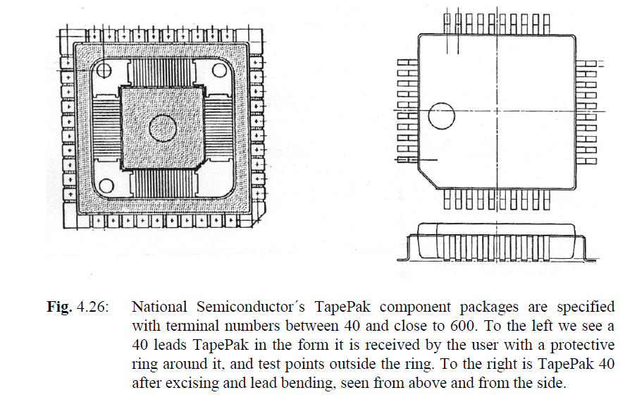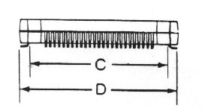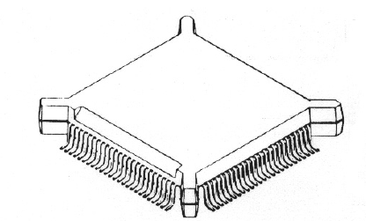

## **Chip Scale Packages**

Flip chip technology has been the main enabler for this change, which also has made high density chip connect without wire‐bonding possible.

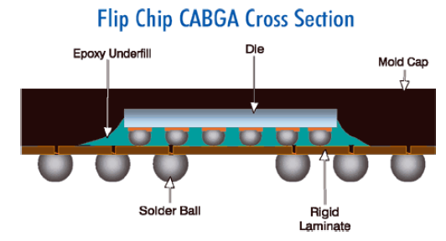The idea is to place the flip‐chipped die on a small laminate, which in turn allows attachment for example by larger ball grid array (figure 1, 2, 3, CABGA) or using small leaded or leadless packages (figure 4).

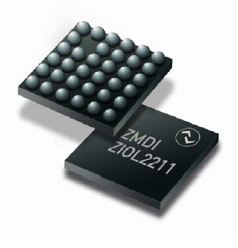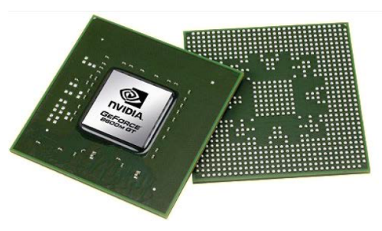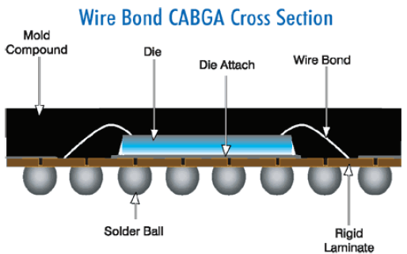UNWRITTEN RULE: the package must have an area no greater than 1.2 times that of the die and it must be a single‐die, direct surface mountable package.

* 1. **MEMS packaging**

MEMSpackages 🡪 they are less standardized than IC packages. That’s because **MEMS packages usually need an additional window to the outside environment.**

This is illustrated in the figure below 🡪 differential pressure sensor need defined interfaces towards the measurement environment in which pressure will be measured. Still, you will see that the device is made so that it possibly can be handled with automated pick‐and‐place assembly equipment, but additional manual after‐work to attach tubing is certainly needed.

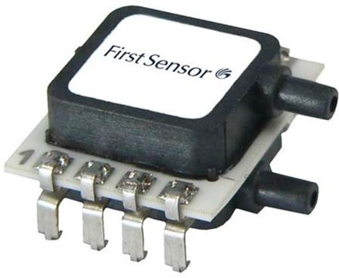We will revisit MEMS packaging later in the course.

* 1. **Component packaging for delivery and automatic placement**

Components are usually delivered in standardized formats prepared for automated pick‐and‐place robots. These include:

* Paper tape (hole mounted passives)
* Blister tape (SMD passives, discretes, small ICs)
* Sticks (DIPs, SMD ICs)
* Waffle trays (Flatpacks)
* Stack magazine
* Bulk: Not suited for automatic mounting

**PAPER TAPE 🡪** Hole-mounted axial components (resistors, capacitors) are supplied on paper tape. The ends of the components are held between two layers of sticky tape, and the tape is rolled on to a reel. Radial components (capacitors, transistors) are supplied on similar tape. When the components are to be removed from the tape, the leads are cut.

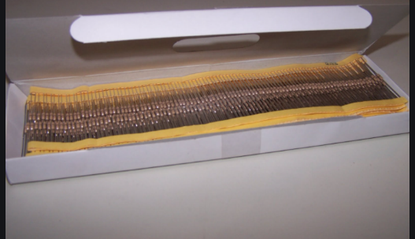

**BLISTER TAPE 🡪** The most efficient form of packaging for small surface mounted components (resistors, capacitors, transistors, small integrated circuits, etc.), is the so-called "blister tape. Each component is in a recess in a tape, which is normally made of plastic. A thin protective film is on top, sticking to the tape, so that the components do not fall out. For the smallest chip components there are 4.000 or 10.000 per reel.

Conductive, metallised plastic tape, or tape made of aluminium, is used for components that are sensitive to electrostatic discharges. The blister tape is especially well suited for pick-and-place machines mounting

SMD components.

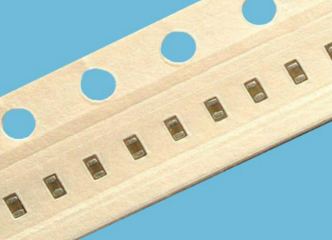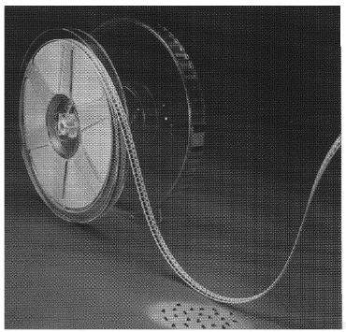

**STICKS 🡪** For DIP integrated circuits plastic "stick magazines" are the most common form of packaging. Sticks are also much in use for surface mounted integrated circuits. The plastic has an anti-static coating to avoid generation of static electricity. Even this packaging form is well suited for automatic mounting.

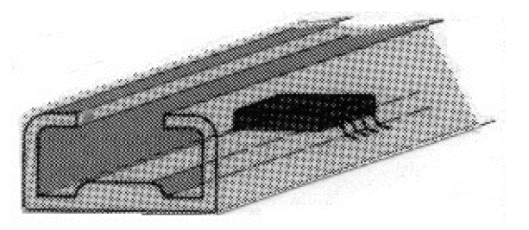

**WAFFLE TRAYS 🡪** The waffle tray packaging is less suitable for mounting with the ordinary pick-and-place machines. However, programmable mounting robots can pick components efficiently from such packaging.

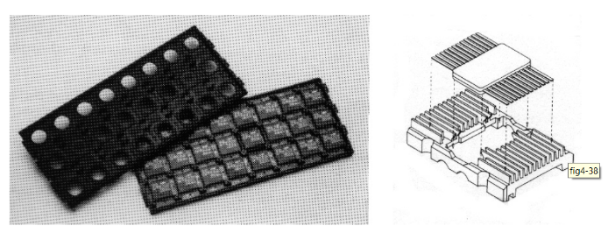

**STACK MAGAZINES 🡪** Another packaging form for flatpacks is individual plastic frames that can be stacked on top of each other in a magazine, "stack magazines", during transport and mounting.

**BULK 🡪** Components in small quantities are often supplied in bulk, i.e. packed only in a plastic bag. When these components are to be mounted automatically, they have to be oriented in a vibration feeder.

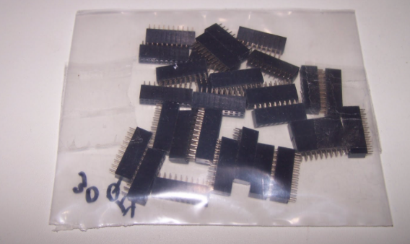

* 1. 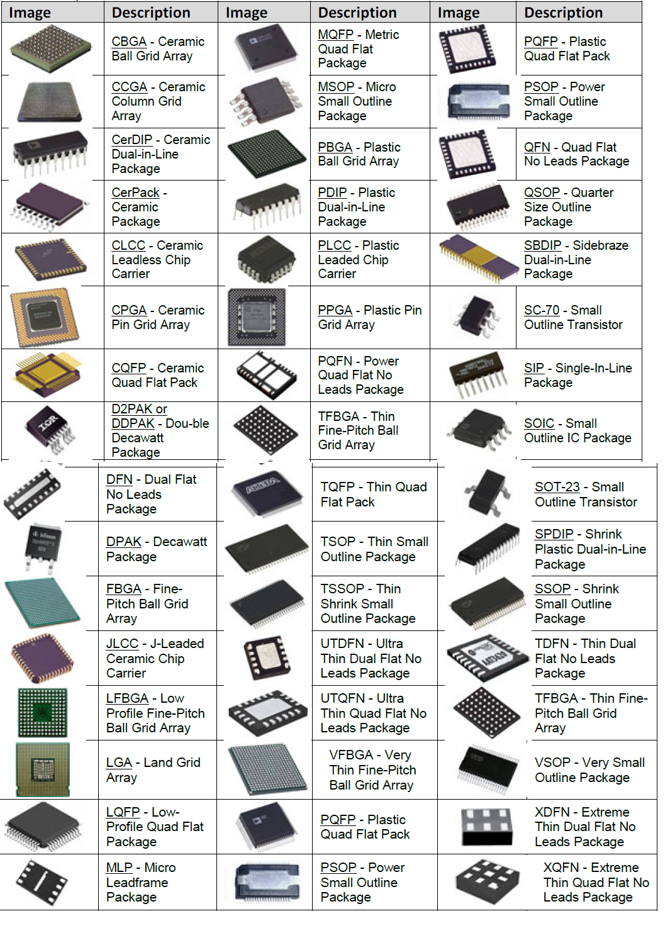**Appendix: Overview of IC packages**

1. **PRINTED CIRCUITS BOARDS**

**A printed circuit board (PCB) mechanically supports and electrically connects electronic components using conductive tracks, pads and other features etched from copper sheets laminated onto a non-conductive substrate.**

PCBs can be single sided (one copper layer), double sided (two copper layers) or multi-layer. Conductors on different layers are connected with plated-through holes called vias. Advanced PCBs may contain components -capacitors, resistors or active devices -embedded in the substrate

In principle/by definition, an electrical circuit is not a circuit before it is closed, that is, components have been attached.

* PRINTED WIRING BOARD: a board which has only copper connections and no embedded components. Although more accurate, the term printed wiring board has fallen into disuse, but is used to clarify when we specifically discuss issues related to the substrate and wiring.
* PRINTED CIRCUIT BOARD: a board which hosts a closed circuit, namely the components have been attached.

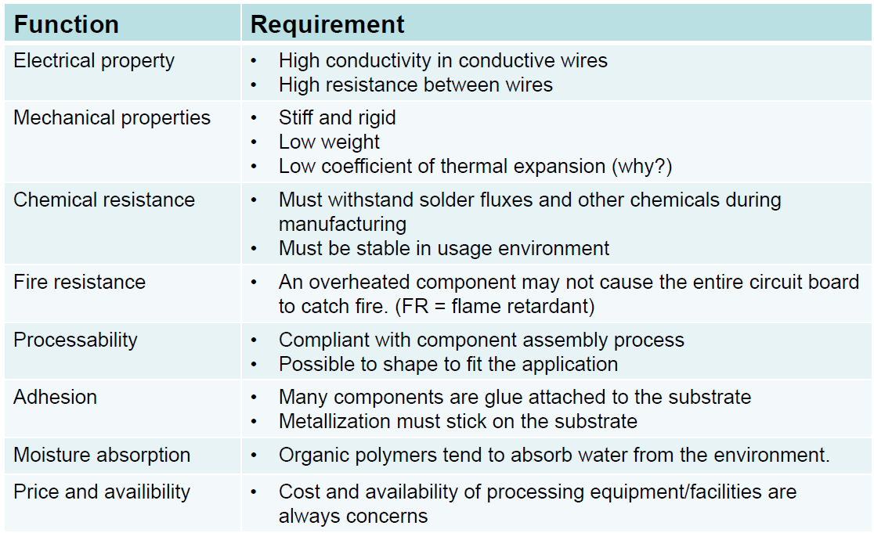When we require for a PCB we ask for it to have several features:

* 1. **CLASSIFICATION OF PRINTED WIRING BOARDS**

PWBs may be classified in many different ways according to their various attributes. One fundamental structure common to all of them: they must provide electrical conductor paths which interconnect components to be mounted on them.

First consider this scheme 🡪 we’ll analyze it in a moment.

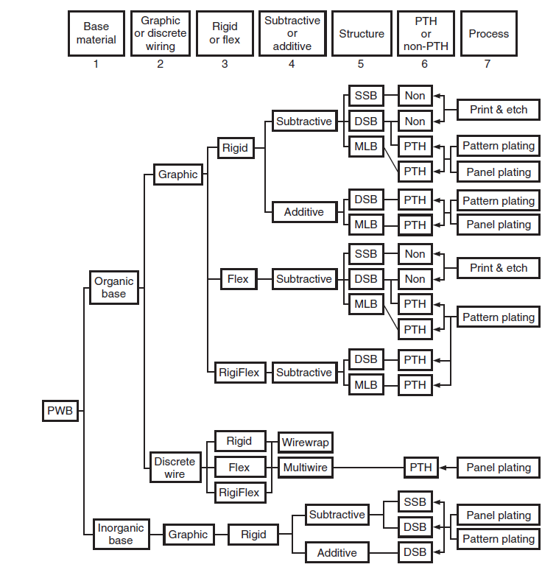

* + 1. **Base materials**

One of the major issues 🡪 the availability of materials for the PWB substrate that are compatible with these product and process needs. This includes the stresses on substrate material created by more and longer exposure to soldering temperatures during the assembly process, as well as the need to match the coefficient of thermal expansion for components and substrate. The resultant search has found new materials, both organic and nonorganic based.

**Organic Substrates:** consist of layers of paper impregnated with phenolic resin or layers of woven or nonwoven glass cloth impregnated with epoxy resin, polyimide, cyanate ester, BT resin, etc. The usage of these substrates depends on the physical characteristics required by the application of the PWB, such as operating temperature, frequency, or mechanical strength.

**Nonorganic Substrates:** consist mainly of ceramic and metallic materials such as aluminum, soft iron, and copper-invar-copper. The usage of these substrates is usually dictated by the need of heat dissipation, except for the case of soft iron, which provides the flux path for flexible disk motor drives.

* + 1. **Graphical and discrete wiring boards**

Printed wiring boards may be classified into two basic categories, based on the way they are manufactured:

**Graphical Interconnection Board:** the image of the master circuit pattern is formed photographically on a photosensitive material, such as treated glass plate or plastic film. The image is then transferred to the circuit board by screening or photoprinting the artwork generated from the master.

Direct laser imaging of the resist on the PWB can also be used. In this case, the conductor image is made by the laser plotter, on the photoresistive material, which is laminated to the board, without going through the intermediate step of creating a phototool*.*

**Discrete-wire boards**: conductors are formed directly onto the wiring board with insulated copper wire. Because of the allowance of wire crossings, a single layer of wiring can match multiple conductor layers in the graphically produced boards, thus offering very high wiring density. However, the wiring process is sequential in nature and the productivity of discrete-wiring technology is not suitable for mass production.

Wirewrap and MultiWire 🡪 most used techniques

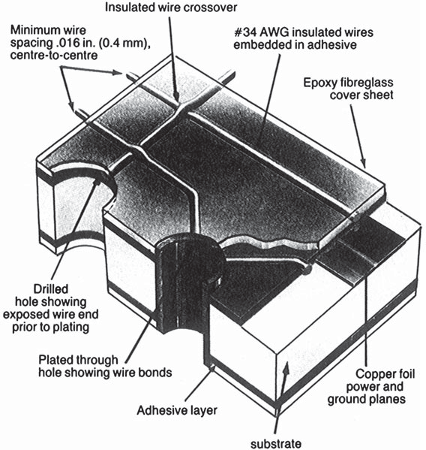

* + 1. **Rigid and flexible boards**

**Rigid 🡪** picture 1

**Flexible** boards generally are made of polyester and polyimide bases. 🡪 picture 2

**Rigi-flex boards***,* a combination of rigid and flexible boards usually bonded together, have gained wide use in electronic packaging. Most rigi-flex boards are three-dimensional 🡪 picture 3

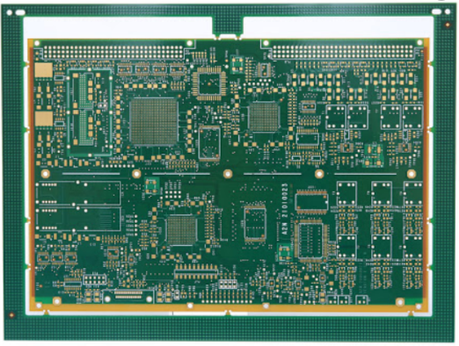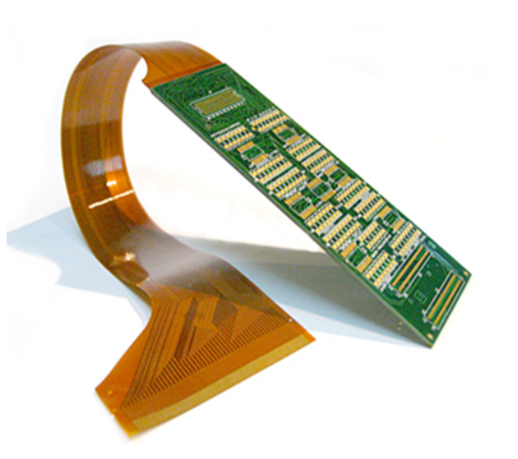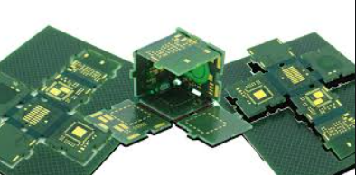

* + 1. **Subtractive or additive process**

There are two basic ways to form these conductors:

* *Subtractive* 🡪 the unwanted portion of the copper foil on the base substrate is etched away, leaving the desired conductor pattern in place.
* Additive 🡪 formation of the conductor pattern is performed by adding copper to a bare substrate in the pattern and places desired. This can be done by plating copper, screening conductive paste, or laying down insulating wire onto the substrate on the predetermined conductor paths.
  + 1. **Graphically produced boards**

The majority of boards produced in the world are graphically produced. There are three alternative types:

* Single-sided board
* Double-sided boards
* Multilayer boards

**Single-Sided Boards (SSBs):** Single-sided boards (SSBs) have circuitry on only one side of the board and are often referred to as print-and-etch boards because the etch resist is usually printed on by screen-printing techniques and the conductor pattern is them formed by chemically etching the exposed, and unwanted, copper foil.

**Double-Sided Boards:** By definition, double-sided boards (DBs) have circuitry on both sides of the boards. They can be classified into two categories:

* Without through-hole metallization
* With through-hole metallization**:**
  + Plated-through-hole (PTH): Since PWB substrate is an insulating material, and therefore nonconductive, holes must be metallized first before subsequent copper plating can take place. The usual metallization procedure is to catalyze the holes with palladium catalyst followed by electroless copper plating. Then, thicker plating is done by galvanic plating. Alternately, electroless plating can be used to plate all the way to the desired thickness, which is called *additive plating.*
  + Silver-through-hole (STH): STH boards are usually made of paper phenolic materials or composite epoxy paper and glass materials, such as CE-1 or CE-3. After copper-clad (rivestimento) materials are etched to form conductor patterns on both sides of the panel, holes are formed by drilling. Then the panel is screened with silver-filled conductive paste. Instead of silver, copper paste can also be used.

**Multilayer boards:** By definition, MLBs have three or more circuit layers (see Fig. 5.4). Main applications of MLBs used to be confined to sophisticated industrial electronic products. Now, however, they are the mainstream of all electronic devices, including consumer products such as portable video cameras, cellular phones, and audio discs.

* + 1. **Plated-thru-hole technology**

In through-hole technology, the components are mounted on the PCB board by inserting their leads through the respective hole. These holes are called through holes since they are drilled from the top to the bottom of the board.

When using **Plated Through Holes,** as the name suggests, the inner wall of the holes is covered with a thin layer of Copper, which makes the entire inner hole area conductive. This conductivity benefit establishes an electrical connection between components and Copper tracks. It also enhances mechanical stability and reduces the overall resistance to support smooth current flow. The average Cu plating thickness is min 20µm.

As electronic components become more integrated and complex, the industry has started to focus more on the development of double-sided and multi-layered PCBs along with plated through holes, so that components may connect to the desired layers, whenever required.

* + 1. **Pattern plating & print and etch**

Find pieces of information about this topic, on the book it is not clear.

* 1. **Impact of lead-free soldering requirement changes the FR-4 composition**

As a material is heated to higher temperatures, a point is reached where the resin system will begin to decompose. The chemical bonds within the resin system will begin to break down and volatile components will be driven off, reducing the mass of the sample. **The decomposition temperature, Td, is a property which describes the point at which this process occurs.**

**The traditional definition of Td is the point where 5% of the original mass is lost to decomposition.** However, 5% is a very large number when multilayer PCB reliability is considered, and temperatures where lower levels of decomposition occur are very important to understand, particularly with respect to lead-free assembly. To illustrate this, consider the figure below 🡪 you can see curves for two FR-4 materials.

* The “traditional FR-4” has a decomposition temperature of 320°C by the 5% weight loss definition.
* The “enhanced FR-4” has a decomposition temperature of 350°C by the 5% weight loss definition. Many standard high-Tg FR-4 materials actually have decomposition temperatures in the range of 290–310°C, while the 140°C Tg FR-4 materials generally have slightly higher Td values.

A very common question is, if a PCB will be assembled at 260°C, and the material has a decomposition temperature of 310–320°C, then why wouldn’t it be compatible with lead-free assembly?

ANSWER: In the tin-lead temperature range, neither material exhibits a significant level of decomposition. However, in the lead-free assembly temperature range, the traditional FR- 4 begins to exhibit 1.5–3 percent weight loss. This level of decomposition can compromise long-term reliability or result in defects such as delamination during assembly, particularly if multiple assembly cycles or rework cycles are performed.

Message: lead solders 🡪 they are not good for the environment. They melt around 210°C 🡪 the PCB has to survive for some time at this temperature in order to let the solders melt and the process is completed.

At high temperature, the material starts degrading and to lose weight. A PCB made using lead solders can resist up to lower temperatures than a PCB made with lead-free solders.

So one has to avoid using these kind of solders both for the environmental problem and for this reliability concern.

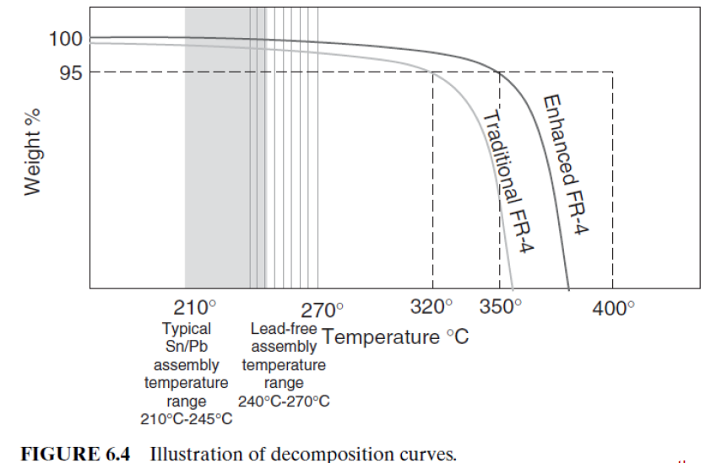

* 1. **Another way of classifying boards**

One can find many criteria to classify a board, but among them we can distinguish

* the **resin** with which the board is made
* the **reinforcement** used
* whether the board is flame retardant or not

Another interesting feature is the X/Y CTE 🡪 tells us about the expansion properties of the substrate material in both the planar directions.

One has always to remember that the materials of the substrate and in general for composing a PCB have to be chosen depending on the specific usage of the board. We saw a lot of different materials with their main properties and all of them must be considered when building a board. Among them we remind of CTE, Glass transition temperature for plastic materials , Thermal conductivity and many more.

**FR4** is the most common PCB technology and is also the most convenient to use in general.

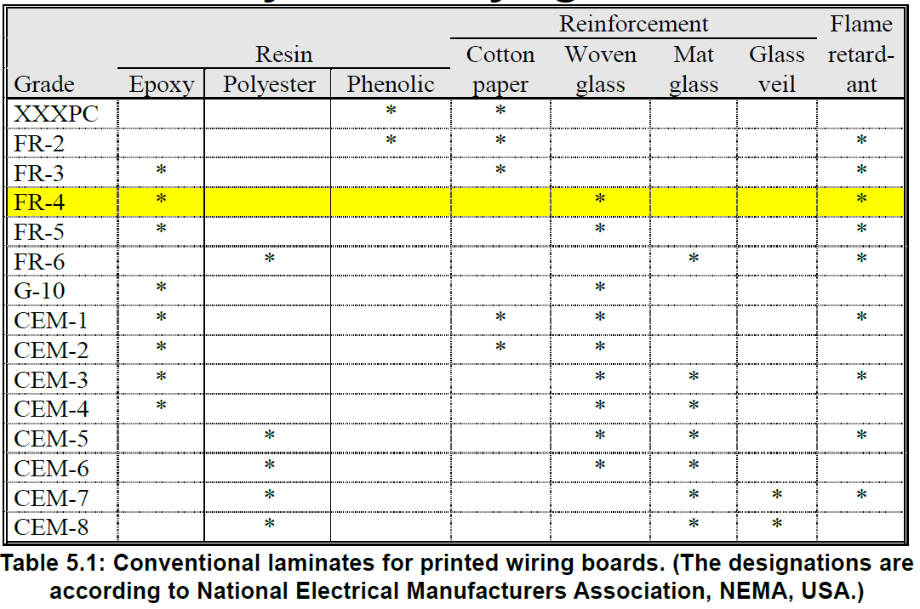

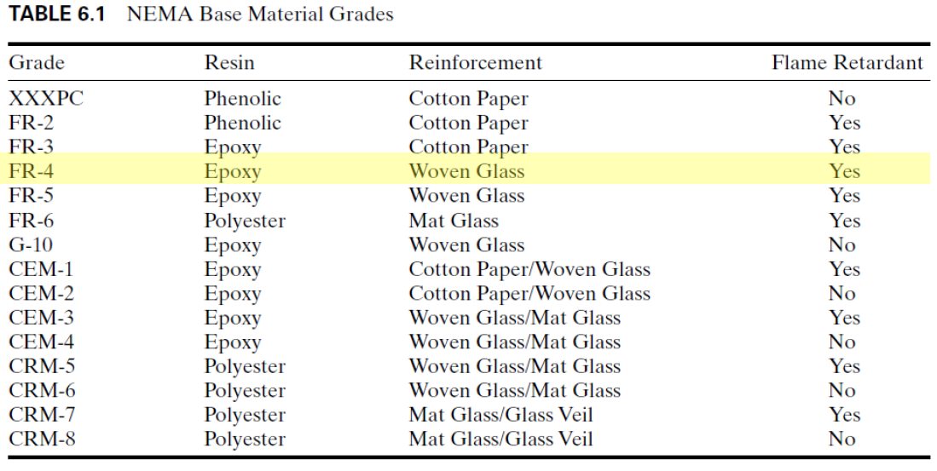

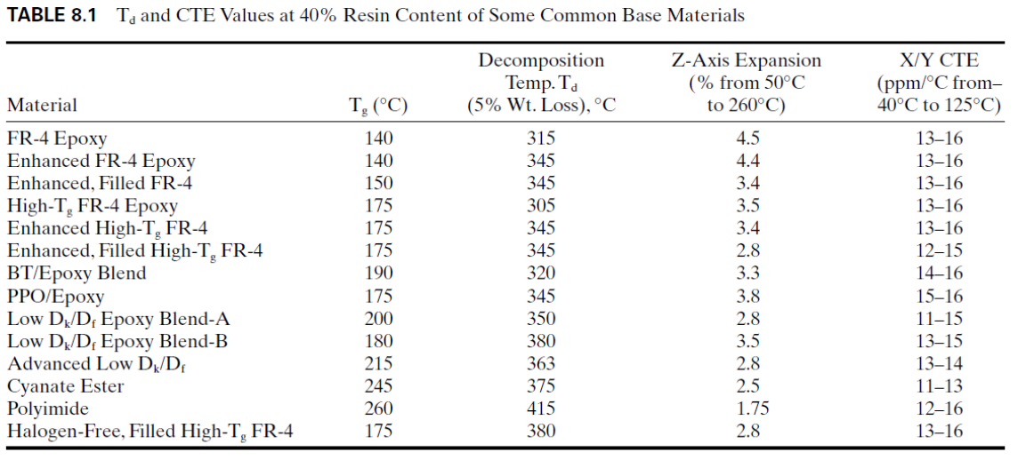

* 1. **Laminates and FR4**

**laminate** 🡪 the starting material for printed wiring boards. It consists of many laminated layers of binder and reinforcement. Common binders are

* Epoxy
* phenolic (for low price consumer products with low requirements on reliability)
* polyimide and other materials (for high performance and demanding applications)

Common forms of reinforcement are

* woven glass fibres and paper for low price laminates.
* Quartz and aramid (Kevlar) are used to a limited extent, they are costly and difficult to processes of

conventional printed wiring board materials.

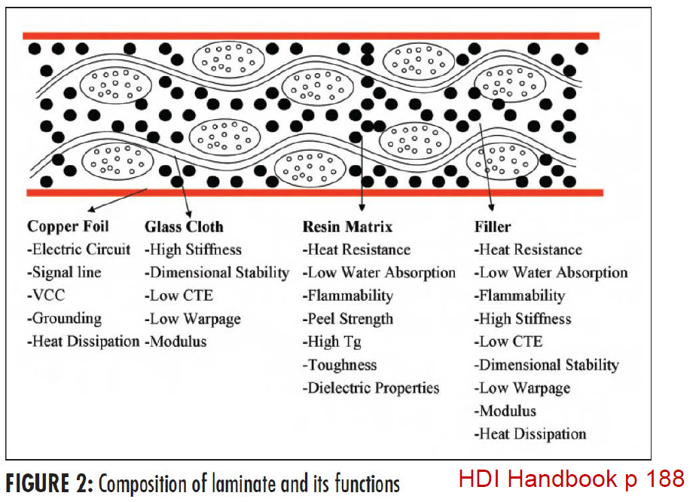

Today, glass/epoxy laminates are the most common; particularly the type that is designated **FR-4**.

**FR means Flame Retardant 🡪 FR4** is the most widely used starting point for PCBs.FR4 consists of a woven glass fibre mesh soaked in organic polymer (epoxy) with copper layers laminated –possibly with filler material (similar to steel-enforced concrete).

OTHER USEFUL CONCEPTS:

**Organic substrates**: Substrates where organic polymers are binders

**Prepreg**: The laminate before copper is added and before final curing of laminate

For more pieces of information regarding these two aspects, see LECTURE NOTES pdf. The professor didn’t mention all of these concepts during the lecture, anyway.

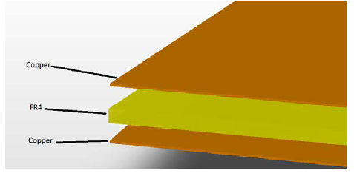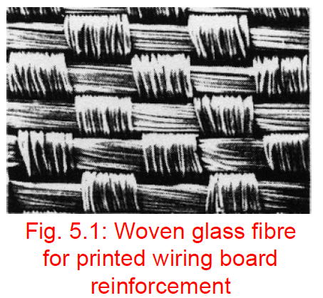

* 1. **Conventional manufacturing process for PCB laminates**

The overall conventional manufacturing process is illustrated in the figure 🡪 subdivided into two processes:

* prepreg manufacturing: Prepreg is also called B-stage or bonding sheets
* laminate manufacturing: laminate is sometimes called C-stage.

The terms B-stage and C-stage refer to the degree to which the resin system is polymerized or cured. B-stage refers to a state of partial cure. B-stage is designed to melt and continue polymerizing when it is exposed to sufficient temperatures. C-stage refers to a state of “full” cure (typically we never realize full cure, in the sense that not all reactive sites on the resin molecules have cross-linked; however, we use the term full cure to mean that the overwhelming majority of such sites have reacted and additional exposure to temperature will do little to advance the state of cure).

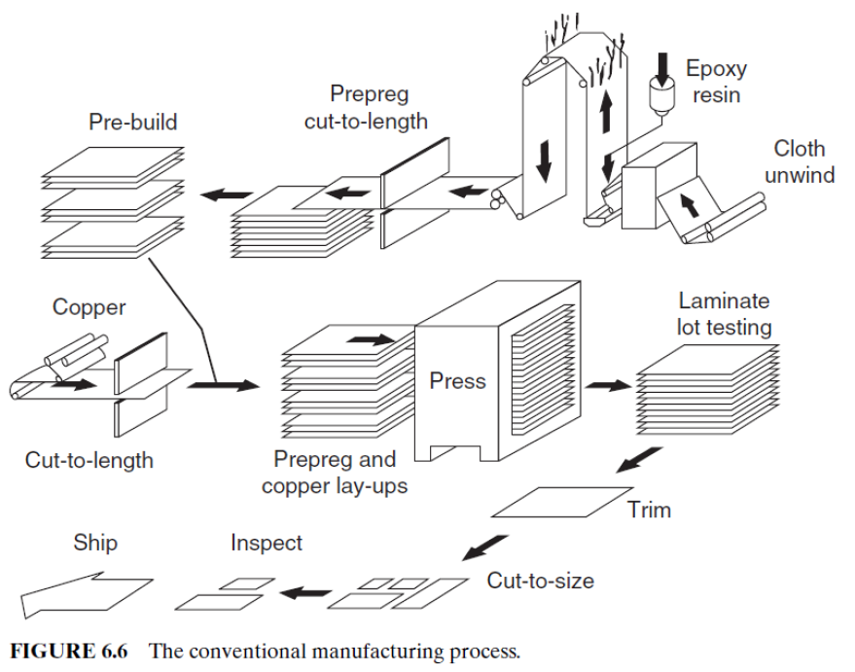

* + 1. **Prepreg manufacturing**

The first step involves coating a resin system onto the chosen reinforcement, most commonly a woven fiberglass cloth. Rolls of fiberglass cloth or alternative reinforcement type are run through equipment called treaters. Next the cloth is pulled through a series of heating zones. These heating zones commonly utilize forced air convection, infrared heating, or a combination of the two. In the first set of zones, solvent used to carry the resin system components is evaporated off. Subsequent zones are dedicated to partially curing the resin system, or B-staging the resin. Finally, the prepreg is then rewound into rolls or cut into sheets.

Because the resin system at this point is only partially cured, prepregs must typically be stored in temperature- and humidity-controlled environments.

* + 1. **Laminate manufacturing**

The process of copper clad laminate manufacturing begins with the prepreg material. Prepregs of certain fiberglass cloth styles and specific resin contents are combined with the desired copper foils to make the finished laminate. First, the prepregs and copper foils are sheeted to the desired size. These materials are then laid up in the proper sequence to produce the desired copper clad laminate.

Process controls in the lamination/pressing process are also critical. Cleanliness in the manufacturing environment and cleanliness of the steel separator plates are critical in achieving good surface quality and in avoiding embedded foreign material within the laminate. Control of the temperature rise during lamination, control of the cooldown rate, the length of time that the laminate is above the temperature required to initiate the curing reaction, how much this temperature is exceeded are all important factors.

* 1. **PBB production 🡪 after laminate**

Once that the laminate has been produces, we proceed with the realization of the final PCB: here we report some examples of the final result and then we analyse every step of the process.

In figure 1 we see several examples of

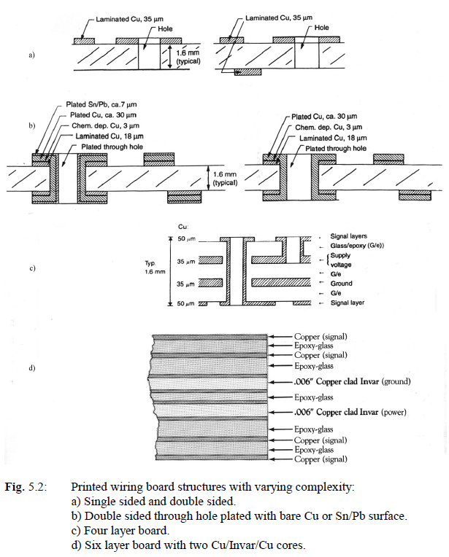

Multilayer PCBs are becoming more and more common and diffused: in the second figure we can see a cross section of 14-layer multilayer printed wiring board, showing a typical inner layer and prepreg material relationship. In this case, to reduce z-axis expansion, the innerlayers are polyimide, while the prepreg material is semicured polyimide.Typical signal, power, and ground layers are also indicated, as well as the thickness of the copper foil for each layer.

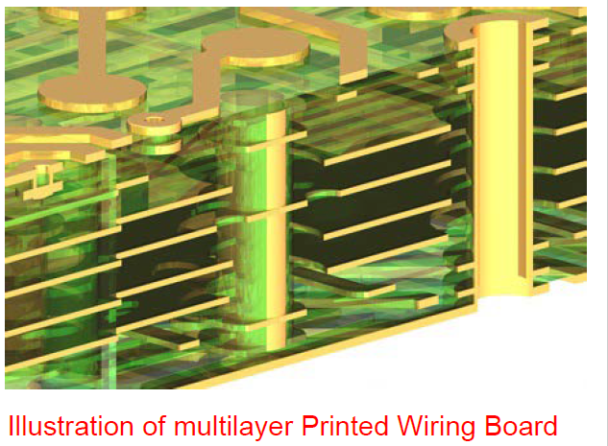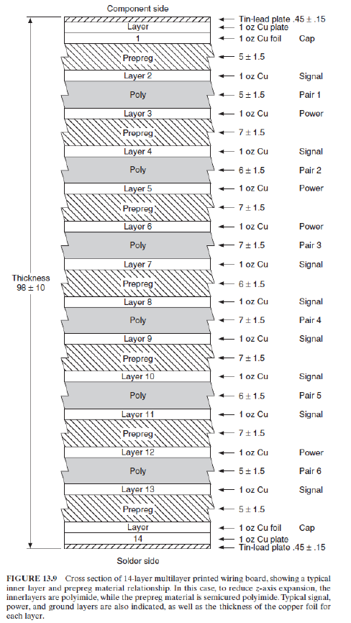

* + 1. **Schematics and photo-plotter**

The wiring board design, from net list and schematics to conductor pattern layout is normally made on a **computer assisted design system** (CAD), where detailed component information is stored, including geometrical information about the solder lands for each type of component. The CAD system also has stored information about minimum conductor distances, minimum conductor width and other design rules, and it gives a warning if the designer attempts to break these rules. The designer enters net list and component placement into the CAD system, he generates the circuit diagram, performs simulation and routing of the conductor pattern. The routing may to a large extent be done automatically, but the designer can choose to specify critical paths manually.

The information in the CAD system is post-processed to a format suitable for the further processing, which is **photo- or laser plotting**. One also obtains information for numerically controlled drilling and milling machines that are needed for production of the wiring board, pick-and-place machines, testing and test fixtures, component listing for purchase, drawings and other documentation.

The film that is to be plotted in the photo plotter, lies on moveable a table, which can be moved in the x- and y-direction, controlled by the data from the CAD system. A light source illuminates the film over a small area at a time, through a so-called plot wheel. The wheel has openings of different sizes, so it is possible to choose the size of the film area that is illuminated at any time. We can illuminate lines with constant width by moving the x-y table while the light goes through a particular opening. The width of the conductor can be changed by rotation of the wheel, bringing a different opening into position. A single flash illuminates a circular area, and areas of complex form are made by moving the table back and forth and "paint" with a small light spot. The whole illumination process is done automatically. Then the film is developed.

The laser plotter is on its way to take over from the photo plotter. In the laser plotter a laser beam sweeps across the film, line by line, while it is turned on and off depending on whether the points on the line are to be blackened on the film or not.

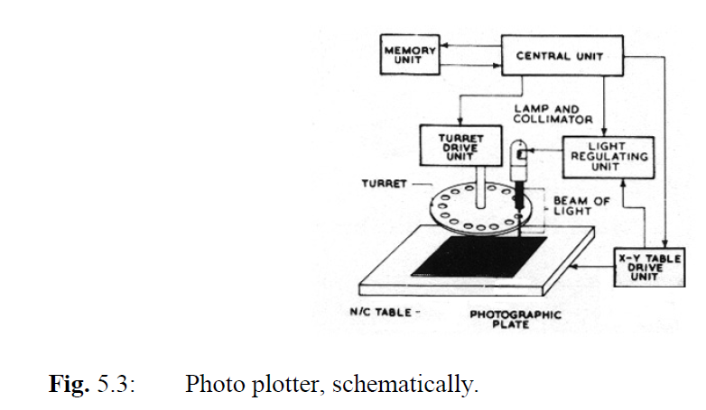

* + 1. **Single-sided wiring board production**

The simplest way to define the conductor pattern on single sided wiring boards is the so called **print and etch process**.

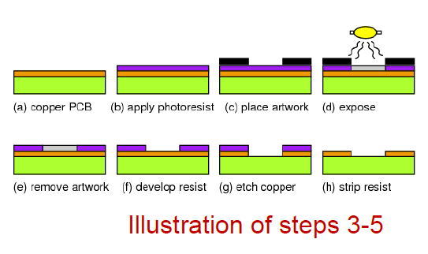

We start with a laminate of paper/phenolic, glass/epoxy or a mixture. After cutting to suitable standard sizes, the main steps of the "print and etch" processes are as follows:

1. Drilling or punching of registration holes.
2. Panel cleaning: Mechanical brushing or chemical rinse (light etch) to remove oxide, grease etc.
3. Printing of etch resist: An organic material that is resistant to the etch bath for the subsequent etching process is screen printed on to the surface through a printing mask with the correct conductor pattern. The etch resist is cured at elevated temperature or with UV illumination.
4. Etching: This takes place by dipping the panel into an etch bath, or using an etching machine that sprays etchant uniformly over the whole surface, until all copper has been dissolved where it is not covered by etch resist. Common etchants are solutions of CuCl2 or FeCl3. Then the panel is rinsed.
5. Stripping: The etch resist is dissolved in a suitable solvent.
6. Printing of solder resist: An electrically insulating, organic layer (for example an epoxy), is screen printed on top of the conductor pattern, with openings for the solder lands and hole pads for the component holes.
7. Curing of the solder resist, in heat or in UV light, to evaporate the solvents and increase the resistance to chemicals and thermal and electrical stress.
8. Cleaning of the copper solder areas: At this stage of the process, the copper is oxidised, and the panel is exposed to a mild micro etch with subsequent cleaning, to get good solderability.
9. Deposition of solder coating: To avoid oxidation of the copper and to protect the solderability during storage, a thin solderable layer (about 1 μm thick) of organic material is often deposited by dipping or by roller coating.
10. Punching of holes and edge contour, or drilling/milling: Paper/phenolic and certain other materials can be punched, which is the most efficient method at high production volumes. Glass/epoxy will quickly damage the punching tool, therefore holes are instead drilled and the edge contour is milled by numerically controlled drilling and milling machines.

This is a subtractive process. That means that the conductor pattern on the boards is defined by removing material (etching of the copper).

There are several modifications of this process, e.g. to fabricate narrow and complex conductor patterns the pattern is defined photographically 🡪 A photo sensitive dry film resist is laminated on to the panel. It is negative, meaning that after illumination the non-illuminated parts of the resist are removed. The panel is illuminated through a negative film, meaning that the conductor pattern on the film is transparent, while the rest is black. The dry film remaining after development serves as an etch mask.

A third alternative for etch resist is to use plated metal instead of organic material, and in this case tin/lead is selectively plated.

* + 1. **Production steps for 4-layer PCB**

**Process description based on the production of eutectic tin-lead solder. This is not according to industry standards, but illustrates the principles and the way the project prototypes are manufactured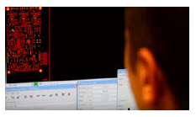.**

**PREPARATION**

* Front end tooldata preparation
  + PreparetheCAD files to produce Gerber production files
* Preparing the phototools:
  + Photoplotter: creates films to be used during photoprocesses
  + 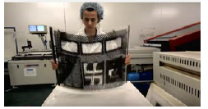Add registration holes to align different films and substrate layers

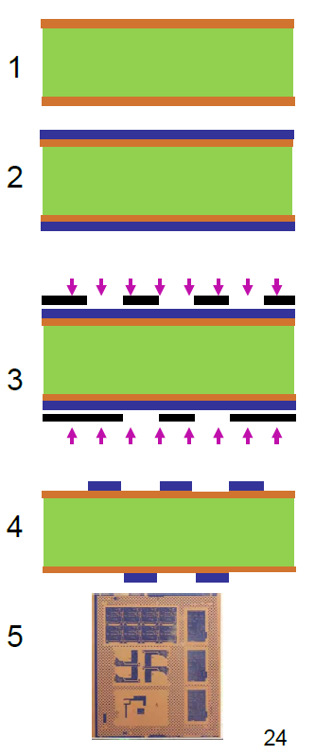

**PRINT INNER LAYERS**

* Clean the copper-laminated prepregs
* Coating of photoresist (both sides)
* Expose the laminated prepreg to UV light through a photomaks
* Spray with alkaline material to remove unhardened resist. Afterwards, pressure wash and drying of the panels
* End result: copper we want is covered by the hardened photoresist

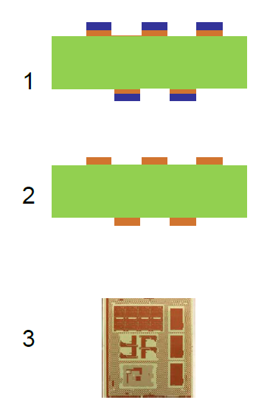

**ETCH INNER LAYERS**

* put panels in a powerful alkaline solution to etch away the exposed copper
* strip of the hardened photoresist
* end result: copper pattern we want is established on inner layer panels

**HOW COPPER ETCHING OCCURS IN AN ALKALINE SOLUTION?**

The process is usually done in iron chloride solutions in a two-steps redox reaction to copper(I) chloride and then to copper(II) chloride in the production of printed circuit boards.

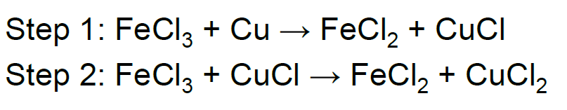

Here CuCl2 is dissolved in the etchant solution.

**PUNCH OF REGISTRATION HOLES AND OPTICAL INSPECTION**

* Punch registration holes in panel corners to allow alignment with other panels
* 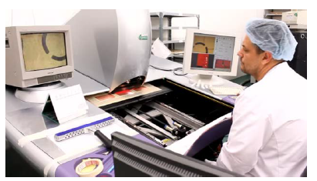Inspect the panel to ensure that it is according to the objectives (this is the last chance to fix failures before the panel is sandwiched with other panels)

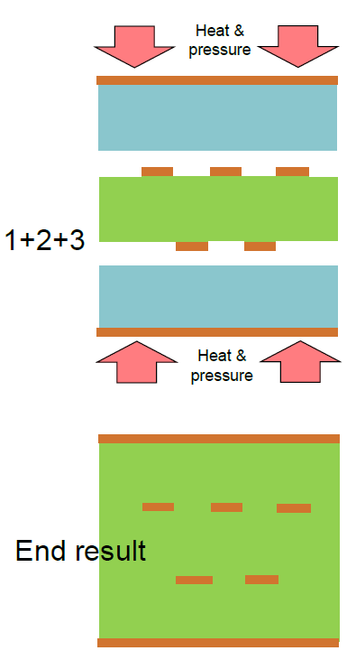

**LAY-UP AND BONDING OF INNER AND OUTER LAYERS**

* Outer layer consists of sheets glass cloth impregnated with uncured epoxy (prepreg) and a thin copper foil
* Stack foils in press
* Heat and pressure join the sheets and hardens the prepreg to form a lasting 4-layer PCB with copper on outer layers

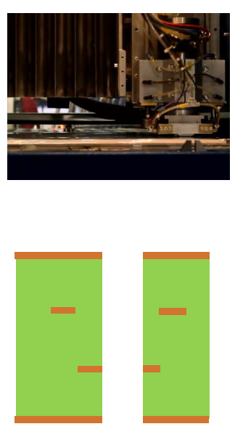

**DRILLING THE PCB**

* Drill holes for hole-thru components and for holes linking the different conductor layers together
* Drill registration holes (use x-ray imaging to align with inner layers)
* High speed drilling, but drilling is a slow process (you can do one hole per time). The minimum hole size is 100um
* Excess material squeezed to the outer parts of the panel are cut away
* Panel is now ready for plating

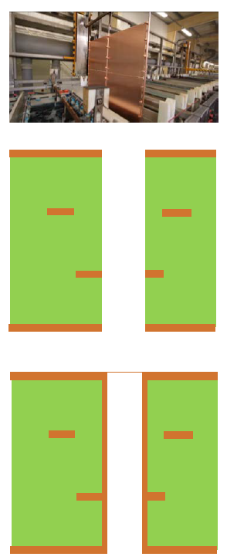

**ELECTROLESS COPPER DEPOSITION**

Need to deposit around 25um thickness of copper inside the holes. We have two main alternatives: pattern plating and panel plating (see discussion below). Here we’ll describe panel plating. We start by electroless process to make the hole conductive

* Electroless copper deposition process
  + Pretreat the panel
  + Seed with palladium particles
  + Rinse
  + Electroless copper deposition (around 1um)

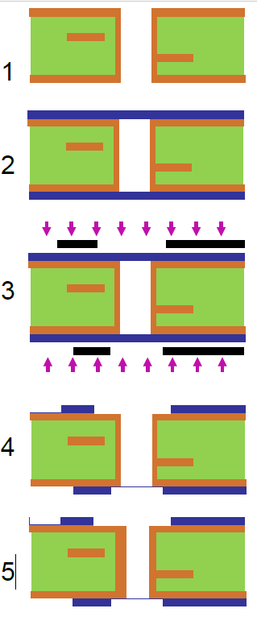

**IMAGE THE OUTER LAYERS**

* Starting point: plated 4-layer panels with holes
* Deposit photosensitive film (hot roll process)
* Expose photosensitive film to UV light through photomask
* Remove unhardened photosensitive material
* Electroplating the board with copper
  + Place in electrolyte that contains Cu2+ ions, for example CuSO4 dissolved in H2SO4
  + Add bias to panels to drive Cu2+ ions to the panels
  + Deposit electroplated copper to reach 25um
  + Rinse
* End result: 25um copper thickness in the holes

Pay attention: this process also puts copper on exposed panels

**ELECTROPLATING: REMINDER**

Once the entire surface is coated by electroless copper, it is possible to do electroplating: The panels are biased in a bath containing dissolved CuSO4 (Cu2+ and SO4(2-) ions). The Cu2+ ions are driven towards the conductive panels due to the electrical bias.

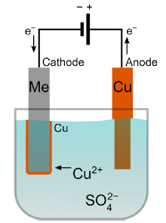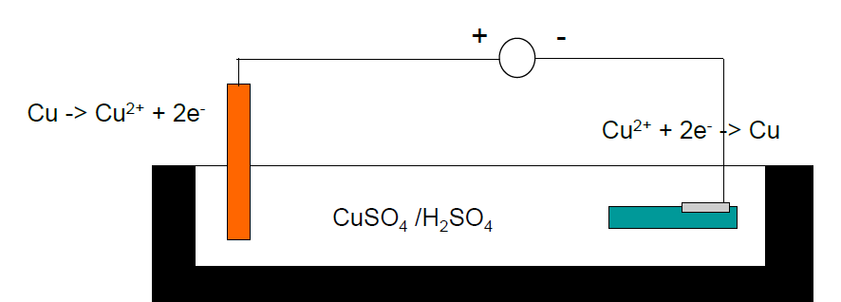

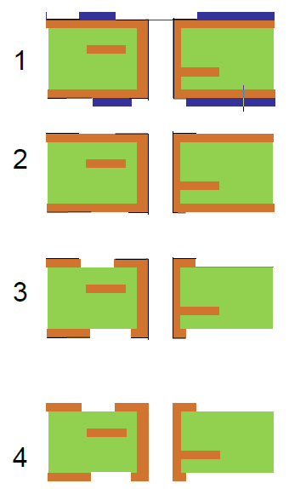

**ETCH THE OUTER LAYER**

* cover with tin as etch resist
* dissolve and wash away the photosensitive film
* etch exposed copper (not covered by tin) in an alkaline solution
* The tin/lead layer serves two purposes: It is both an etch mask and it makes a durable, solderable surface.
* If one wishes clean copper surface on the completed boards, in this step the Sn/Pb is removed.
* end result: 25 um copper thickness in holes + exposed copper in track and vias, unwanted copper removed

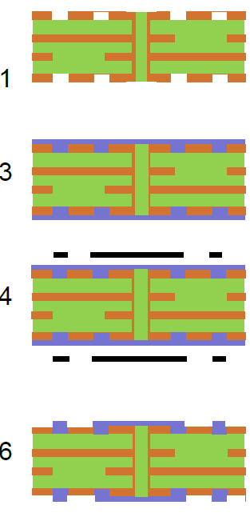

**APPLY SOLDER MASK**

Most PCBs have an epoxy solder ink mask applied to prevent the solder circuit and to prevent short-circuiting during assembly

Solder mask is the green part in a classical PCB

* Panels are cleaned and brushed
* A photo-sensitive epoxy solder mask ink is applied
* Dry the solder mask ink sufficiently to allow it to be printed (photo processed)
* Coated panels are imaged. UV lamps harden the solder mask where the mask is clear. (in the drawing it seems the contrary) This is where the solder mask is needed.
* Unhardened solder mask is dissolved and washed away.
* The solder masks are hardened further in a conveyerized oven
* In figure below we have a pcb without and with the solder mask.

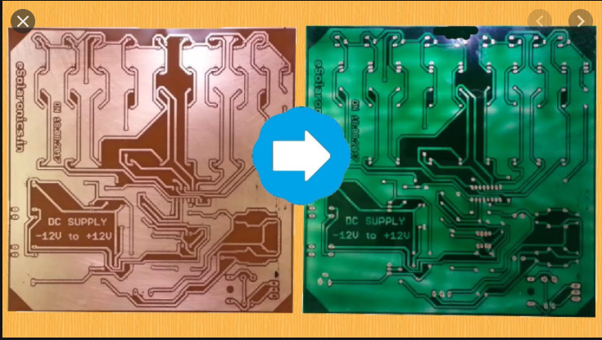

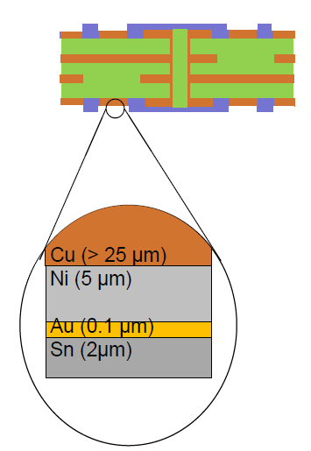

**ELECTROLESS GOLD OVER NICKEL COATING**

A surface coating is added on the exposed copper surface to ensure solderability and durability of the metal pads

* Electroless nickel deposition (5um) on exposed copper surfaces
* Electroless gold deposition (0.1um) on nickel/copper surfaces
* Deposition of tin: panels are dipped in molten tin. When removed, hot air flow is used to blow off excess tin (see figures at the end of the paragraph). A thin layer of tin (2um) remains on all surfaces that are not covered with solder masks.

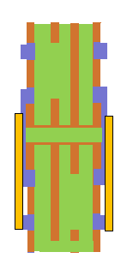

**HARD ELECTROPLATED GOLD FOR EDGE CONNECTORS**

Edge connectors that will be inserted and removed multiple times need hard gold protection of pads. There are electroplated with only the edge of the PCB lowered into the plating bath.

Approximately 2um of gold is applied.

Other parts are protected by a tape during the process. Tape is peeled off after the process is completed.

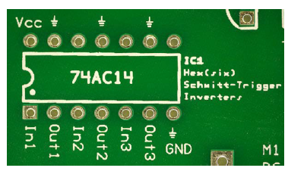

**SILK SCREENING (SERIGRAFIA, STAMPA STERIGRAFICA)**

The silk screen is used to define legends to the different components. This is done using ink jet printing. Often the ink jet printing is cured together with the final curing of the solder mask.

**FINAL ELECTRICAL TESTING, PROFILING AND PACKAGING**

* Logical testing that the different conductive paths are connected where required and non-conductive elsewhere
* Following the successful electrical test, the panels are cut into the target size PCBs using a milling machine or a V-cutter
* Final optical inspection
* Wrapping and boxing of the finished boards ready to be shipped to customers

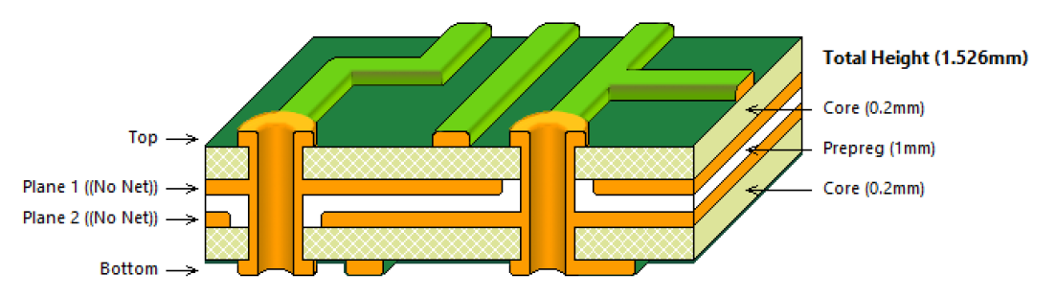

**PANEL PLATING AND PATTERN PLATING**

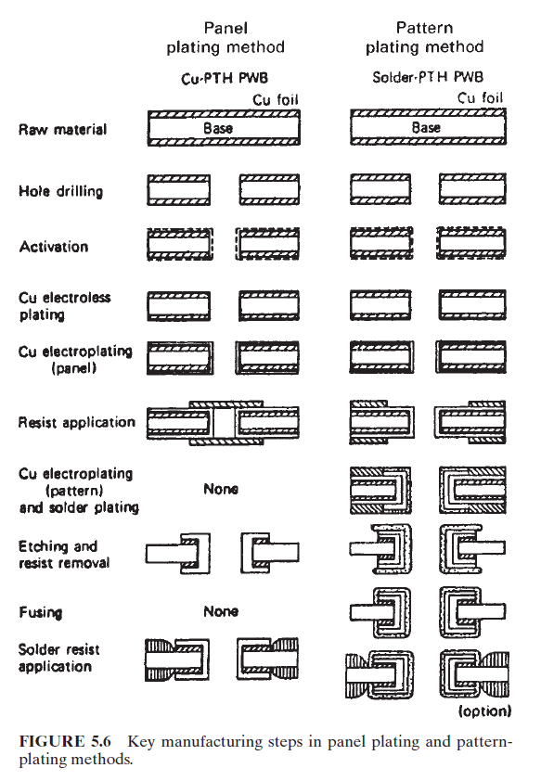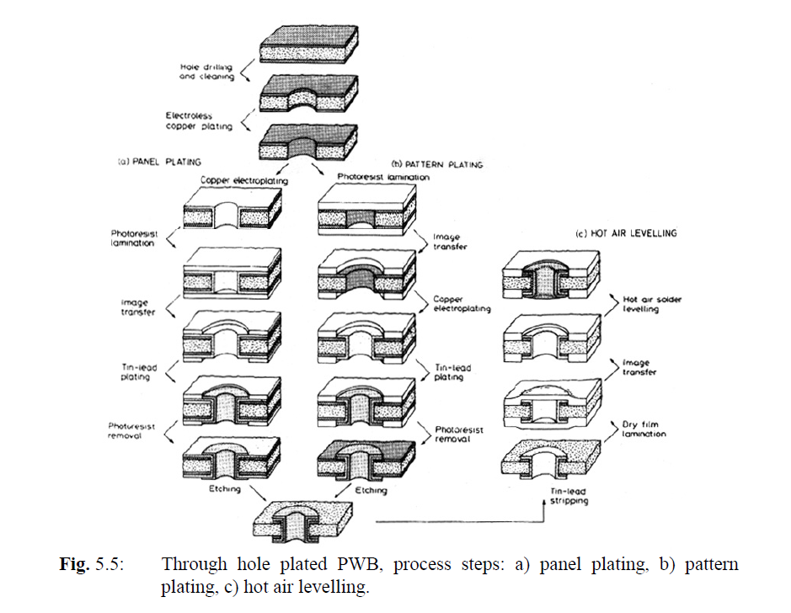These are two alternatives for plating and defining the copper pattern for both the vias and the circuit on the board surface. We can see the main differences in the pictures

**SUMMARY OF THE MAIN DIFFERENCES BETWEEN PANEL AND PATTERN PLATING**

**Panel plating:**

-All surfaces are electroplated

-This requires considerable power

-Afterwards, you often end up etching a lot of the plated copper away again

**Pattern plating:**

-Masking off areas where plating is not needed gives reduced surface area

-Less copper consumed and less copper needed to be removed in subsequent etching

-Increased complexity because you need to tin plate surface prior to etching

PANEL PLATING: in the picture above the pattern of the circuit is not included, so this could generate some misunderstandings in the reader if one tries to compare with the process described in the paragraphs above.

In any case, the main message is that when we want to cover a via with copper we can cover the whole PCB with copper (as described above) and then define the path through some photoresist. One then puts some tin where the copper has to be kept and etches away all the rest. This can lead to some wase of copper, since a 25um layer is present everywhere and only some of it has to be kept. In this process, the vias are covered (tappate) with tin, since the copper there has to be preserved from etching.

PATTERN PLATING: here only the pattern and the vias are covered with copper, so in principle there is less waste. Copper is put only where needed. One starts with a thin layer of copper everywhere, covers it with photoresist and then defines where the thicker copper needs to be. The copper layer will be deposited where the photoresist is no more present. Then it is covered with the solder resist and everything that is not covered with it (namely the photoresist) is etched away. Then one proceeds with the etch of the lower layer of copper, which now is limited to a few um, since not all the surface of the pcb has been covered with electroplating. This is the dominating process today.

Selective tin/lead deposition or "hot air/hot oil levelling"🡪 In this process the panels with bare Cu, and solder resist deposited, are dipped in to a bath of molten solder alloy, so that tin/lead wets all copper areas that are exposed. The hot, strong air (or oil) stream blows off superfluous tin/lead on the surface and in the holes, so only a layer 20–100 μm remains. Normally this is considered the best type of surface metallisation.

**DIFFERENT HOLE AND VIAS TYPES**

**"Buried via holes" are plated holes that connect inner layers, without appearing at the surface**. Such holes occupy space only on the layers where they have the electrical function to connect neighbouring layers. However, making them require that the inner panels are processed as complete double layer through hole plated boards before the lamination process. The completed boards will be denser, but more expensive.

**"Blind via holes"** connect an outer layer to an inner layer. They may be made with precise laser- or regular drilling after the lamination has been carried out.

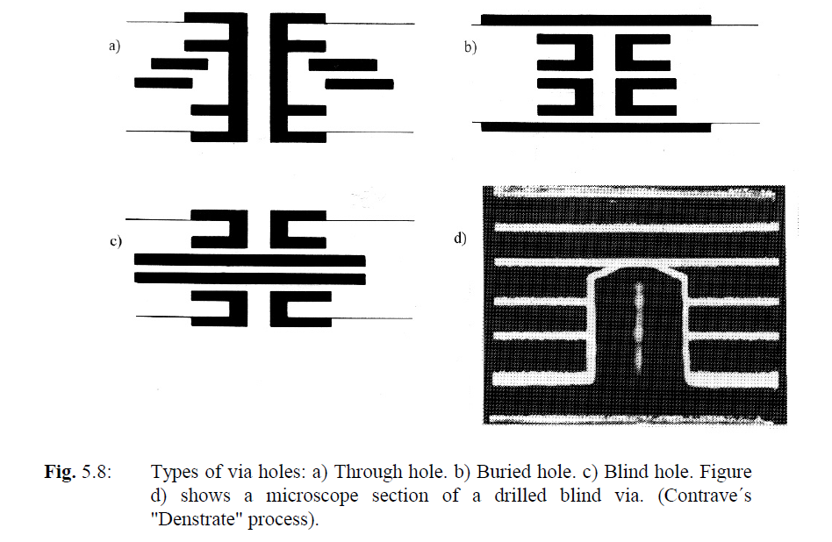

**UNDESIRED EFFECT: UNDERETCHING**

By etching of copper foil we get an undesirable lateral etching at the same time as the etch dissolves copper downwards. This is called **underetch.**

The degree of underetch may be defined by an etch factor Ef:

$$E_{F}=\frac{A}{T}$$

where A = sideways etching and T = the thickness of the copper foil. In practice Ef is between 0.7 and 3, the lower the better.

There is always some uncertainty in the etching speed of the bath. Therefore, we need to use a longer etching time than the ideal time to be sure to etch through the thickness of the foil. This gives an increased underetch. To some extend it can be compensated for by designing the conductors somewhat wider than what we need in the completed wiring board. Control of the conductor width is important: With too much underetch we get, in the worst case, a discontinuity of the conductor. If the conductor is too narrow, the conductor resistance increases and the maximum current carrying capacity of the conductor is reduced 🡪 For high frequency circuits with constant characteristic impedance, the conductor width is one of the dimensions that determines the impedance. Variations in the conductor width on the wiring board therefore will give variations in impedance and poor high frequency performance of the circuit.

These factors limit how narrow conductors we can make in a subtractive process, particularly when the foil is thick. To make the conductors narrower, the foil that is to be etched must be thinner, or a fully additive technique must be used.

**METAL CORE PCBs**

For surface mounted printed circuit boards with large leadless chip carrier packages we need thermal compatibility, meaning nearly the same thermal coefficient of expansion (TCE) for substrate and component 🡪 This can be obtained by one or two metal cores in the wiring board, composed of a combination of metals with low TCE: **"metal core boards"**.

The most common metal core combination is a **copper/Invar/copper** structure 🡪 By choosing the thickness of each layer of the laminate correctly, one may "design in" the desired TCE for the complete wiring board.

Due to the temperature variation of the properties of the materials and due to standardisation of the thicknesses available, the match will not be ideal, but it will be good enough even for very demanding requirements.

Another advantage of the metal core board is that the thick metal gives excellent **thermal conductivity** and effectively spreads the heat away from components with high power dissipation.

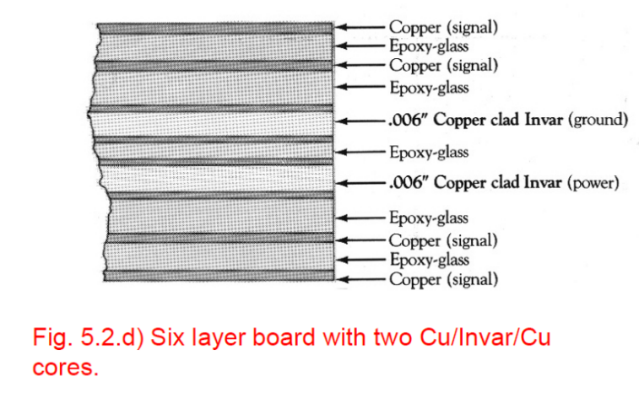The boards will however be **much more costly** than ordinary FR-4 boards (typically 4 - 5 times price difference).

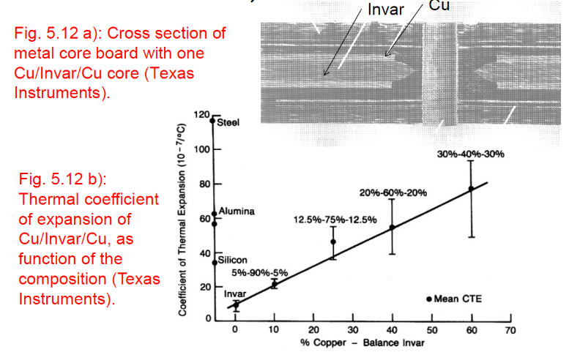

**FLEXIBLE WIRING BOARDS**

Flexible wiring boards are used in products that are moveable during use (dynamic): Disk drives for computers, printers, etc., or static, where the board is bent in the right shape and remains in this position during operation. Flexible PWBs are made primarily from polyester and polyimide.

* The thickness of the polyimide layer may be 0.05 - 0.2 mm
* the substrates may have single sided or double-sided conductor pattern, possibly with through hole plated via holes. Multilayer structures are also made.
* The combination of flexible parts and rigid parts, "flexi-rigid" is common (second figure below). The rigid parts may be passive stiffeners without conductor pattern, or they may be laminated together with a flexible part.

The processing of flexible boards (first figure below) is similar to that of rigid boards. An adhesive layer of epoxy or acrylic is used between the polyimide and the copper foil in order to let this adhere to the substrate. Printing, photo processing, plating and etching takes place from roll to roll 🡪 the process takes place while the film moves through the machines and the process baths.

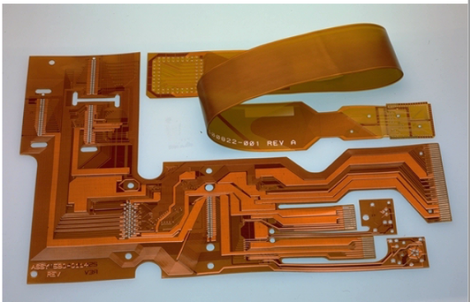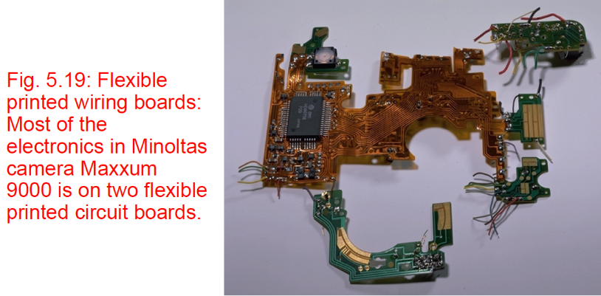

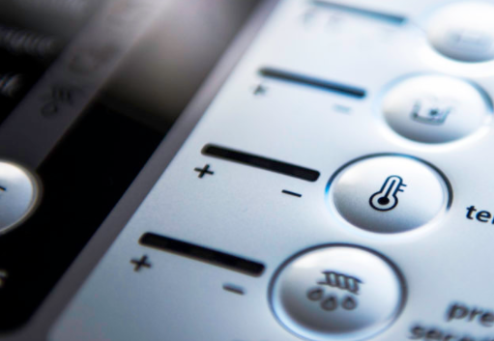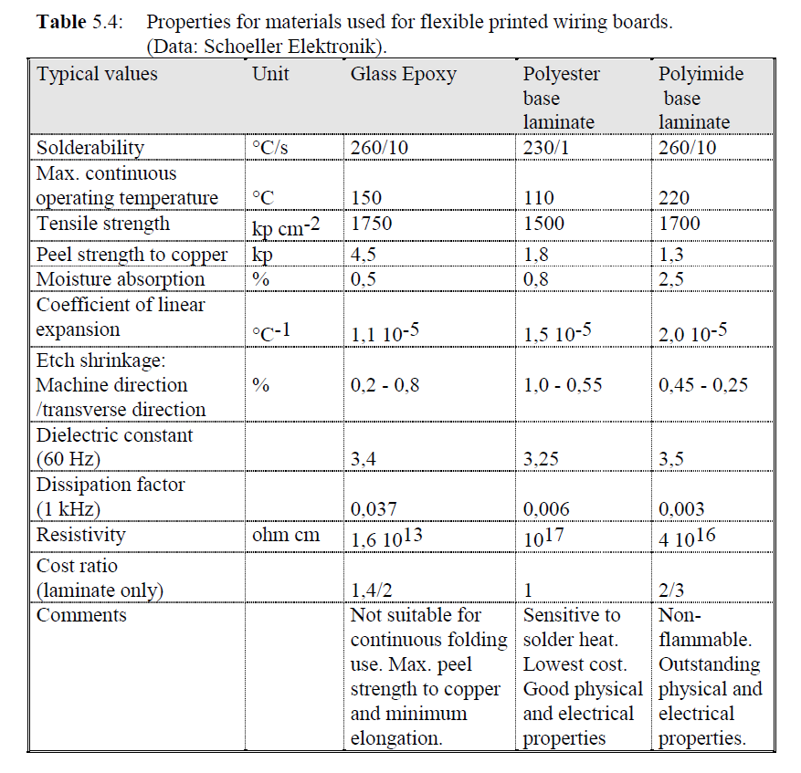

**MEMBRANE SWITCH PANEL**

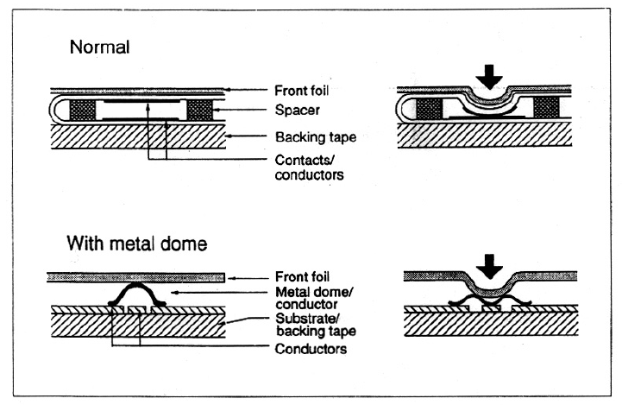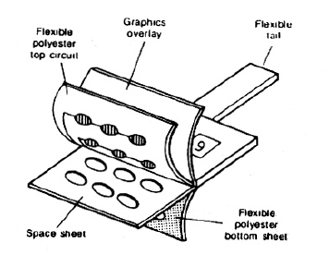All the switching elements are defined on plastic foil (normally polyester) by screen printing of the conductor patterns. The two contact points in each switching element are kept apart by a spacer layer. When the contact is pressed, the two parts touch and give a short circuit.

* 1. **HOW TO CONSTRUCT AND ASSEMBLE PCBs THAT WORK**

Designers are key personnel in the development of electronic products, but is not the only player, and must work in intimate cooperation with:

* Sales, marketing and customers
* Subcontractors
* Production process experts
* Cost engineers
* Logistics and purchasing staff
* etc.

And a product's success relies first of all on its **ability to meet end user needs!**

One of the main instruments used to project and design a PCB is a CAD tool electronics design: softwares such as CadStar contain pieces of information about components, materials, dimensions, specifics, schematics, routing, simulations and many more features. They are ESSENTIAL for nowadays production processes!

When a final product is reached, one has often to face with problems. They may not be immediately individuated 🡪 knowing the target specifications is a good starting point. One check whether all the specifics have been fulfilled and possibly finds any problem related to them.

Before the production, once that the target specifications have been announced, one makes some choices:

* best suited technology
* appropriate components (balance reliability, costs, performance…)
* build a well chosen design for production, testability, repairability
  1. **LARGE SCALE AUTOMATED PRODUCTION**

See video for an example: <https://www.youtube.com/watch?v=2qk5vxWY46A>

* + 1. **PLACING**

**THRU-HOLE COMPONENTS**

We can distinguish between axial, radial and DIP components:

* Axial components: delivered on a tape, from which we generate a new one in which the components are placed in the order that makes the subsequent placement optimized. Then it starts over, mounting the same series of components for the next board. The sorting of the components is made at a speed of approximately 5000 components per hour. Then the new tape is put in the actual mounting machine 🡪 includes cutting the component out of the tape, forming the leads to fit in board holes, mount, and then cut and clinch the leads to avoid that the component falls out during handling (see figure).

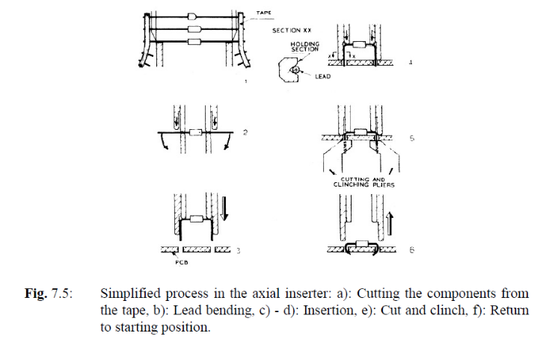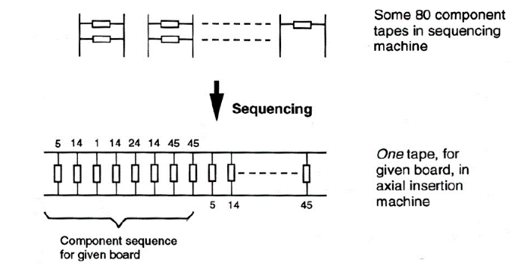

* Radial components: sequencing is not used. The machine for radial insertion will often have stored the tapes with all components needed, and a transport mechanism bringing each component from tape position to insertion position.
* DIP ICs: they are normally delivered in plastic tubes, sticks, which are stored in a separate DIP inserter. The holder of the tubes moves back and forth, to place the right stick in position for mounting. At the same time, the PCB is moved to get the location of the component in the right place underneath.
* Manual semi-automated mounting: for prototyping hand mounting is still used. The operator is helped in the placement by a computer which highlights the spot in which a selected component has to be placed.

**SURFACE MOUNTED COMPONENTS**

When the SMDs are wave soldered, they must be fastened in advance by an adhesive. There are three main methods of applying the adhesive:

* Screen printing: Screen printing of adhesive is done in a manner similar to printing of solder paste 🡪 0.5 mm thick Teflon stencil is used. Bigger holes for bigger and heavier components. A paste is then put on the stencil and squeezed on all the surface. Only the holes will let it pass through, where the components will then be placed. This way of adhesive application is efficient, as all adhesive dots are placed simultaneously. However, the board surface must be plain, and this process must be done before any component is mounted.
* Application by dispenser: you just use a sort of syringe to put the adhesive to the board. This is the most used method
* Pin transfer: Pin transfer consists of a pin that is first dipped into a pot of adhesive, then touching the board and leaving an adhesive dot at the point where the component will be mounted. Pin transfer is suited for very high-volume production. In that case, a jig is made with a matrix of pins in the positions of all components to be glued. The jig is lowered into a big pot of glue and all adhesive dots are then deposited simultaneously.

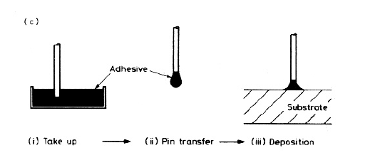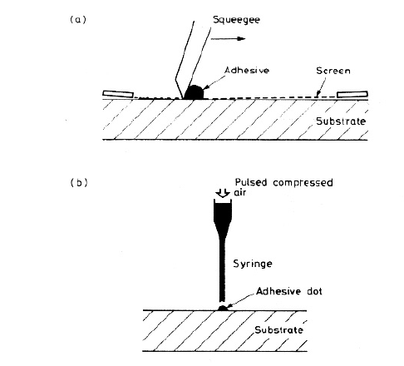

The demands on the adhesive and the gluing process are high:

* The adhesive must not flow onto the solder pads, otherwise the solderability is ruined.
* It must wet the component well and immediately hold the component sufficiently well for the handling necessary until curing of the adhesive.
* It must have a long shelf life with stable viscosity, yet cure fast for a high-volume production.
* Viscosity and rheology must be stable, assuring reproducible amounts of deposited adhesive.
* When repair is needed, the adhesive must soften during the repair processing.

The adhesives can be cured in 2 ways: by using heat or UV light.

* Heat curing often takes place in an IR in-line furnace, of the type used for IR reflow soldering. Typical curing conditions are 150 °C for 1 - 2 min.
* UV curing takes place in an in-line equipment, containing a powerful UV lamp. For UV curing to be possible, parts of the adhesive dots must "see" the UV light. The curing takes only a few seconds.

The application of these adhesives is only for keeping components in place before soldering through reflow or wave soldering. Their purpose is not of constituting the contacts between ICs and the copper pattern on the board 🡪 for this we’ll discuss isotropic and anisotropic conducting adhesives.

* + 1. **CONNECTING THE COMPONENT TO THE CIRCUIT: SOLDERING AND CONDUCTING ADHESIVES**

**WAVE SOLDERING**

IN SYNTHESIS:

* Apply adhesive by dispenser, screen printing or pin transfer
* Cure by heat or UV
* Turn board
* Wave solder
* Double-wave soldering machine common for SMT
* Not all SMD components suitable for wave soldering

MORE IN DETAIL:

A conveyor transports the PCB through the machine. First, the board will pass through a fluxing unit, where solder flux is applied to dissolve oxides and improve wetting and solderability. The flux contains alcohol or another solvent to give the right viscosity. Then the board passes over a preheating zone where the board is heated by a hot metal plate underneath through radiation and convection, to approximately 100°C. The purpose of this is:

* To activate the chemically active parts of the flux (chlorine is dissociated from the organic component of the flux)
* To evaporate the chemically inactive solvents
* To heat the board slowly to avoid thermal shock in the subsequent solder bath.

After the preheating the board goes through the solder zone, passing a wave of molten solder. The solder is normally close to a eutectic composition of tin and lead, 63 % / 37 % by weight. A typical solder bath temperature is 230 - 250 °C.

The solder is located in a container. A pump forces it up through a slit, forming a wave at right angle to the motion of the board. The shape of the wave is important for the solder quality, and so is the speed of board motion, the contact time and the solder temperature. The solder is also pulled up into the component

holes by capillary forces.

For thru-hole components it is sufficient to solder the components to the board, no adhesive is needed to hold them in place since they are already kept steady by their own pins. For SMD components on the contrary one needs the adhesives to keep them in place.

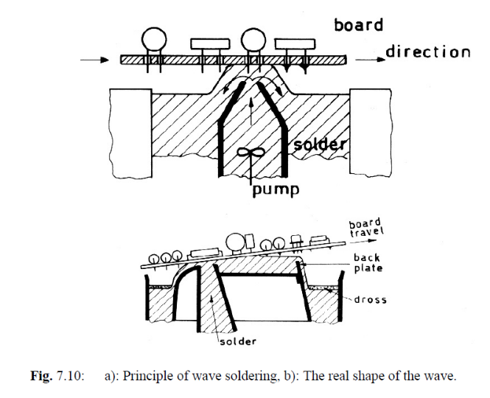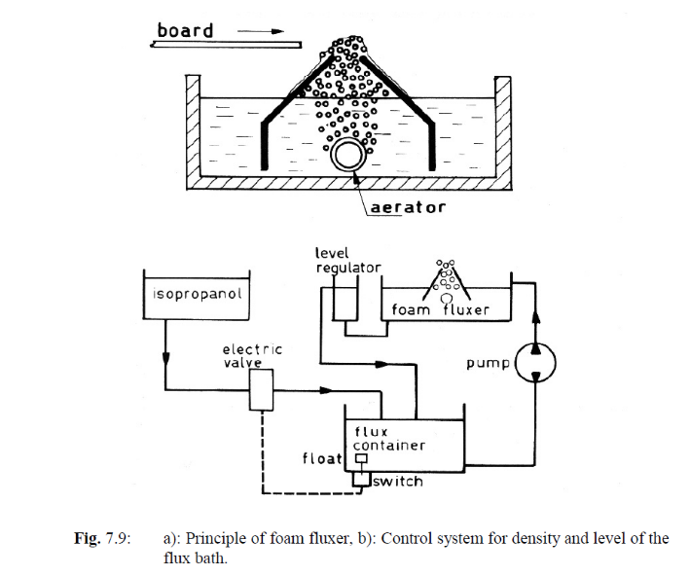

MAIN PROBLEMS:

* The component bodies cast shadows for themselves (si fanno ombra da soli) and their neighbours 🡪 many machines have two waves: the first is a turbulent wave, reaching and wetting all corners and crevasses, but, it will create solder bridges. The second, called the "lambda wave", is a gentle wave that removes the superfluous solder.

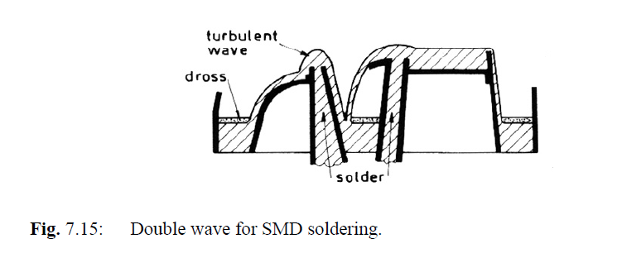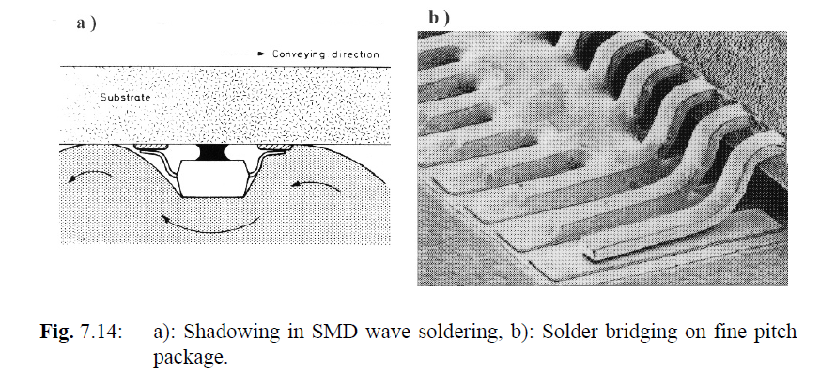

* 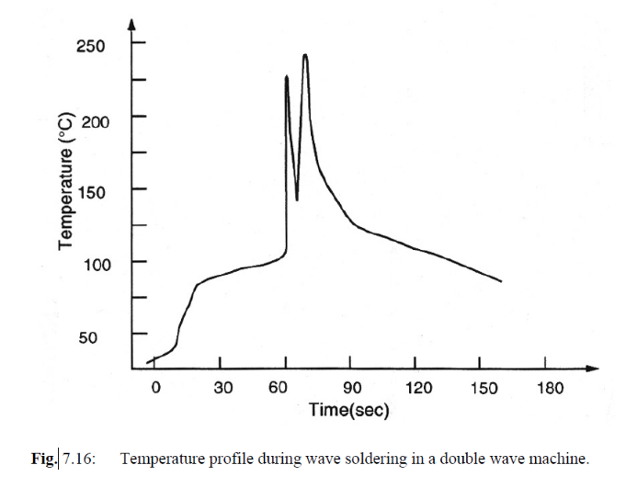Components are fully immerged into a solder bath at 250°C, so the thermal stress is very high, especially if the components are not pre-heated. Not all the components can stand with this thermal stress (especially SMD) and thus one has to care about it.
* SMD can have pins on all four sides of the central package 🡪 these components should not be wave soldered since the orientation of the pins with respect to the direction of motion of the wave can drastically influence the quality of the soldering.

**REFLOW SOLDERING**

IN SYNTHESIS: a small amount of solder metal is applied directly to the metal pads on the PWB that need to be soldered. It is preferrable to have a very thin layer of that metal also before this second one is added, for perfect solderability. Then a solder paste is added on the pads. Once that the component is put in place, everything is cured, the solder paste melts and the component is fixed to the board.

MORE IN DETAIL:

The paste 🡪 Solder particles + Flux + Solvents. The alloy in the solder particles is Sn 63 / Pb 37 % by weight. It is common to have 2 % Ag in the solder to reduce leaching of Ag from capacitor component terminals. The dimension of the solder particles can be varied according to the dimensions of the component to be soldered.

Solder paste is applied through stencil or screen printing. Due to the filaments and the slight deformation when the screen is pushed down by the squeegee, the definition is limited 🡪 Fine screens with thin filaments and a high mesh count must be used for high-definition screens. They are easily broken, giving delay and extra cost in the production. For large areas, the screen tends to stretch unevenly during printing, also limiting the precision of paste deposition near the edges.

POSSIBLE FAILURE: thombstoning (see picture).

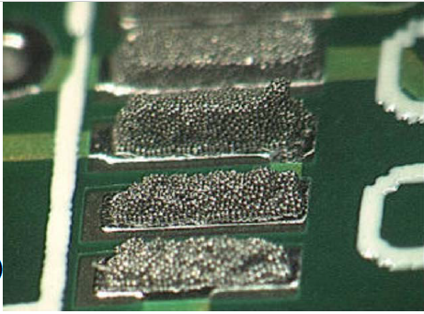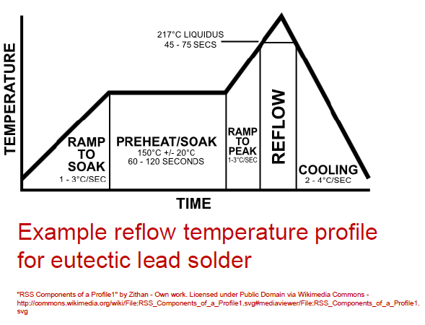

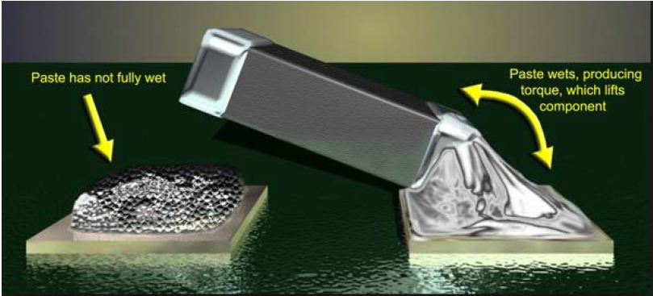

**CONDUCTING ADHESIVES**

We have many adhesives and also many different usages for them. In general we can say that they can be applied as:

* Screen printing
* Deposition of droplets with syringes
* Components can simply be immersed on top of the adhesive paste (see ICA below)
* Conductive films (ACF)

They can then be cured with

* Heating (similar to a reflow oven)
* UV light curing

Anisotropically conductive adhesive of film: used with components with many pins.

* It is screen printed over the whole area under the component.
* It is designed to lead the current just in one way.
* We can use small conductive balls: they can be metallic or made with polymers covered with metals. The principle is that in the adhesive paste we have a density of these spheres such that for sure there will be some of them between the conductive pins of IC and substrate, but the density is too low to have a continuous chain of these speres between two adjacent pins.

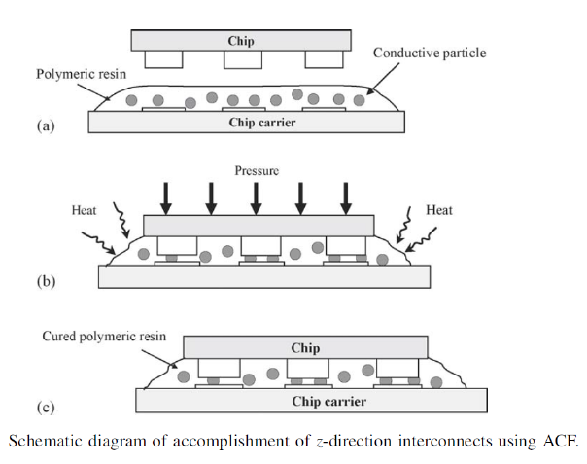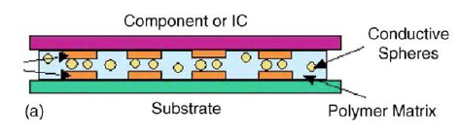

Isotropically conducting adhesive of film:

* composition is similar in all directions, thus it is also conductive in all directions in the same way.
* We have to prevent the adhesives to join between each other because we would create a short circuit. The working principle is similar to the one discussed above for anisotropically conducting adhesives.

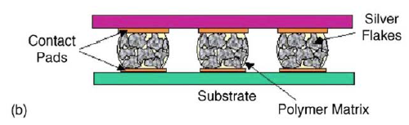

The discrimination between the first and the second type of adhesives is given only by the concentration of the conductive particles in the paste.

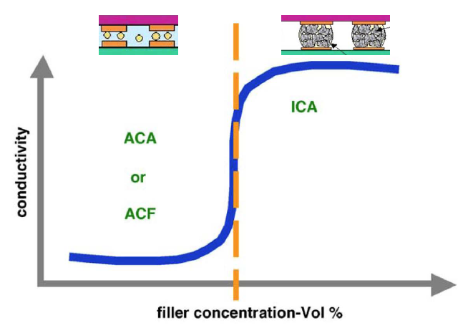

Conductive adhesives in Flip-Chip (or stud-bump) bonding:

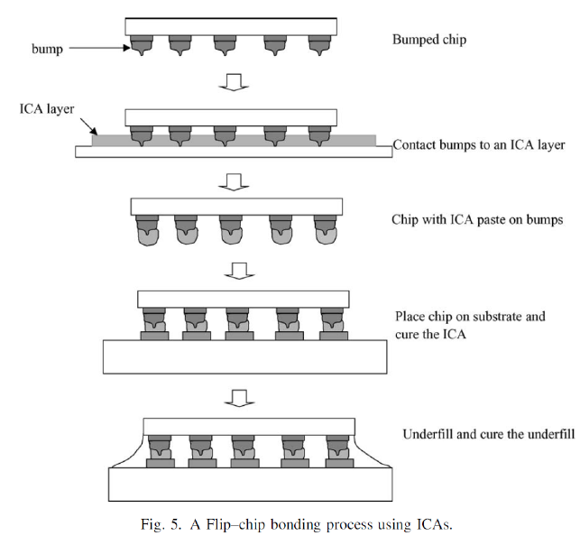Bumps can be made by gold 🡪 the small point is made in order to increase mechanical stability.

* 1. **SOME TIPS FOR A GOOD CIRCUIT DESIGN**

It is essential to design for right quality. This implies that the product must satisfy all specifications regarding electrical performance, reliability and product operating lifetime, ergonometry, etc. but the product should not be over-specified and thus unnecessarily costly. To achieve this it is important to:

- Choose the best suitable technology or combination of technologies, and

an optimal partitioning

- Choose components with the right reliability and suitable packaging

- Design for manufacture

- Design for testability

- Design for ease of repair, etc.

1995 🡪 some advices for what concerns component placements. Today we have more flexibility because of improved pick-and-place robots performance and automated inspection tools after soldering.

DESIGN FOR MANUFACTURE: By "manufacturability" we also mean that it is fit for robot mounting if it is planned, that components and materials can withstand the solder processes to be used, etc.

General rules that should be attended in this sense:

* As few conductor layers as possible in the PWB.
* As coarse (grossolano) conductor pattern as possible (no fine line)
* As few component types as possible (standardisation)
* Robust electrical design (no tight tolerances) 🡪 this means that
  + Design windows allowing for variations in component parameters.
  + Process windows allowing for variations in each process step.
  + Regulatory requirements on safety and EMC should be passed within the specified design and process windows.

The components should be placed orderly, polarised components (diodes, electrolytic capacitors, ICs, etc.) oriented the same way when possible. This gives the highest component density and most efficient assembly process, and it makes visual inspection easier.

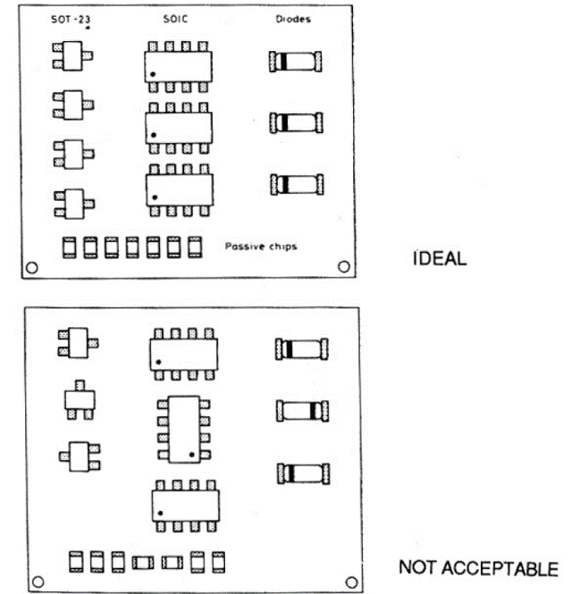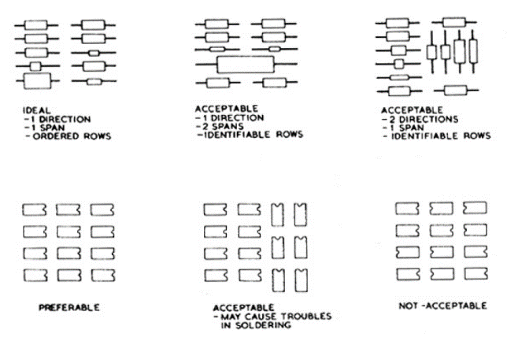

Here we mention the most important parameters that one should care about when generating the schematics for the PCB.

MINIMUM DIMENSIONS: several factors determine the minimum dimensions of the pcb.

* 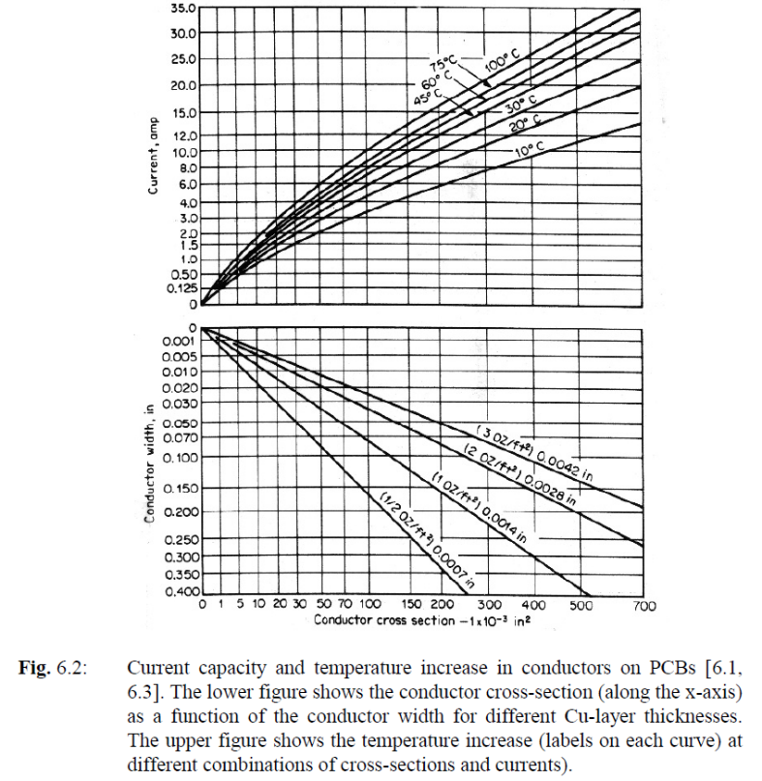The conductors cross sectional area determines the maximum current in a conductor without excessive heating of the conductor and the PCB. The figure shows the temperature increase as a function of current and conductor cross section.
* The voltage drop in a long narrow conductor may also be of importance. It is given by

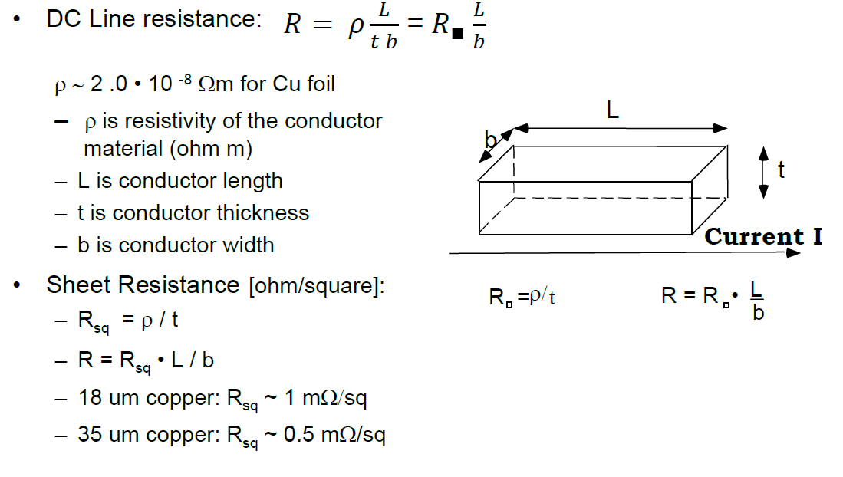

* Resistance and temperature dependence has also to be considered

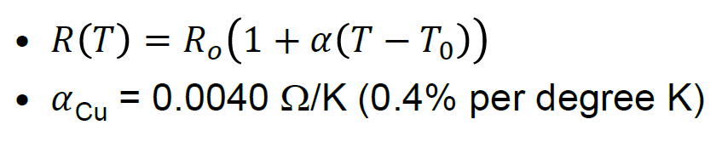

1. **Ceramic circuits**

**Hybrid = composite 🡪 In the context of hybrid technology, we mean a mixture of integrated components (conductors, resistors, capacitors, etc.) that are manufactured as part of the substrate and discrete components that are soldered or bonded on top of the substrate.**

The traditional types of hybrid technology are:

* thick film
  + ceramic substrate (usually alumina)
  + polymer substrate 🡪 polymer thick film technology (more recent)
* thin film:
  + conventional (one layer)
  + multilayer (more recent)
* Multilayer ceramic (co-fired)
  + High-temperature co-fired ceramic (HTCC)
  + Low-temperature co-fired ceramic (LTCC)

*What marks the difference between PTF and ceramic thick film technology? Are the polymers used in the substrate, in the pastes or both things?*

These multilayer ceramic circuits belong to a much larger category: Multilayer Chip Modules, which consist in multiple naked integrated circuits connected onto a single board or to a package.

Three main types:

* Ceramic
  + HTCC
  + LTCC
* Deposited:
  + Thick film
  + Thin film
* Laminated
  + PCB
  + PTF (polymer thick film)

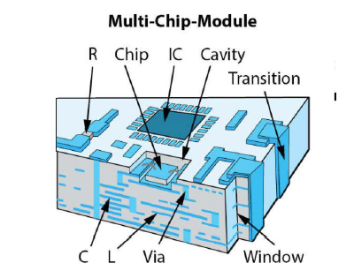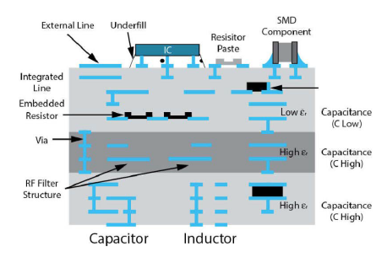

Returning now to ceramic circuits in general, why using ceramic circuits instead of standard PCBs?

* saving space, volume and weight compared to ordinary printed circuit boards
* Sharper line widths for the conductive pattern (especially for thin film boards)
* we can also achieve superior high frequency properties
* very high reliability 🡪 hybrid circuits are suitable for demanding military systems, space applications, medical electronics, as well as computers, telecommunication equipment, etc.

More features, both positive and negative:

* Good dimensional stability with respect to high temperature processing
* Good adhesion between substrate and materials printed on top
* High thermal conductivity
* Relatively low CTE (6-7 ppm/K) 🡪 relatively similar to the Si (2.6 ppm/K)
* High electrical resistance in the substrate, thus good isolation between components
* Dielectric constant: values from moderate to low
* Moderate dielectric losses
* Machinable (lavorabili)
* Low Price

Consider that there’s no material that satisfies all these requirements at the same time! One has always to choose the proper one for the considered application.

* 1. **Thick film substrate technology**

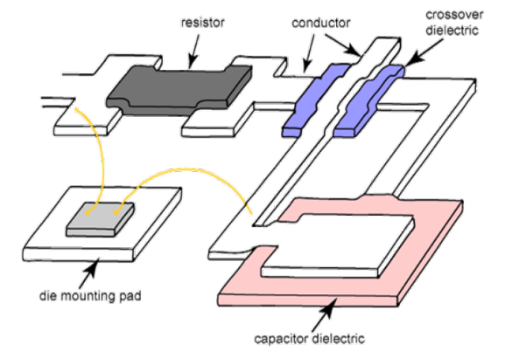

For the substrate, Alumina is the most widely used material:

* Reasonable stability during fabrication (shrinkage approx. 20%)
* Good adhesion between substrate and integrated components and components/conductor paths
* High thermal conductivity (20 W/m K) 🡪 100 times better than organic substrates
* Favorable CTE (6.4 ppm/K)
* High electrical resistivity
* Intermediate dielectric constant (9.4)
* Low price
* 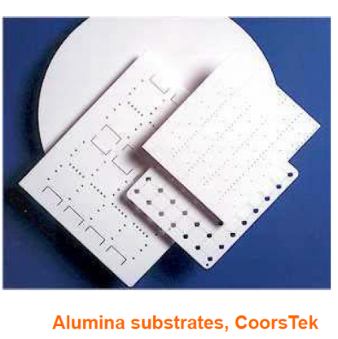Somewhat difficult to machine (brittle = hard but brakes easily) 🡪 this limits the maximum size to 10 - 15 cm. After the material has been sintered, it is not easy to shape it. However, it can easily be cut by breaking after a partial cut is made by a high-power laser. For small circuits, it is common to print and mount components on many substrates that are produced together and then broken apart in the end, to make a rational production process. Holes through the substrate may also be made by laser, but it is simpler to punch holes while the ceramic is pliable, before the sintering.

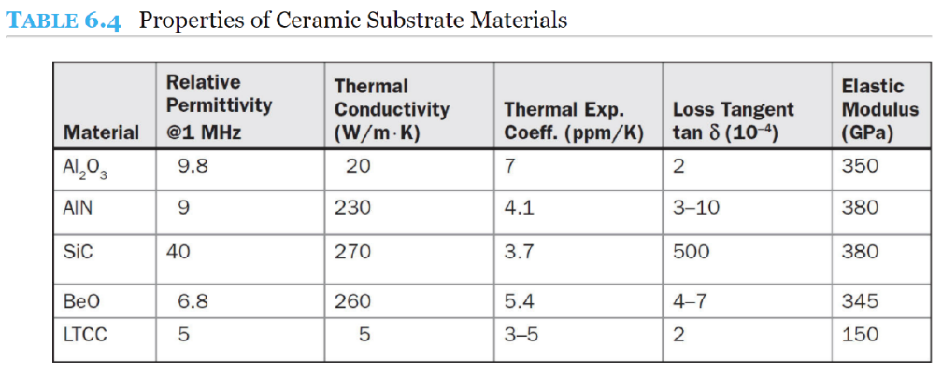

Materials for special applications:

* AlN 🡪 used for circuits that need high thermal dissipation
  + Thermal conductivity of 200W/K
  + Low CTE 🡪 4.5 ppm/K
* BeO 🡪 even higher thermal conductivity that AlN, but very poisonous
* Sapphire glass (SiC) 🡪 Very high thermal conductivity, but very expensive
  + 1. **Principles for thick film circuits production**

Conductors, resistors and dielectric materials are applied in paste form by screen printing (see previous lectures) and they are transformed/sintered by heating to high temperature (firing). The pastes have three main ingredients:

* Functional element (metal-, alloy- or oxide particles, depending on the role of the layer that is being printed, namely resistor, capacitor etc.)
* Matrix or "binder" (glass particles) 🡪 in PTF they are substituted with organic compounds
* Organic solvents and "temporary binder" 🡪 these are responsible for the features of the paste in its initial state (more or less viscous and so on)

The layers are dried at 100-150°C and then fired at 800°C. Put the elements together and each plays a different role:

* temporary binders are polymers that give control over the printing properties: they decompose and evaporate early in the firing process, together with the solvents.
* The glass particles melt in the firing process, adhere to the substrate, bind the active particles together and give stability for the circuit.
* The high firing temperature, typically 800 - 900 °C is important for the long-term stability and reliability.

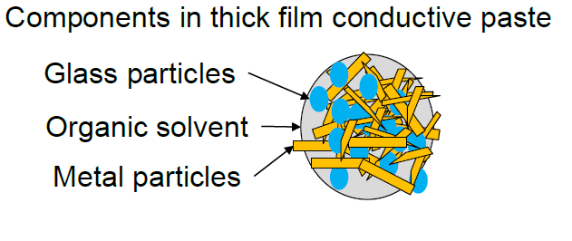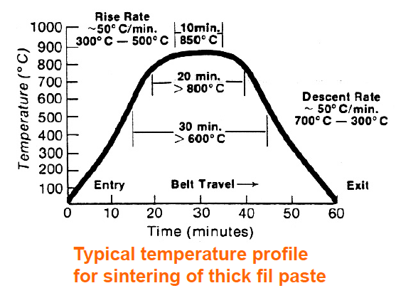

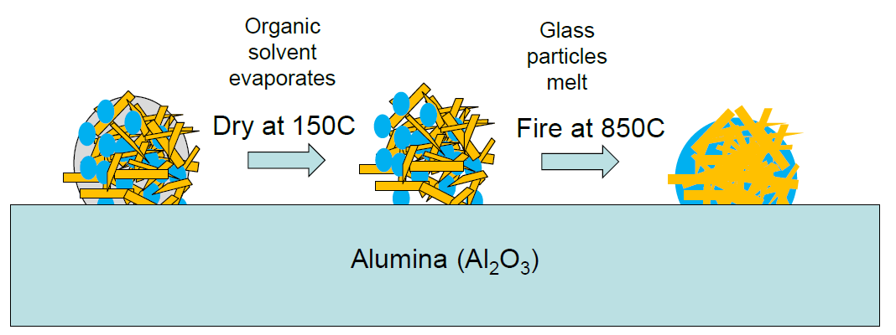

**CONDUCTORS**

The conducting pastes should give:

* High electrical conductivity
* Strong adhesion to the substrate
* Excellent solderability for soldering of packaged components
* Reliable bondability for wire bonding of naked IC chips.
* Price is also an important parameter.

Normally one conductor paste can not satisfy all these criteria, and it is necessary to make several conductor prints. The most used conductor systems are gold, copper, alloys of palladium/silver, palladium/gold and platinum/gold 🡪 Noble metal systems are used because the heat treatment takes place at above 800 °C, where other metals are ruined by oxidation. However, each of the mentioned components has pros and cons:

* gold and platinum are expensive materials, so the material cost is an important factor in the final price of the circuit.
* Gold is very well suited as basis for bonding, but it is not suitable for soldering 🡪 this is due to the fact that gold is very quickly dissolved in solder metal during the soldering process, and it gives a brittle intermetallic composition with poor reliability properties.
* Pure silver has a strong tendency for migration, which may cause reliability problems after some time.
* Silver/palladium gives little migration, it is excellent for soldering, and is well suited for making contact areas for printed thick film resistors 🡪 this is the most used as conductor material, although it has lower conductivity than the pure elemental conductors.
* Copper has high conductivity and low price. However, strong oxidation in air at high temperature makes it necessary that copper must be fired in a neutral nitrogen atmosphere. That gives a more complicated and costly process and has impeded the use of copper conductors.
* Nickel is also used to some extent, but it has lower electrical conductivity than the other materials.
* We do not use tin or Al since the whole package has to be fired at 850°C, then these metals will melt.

Typical thicknesses for the conductors are 5 - 10 μm after firing, linewidth is around 150um for Cu and Ag, 50um for Au. The sheet resistivity is typically between 2 and 25 mohm/sq.

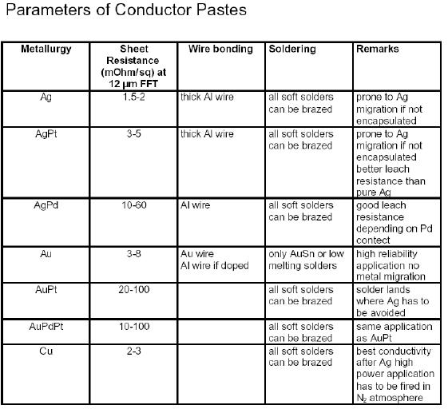

**RESISTORS**

Important properties of thick film resistors are:

* Large range of available resistor values
* High stability
* Low thermal coefficient of resistivity, with little spread over the substrate
* Low voltage dependence of the resistance
* Good noise properties.

Pastes for the resistors are characterized by active elements with low electrical conductivity. They are most often based on various types of oxides of ruthenium: RuO2, BaRuO3, Bi2Ru2O7. In addition, oxides of iridium, rhodium and osmium are used. The sheet resistivity is determined by the active material in the paste, the amount of glass matrix mixed in, the geometry of the resistor, the area of the resistor, the film thickness. We can reach values over 9 decades, up to GOhm.

Minimum tolerance in achieved resistance is lowest for the intermediate values of sheet resistivity. We obtain termination of the resistors by printing a conductor underneath or on top of the ends of the resistor.

* Resistance drift lower than 0.5 % under harsh climatic conditions over long periods of time makes thick film hybrid technology attractive for demanding applications.
* The temperature coefficient of resistance: typically in the range +/- 100 - 700 ppm/°C, with variation over a circuit, for resistors printed with the same paste, below +/- 15 ppm/°C.
* 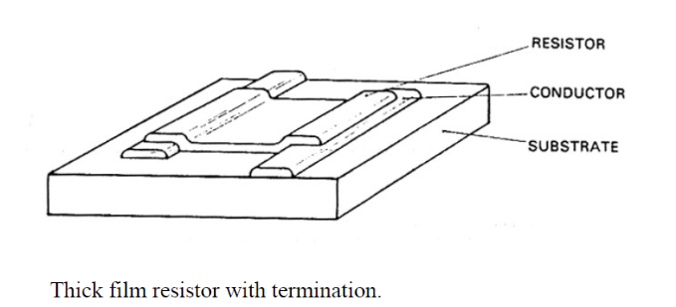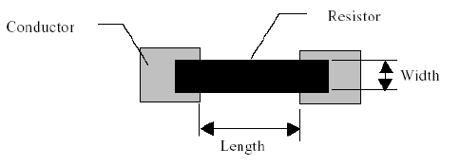The tolerance in absolute resistance after printing and firing is typically +/- 10 -20 %. However, by laser trimming one can achieve tolerances down to approximately 0.5 % absolute, and 0.1 % relative value.

**DIELECTRICS**

Dielectric materials are printed for various purposes: Al2O3 and glass are the most used materials for isolation and passivation (*passivation refers to a material becoming passive, namely it is less affected or corroded by environment or future use.* *Passivation involves creation of an outer layer of shield material that is applied as a microcoating, created by chemical reaction with the base material, or allowed to build from spontaneous oxidation in the air*).

* **For insulation**: low capacitance between conductors is desirable and we use materials with low dielectric constant. MATERIALS: aluminium oxide is the common functional element, together with glass. The glass melts and crystallizes during firing at 850 - 950°C, but it does not melt if heated again. The relative dielectric constant is typically εr = 9 - 10, and breakdown field strength 20 V/μm.
* **For capacitors:** materials with high dielectric constant are used, to achieve high capacitance with little area consumption. Important properties of dielectric materials. MATERIALS: The dielectrics for high value capacitors consist of ferroelectric materials with εr up to above 1000, similarly to ceramic multilayer capacitors (SMD). However, the properties of these materials change drastically near the Curie temperature. For small capacitors the pastes of magnesium titanate, zinc titanate, titanium oxide, and calcium titanate are used, with ε r = 12-160.

In general the following properties are desirable:

* High insulation resistance
* High breakdown field
* For insulators: Low dielectric constant
* For capacitors: Suitable dielectric constant, low temperature coefficient and low voltage coefficient of dielectric properties
* Low loss tangent
* Low porosity

**Capacitors are not suitable for laser trimming** 🡪 printed capacitors are used only in small values and where accuracy in capacity is not mandatory (e.g. decoupling capacitors).

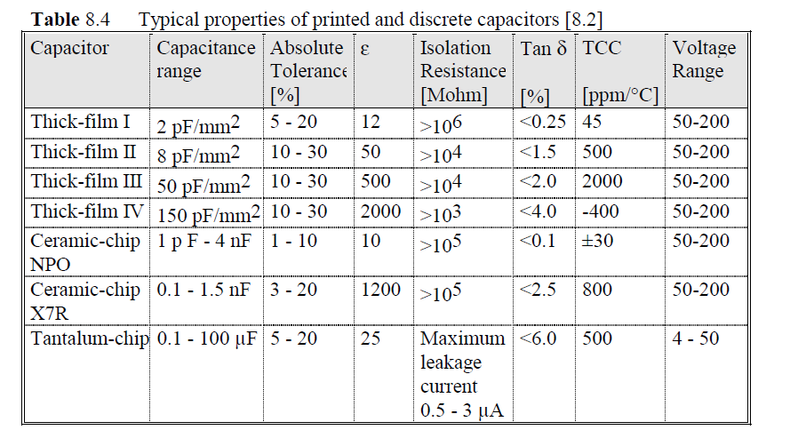

**PRODUCTION PROCESS**

Layout 🡪 CAD tools, photo plotting or laser plotting (analogous to those used for normal PCB, see previous chapter).

Photographic films are produced for the pattern of each layer. From these films, screens for screen printing are produced, using a photolithographic process.

When a print has been made the circuit is dried in an in-line furnace at typically 100 - 150 °C. Then the firing is done in a different furnace at 700 - 1000 °C. The process is repeated for each layer, but all resistor layers are fired in the same process step, after the conductor layers. To achieve good reproducibility for resistors the temperature profile, the top temperature and the time have to be very precisely controlled, maximum deviation in temperature is below 1 °C.

It is possible to make conducting contact between the top side and the bottom side of the substrate by printing through holes in the substrate. This is done by sucking the paste through the hole by use of vacuum on the bottom side of the substrate while the printing on the top side is done. To achieve reliable contact the substrate is then turned around and the paste is printed again from the other side in combination with the vacuum. It is common to have all the conductors and discrete, surface mounted components on one side and the resistors on the other for easy laser trimming.

Testing is normally done on the substrates before component mounting 🡪 During the testing the resistors are adjusted by laser trimming (previously sandblasting). The resistance will always increase by the trimming; therefore the resistance after printing is made 20 - 30 % lower than the desired end value. Three techniques:

* With an L- cut the coarse trimming is done with a track perpendicular to the resistor length, and the fine trimming to accurate value is done by the track along the direction of the current.
* Digital trimming gives the best stability and noise properties but occupies more substrate area.

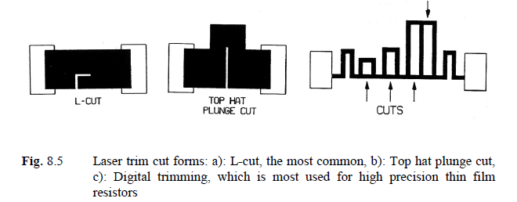

Figure below shows the typical process flow for a simple circuit with two conductor layers and one resistor layer.

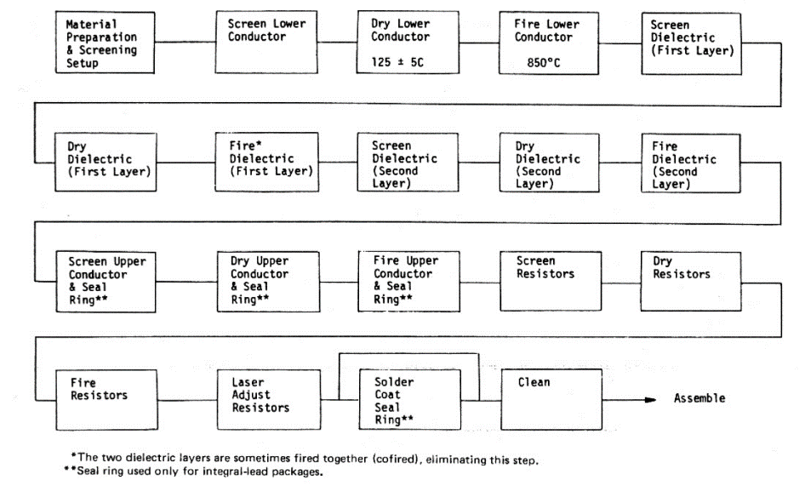

**COMPONENT MOUNTING**

SMD passive components are soldered by using solder paste and reflow soldering, or they are glued with electrically conductive adhesive 🡪 Reflow soldering is done with a hot gas convection belt furnace, an IR (infrared) furnace or vapour phase furnace.

Conformal (on all surfaces) coating is an extra protection by an organic material over the components and substrate 🡪 It gives mechanical and environmental protection and binds loose particles.The hybrid circuits may be used unencapsulated or they may be mounted in metal- or ceramic flatpack packages. Circuits with naked ICs are encapsulated hermetically or the naked chips may be protected by drops of epoxy ("glob top" encapsulation).

(example on SINTEF 🡪 see slides)

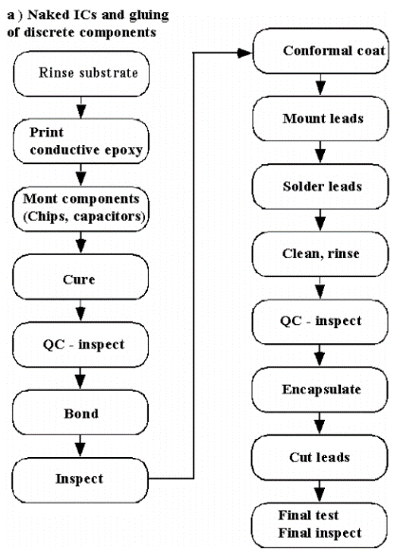

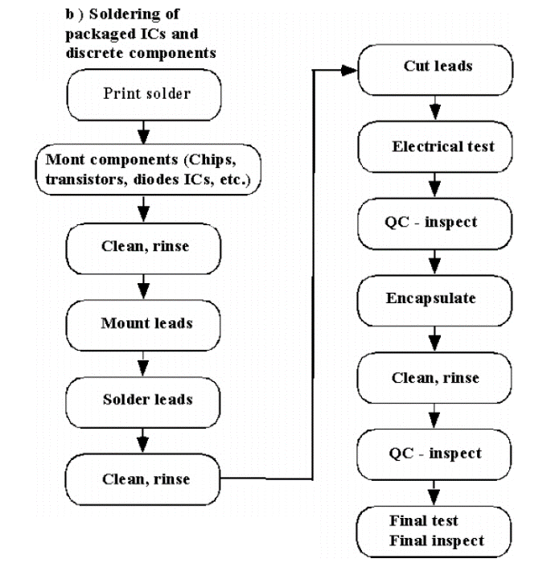

**PHOTODEFINABLE THICK FILM PROCESS**

This is a process that combines techniques from conventional thick film technology with elements of thin film technology 🡪 Low cost solution to producing high quality microwave circuits.

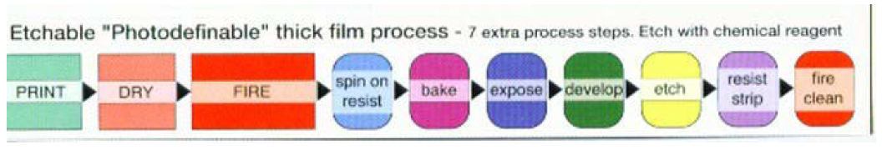

Thick film combined with photo process can give more narrow line widths/structures

Example: HeraeusKQ:

* 25 μm on 96% alumina
* 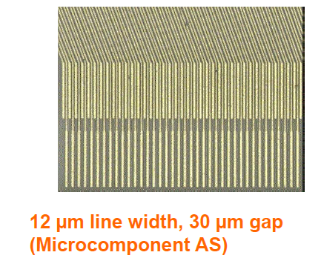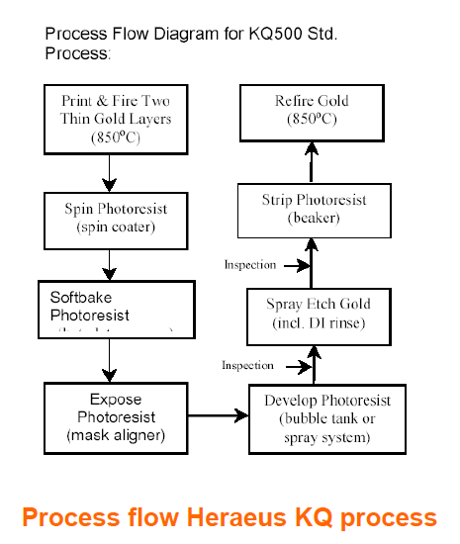10 μm on more planar substrates
  1. **Polymer based thick film (PTF)**

In polymer thick film hybrid technology (PTF) the glass particles used in traditional thick film technology are substituted with polymers as binders for conductors, resistors and insulating layers. The substrate can be ordinary FR4.

**The main purpose of PTF** 🡪 achieve lower cost than what is achievable with conventional PCB technology or with high temperature thick film hybrid technology. Both advantages and disadvantages will be discussed in a moment. What do we have in common between ceramic and polymer thick film technology?

* The starting material for conductors, resistors and insulation is in paste form, and the transfer takes place by screen printing, like in high temperature thick film hybrid technology.
* The curing processes are also analogous to those of high temperature thick film, but they are performed at considerably lower temperatures.
* After the printing of a layer, it is dried to evaporate the solvents. Then it is cured by heat or irradiation. The design of PTF-based printed circuits is similar to that of high temperature thick film design.

The most important advantages of PTF are the following:

* Low price.
* Simple processing.
* Quick production of prototypes and full production volumes.
* PTF is well suited for repair/modification of regular printed wiring boards (in the sense that it can be added to a standard PCB to replace some broken component)
* Printed resistors can be made.
* Additive technology 🡪 little waste and environmental problems.
* Substrates: Regular printed wiring board laminates.
* Specialities:
  + Membrane switch panels.
  + Low price contacts for keyboards and for contact points to elastomeric contacts for LCD displays.

Important limitations of PTF:

* PTF circuits satisfy only moderate environmental requirements
* Only moderate complexity can be achieved.
* High resistivity in the conductors (> 10 x that of Cu foil), except when plated conductors are used
* Design does not follow conventional rules
* Limited solderability.
* The materials have limited shelf life (durability) before they are used.
* 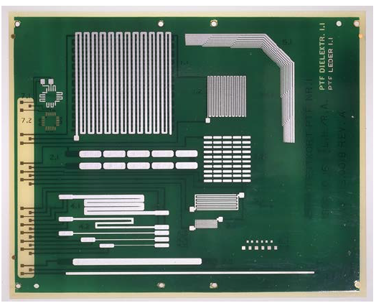Limited availability (i.e. few producers).
  1. **Thin film technology**

Thin film circuits consist of conductor layers, resistor layers and dielectric layers, similarly to thick film circuits. **However, the thin film thicknesses are normally 1 μm or less, an order of magnitude less than for thick film.** Processes from silicon technology are used for deposition and definition of patterns 🡪 higher circuit density than in thick film.

The most used substrate materials: glass and 99.6 % alumina, also Si can be employed. The fine conductor dimensions in thin film require a smoother and more uniform surface underneath, so the substrates are polished. For high frequency use, low losses are important and the purer quality alumina used in thin film circuits has lower tan δ than the substrates used in thick film technology.

**CONDUCTORS**: gold and aluminium.

* Gold is chemically stable, it has high electrical conductivity and good bondability. However, gold diffuses very fast into many other conductors and insulating materials 🡪 diffusion barriers are used. They serve also because gold has poor adhesion to many materials: **Nickel is suitable for diffusion barrier, nickel/chromium alloy improves the adhesion** 🡪 Au system is deposited by vacuum evaporation or by sputtering or may also be electrolytically plated, particularly for microwave circuits, where a 5 - 10 μm thick layer gives low conductor resistance, which is important to achieve low high frequency loss. NiCr is deposited by evaporation/sputtering + photoprocess.
* Aluminium is used much as electrode material for thin film capacitors.

**DIELECTRICS**: Various materials are used for dielectric depending on whether one wants to make capacitors, multilayer insulation or passivation.

* Passivation 🡪 SiN3 is well suited, chemical vapour phase deposition
* insulation between conductor layers 🡪 SiO2 because it has low dielectric constant (εr = 4), and high breakdown field strength (106 V/cm), chemical vapour phase deposition.
* Capacitors 🡪 SiO is used, or SiO2, Al2O3, Ta2O5 🡪 produced by vacuum evaporation, or chemical deposition, or anodic oxidation.

**RESISTORS**: made from NiCr, as well as Ta2N, by vacuum evaporation or by sputtering. While we can achieve over 6 decades of variation in sheet resistivity in thick film hybrid technology, the range we achieve with practical thicknesses in thin film technology is only between approximately 10 and 1000 ohm/sq.

**PRODUCTION PROCESS**

Figure below shows the process steps for the most common form of thin film circuits, with one conductor layer and one resistor layer.

* In the first step, the resistor layer is deposited all over the substrate.
* A diffusion barrier is deposited and then the conductor metal. Conductor and resistor geometries are defined by photolithography and etching 🡪 A few drops of photoresist are deposited and spread by the centrifugal force when the substrate is rotated on a spinning table. The conductor pattern for circuits is defined by exposing the resist through a photo mask, development and curing.
* Then the gold is removed by etching where it is not wanted. A solution of potassium iodide may be used, without dissolving the NiCr layer (resistor film). If we need conductor widths less than 2-3 μm, the etching is done by reactive ion etching, which etches fast vertically, but more slowly horizontally, and thus reducing the underetching. A new step of photoprocessing is done to define the pattern of the resistors, and the diffusion barrier and the resistor films are etched where they are to be removed, for example with nitric acid. (Where the circuit has conductor pattern, there is still the resistor layer underneath the conductor material)
* Finally, the circuit is cured in air at 250 - 350 °C for some hours, to make a passivating layer of chromium-oxide to protect and stabilize the resistors.
* When the thin film substrate has been completely processed, resistors may be laser trimmed like in the case of thick film circuits. After this, components will be mounted on the substrate
  + Integrated circuits are normally mounted in the form of naked chips that are glued on to the substrate and wire bonded
  + Discrete resistors and capacitors are normally mounted with conductive adhesives for electrical and mechanical contact and not soldered.
* In most cases, the complete circuit will be mounted in a hermetic package that is made of ceramic, or in most cases of metal. Terminal points on the substrate will be connected to the leads of the package by wire bonding. A soldered metal lid (coperchio) on the package ensures hermeticity and good reliability.

*NB: when we do vertical etching, we can have also horizontal etching (underetching). However, horizontal dimensions are on the order of mm, while vertical ones are on the order of um, thus some underetching may not even be considerable 🡪 we’ll see this aspect better.*

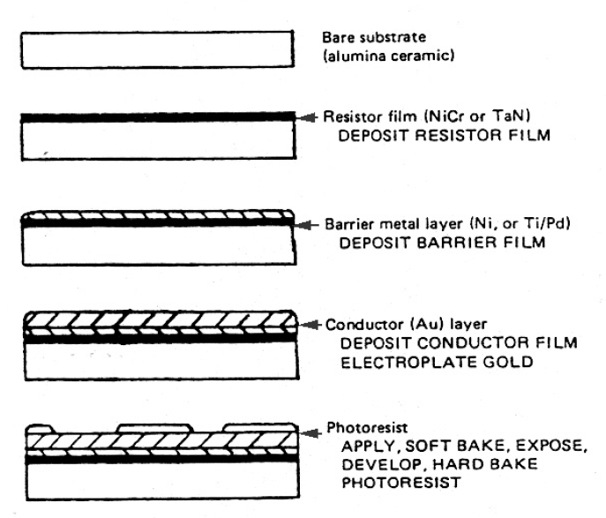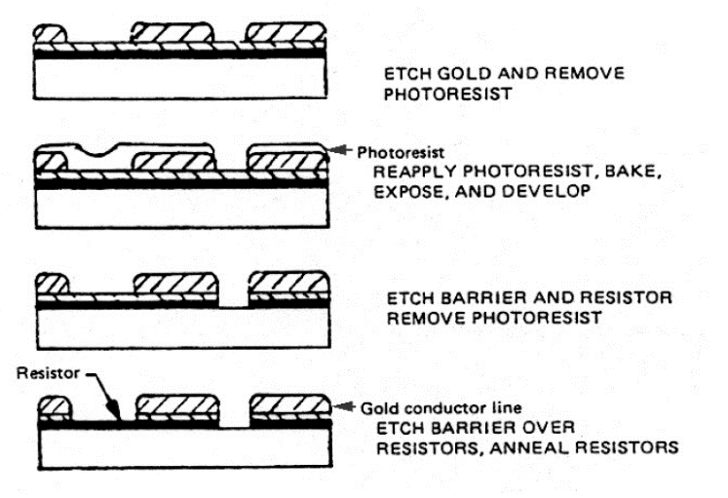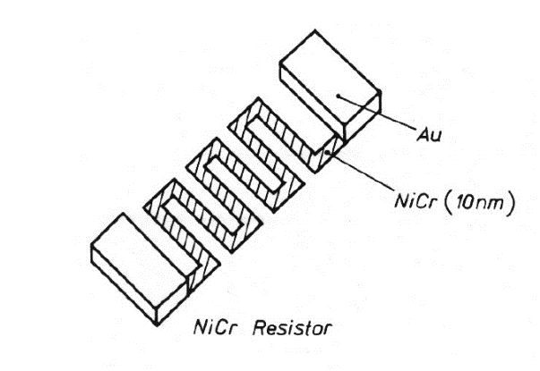

**THIN FILM COMPONENTS**

A type of "components" that is very suitable for being made by thin film technology is **precision R/C networks** (figure on the left). They are also available as off-the-shelf components (component standard) for mounting on other thin- or thick film substrates.

Diodes and transistors can also be fabricated (see figure on the right) 🡪 Large thin film diodes made from Cu2S/CdS hetero-junctions give low price solar cells, and thin film transistors have been under development for 10 - 15 years. A matrix of thin film transistors is of great interest for the control of big LCD screens for flat televisions, etc. The structure is similar to Si -MOS transistors, and CdSe as well as Si/H are used as the semiconducting material.

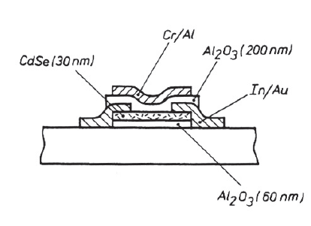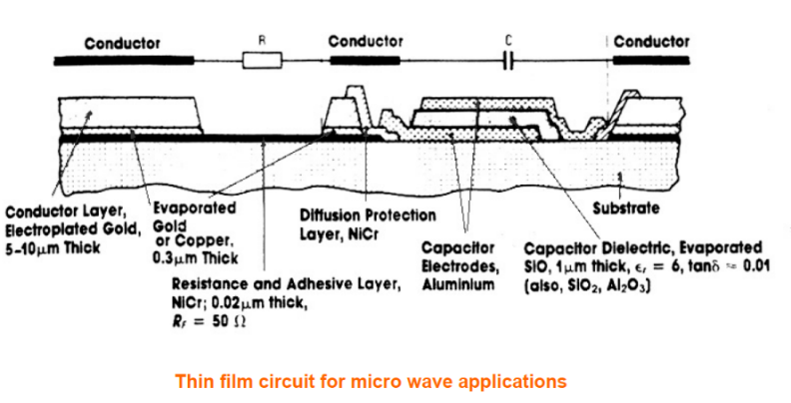

* 1. **MCM – Multilayer Ceramic Modules**

For multichip modules, alumina is the most used material 🡪 The structure consists of many layers of ceramic, with metallization between the layers, and vias through the layers for electrical contact.

* + 1. **High temperature co-fired Ceramic (HTCC)**

**FABRICATION**

The fabrication of multilayer ceramic modules by "**tape casting**" is shown schematically in the figure below.

* The non-sintered, pliable (pieghevole) ceramic consists of alumina powder, organic binders and solvents. The material is transferred from the container to a carrier.
* The ceramic "tape" ("green sheet") is given the appropriate thickness on the transport carrier by passing underneath a "doctor blade" in a precisely controlled distance.
* The tape is cut to correct size, and holes and component cavities are punched out with a numerically controlled punching tool or with a permanent, product specific punching tool for high production volume of a given product.
* Metallization of the via holes and fabrication of conductors is done by screen printing of tungsten (or molybdenum). These are the only metals that can withstand the high process temperature later.
* All layers are laminated together under hydrostatic pressure at elevated temperature, to evaporate the binder and solvent. Then the whole structure is sintered at 1500 - 1700 °C, 30 - 50 hours, in hydrogen atmosphere. Then the external contacts are soldered to the substrate and finally gold may be plated on the surface with nickel as diffusion barrier on top of the tungsten (present in the vias).
* During the process, the ceramic shrinks approximately 18 % linearly. The shrinkage is material- and process dependent, so the finished circuits typically have linear dimensional tolerances 0.5 - 1 %.

**PROPERTIES**

The minimum conductor widths and conductor distances are typically 0.15 - 0.2 mm, diameter of via holes 0.1 - 0.2 mm. Extended ground planes are made as grids of printed lines rather than continuous, due to the dissimilar thermal properties of metal and ceramic during sintering.

**Advantages:**

* High thermal conductivity
* Low TCE, good thermal match to Si and GaAs as well as to leadless SMD components
* Good control over characteristic impedance, good high frequency properties
* Both soldering of encapsulated components, TAB bonding of naked chips and flip chip mounting of smaller Si chips can be used (although there is not a perfect thermal match to flip chip soldered Si chips)
* Complete hermetic encapsulation is possible, or hermetic encapsulation of local areas, by using a lid over individual ICs in cavities.
* High reliability.
* Many conductor layers are possible, with high production yield. This is because each layer can be inspected before the lamination, and faulty layers be discarded (contrary to thick film where one fault in one layer will ruin the whole circuit)
* Easy to mount edge contacts, coaxial contacts, etc.

**Disadvantages**

* Low electrical conductivity in the inner layers (sheet resistivity 15 mohm/sq)
* High dielectric constant gives bad properties at high frequencies
* The producers generally make standard packages in large volumes, and have high start-up cost for custom circuits.

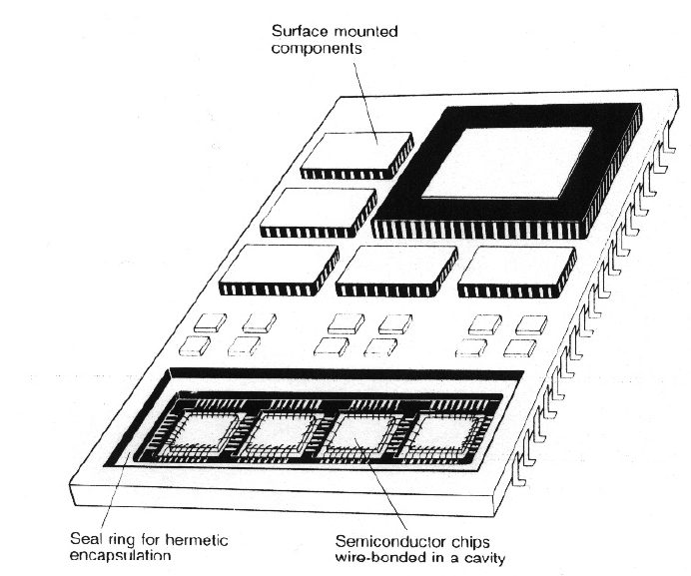

* + 1. **Low temperature co-fired ceramic (LTCC)**

These are multilayer ceramic based on glass compositions similar to those used in thick film dielectrics (in HTCC the main components are alumina and binders). The fabrication is made in a process similar to that used for high temperature ceramic, but some differences are present.

* The sintering takes place at around 850 °C, 15 min., normally in air atmosphere (after a burnout at 350 °C to remove the organic binders and solvent) 🡪 the metal systems used in ordinary thick film technology are suitable for inner layers, with much better electrical conductivity than tungsten. Thick film firing furnaces may be used for the process. Resistors can also be inserted in inner layers.
* Materials in the substrate are mullite, corderite, lead borosilicate glass and others.
* Typical conductors minimum width and separation are 0.15 - 0.2 mm, diameter of the via hole 0.15 - 0.2 mm, and distance between via holes 0.25 - 0.4 mm.

**Advantages compared to HTCC technology:**

* Low process temperature, normal process atmosphere, requires low investments for thick film producers to start their own production ($ 100k - 200 k).
* Flexibility in choice of conductor materials, low sheet resistivity
* Plating is not necessary, bondable gold can be screen printed
* Resistors may be screen printed internally and on the surface
* Dielectric materials with relative dielectric constant down to 4 - 5 are used.
* Technology compatible with the ordinary metals used in thick film technology, since we do not have to reach extreme temperatures as in the HTCC case.

**Disadvantages:**

* New, immature technology
* Low thermal conductivity
* Brittle material, mechanically less robust
* So far, low availability.

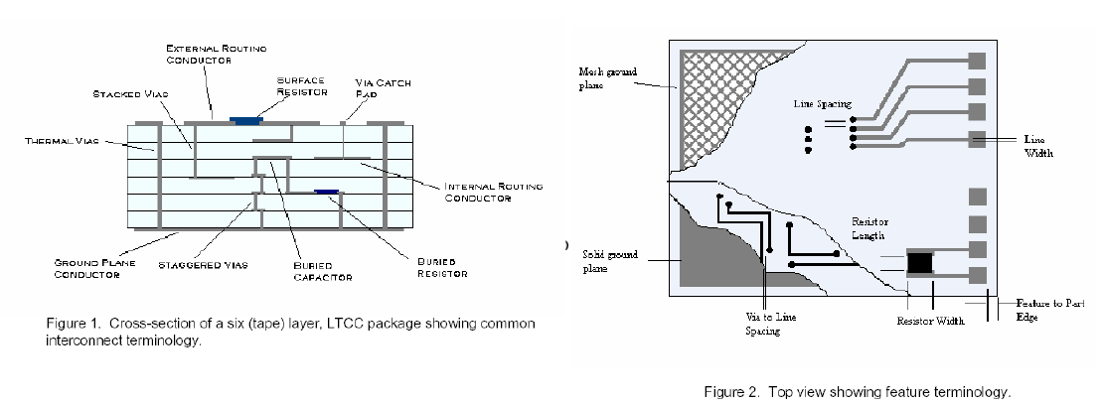A "transfer tape" version is also available, which is fired for each layer.

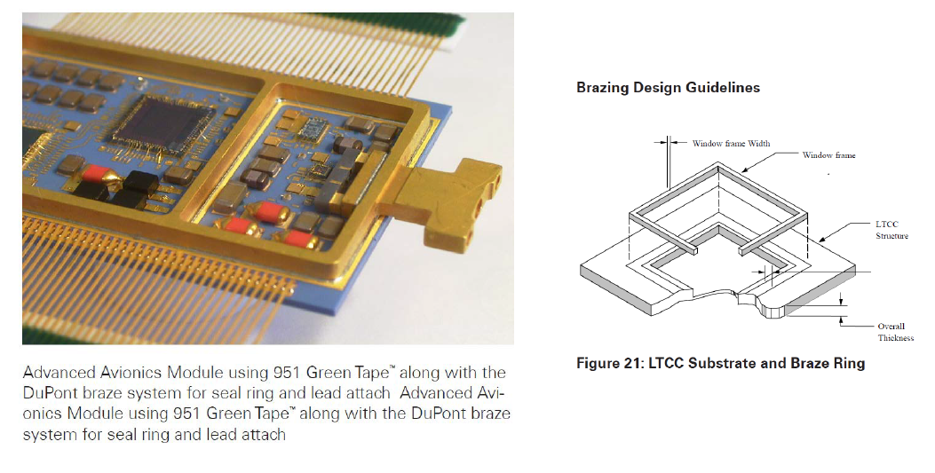

**PRODUCTION 🡪 I don’t know if it is different from that discussed for HTCC 🡪 ASK!**

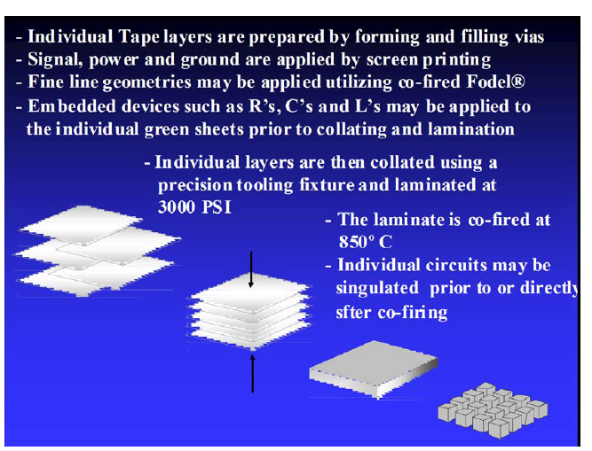

* + 1. **Final remarks on MCM**

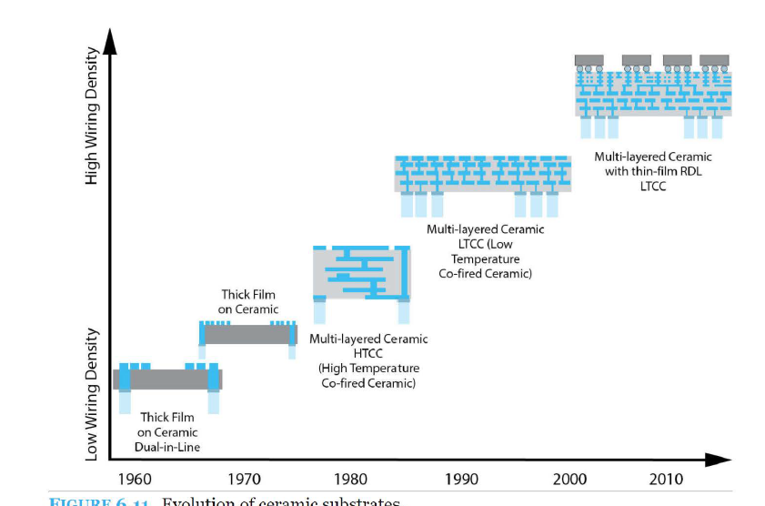

* 1. **Power electronics**

In power electronic circuits and modules each transistor may over short periods of time conduct up to 100 A and more and occupy several square cm of silicon. Some of the major challenges are:

* Spread the heat from the silicon chip through a good thermal conductor underneath and reduce the total thermal resistance between chip and a good heat sink
* Reduce thermal stress due to material thermal mismatch
* Provide electrical insulation for voltages up to 2.5 kV and more
* Design for electromagnetic compatibility, particularly reduce the inductance to avoid large voltage spikes when large currents are switched on and off.
* Higher integration: Combining power and control on the same Si chip or on the same substrate, "smart power".

Technologies used for power circuits and modules include the following:

* Polymer on metal substrate technology
* Thick film technology
* Plated ceramic substrate technology
* Direct copper bonding (DCB) technology.
* Plasma sprayed dielectric on metal base.

We will now limit our discussion to DCB technology

* + 1. **Direct Copper Bonding (DCB) technology**
* Direct copper bonding (DCB) substrates have alumina or AlN ceramic insulator, typically 0.6 mm thick, and a 0.3 mm thick Cu foil on both sides (see figure below).
* The oxidised Cu is bonded to the ceramic by heating to a temperature slightly above 1065°C, 20 °C below the melting point of copper. At 1065°C a eutectic composition of Cu and 1.6 % CuO has its melting point. The molten phase wets alumina and creates a strong bond to the ceramic upon solidifying, by penetrating into the molecular structure of the ceramic.
* Since the copper on the top of the substrate does not melt, the pattern of the foil will be defined after the bonding process. Alternatively a uniform Cu foil may be bonded and patterned by etching. It is important to have Cu on both sides of the ceramic, to equalize the thermal stress and reduce bowing (curvature) of the substrate. The thermal resistance is reduced by using thick Cu layers. This, however, will increase the thermal coefficient of expansion for the composition, and increase the thermal mismatch to Si chips. The reliability of the DCB structure under temperature cycling will also be reduced.
* The silicon chips are soldered to the substrates by high melting point solder in an inert or reducing atmosphere, and electrical connections are made by heavy Al wires (see wire on top of copper in figure below). Many wires are used for each contact to reduce resistance and inductance. In some modules the substrate is soldered to a heavy Cu plate for further heat spreading.
* 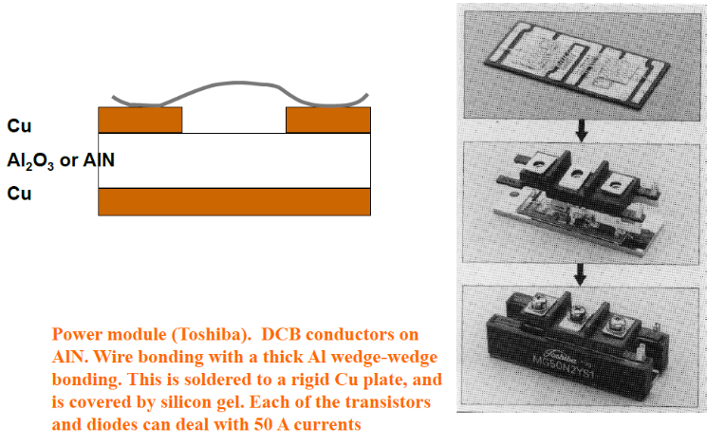The complete modules are mounted to the heat sink below by screws (viti). Even better thermal conductors than alumina and AlN are desirable for the dielectric in power modules. A big research effort has been started for deposition of diamond layers, with thermal conductivity of 1 000 - 2 000 W/°C x m .

1. **Metallization and interconnections**
   1. **The electronics metallization super-heroes**

Metallizing is the general name for the technique of coating metal on the surface of objects. Metallic coatings may be decorative, protective or functional. When the deposited metal has the task of conducting electricity 🡪 **key word = low resistivity!**

The best conductors in nature are

* Silver (1.60 μΩ−cm)
* Copper (1.67 μΩ−cm)
* Gold (2.3 μΩ−cm)
* Aluminum (2.69 μΩ−cm)
* Tin (11.0 μΩ−cm) 🡪 not so good as conductor, but still used in electronics

It is not a coincidence that Cu, Au and Ag have good conduction properties 🡪 they are in the same group, thus they share the external electronic configuration.

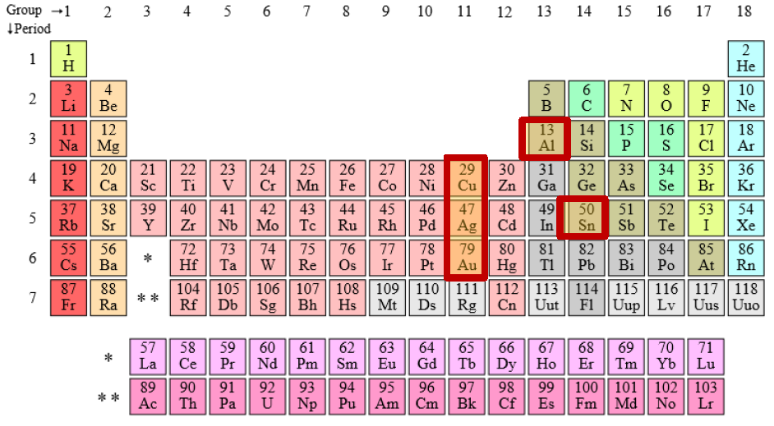

**SILVER**

**Good**

* Excellent electrical conductivity (the best you can buy).
* Frequently used in glass and adhesive mixtures as conductive ingredient.

**Bad**

* Ag is a VERY fast diffuser in dielectrics, especially when driven by an electric field. The rapid diffusion is because diffusion happens as an Ag+ ion which is much smaller in size than the neutral Ag atom, and thus moves easily. Susceptible for electromigration.
* Pure Ag also quickly forms oxides.
* Ag is quite rare and relatively expensive.

**ALUMINUM**

**Good**

* Most ICs bond pads are covered with sputter deposited aluminum, providing a satisfactory surface for conventional wire bonding.
* can be shaped into fine wires applied for wedge-wedge Al bonding.

**Bad**

* Al immediately forms oxides in air
* Aluminum is not a readily solderable surface, neither wettable nor bondable by most solders.
* Aluminum may corrode over time when not protected from the environment.
* Low melting temperature (660°C), limiting its use in ceramic hybrids.

**GOLD 🡪 METALLIZATION SUPER-HERO**

**Good**

* Highly conductive and ductile
* It does not corrode and is frequently used as a protective layer.

**Bad**

* Diffuses easily into tin and into unprotected silicon, in which it can destroy semiconducting band-gaps 🡪 Gold is therefore strictly forbidden in several IC and microsystems processing facilities.

**TIN**

**Good**

* Tin is a soft, ductile, low melting point metal that wets and blends (si mescola) in wherever it can!
* Sn is responsible for the reduced soldering temperature in most (bi-/multi-metal) soldering compositions
* Tin has a reasonable resistance towards the environment, making it an acceptable surface finish for printed circuit boards.

**Bad**

* The electrical conductivity of Sn is not comparable to Al, Au, and Cu
* Can create whiskers (baffi, filamenti) that causes reliability concerns.

**COPPER 🡪 METALLIZATION WORKHORSE (MULO DA TIRO)**

**Good**

* Conductivity comparable to silver.
* Cu can be electro- and electroless plated on many surfaces.
* Excellent electrical and thermal conductivity and ductile.
* Increasingly applied for IC metallization

**Bad**

* Oxidizes in air 🡪 flux treatment is needed prior to soldering
  1. **Interconnections** 
     1. **Wire bonding, failures and test structures**

**FAILURE MODES IN METALS: INTERMETALLIC GROWTH** 🡪 **PURPLE PLAGUE IN Au-Al INTERFACES**

Consists in connecting components (generally chips) with the conduction pattern on the PCB through wires. Wires and connections between wires and components/pads can be made in different ways:

* Gold (ball-wedge)
* Copper(ball-wedge)
* Aluminium (wedge-wedge)
* Alloyed aluminum wires 🡪 Aluminium wires are often alloyed with 1% Si or 0.5% Magnesium for greater drawing ease to fine sizes (maggiore facilità di trafilatura a dimensioni fini) and higher pull-test strengths (maggiore resistenza alla trazione)

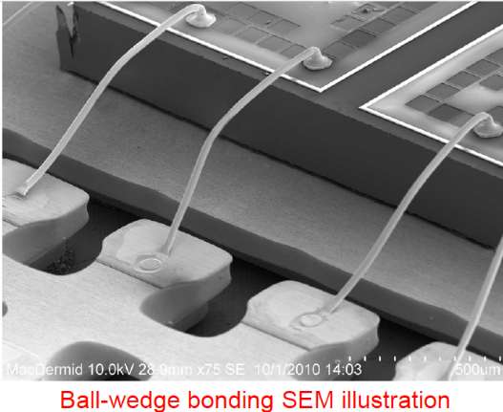

A gold-aluminium intermetallic is an intermetallic compound of gold and aluminium that occurs at contacts between the two metals. These intermetallics have different properties than the individual metals which can cause problems in wire bonding in microelectronics. The main compounds formed are

* Au5Al2 (white plague) 🡪 very low conductivity
* AuAl2 (purple plague) 🡪 primarily is very brittle

Both form at high temperatures. Long exposure of a circuit to T > 100 °C is sufficient to develop purple plague. (notice that the purple plague forms at temperatures which are mush lower than its melting temperature, that’s perfectly fine).

Cavities may also appear: when the temperature increases, there are many possible compounds of Au and Al that may appear, some of them grow faster and some grow slower. The voids form when the denser and faster-growing layers of AuAl2 consume the slower-growing ones (see figure below) 🡪 process known as Kirkendall voiding 🡪 leads to both increased electrical resistance and mechanical weakening of the wire bond. We will analyze Kierkendall voiding also later.

All problems caused by gold-aluminium intermetallics can be prevented either by using bonding processes that avoid high temperatures (e.g. ultrasonic welding), or by designing circuitry to avoid aluminium-to-gold contact using aluminium-to-aluminium or gold-to-gold junctions.

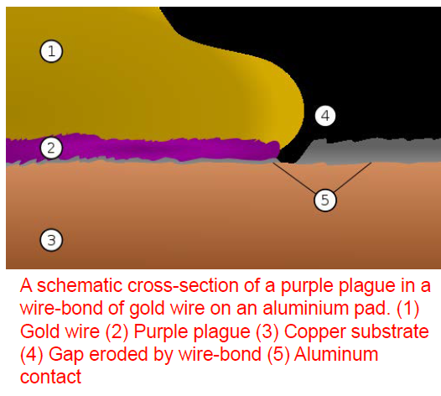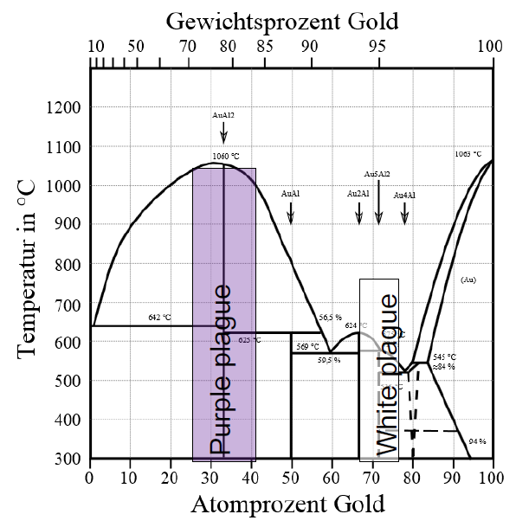

**FAILURE MODES IN METALS: WIREBONDS TESTING**

Devices measuring the pull strength is frequently used to measure wire bonding quality 🡪 Fresh wire bonds typically should have bond strengths of the order of 10 grams force.

TEST: one produces some samples and tries to pull the wire with a hook (uncino) (see figure)

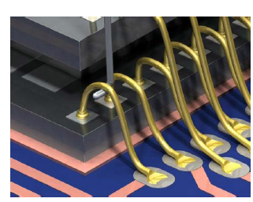

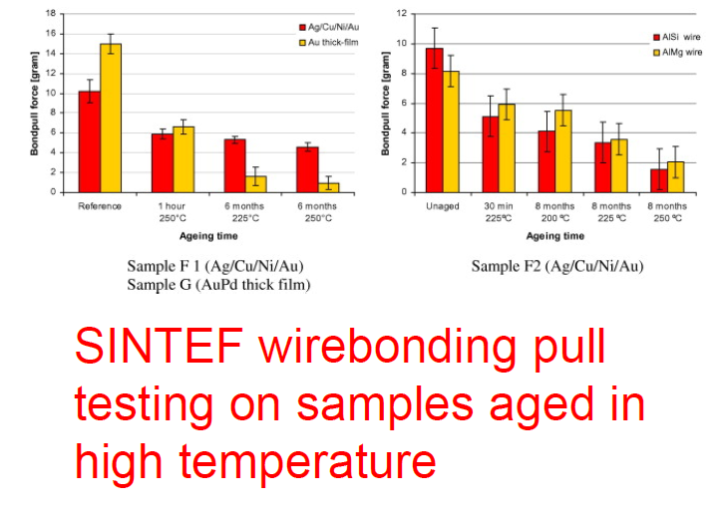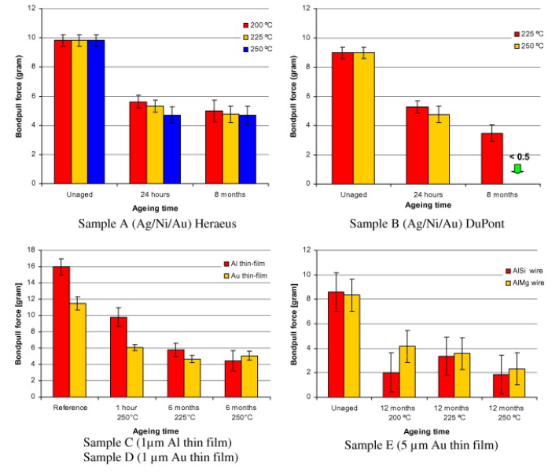Many tests are performed on a population of ICs connected to the PCB with wire bonding 🡪 tests are useful to get info on how the ageing and exposure to different factors (e.g. high T) affect the bonding properties

**FAILURE MODES IN METALS: KIRKENDALL VOIDING**

The Kirkendall effect is **the motion of the boundary layer between two metals that occurs as a consequence of the difference in diffusion rates of the metal atoms.**

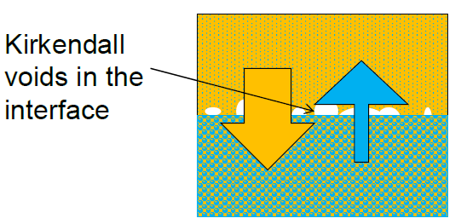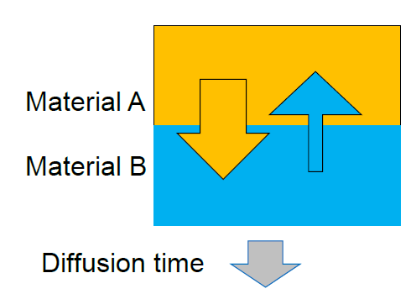

IDEA: MatA is happier to go into MatB than MatB is to go into MatA 🡪 MatA diffuses very fast, MatB diffuses very slowly 🡪 Holes are created.

In general, diffusion coefficients are not the same for material A into material B as B into A 🡪 voids are formed in the interface, causing mechanical weakening and increased interface resistance.

**FAILURE MODES IN METALS: ELECTROMIGRATION**

**Electromigration is the transport of material caused by the gradual movement of the ions in a conductor due to the momentum transfer between conducting electrons and diffusing metal atoms.**

Effects increase with increasing current densities 🡪Aluminium is for example prone to electromigration. Addition of 2-4% Cu lowers the tendency to 1/50th due to changes in the microstructure.

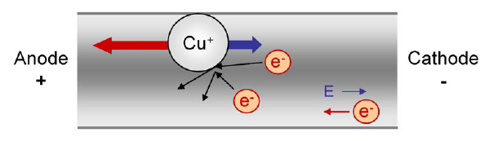The effects of electromigration are also visible at naked eye, since the wire can bend!

**FAILURE MODES IN METALS: WHISKERS**

**Metal whiskering is a crystalline metallurgical phenomenon involving the spontaneous growth of tiny, filiform hairs from a metallic surface.**

The mechanism behind metal whisker growth is not fully understood, but seems to be encouraged by compressive mechanical stresses. Whisker formation is common in tin where the growth can cause short circuits.

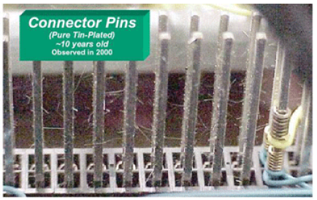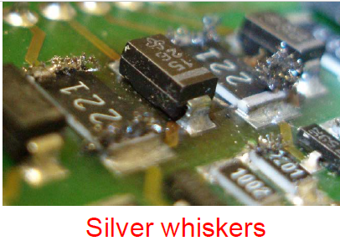

**CONDUCTOR PASTES FOR HYBRID CIRCUITS**

We saw these aspects also in the previous chapter, but now we can regard at them being more conscious of the possible failure mechanisms that have to guide us in the choice of the proper metal to use for ceramic circuits. The metals contained in the pastes used to make conductor paths in ceramic hybrids will then be generally wire-bonded to some chips inserted in the module 🡪 possible failure modes are those indicated above, but the most probable one (regarding metals) is the growth of purple plague (see figure)

One has to search for a metal that has:

* High electrical conductivity
* Good adhesion to substrate
* Solderable: Cu and AgPd gives good solderablity, Au not possible to solder to (gets dissolved in the solder)
* Wirebondable: Au and Ag-based works well, Cu (and Ni) more difficult due to oxidation
* Reasonable price: Au is very expensive
* Line widths: Cu, Ag 150 μm, Au 50 μm
* ADDED: check for possible failure modes and consequently choose the metal

Also in ceramic hybrid circuits the predominant metals are the super-heroes mentioned before. Sintering at high temperatures means that noble metals predominantly are used: Au, Cu, Ag, AgPd and other alloys of Au or Ag with Pd or Pt.

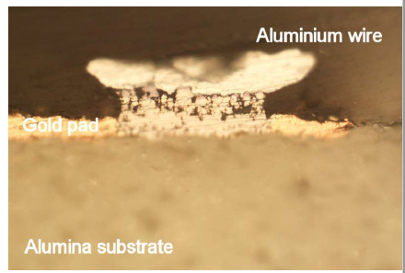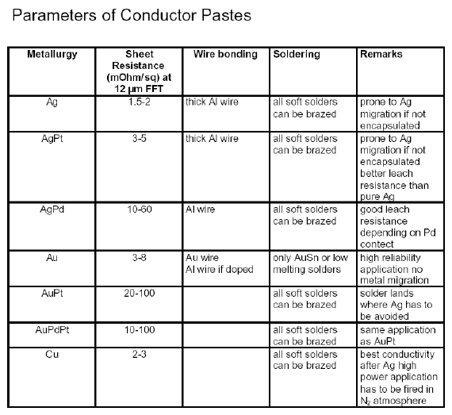

**FAILURE ANALYSIS: COMMON TEST STRUCTURES**

With test structures we can get an idea on how often a failure occurs on a particular circuit/component, which is the most probable one, what can cause it and so on.

**Daisy chain**: access quality and conductivity of wire bonding. It is difficult to test 100 separated wire bonds, so one makes a chain with them and measures all the needed parameters.

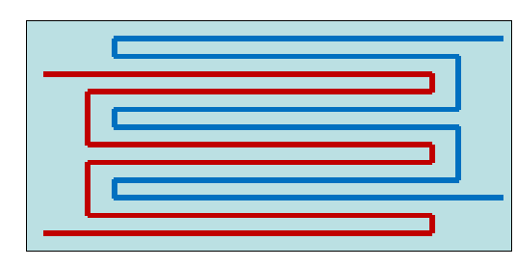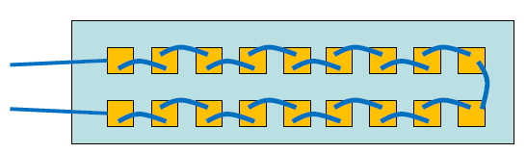

**Electromigration:** we can have wires with positive and negative bias close to each other. In time the electromigration process can occur and the wires may get in contact 🡪 we need to avoid this. With this structure we maximize the risk of this phenomenon, in how much time and so on (see figure above, right)

**Kelvin structure for testing vias resistance**

Idea: if you measure the resistance through a via from one side to the other, then the resistance contains also contributions from contact points 🡪 this can be a non-negligible contribution.

Solution: we use a total of 3 vias

* run a current from 3 to 1, so the current goes through 2 vias and the circuit is closed. By doing so, we create a voltage drop across each via traversed by the current.
* We then measure the voltage drop between 2 and 4, where current is not flowing.

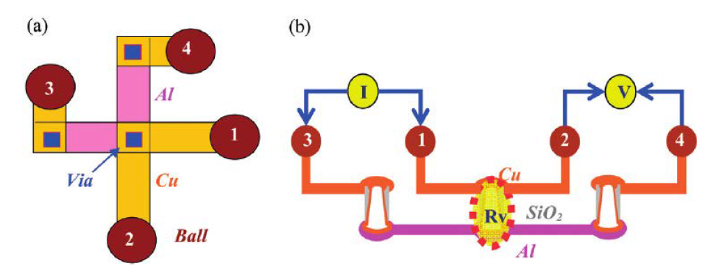

* + 1. **Pad metallization**

**Pads are the main connection between chips and conductive pattern on a PCB, or between the PCB and the outer pins** 🡪 depending on the application and materials used, a number of functions must be implemented on an electrical pad 🡪 This is usually implemented in a layer-by-layer approach.

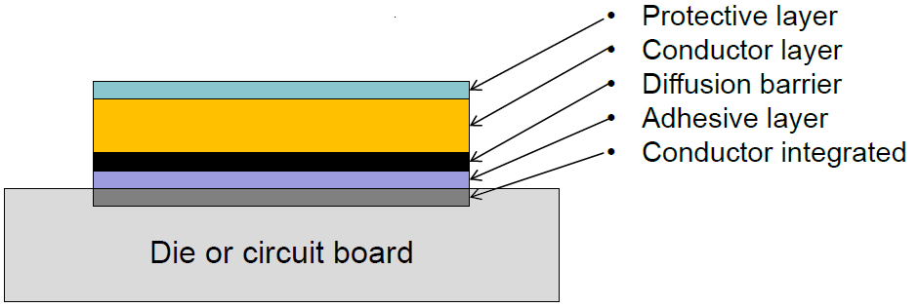

* Protective layer: protects pad from the environment and ensures bondability, even after storage. Example: 1 μm Sn or 10 nm Au
* Conductor layer: shall ensure low resistivity conduction. Example: Cu on PCBs, Au, Ag or Pt glass matrix on ceramic substrates, Cu or Al on ICs
* Diffusion barrier: Shall prevent the atoms of the conductor to diffuse in the underlying layers. Example: Ta or W based nitrides or more complex oxides/nitrides for Cu diffusion in ICs, Cr in PCB
* Adhesion layer: Shall ensure that metallization sticks on the surface. Example: Nickel Chrome (NiCr) is often used as a adhesion layer towards gold.
* IC or PCB conductor layer: Usually aluminum or Cu (can in some cases be doped silicon) on ICs
  + 1. **Soldering**

**Soldering: to create a metallic connection between two metal surfaces by using a molten metal in between.**

Wetting properties are important 🡪 the soldering material shall wet designated areas, but not others. The wetting is governed by Young’s equation (gamma=surface tension)

$$γ_{ls}+γ_{l}cosθ=γ_{s}$$

Where

* $γ_{ls}$ is the surface tension between the solder and the base material (liquid and solid)
* $γ_{l}$ is the surface tension of the solder
* $γ_{s}$ is the surface tension of the solid

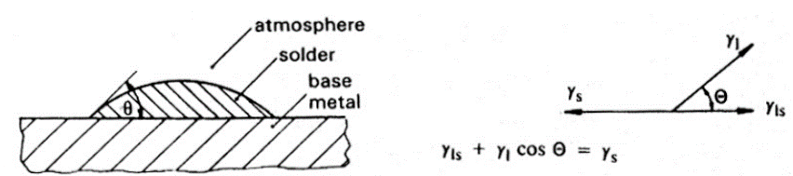

Solder wetting properties and minimalization of surface energies help you align your components: when you place components on a solder paste for example, they do not have to be perfectly aligned in their final position 🡪 in fact, once the solder paste is melted and the the solidification process starts, the minimization of the energy will bring the components in their final configuration. If the process is done correctly, they’ll be aligned with the corresponding pads.

* + 1. **Flip-chip bonding**

Flip chip is used for interconnecting semiconductor devices, such as IC chips and microelectromechanical systems (MEMS), to external circuitry with solder bumps that have been deposited onto the chip pads 🡪 this was already discussed in the previous chapters

**UNDER-BUMP METALLIZATION**

It is not possible to solder directly to Al (oxide) pads. An **under-bump metallization** (UBM) is therefore needed:

* It must provide a strong, stable, low resistance electrical connection to the aluminum.
* It must adhere well both to the underlying aluminum and to the surrounding IC passivation layer (for clarifications about where the passivation layer is, see figure)
* provide a strong barrier to prevent the diffusion of other bump metals into the IC.
* It must be readily wettable by the bump metals, for solder reflow

About 75% of UBM currently produced consists of many metallic layers evaporated or sputtered in a vacuum system. A typical process sequence would be:

1. Etch the native oxide (which acts as a passivation layer, green in figure) and expose fresh aluminum surface.
2. Deposit 100nm Ti / Cr/ Al as the adhesion layer.
3. Deposit 80nm Cr:Cu as the diffusion barrier layer.
4. Deposit 300nm Cu/ Ni:V as the solder-wettable layer.
5. Deposit 50nm Au as the oxidation barrier layer(optional).

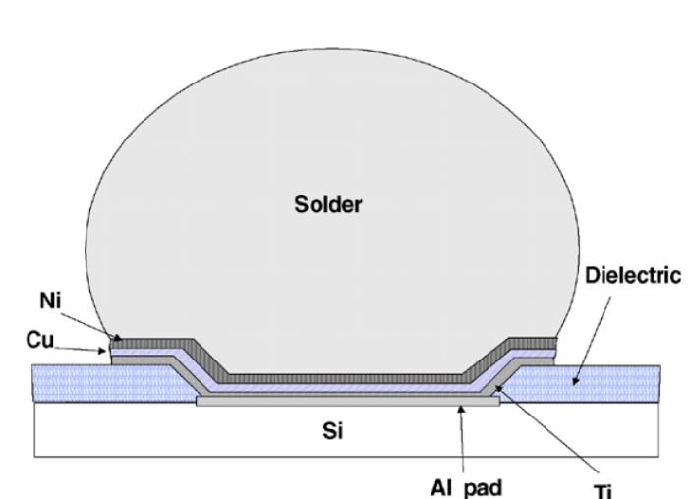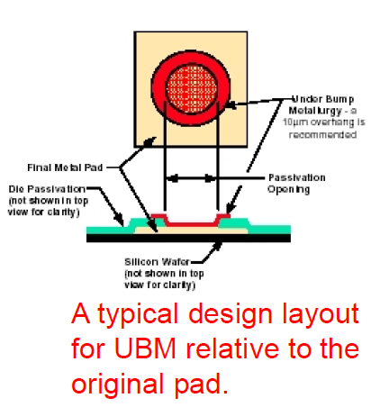

**UNDERFIL – MECHANICAL STRENGTHENING OF FLIP CHIP BONDS**

Flip chip process: take the chip, put solder balls below it, place the component, heat the PCB 🡪 the solder melts 🡪 the chip is attached to the substrate and the solder constitutes also the electrical connection between chip and pads on the board.

Following flip chip reflow, it is common to apply an adhesive that flows between the solder balls and solidifies to form a strong chip attachment 🡪 The underfill material is usually an epoxy resin highly filled with SiO2 particles. The underfill process is driven by capillary forces, so the viscosity and flow properties of the uncured underfill material are therefore crucial.

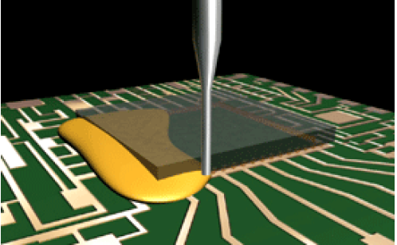

**STUD BUMP BONDING**

Stud bump (protuberanza del perno) bonding: **cross-breed of wire bonding and flip chip bonding**

* Gold ball bonding is first performed on wafer or chip level, but the wire is cut right above the ball 🡪 practically we have to make a gold ball under the chip, then pull a little wire from the ball and cut it as close as possible to the ball itself, in order to get a very small bump
* The chip is flipped and placed in position.
* Underfills deposited and cured
* In the underfill curing process, the adhesive shrinks, thereby strengthening the mechanical bond between the stud bumps and the interfacing substrate

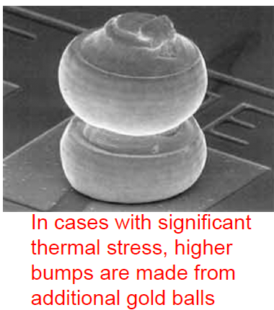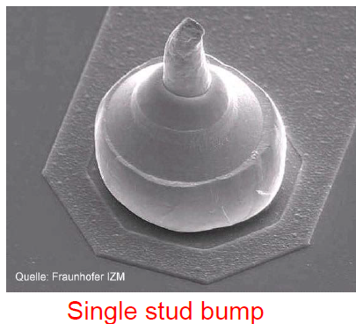

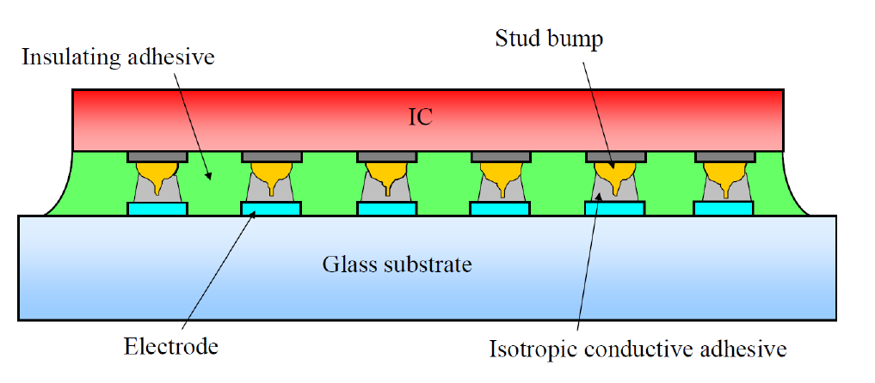

**SOLID-LIQUID INTERDIFFUSION (SLID) BONDING**

This is not the central aspect of the course, it is treated just for completeness.

SLID is a way to bond a chip to the substrate with even smaller pitch than what is allowed by flip-chip bonding.

Imagine having a chip, a substrate with UBM, a high melting temperature metal (generally copper) both right under the chip and on the top of the UBM. In between, one has a low-melting temperature metal (e.g. tin) 🡪 put everything together and heat it up 🡪 tin diffuses into copper , they mix and a bond is created with Cu3Sn. Melting temperature is very high, but can be realized in an easy way. Interfaces do not have to be perfectly matched when we place the components!

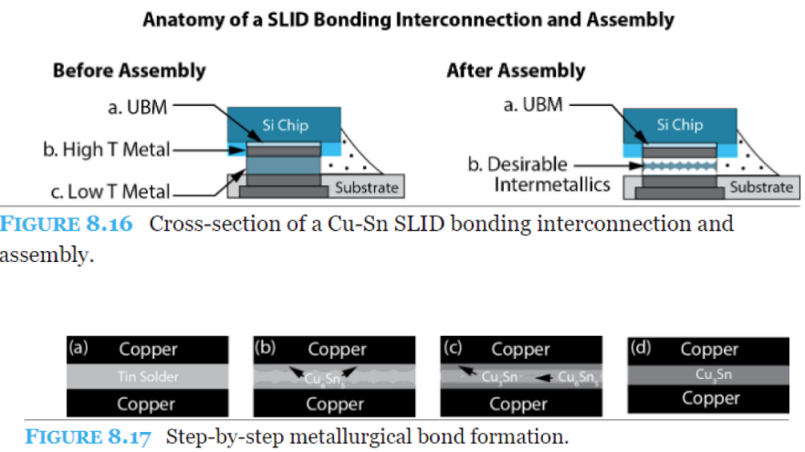

* + 1. **Die attach**

Die attach: **the process of making the electrical connection between the semiconductor device die and its package.**

Requirements on die attach process:

* The material used for the attaching process has to be conductive (usually) to ground the chip
* Thermally conductive
* must be stable at normal soldering temperatures (the package can undergo a heating up later in the process)
* must withstand high shear stresses

The attachment can be performed in two ways:

* High temperature soldering (hard solders, good thermal conductivity)
  + AuSi (420°C) and AuSn (350°C)
  + High lead, e.g. Pb90Sn10 (300°C)
* Adhesives (high tensile stresses from curing, moderate thermal conductivity)
  + Silver filled adhesives: Epoxy resin that has been highly loaded with silver metal flakes

TESTING THE QUALITY OF DIE ATTACH 🡪 put several silicon chips on a board and try to delaminate them with a proper machine 🡪 measures the force needed for the operation. With the test, we can characterize the curves for that specific type of bond (see figure on the right)

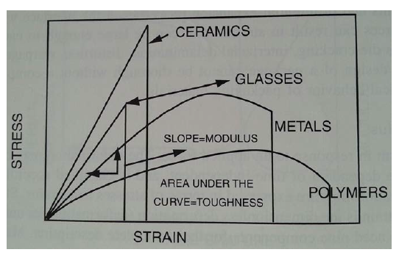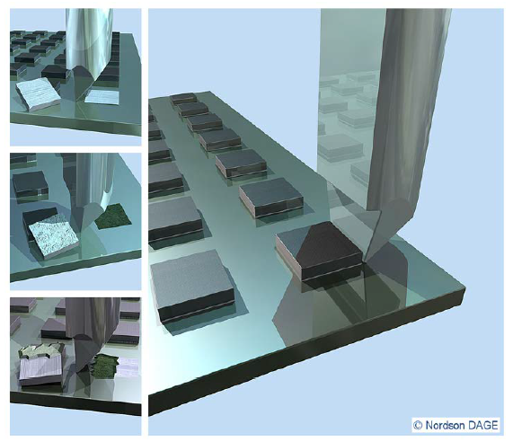

* + 1. **Adhesives in electronics**

Adhesives categorized into

* Non-conductive adhesives
* Isotropic Conductive Adhesives
* Anisotropic Conductive Adhesives

**ISOTROPIC CONDUCTING ADHESIVES**

Isotropic conductive adhesives 🡪 filled with conductive particles (usually silver) with sufficient density to ensure high conductivity in all directions (isotropic) upon solidification.

The shrinking during curing contributes to ensuring electrical contact between the conductive particles. Since here there are no wetting considerations that can be done, we need to place the components with extreme precision!

This kind of adhesive cannot be places uniformly, since we would create a short circuit between all pads!

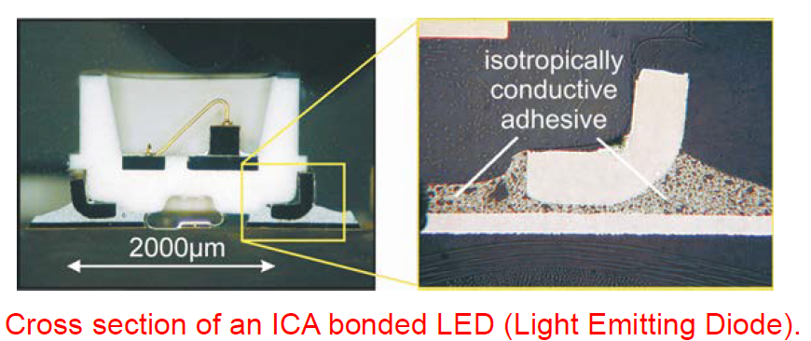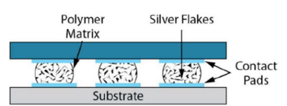

**ANISOTROPIC CONDUCTING ADHESIVES**

Anisotropic adhesives 🡪 strategies are adopted to let the electrical conduction only takes place in a single (anisotropic) direction.

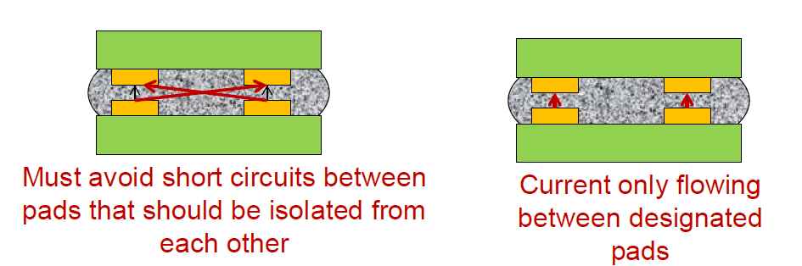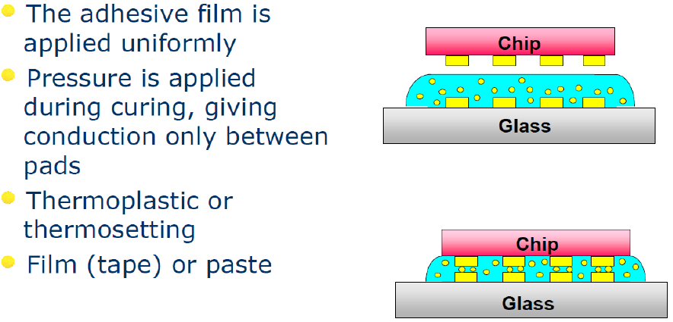

CONPART 🡪 Norwegian industry that uses this process.

**Conpart monodisperse sphere approach to anisotropic conductive adhesives**

Conductive particles are the most critical component in adhesives, requiring specific mechanical properties, a very narrow size distribution and an intolerance of large off-size particles for optimal reliability of the ACA assembly (the particles must have the same size to ensure the correct conductive behaviour of the adhesive) 🡪 they invented a system to produce sphere of the same size

Spheres: styrene (polymer) core + metal on the surface.

We see also that the particle is allowed to compress.

**This system cannot deal with high currents, but for logic signals it’s extremely efficient and reliable.**

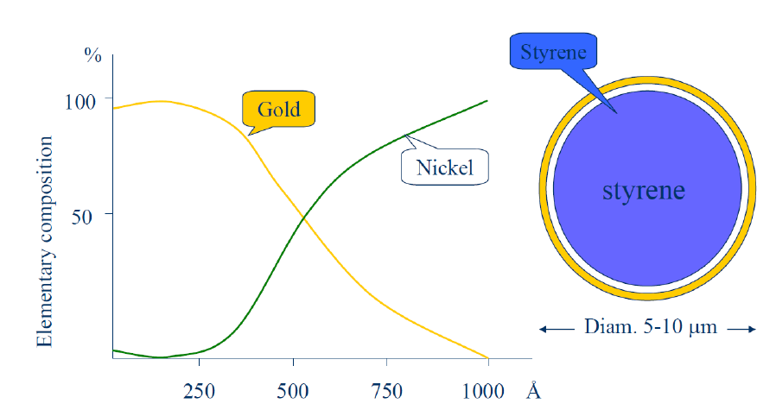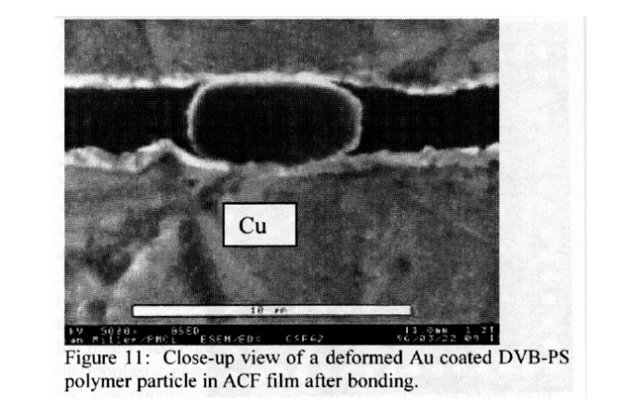

CondAlign 🡪 alternative process.

The CondAlign technology uses an electric field to structure and align particles in a polymer matrix. The matrix is then cured, locking the particles into their aligned positions. We achieve a conduction only in the vertical direction, but not in the horizontal one.

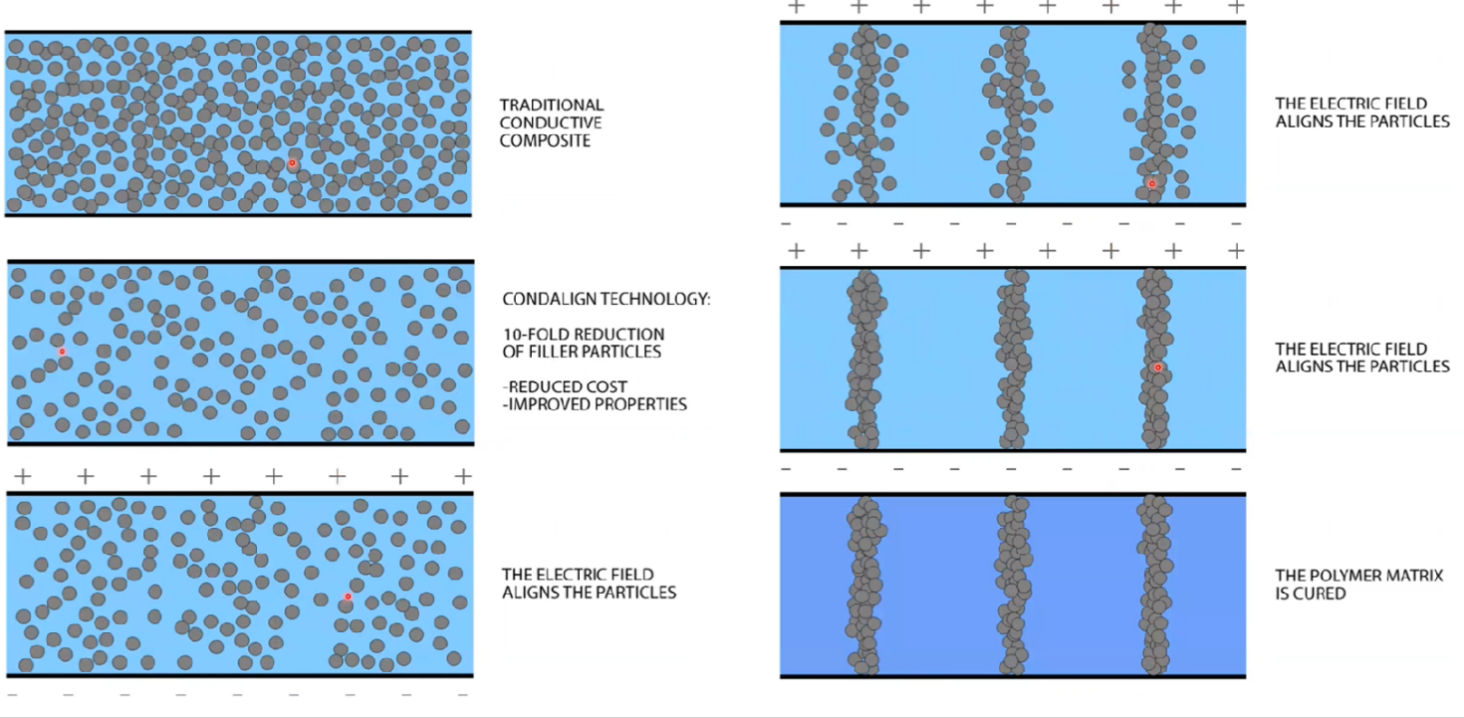

* + 1. **Recap table and final remarks**

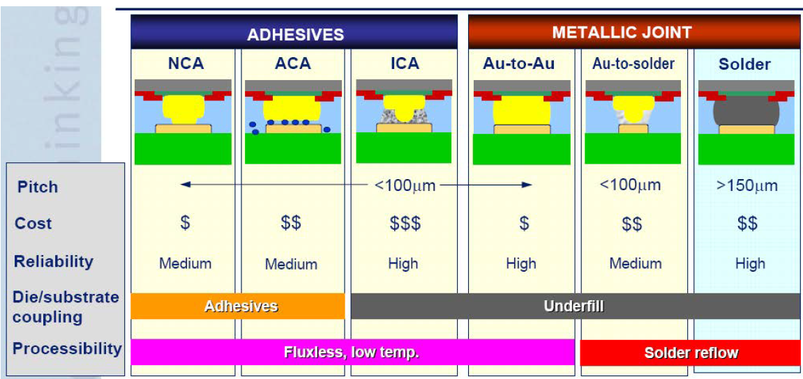

TAKE HOME MESSAGE: when we are talking about flip chip bonding there are many alternatives to create interconnections. Flip chip bonding is not a standardized process.

What to remember:

* Metals are different, and a lot of things takes place on the atomic scale.
* You should be able to explain the various ways to electrically connect a die to a circuit board or package

1. **Thermal management**

LEARNING OBJECTIVES

* Types of heat transfer mechanisms
* Approaches to cool electronics
* One dimensional thermal resistance calculations to estimate temperature and heat flow

Heat is an unavoidable product of every circuit 🡪 it can cause problems and wrong functioning in the devices 🡪 from here the need for thermal management solutions. Every year we observe a trend in increasing the clock frequency and reducing the dimensions of the electronic components 🡪 more heat density is generated 🡪 thermal management is a fundamental part in circuit design.

Heat is generated by

* **resistive heating** 🡪 self-explanatory
* **semiconductor switching**: switching on and off a semiconductor device causes heating dissipation according to the law

$$P=\frac{CV^{2}}{2}f$$

where

* + C = input capacitance in Farads
  + V = peak-to-peak voltage
  + f = switching frequency

The major challenge is to reduce P while f is increasing 🡪 possible solutions:

* Lower input capacitance (smaller dimensions)
* Lower switching voltages (5.0 V 🡪 3V 🡪 1 V)
* Efficient cooling strategies
* **energy conversion:** all energy conversion is connected with a conversion efficiency and the rest is loss, generally in form of heat.

Examples of energy conversion processes:

* + Power converters (AC-DC, DC-DC converters)
  + Light diodes (converting electrical power into light and heat)
  + Motors (converting electrical power into mechanical energy)

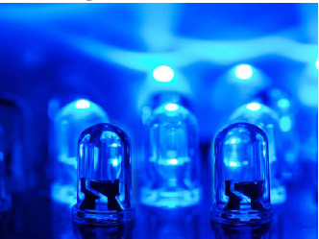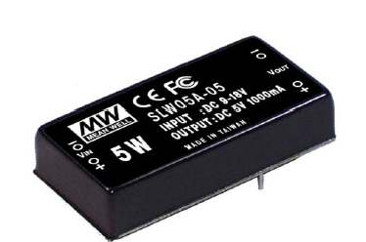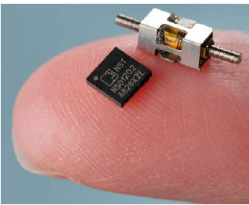

* **much more**.
  1. **Why thermal management?**

We have mainly 3 reasons:

* Temperature changes circuit operation
* Temperature affects the physical construction
* Failure rates increases
  + 1. **Temperature changes circuit operations**

Increasing temperature of an active electronic component changes its electrical parameters, such as gain, leakage currents and offset 🡪 example: leakage currents can double every 10°C temperature increase in active devices.

* PASSIVE DEVICES: change in their temperature means change in their characterizing values
  + TCR for resistors goes from several ppm/°C to several hundred
  + Temperature variations for capacitors from 30 ppm/°C to 60%, depending on the dielectric material, on the type of capacitor and on the environmental conditions in which it has to operate.
* ACTIVE DEVICES: they produce heat for the reasons cited above 🡪 a good design is mandatory to minimize the effects due to self-heating of the circuit. Example: some circuits are designed to track the temperature (tenere conto della temperature) in order to maintain the required specifics (gain for example) 🡪 in the following circuit R2 is close to the amplifier, which dissipates heat 🡪 R2 gets hotter, but R1 does not 🡪 the gain changes. POSSIBLE SOLUTIONS:
  + place R1 close to R2 and isolate them from the amplifier
  + lower the temperature of the transistor so that it has less effects on R2

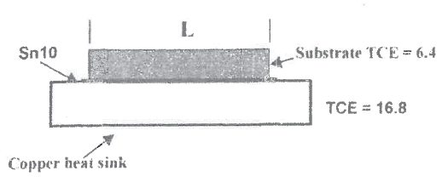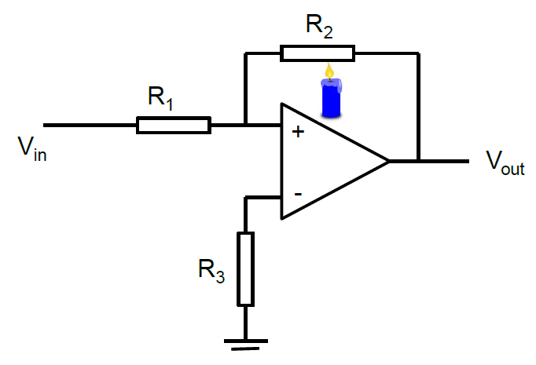

* + 1. **Temperature affects the physical construction**

Different materials have different coefficient of thermal expansion (CTE). Thermal stresses occur when materials are constrained during expansion or contraction. Extended stress cycles may need to fatigue and failure. Example: ceramic has TCE = 6.4 ppm/K, Cu has TCE = 16.8 ppm/K. During temperature cycling copper expands and contracts at a higher rate than ceramic, but the two materials are constrained 🡪 may induce failures (see figure above on the right)

* + 1. **Failure rates increasing with increasing temperature**

The failure rate *f* of an electronic component increases with temperature, and can often be described by the Arrhenius equation derived in statistical mechanics

$$f=A exp\left[-\frac{E_{A}}{k_{B}T}\right]$$

where

* $f$ = failure rate
* $A$ = constant
* $E_{A}$ = activation energy (eV)
* $T$ = junction temperature in Kelvin

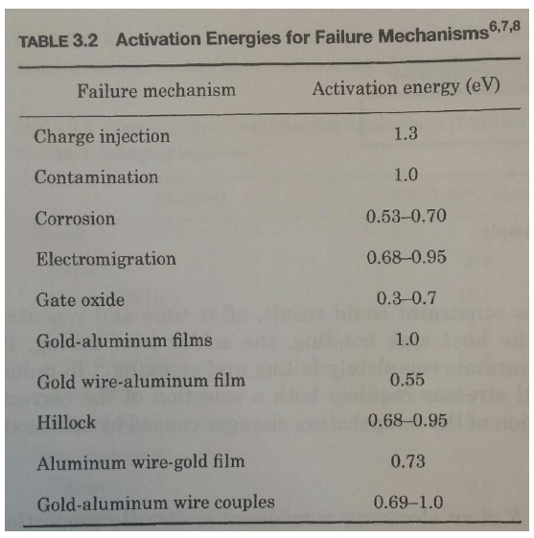

To compare failure rates at different temperatures one uses

$$\frac{f_{1}}{f_{2}}=\frac{exp\left[-\frac{E_{A}}{k_{B}T_{1}}\right]}{exp\left[-\frac{E_{A}}{k_{B}T_{2}}\right]}$$

Example:

* If Ea = 1eV, dt=10°C 🡪 failure rate increases by a factor 2.9
* If Ea = 0.65eV, dt=10°C 🡪 failure rate increases by a factor 2

This last value of activation energy is taken as rule of thumb by the constructors 🡪 for Ea=0.65 the failure rate doubles every 10°C increase in temperature.

Example of reation: purple plague formation at Au-Al interface.

NOTICE:

In terms of electronics, the Arrhenius equation has been used to model the influence of temperature on the mean time to failure of electronic devices. The activation energy is related to physical processes that gives rise to failure (i.e., failure mechanisms). Failure mechanisms that are well suited for modelling with the Arrhenius equation include intermetallic growth, corrosion, metal migration, void formation, and dielectric breakdown. However, activation energies for these failures in electronic devices can vary to a large degree. An error in the value of the activation energy of 0.1 eV at 60°C can increase or decrease the mean time to failure by a factor of more than 30. In some cases, the failure mechanism will not occur unless the temperature is above the threshold temperature. **So the Arrhenius equation in this context can give only estimations of the failure rates, it is not so precise!**

* 1. **Heat flow theory (basic know-how)**

In this course we’ll introduce only the main and most simple aspects of heat flow. We’ll see everything from the simple perspective of a 1-dimensional model.

* + 1. **Second law of thermodynamics**

This law states that heat flows spontaneously from hotter regions to colder regions. In electronics this means that every active or passive component is a source of heat, since they are always hotter than the surrounding environment.

* + 1. **Heat transfer mechanisms**

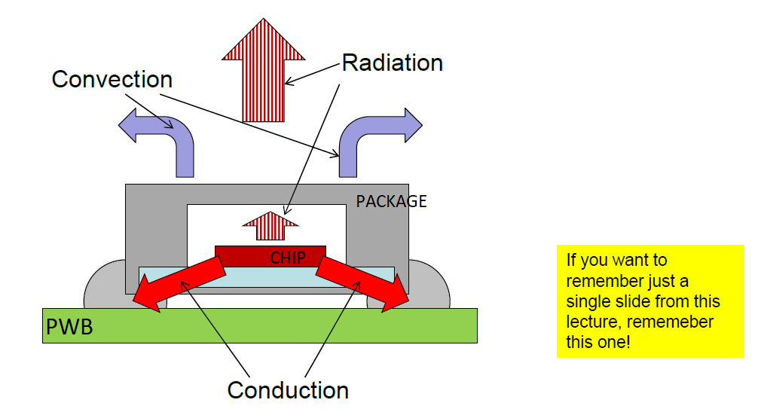

**CONDUCTION**

**Thermal conduction is a process in which heat flows through a solid, liquid, gas or between two media that are in intimate contact.**

In general thermal conduction involves the transfer of kinetic thermal energy from one electron to another with no visible global effects: the way heat is actually transferred depends on the state of the involved materials and on their electrical properties 🡪

* Dielectrics: Heat transfer dominated by lattice vibrations
* Metals: Added energy transport through free electrons 🡪 Electrical and thermal conductivity closely linked
* Liquids: Lower conduction than solids due to weaker inter-molecular bonds
* Gases: Even weaker (and random) inter-molecular bonds causing gases to have poor thermal conductivity

FOURIER’S LAW: **The heat flow rate dQ/dt equals the product of the cross-sectional area normal to the heat flow path multiplied with the thermal conductivity of the medium and the temperature gradient**

$$P=\frac{dQ}{dt}= -KA\frac{dT}{dx}$$

* $K$ is the thermal conductivity of the medium [W/m*K]
* $A$ is the cross-sectional area of the medium normal to the heat flow
* $T$ is the temperature of the medium
* $X$ is the position along the medium
* $Q$ is the heat flow in Watts normal to the cross section
* $q$ is the heat generated per unit volume (heat density in J/cm^3)
* $P$ is the power associated to the heat flux

The temperature and the cross-sectional area are evaluated at the same point X.

In general, the variation of $K$ with temperature is considered as a second order effect.

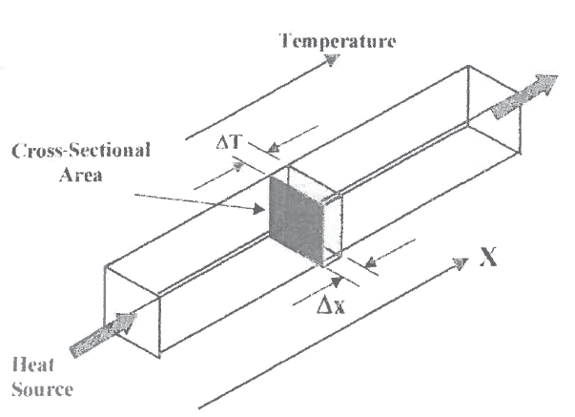

We manipulate the previous equation and introduce the thermal resistance.

$$PdX= -KAdT → Px= -KAΔT → ΔT=\frac{x}{KA}P=RP$$

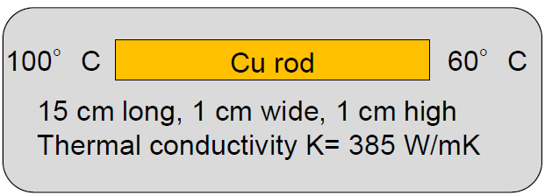Example:

$$R=\frac{x}{KA}=\frac{0.15}{385*{0.01}^{2}}KW^{-1}=3.9KW^{-1} → P=\frac{ΔT}{R}=\frac{40}{3.9}W=10.2W$$

The introduction of *R* helps us in making an analogy between thermal characteristics and electrical circuits’ language!

* Temperature variation becomes voltage
* Thermal resistance becomes electrical resistance
* Heat flow becomes current flow
* Thermal conductivity becomes electrical conductivity

THEN 🡪 **When several materials are stacked in series, the equivalent or total thermal resistance becomes the sum of the individual resistances.**

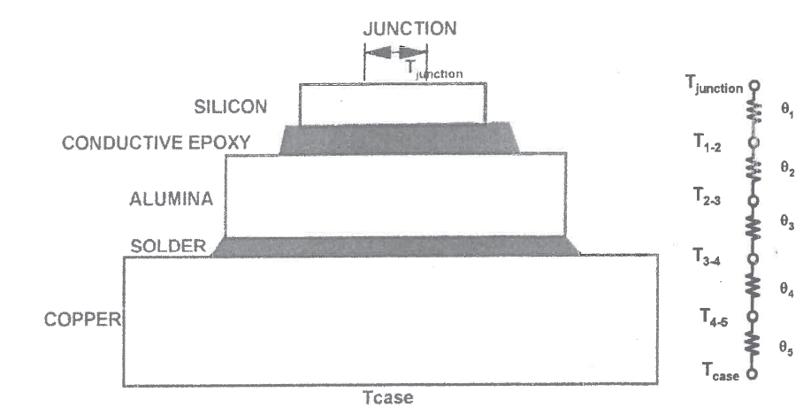

* R1 = resistance of silicon die
* R2 = thermal resistance of conductive epoxy die attach
* R3: thermal resistance of alumina substrate
* R4: thermal resistance of substrate attach (solder)
* R5: thermal resistance of copper case
* T(junction): junction temperature
* T(case): case temperature

$$ΔT=T_{junction}-T_{case}=R_{tot}P$$

NOTICE: the temperature at the interface of two layers cannot change discontinuously 🡪 the temperature at the bottom of the die will be the same as the temperature at the top of the conductive epoxy die attach material. It is denoted as T_12

HEAT SPREADING

Heat spreading is generally a 3D phenomenon 🡪 all the dimensions of space are involved. Generally we have a small circuit generating a great amount of heat, and this circuit is placed next to a high thermal conductivity material 🡪 we can diffuse heat more efficiently away 🡪 if we have a situation like described in figure, flow in x and y directions might be larger than in the z direction. The heat spreaders are posed between the heat-generating component and the large heat sink (alumina in this case)

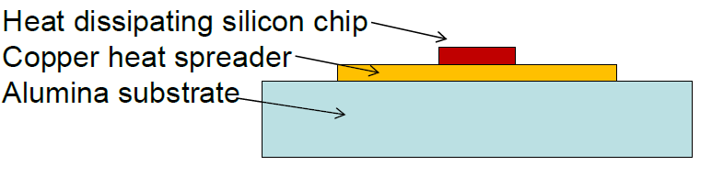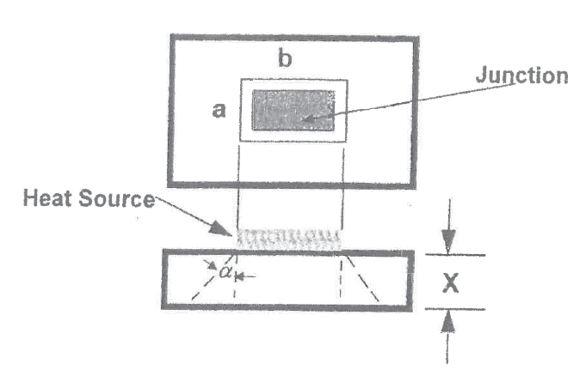

We can introduce the spread angle alpha as

$$α=atan⁡(K_{1} /K_{2})$$

where K1 and K2 are the thermal conductivities respectively of the current and next materials. If the lower layer has a much higher K 🡪 spreading is at minimum. Still there is always a bit of spreading due to the randomness of the thermal energy 🡪 we always have alpha>0.

Obviously, the thermal resistance is influenced by the geometrical shape and by the disposition of the various components on the circuit.

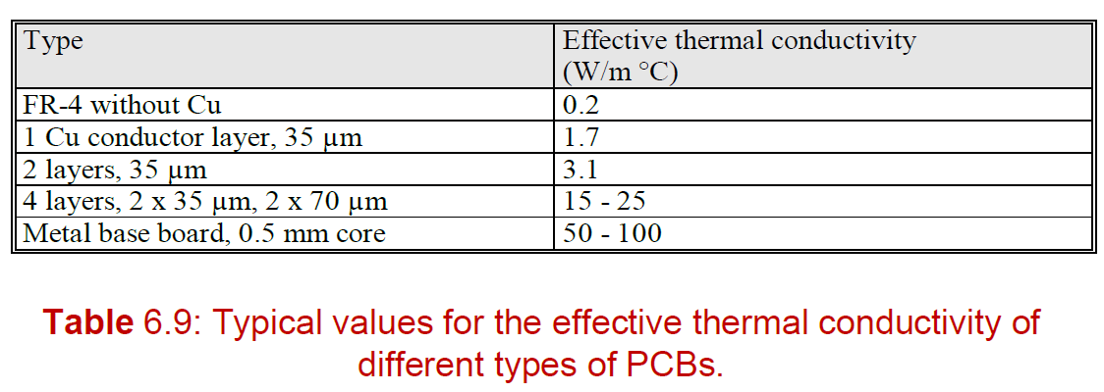

**CONVECTION**

**Convection is the transfer of thermal energy between two surfaces as a consequence of a relative velocity between them.**

Convection only occurs in fluids, and the transfer mechanism is the mixing of fluids

Most practical example: Interface between a solid surface and a fluid (usually air)

Convection cooling is also known as Newtonian cooling: the heat loss due to conventional cooling is proportional to the temperature difference between a fluid and the heat-emitting material.

$$Q_{c}=h_{s}A_{s}\left(T_{s}-T_{A}\right)=h_{s}A_{s}ΔT$$

where

* $Q_{c}$ is the heat transferred from a surface to the surrounding environment
* $A_{s}$ is the surface area of the material emitting thermal power
* $T_{s}$ is the surface temperature
* $T_{a}$ is the ambient temperature
* $h_{c}$ is the convection heat transfer coefficient. It is position and temperature dependent 🡪 usually approximated with an average value, combined with an average surface temperature.

We can define the convective surface thermal resistance

$$R_{s}={\left(h_{c}A_{s}\right)}^{-1}$$

NOTICE: this is simply a definition, not a law as the Fourier’s one. The temperature coefficient actually depends on the surface and surrounding temperatures, fluid velocity, viscosity, density, surface geometry.

TYPES OF CONVECTION:

* Natural convection: energy exchange caused entirely by differences in temperatures and densities causing fluidic movement. Here the fluid particles in close contact with the surface increase in internal energy 🡪 density of the nearby fluid decreases 🡪 particles tend to move to regions with lower temperatures.

Convection heat transfer coefficient is estimated as

* + D is a constant for air properties 🡪 determined by the path of hot masses (see figure)
  + E is a constant for surface configuration (E=1.9e-4 for a flat plate)
  + L is the characteristic length of the dissipator surface
  + dT is the temperature difference between the dissipator temperature and air temperature

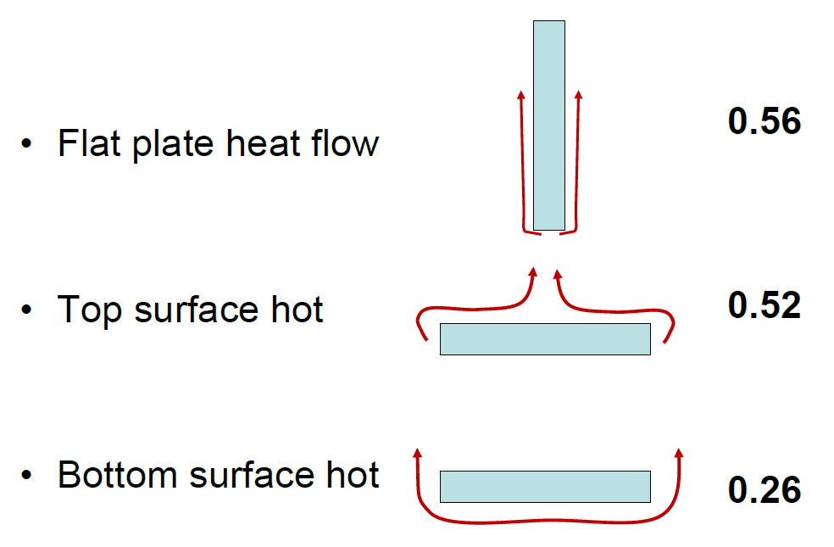

* Forced convection: The heat transfer is propelled by artificial means, e.g. fans.

Convection heat transfer coefficient is estimated as

* + B is a constant for air properties and surface configuration
  + v is the linear velocity of air
  + L is the characteristic length of the surface in direction of flow

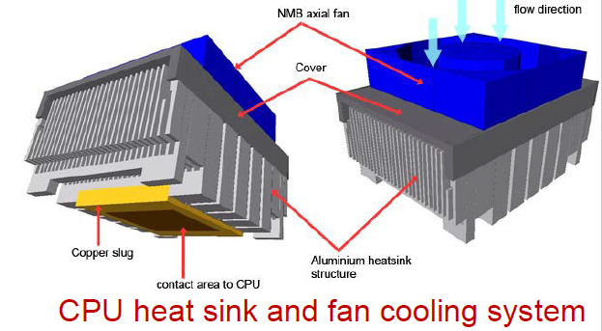

NOTICE: both of the formulas written above for h are just approximations 🡪 one should consider turbulent motion of fluids, but calculations are quite complicate. However, the take home message is that we are dealing with non-linear effects!

**RADIATION**

All objects with temperature above 0 K emit thermal radiation 🡪 **Radiation cooling is the transfer of heat by electromagnetic emission, mainly in infrared wavelengths (0.1 to 100 um)**.

This is the only possible way to extract heat from a system in pure vacuum! (actually it is maximized in this condition)

Thermal radiation is a purely surface related phenomenon, and we distinguish between Non-blackbodies and **Black bodies** 🡪

* absorbs all the entire thermal radiation incident upon it, neither reflecting nor transmitting any contribution of the incident radiation.
* The blackbody, at any given temperature, radiates more energy, both in the total spectrum and for each wavelength interval than any other temperature radiator.
* Emissive power of a black body: Eb
* Emissivity of a body or surface: $ϵ=E /E_{b}$
  + Blackbody 🡪
  + Real body 🡪

Surface treatments can change radiation properties completely!

* Polished Aluminum 🡪 ε = 0.03
* Black anodized aluminum 🡪 ε = 0.86
* Aluminum with 10nm gold 🡪 ε = 0.04-0.23

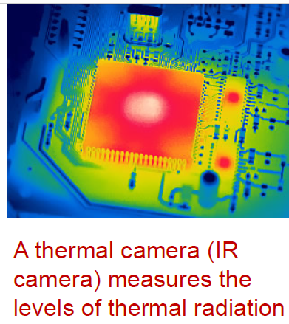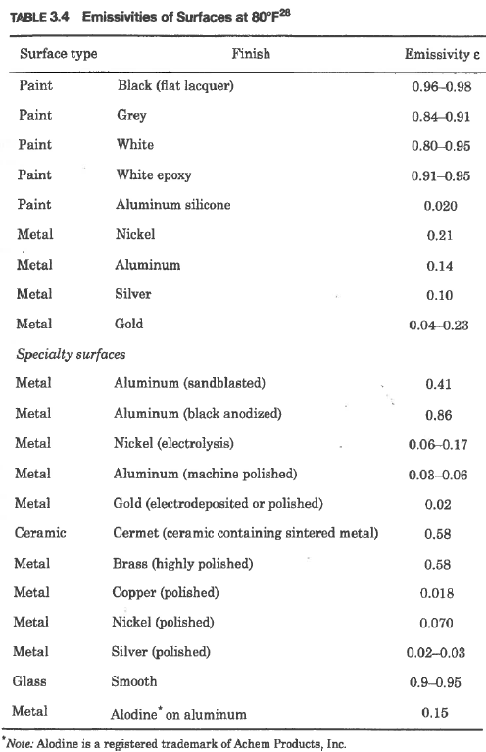

STEFAN-BOLTZMANN LAW:

The rate of emission R of radiant energy from the surface of a body, canbe expressed by the Stefan-Boltzmann law:

$$R=ϵσT^{4}=\frac{Q}{A}$$

* ε = surface emissivity [J/ s m2]
* σ = Stefan-Boltzmann constant
* Q = heat transferred [W]
* A = radiating surface area [m2]
* T = surface temperature [K]
  + 1. **Summary of heat flow calculations**
* Heat flows from hot to cooler regions
* Electrical analogy using thermal resistance networks makes calculations easy!
* The total thermal resistance R of multiple parallel paths are
$$\frac{1}{R_{tot}}=\frac{1}{R_{conduction}}+\frac{1}{R_{convection}}+\frac{1}{R_{radiation}}$$

* You should be able to estimate which effects are important in your design!
  + 1. **Final remarks and examples**

**REAL SURFACES HAVE A ROUGHNESS**

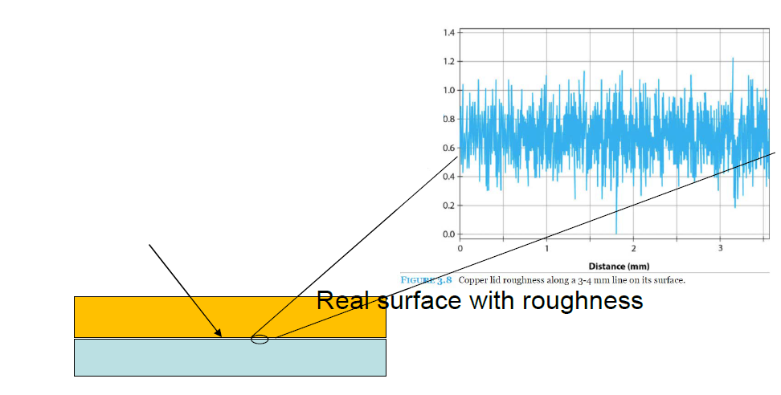This implies that we could have trapped air between two layers of two different materials 🡪 this changes the cross-section area that enters in the heat dissipation formula. The area is reduced because one has less contact points than what expected 🡪 thus one uses a **thermal interface material to fill voids**, usually a gel or a grease.

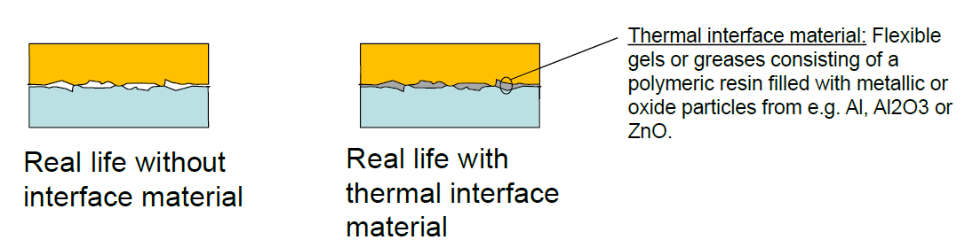

**THERMAL CONDIVTIVITY OF SOME MATERIALS**

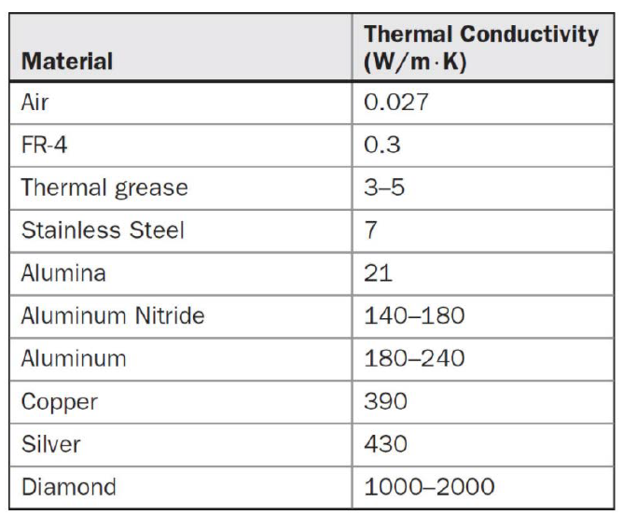

**EFFICIENT COOLING STRATEGIES**

* Thermal vias 🡪 discussed with Halvor. They are vias that lead heat to the other side of the PCB.

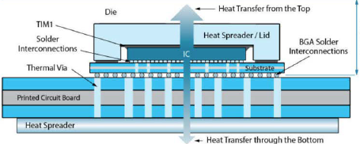

* 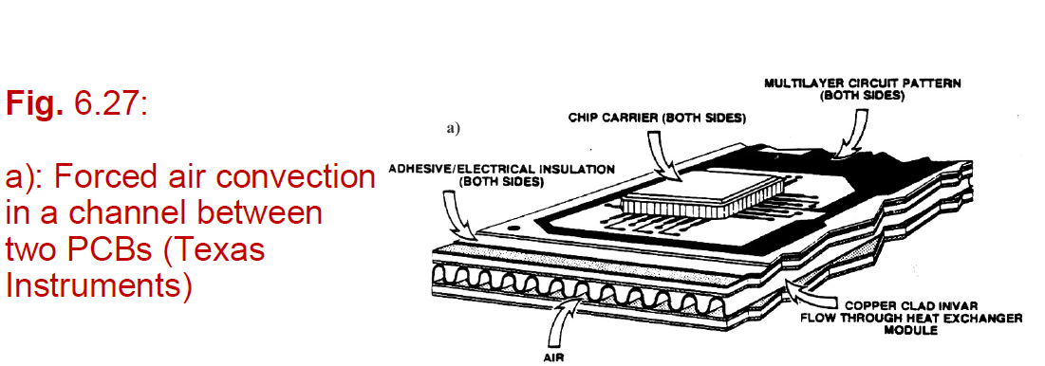Cooling fins (alette di raffreddamento)
* Fan
* Thermally conducting gas: helium, fluorocarbon
* Liquid: water, fluorocarbon, oil
* Boiling liquid

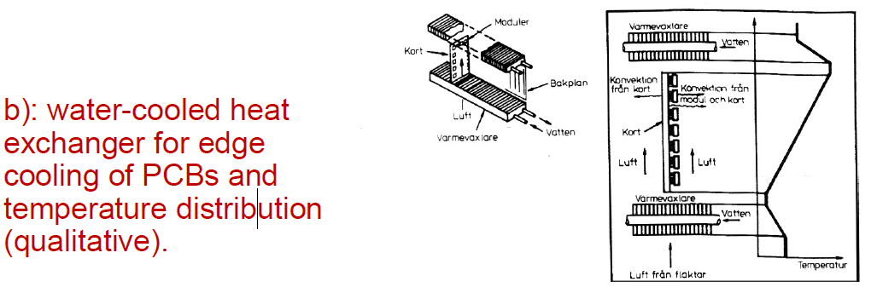Notice also that some fluids have better thermal conductive properties than others 🡪 see figure

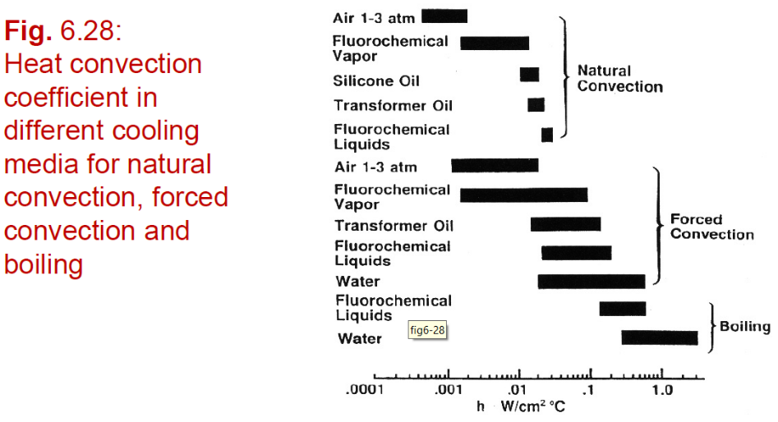

* Heat pipe: hot domain (where we want to cool) on one side and cool domain on the other. We have a fluid inside an external tube, it becomes vapor in the hot domain and condenses in the cold region. Due to microcapillary effects, once that the gas is returned into a liquid form it will naturally return to the hotter region.
* 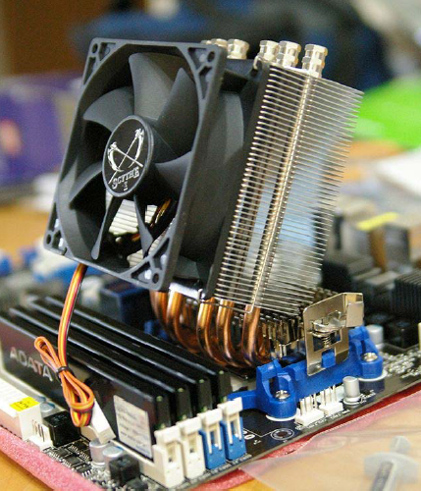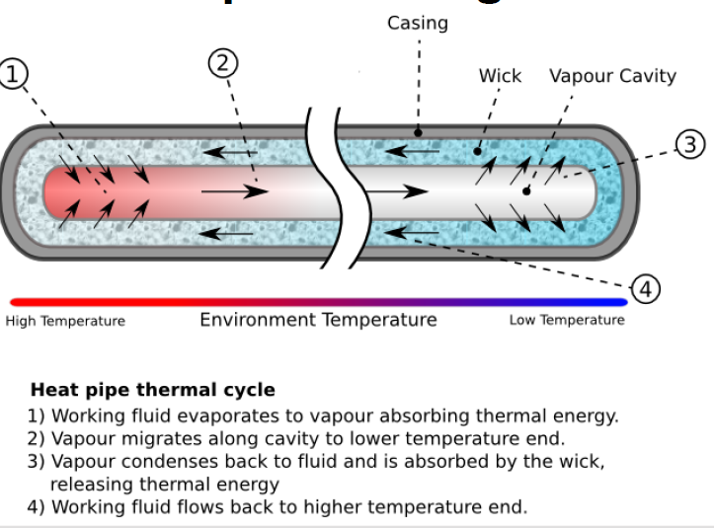
* Impingement cooling 🡪 we lead water directly to a hot component
* Microbellows 🡪 same principle, but bellow means “soffione (da caminetto)”, so its simply a particular technique to deliver the liquid to the backside of the component

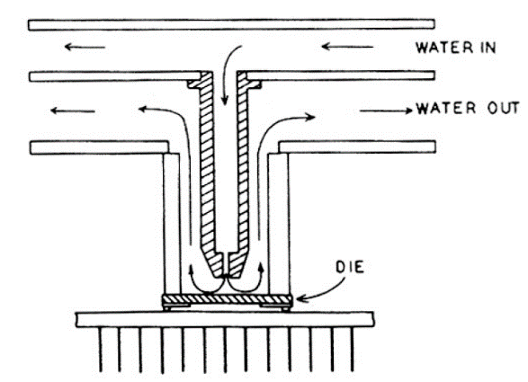

* Microgrooves 🡪 micro-scanalature: we simply use a structure to force the liquid to pass nearby the component to be cooled

